STAT5703 Data Mining I – Final Project Report

Appendix

Winter 2018

Michael Armanious (100978616), Alex El-Hajj (100887389), Muneer Khan (100650973) and Enrique Reveron (101066270)

April 17th, 2018

Table of Contents

1. Visualization 2

1.1 Calling Neccesary Libraries 2

1.2 Setting Up the Directory and Variables for Reproducibility 5

1.3 Calling Neccesary Functions 6

1.4 Loading the Data 6

1.5 Clean the Data 7

1.6 Scaterplot Matrix 9

1.7 Create a New Variable (Disease) 11

1.8 Create New Dataset with Factor Variables 12

1.9 Create New Dataset with Factor Variables and Names 13

1.10 Scaterplot Matrix Colored by Disease 15

1.11 Histogram Plots 16

1.12 Mosaic Plots 20

2. Split the Dataset into Train and Data 24

3. Mining Association Rules (apriori) 26

4. Logistic Regression (Quasibinomial) (glm) 84

5. Logistic Regression (Binomial) (glm) 91

6. Logistic Regression (Binomial) with Factor Variables (glm) 97

7. Linear Model with Stepwise Feature Selection (glmStepAIC) 103

8. Kmeans (eclust) 163

8.1 PCA 163

8.2 All Data Whithout PCA 176

9. Support Vector Machine (SVM) 181

9.1 SVM Radial (svmRadial) 181

9.2 Linear SVM (svmLinear) 189

10. Neural Networks (nnet) 194

11. K-Nearest Neighbors (knn) 198

12. Random Forest 203

12.1 Random Forest with Tuning Parameters (rf) 203

12.2 Random Forest Boosted Tree (bstTree) 208

12.3 Random Forest Boost with Tuning Parameters (gbm) 213

12.4 Random Forest with Stochastic Gradient Boost (gbm) 219

13. Classification Tree (rpart) 226

14. Fast-and-Frugal Decision Trees (FFTrees) 232

15. Custom Fast-and-Frugal Decision Trees (FFTrees) 238

16. Forest of Fast-and-Frugal Decision Trees (FFForest) 244

17. Minimun Cost 257

18. Results 259

18.1 Mining Association Rules 259

Train Set 264

Test Set 269

17.2 All Prediction Models Results 273

Confusion Matrix (Test Set) 275

Models Accuracy 277

Models Residuals 283

# 1. Visualization

## 1.1 Calling Necessary Libraries

############################################  
### 1.1 Calling Necessary Libraries   
l_packages = **c**("stats", "pls", "factoextra", "NbClust","ggplot2", "ggpubr","gridExtra",  
 "fastICA", "plot3D", "caret", "randomForest","bst","pROC",  
 "arules","arulesViz", "rpart", "FFTrees","rpart.plot",  
 "knitr","kableExtra","formatR", "xtable") *# used to create the Report (knitr)*  
  
**for**(p **in** l_packages){  
 **if** (**!require**(p,character.only = TRUE)) **install.packages**(p)  
 **library**(p,character.only = TRUE)   
}

## Loading required package: pls

##   
## Attaching package: 'pls'

## The following object is masked from 'package:stats':  
##   
## loadings

## Loading required package: factoextra

## Loading required package: ggplot2

## Welcome! Related Books: `Practical Guide To Cluster Analysis in R` at https://goo.gl/13EFCZ

## Loading required package: NbClust

## Loading required package: ggpubr

## Loading required package: magrittr

## Loading required package: gridExtra

## Loading required package: fastICA

## Loading required package: plot3D

## Loading required package: caret

## Loading required package: lattice

##   
## Attaching package: 'caret'

## The following object is masked from 'package:pls':  
##   
## R2

## Loading required package: randomForest

## randomForest 4.6-14

## Type rfNews() to see new features/changes/bug fixes.

##   
## Attaching package: 'randomForest'

## The following object is masked from 'package:gridExtra':  
##   
## combine

## The following object is masked from 'package:ggplot2':  
##   
## margin

## Loading required package: bst

## Loading required package: gbm

## Loading required package: survival

##   
## Attaching package: 'survival'

## The following object is masked from 'package:caret':  
##   
## cluster

## Loading required package: splines

## Loading required package: parallel

## Loaded gbm 2.1.3

## Loading required package: pROC

## Type 'citation("pROC")' for a citation.

##   
## Attaching package: 'pROC'

## The following objects are masked from 'package:stats':  
##   
## cov, smooth, var

## Loading required package: arules

## Loading required package: Matrix

##   
## Attaching package: 'arules'

## The following objects are masked from 'package:base':  
##   
## abbreviate, write

## Loading required package: arulesViz

## Loading required package: grid

## Loading required package: rpart

## Loading required package: FFTrees

## O

## / \

## F O

## / \

## F T

## FFTrees v1.3.5. Email: Nathaniel.D.Phillips.is@gmail.com

## FFTrees.guide() opens the package guide. Citation info at citation('FFTrees')

##   
## Attaching package: 'FFTrees'

## The following object is masked from 'package:pROC':  
##   
## auc

## Loading required package: rpart.plot

## Loading required package: kableExtra

## Loading required package: formatR

## Loading required package: xtable

## 1.2 Setting Up the Directory and Variables for Reproducibility

The **folder** variables needs to be updated in order to reproduce the work.

############################################  
### 1.2 Setting Up the Directory and Variables for Reproducibility  
*# Student and Assigment Information Variables*  
AS <- "FINAL-PROJECT"  
*# Folder Variables*  
drive="C:"  
path.upto <- **paste**("Users", "Enrique","Documents",   
 "Carleton", "Winter 2018", "STAT5703 Data Mining I", sep="/" )  
code.dir <- **paste**(drive, path.upto, AS, "Code", sep="/")  
data.dir <- **paste**(drive, path.upto, AS, "Data", sep="/")  
work.dir <- **paste**(drive, path.upto, AS, "Work", sep="/")  
report.dir <- **paste**(drive, path.upto, AS, "Report", sep="/")  
**setwd**(work.dir)  
**getwd**()

## [1] "C:/Users/Enrique/Documents/Carleton/Winter 2018/STAT5703 Data Mining I/FINAL-PROJECT/Work"

*# For reproducibility*  
**set.seed**(12345)

## 1.3 Calling Necessary Functions

############################################  
## 1.3 Calling Neccesary Functions  
**source**(**paste**(code.dir, **paste**(AS, "functions.r", sep=" "), sep="/"))

## [1] "successful!"

**lsf.str**()

## %w/o% : function (x, y)   
## convert_to_main.r : function ()   
## correct_kmeans_ids : function (class_ids, kmeans_ids)   
## count_missclassifications : function (class_ids, kmeans_ids)   
## count_rows : function (data, column, value)   
## create_kmeans_clusters : function (data, method, k_max, type_data, var1, var2)   
## elapsed_time : function (tic1, tic2)   
## f.data.std : function (data)   
## find_best_seed_kv2 : function (data, method, initial_seed, final_seed, k, real_class)   
## find_best_seedv2 : function (data, method, min_seed, max_seed, min_k, max_k, real_class)   
## find_unique_variables : function (data)   
## get.train : function (data.sz, train.sz)   
## has_empty_cluster : function (data)   
## panel.cor : function (x, y, digits = 2, prefix = "", cex.cor)   
## panel.hist : function (x, ...)   
## panel.smooth.asp : function (x, y, col = par("col"), bg = NA, pch = par("pch"), cex = 1,   
## col.smooth = "red", span = 2/3, iter = 3, asp, ...)   
## per_rows : function (data, column, value)   
## plot_clusters : function (clusters_plots)   
## print_kable : function (data, num_lines = 0, latex_options = 0, caption = NULL)   
## print_kablev2 : function (data, num_lines = 0, latex_options = 0, caption = NULL)   
## print_table : function (data, num_lines = 0, latex_options = 0, caption = NULL)   
## Sphere.Data : function (data)   
## std.to.orig : function (std.coef, mean.X, mean.Y, s.X, s.Y)

## 1.4 Loading the Data

############################################  
## 1.4 Loading the Data  
data.file <- **paste**(data.dir, "clev.csv", sep="/")  
heart.data<-**read.csv**(data.file, header=TRUE)  
heart.data**$**Ca <- **gsub**("?",NA,heart.data**$**Ca, fixed = TRUE)  
heart.data**$**Ca<-**as.numeric**(heart.data**$**Ca)  
heart.data**$**Thal<-**gsub**("?",NA,heart.data**$**Thal, fixed = TRUE)  
heart.data**$**Thal<-**as.numeric**(heart.data**$**Thal)  
heart.data<-**as.data.frame**(heart.data)  
**summary**(heart.data)

## Age Sex CP Trestbps Chol   
## Min. :29.0 Min. :0.00 Min. :1.00 Min. : 94 Min. :126   
## 1st Qu.:48.0 1st Qu.:0.00 1st Qu.:3.00 1st Qu.:120 1st Qu.:211   
## Median :56.0 Median :1.00 Median :3.00 Median :130 Median :241   
## Mean :54.4 Mean :0.68 Mean :3.16 Mean :132 Mean :247   
## 3rd Qu.:61.0 3rd Qu.:1.00 3rd Qu.:4.00 3rd Qu.:140 3rd Qu.:275   
## Max. :77.0 Max. :1.00 Max. :4.00 Max. :200 Max. :564   
##   
## Fbs Restecg Thalach Exang   
## Min. :0.000 Min. :0.00 Min. : 71 Min. :0.000   
## 1st Qu.:0.000 1st Qu.:0.00 1st Qu.:134 1st Qu.:0.000   
## Median :0.000 Median :1.00 Median :153 Median :0.000   
## Mean :0.148 Mean :0.99 Mean :150 Mean :0.327   
## 3rd Qu.:0.000 3rd Qu.:2.00 3rd Qu.:166 3rd Qu.:1.000   
## Max. :1.000 Max. :2.00 Max. :202 Max. :1.000   
##   
## Oldpeak Slope Ca Thal   
## Min. :0.00 Min. :1.0 Min. :0.000 Min. :3.00   
## 1st Qu.:0.00 1st Qu.:1.0 1st Qu.:0.000 1st Qu.:3.00   
## Median :0.80 Median :2.0 Median :0.000 Median :3.00   
## Mean :1.04 Mean :1.6 Mean :0.672 Mean :4.73   
## 3rd Qu.:1.60 3rd Qu.:2.0 3rd Qu.:1.000 3rd Qu.:7.00   
## Max. :6.20 Max. :3.0 Max. :3.000 Max. :7.00   
## NA's :4 NA's :2   
## Num   
## Min. :0.000   
## 1st Qu.:0.000   
## Median :0.000   
## Mean :0.937   
## 3rd Qu.:2.000   
## Max. :4.000   
##

## 1.5 Clean the Data

############################################  
## 1.5 Clean the Data   
*# We can notice 6 NA's on variables "Ca" and "Thal", let's see those rows*  
**dim**(heart.data)

## [1] 303 14

(heart.data.na <- **subset**(heart.data,(**is.na**(heart.data["Ca"]) **|** **is.na**(heart.data["Thal"]))))

## Age Sex CP Trestbps Chol Fbs Restecg Thalach Exang Oldpeak Slope Ca  
## 88 53 0 3 128 216 0 2 115 0 0.0 1 0  
## 167 52 1 3 138 223 0 0 169 0 0.0 1 NA  
## 193 43 1 4 132 247 1 2 143 1 0.1 2 NA  
## 267 52 1 4 128 204 1 0 156 1 1.0 2 0  
## 288 58 1 2 125 220 0 0 144 0 0.4 2 NA  
## 303 38 1 3 138 175 0 0 173 0 0.0 1 NA  
## Thal Num  
## 88 NA 0  
## 167 3 0  
## 193 7 1  
## 267 NA 2  
## 288 7 0  
## 303 3 0

*# Number of rows with NAs values*  
**nrow**(heart.data.na)

## [1] 6

*# Percentage*  
(**nrow**(heart.data.na)**/nrow**(heart.data) **\*** 100 )

## [1] 1.98

*# Because is only 2% I suggest to remove those rows*   
heart.data <- **subset**(heart.data, **!**(**is.na**(heart.data["Ca"]) **|** **is.na**(heart.data["Thal"])))  
  
*#Check the new data*  
**summary**(heart.data)

## Age Sex CP Trestbps Chol   
## Min. :29.0 Min. :0.000 Min. :1.00 Min. : 94 Min. :126   
## 1st Qu.:48.0 1st Qu.:0.000 1st Qu.:3.00 1st Qu.:120 1st Qu.:211   
## Median :56.0 Median :1.000 Median :3.00 Median :130 Median :243   
## Mean :54.5 Mean :0.677 Mean :3.16 Mean :132 Mean :247   
## 3rd Qu.:61.0 3rd Qu.:1.000 3rd Qu.:4.00 3rd Qu.:140 3rd Qu.:276   
## Max. :77.0 Max. :1.000 Max. :4.00 Max. :200 Max. :564   
## Fbs Restecg Thalach Exang   
## Min. :0.000 Min. :0.000 Min. : 71 Min. :0.000   
## 1st Qu.:0.000 1st Qu.:0.000 1st Qu.:133 1st Qu.:0.000   
## Median :0.000 Median :1.000 Median :153 Median :0.000   
## Mean :0.145 Mean :0.997 Mean :150 Mean :0.327   
## 3rd Qu.:0.000 3rd Qu.:2.000 3rd Qu.:166 3rd Qu.:1.000   
## Max. :1.000 Max. :2.000 Max. :202 Max. :1.000   
## Oldpeak Slope Ca Thal   
## Min. :0.00 Min. :1.0 Min. :0.000 Min. :3.00   
## 1st Qu.:0.00 1st Qu.:1.0 1st Qu.:0.000 1st Qu.:3.00   
## Median :0.80 Median :2.0 Median :0.000 Median :3.00   
## Mean :1.06 Mean :1.6 Mean :0.677 Mean :4.73   
## 3rd Qu.:1.60 3rd Qu.:2.0 3rd Qu.:1.000 3rd Qu.:7.00   
## Max. :6.20 Max. :3.0 Max. :3.000 Max. :7.00   
## Num   
## Min. :0.000   
## 1st Qu.:0.000   
## Median :0.000   
## Mean :0.946   
## 3rd Qu.:2.000   
## Max. :4.000

**str**(heart.data)

## 'data.frame': 297 obs. of 14 variables:  
## $ Age : int 63 67 67 37 41 56 62 57 63 53 ...  
## $ Sex : int 1 1 1 1 0 1 0 0 1 1 ...  
## $ CP : int 1 4 4 3 2 2 4 4 4 4 ...  
## $ Trestbps: int 145 160 120 130 130 120 140 120 130 140 ...  
## $ Chol : int 233 286 229 250 204 236 268 354 254 203 ...  
## $ Fbs : int 1 0 0 0 0 0 0 0 0 1 ...  
## $ Restecg : int 2 2 2 0 2 0 2 0 2 2 ...  
## $ Thalach : int 150 108 129 187 172 178 160 163 147 155 ...  
## $ Exang : int 0 1 1 0 0 0 0 1 0 1 ...  
## $ Oldpeak : num 2.3 1.5 2.6 3.5 1.4 0.8 3.6 0.6 1.4 3.1 ...  
## $ Slope : int 3 2 2 3 1 1 3 1 2 3 ...  
## $ Ca : num 0 3 2 0 0 0 2 0 1 0 ...  
## $ Thal : num 6 3 7 3 3 3 3 3 7 7 ...  
## $ Num : int 0 2 1 0 0 0 3 0 2 1 ...

**dim**(heart.data)

## [1] 297 14

## 1.6 Scatterplot Matrix

############################################  
## 1.6 Some Plots  
**pairs**(heart.data, upper.panel=panel.cor, diag.panel=panel.hist,   
 main = "Scaterplot Matrix")

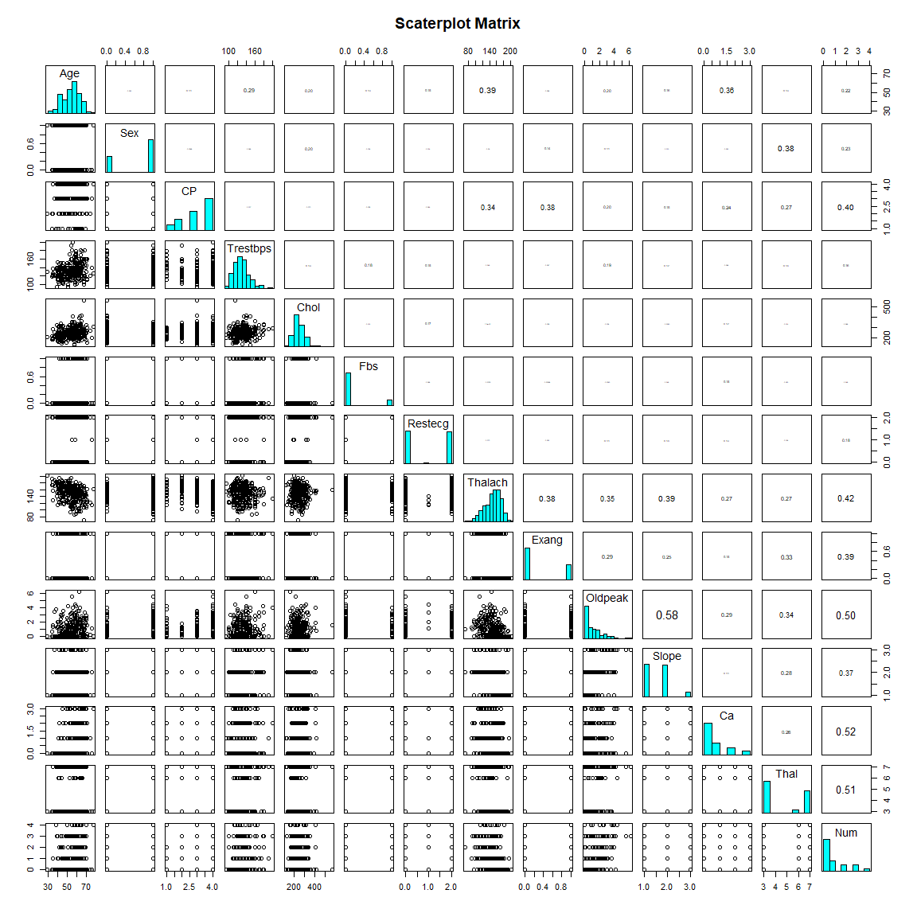

**kable**(**var**(heart.data))

|  |  |  |  |  |  |  |  |  |  |  |  |  |  |  |
| --- | --- | --- | --- | --- | --- | --- | --- | --- | --- | --- | --- | --- | --- | --- |
|  | Age | Sex | CP | Trestbps | Chol | Fbs | Restecg | Thalach | Exang | Oldpeak | Slope | Ca | Thal | Num |
| Age | 81.8977 | -0.3918 | 0.9646 | 46.6937 | 95.3568 | 0.4213 | 1.3498 | -81.9172 | 0.4102 | 2.0803 | 0.8918 | 3.0778 | 2.2208 | 2.4820 |
| Sex | -0.3918 | 0.2195 | 0.0040 | -0.5521 | -4.8256 | 0.0064 | 0.0158 | -0.6502 | 0.0316 | 0.0582 | 0.0097 | 0.0404 | 0.3485 | 0.1312 |
| CP | 0.9646 | 0.0040 | 0.9310 | -0.6338 | 3.6167 | -0.0196 | 0.0613 | -7.5107 | 0.1711 | 0.2287 | 0.0901 | 0.2135 | 0.5022 | 0.4815 |
| Trestbps | 46.6937 | -0.5521 | -0.6338 | 315.5173 | 121.4894 | 1.1323 | 2.6375 | -20.0117 | 0.5565 | 3.9613 | 1.3306 | 1.6337 | 4.7584 | 3.5003 |
| Chol | 95.3568 | -4.8256 | 3.6167 | 121.4894 | 2703.7486 | 0.2329 | 8.5383 | -0.0890 | 1.4494 | 2.3403 | -0.2962 | 5.6609 | 1.0946 | 4.2655 |
| Fbs | 0.4213 | 0.0064 | -0.0196 | 1.1323 | 0.2329 | 0.1242 | 0.0241 | -0.0634 | -0.0001 | 0.0034 | 0.0104 | 0.0503 | 0.0425 | 0.0213 |
| Restecg | 1.3498 | 0.0158 | 0.0613 | 2.6375 | 8.5383 | 0.0241 | 0.9899 | -1.6500 | 0.0383 | 0.1319 | 0.0831 | 0.1205 | 0.0363 | 0.2262 |
| Thalach | -81.9172 | -0.6502 | -7.5107 | -20.0117 | -0.0890 | -0.0634 | -1.6500 | 526.3153 | -4.1423 | -9.3003 | -5.5212 | -5.7887 | -12.2232 | -11.9135 |
| Exang | 0.4102 | 0.0316 | 0.1711 | 0.5565 | 1.4494 | -0.0001 | 0.0383 | -4.1423 | 0.2207 | 0.1585 | 0.0728 | 0.0654 | 0.2977 | 0.2271 |
| Oldpeak | 2.0803 | 0.0582 | 0.2287 | 3.9613 | 2.3403 | 0.0034 | 0.1319 | -9.3003 | 0.1585 | 1.3598 | 0.4174 | 0.3224 | 0.7799 | 0.7219 |
| Slope | 0.8918 | 0.0097 | 0.0901 | 1.3306 | -0.2962 | 0.0104 | 0.0831 | -5.5212 | 0.0728 | 0.4174 | 0.3822 | 0.0637 | 0.3352 | 0.2860 |
| Ca | 3.0778 | 0.0404 | 0.2135 | 1.6337 | 5.6609 | 0.0503 | 0.1205 | -5.7887 | 0.0654 | 0.3224 | 0.0637 | 0.8817 | 0.4667 | 0.6041 |
| Thal | 2.2208 | 0.3485 | 0.5022 | 4.7584 | 1.0946 | 0.0425 | 0.0363 | -12.2232 | 0.2977 | 0.7799 | 0.3352 | 0.4667 | 3.7583 | 1.2287 |
| Num | 2.4820 | 0.1312 | 0.4815 | 3.5003 | 4.2655 | 0.0213 | 0.2262 | -11.9135 | 0.2271 | 0.7219 | 0.2860 | 0.6041 | 1.2287 | 1.5241 |

## 1.7 Create a New Variable (Disease)

############################################  
## 1.7 Create a New Variable (Disease)   
*# This variable will be used in the analysis, if Num == 0 it means heart is Ok (healthy) and*  
*# if Num > 0 means heart disease (non-healthy)*  
heart.data**$**Disease <- **ifelse**((heart.data**$**Num **!=** 0),1,0)  
heart.data**$**Disease <- **factor**(heart.data**$**Disease)  
**str**(heart.data**$**Disease)

## Factor w/ 2 levels "0","1": 1 2 2 1 1 1 2 1 2 2 ...

## 1.8 Create New Dataset with Factor Variables

############################################  
## 1.8 Create New Dataset with Factor Variables  
heart.factor <- heart.data  
heart.factor**$**Age <- **factor**(heart.factor**$**Age)  
heart.factor**$**Sex <- **factor**(heart.factor**$**Sex)  
heart.factor**$**CP <- **factor**(heart.factor**$**CP)  
heart.factor**$**Fbs <- **factor**(heart.factor**$**Fbs)  
heart.factor**$**Restecg <- **factor**(heart.factor**$**Restecg)  
heart.factor**$**Exang <- **factor**(heart.factor**$**Exang)  
heart.factor**$**Slope <- **factor**(heart.factor**$**Slope)  
heart.factor**$**Ca <- **factor**(heart.factor**$**Ca)  
heart.factor**$**Thal <- **factor**(heart.factor**$**Thal)  
heart.factor**$**Num <- **factor**(heart.factor**$**Num)  
*# Check the new Data*  
**summary**(heart.factor)

## Age Sex CP Trestbps Chol Fbs Restecg  
## 58 : 18 0: 96 1: 23 Min. : 94 Min. :126 0:254 0:147   
## 57 : 17 1:201 2: 49 1st Qu.:120 1st Qu.:211 1: 43 1: 4   
## 54 : 16 3: 83 Median :130 Median :243 2:146   
## 59 : 14 4:142 Mean :132 Mean :247   
## 51 : 12 3rd Qu.:140 3rd Qu.:276   
## 60 : 12 Max. :200 Max. :564   
## (Other):208   
## Thalach Exang Oldpeak Slope Ca Thal Num   
## Min. : 71 0:200 Min. :0.00 1:139 0:174 3:164 0:160   
## 1st Qu.:133 1: 97 1st Qu.:0.00 2:137 1: 65 6: 18 1: 54   
## Median :153 Median :0.80 3: 21 2: 38 7:115 2: 35   
## Mean :150 Mean :1.06 3: 20 3: 35   
## 3rd Qu.:166 3rd Qu.:1.60 4: 13   
## Max. :202 Max. :6.20   
##   
## Disease  
## 0:160   
## 1:137   
##   
##   
##   
##   
##

**str**(heart.factor)

## 'data.frame': 297 obs. of 15 variables:  
## $ Age : Factor w/ 41 levels "29","34","35",..: 30 34 34 4 8 23 29 24 30 20 ...  
## $ Sex : Factor w/ 2 levels "0","1": 2 2 2 2 1 2 1 1 2 2 ...  
## $ CP : Factor w/ 4 levels "1","2","3","4": 1 4 4 3 2 2 4 4 4 4 ...  
## $ Trestbps: int 145 160 120 130 130 120 140 120 130 140 ...  
## $ Chol : int 233 286 229 250 204 236 268 354 254 203 ...  
## $ Fbs : Factor w/ 2 levels "0","1": 2 1 1 1 1 1 1 1 1 2 ...  
## $ Restecg : Factor w/ 3 levels "0","1","2": 3 3 3 1 3 1 3 1 3 3 ...  
## $ Thalach : int 150 108 129 187 172 178 160 163 147 155 ...  
## $ Exang : Factor w/ 2 levels "0","1": 1 2 2 1 1 1 1 2 1 2 ...  
## $ Oldpeak : num 2.3 1.5 2.6 3.5 1.4 0.8 3.6 0.6 1.4 3.1 ...  
## $ Slope : Factor w/ 3 levels "1","2","3": 3 2 2 3 1 1 3 1 2 3 ...  
## $ Ca : Factor w/ 4 levels "0","1","2","3": 1 4 3 1 1 1 3 1 2 1 ...  
## $ Thal : Factor w/ 3 levels "3","6","7": 2 1 3 1 1 1 1 1 3 3 ...  
## $ Num : Factor w/ 5 levels "0","1","2","3",..: 1 3 2 1 1 1 4 1 3 2 ...  
## $ Disease : Factor w/ 2 levels "0","1": 1 2 2 1 1 1 2 1 2 2 ...

**dim**(heart.factor)

## [1] 297 15

## 1.9 Create New Dataset with Factor Variables and Names

############################################  
## 1.9 Create New Dataset with Factor Variables  
heart.factor.names <- heart.factor  
  
**levels**(heart.factor.names**$**Sex) <- **c**("Female", "Male")  
  
**levels**(heart.factor.names**$**CP) <- **c**("Typical angina","Atypical angina",  
 "Non-anginal pain","Asymptomatic")  
  
**levels**(heart.factor.names**$**Fbs) <- **c**("< 120 mg/dl", "> 120 mg/dl")  
  
**levels**(heart.factor.names**$**Restecg) <- **c**("Normal", "Having ST-T wave abnormality",   
 "Showing left ventricular hypertrophy")  
  
**levels**(heart.factor.names**$**Exang) <- **c**("No", "Yes")  
  
**levels**(heart.factor.names**$**Slope) <- **c**("Upsloping", "Flat", "Downsloping")  
  
**levels**(heart.factor.names**$**Thal) <- **c**("Normal", "Fixed Defect",   
 "Reversible Defect")  
  
**levels**(heart.factor.names**$**Disease) <- **c**("Healthy", "Non-healthy")  
  
*# Check the new Data*  
**summary**(heart.factor.names)

## Age Sex CP Trestbps   
## 58 : 18 Female: 96 Typical angina : 23 Min. : 94   
## 57 : 17 Male :201 Atypical angina : 49 1st Qu.:120   
## 54 : 16 Non-anginal pain: 83 Median :130   
## 59 : 14 Asymptomatic :142 Mean :132   
## 51 : 12 3rd Qu.:140   
## 60 : 12 Max. :200   
## (Other):208   
## Chol Fbs   
## Min. :126 < 120 mg/dl:254   
## 1st Qu.:211 > 120 mg/dl: 43   
## Median :243   
## Mean :247   
## 3rd Qu.:276   
## Max. :564   
##   
## Restecg Thalach Exang   
## Normal :147 Min. : 71 No :200   
## Having ST-T wave abnormality : 4 1st Qu.:133 Yes: 97   
## Showing left ventricular hypertrophy:146 Median :153   
## Mean :150   
## 3rd Qu.:166   
## Max. :202   
##   
## Oldpeak Slope Ca Thal Num   
## Min. :0.00 Upsloping :139 0:174 Normal :164 0:160   
## 1st Qu.:0.00 Flat :137 1: 65 Fixed Defect : 18 1: 54   
## Median :0.80 Downsloping: 21 2: 38 Reversible Defect:115 2: 35   
## Mean :1.06 3: 20 3: 35   
## 3rd Qu.:1.60 4: 13   
## Max. :6.20   
##   
## Disease   
## Healthy :160   
## Non-healthy:137   
##   
##   
##   
##   
##

**str**(heart.factor.names)

## 'data.frame': 297 obs. of 15 variables:  
## $ Age : Factor w/ 41 levels "29","34","35",..: 30 34 34 4 8 23 29 24 30 20 ...  
## $ Sex : Factor w/ 2 levels "Female","Male": 2 2 2 2 1 2 1 1 2 2 ...  
## $ CP : Factor w/ 4 levels "Typical angina",..: 1 4 4 3 2 2 4 4 4 4 ...  
## $ Trestbps: int 145 160 120 130 130 120 140 120 130 140 ...  
## $ Chol : int 233 286 229 250 204 236 268 354 254 203 ...  
## $ Fbs : Factor w/ 2 levels "< 120 mg/dl",..: 2 1 1 1 1 1 1 1 1 2 ...  
## $ Restecg : Factor w/ 3 levels "Normal","Having ST-T wave abnormality",..: 3 3 3 1 3 1 3 1 3 3 ...  
## $ Thalach : int 150 108 129 187 172 178 160 163 147 155 ...  
## $ Exang : Factor w/ 2 levels "No","Yes": 1 2 2 1 1 1 1 2 1 2 ...  
## $ Oldpeak : num 2.3 1.5 2.6 3.5 1.4 0.8 3.6 0.6 1.4 3.1 ...  
## $ Slope : Factor w/ 3 levels "Upsloping","Flat",..: 3 2 2 3 1 1 3 1 2 3 ...  
## $ Ca : Factor w/ 4 levels "0","1","2","3": 1 4 3 1 1 1 3 1 2 1 ...  
## $ Thal : Factor w/ 3 levels "Normal","Fixed Defect",..: 2 1 3 1 1 1 1 1 3 3 ...  
## $ Num : Factor w/ 5 levels "0","1","2","3",..: 1 3 2 1 1 1 4 1 3 2 ...  
## $ Disease : Factor w/ 2 levels "Healthy","Non-healthy": 1 2 2 1 1 1 2 1 2 2 ...

**dim**(heart.factor.names)

## [1] 297 15

## 1.10 Scatterplot Matrix Colored by Disease

############################################  
## 1.10 Scatterplot Matrix Colored by Disease  
*# Plot colored by Disease*  
n.var <- **length**(heart.factor.names)  
**pairs**(heart.factor.names[,1**:**(n.var**-**1)],   
 col = **as.numeric**(heart.factor.names**$**Disease)**+**1,   
 main = "Scatterplot Matrix Colored by Disease")

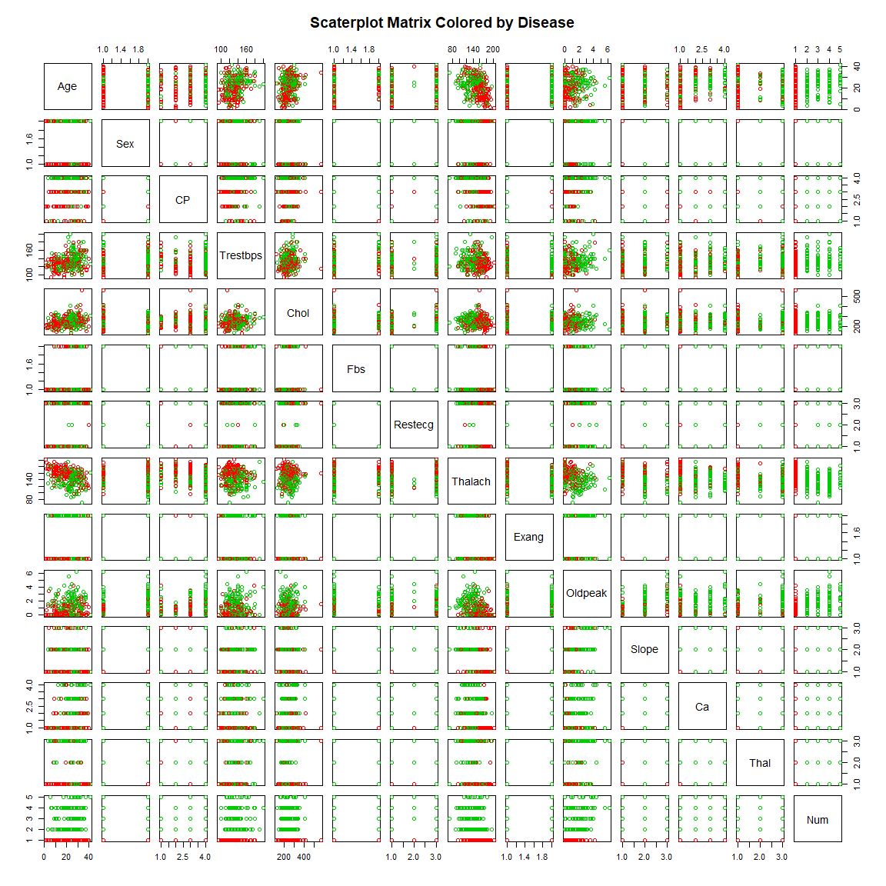

## 1.11 Histogram Plots

############################################  
## 1.11 Histogram Plots  
*# Histogram Age by Disease*  
g.age <- **ggplot**(heart.factor.names, **aes**(x = Age, fill = Disease)) **+**  
 **geom_histogram**(alpha = .8, stat = "count") **+**   
 **scale_fill_manual**(values=**c**(3, 2)) **+** **theme_bw**() **+**   
 **theme**(axis.text.x=**element_text**(angle=90, hjust=1)) **+**  
 **ggtitle**("Histogram: Age by Disease") **+** **xlab**("Age (years)")

*# Histogram Sex by Disease*  
g.sex <- **ggplot**(heart.factor.names, **aes**(x = **factor**(Sex), fill = Disease)) **+**  
 **geom_histogram**(alpha = .8, stat = "count") **+**   
 **scale_fill_manual**(values=**c**(3, 2)) **+** **theme_bw**() **+**  
 **ggtitle**("Histogram: Sex by Disease") **+** **xlab**("Sex")

*# Histogram CP by Disease*  
g.cp <- **ggplot**(heart.factor.names, **aes**(x = CP, fill = Disease)) **+**  
 **geom_histogram**(alpha = .8, stat = "count") **+**   
 **scale_fill_manual**(values=**c**(3, 2)) **+** **theme_bw**() **+**  
 **ggtitle**("Histogram: Type of Chest Pain by Disease") **+**  
 **xlab**("Type of Chest Pain")

*# Histogram TrestBps by Disease*  
g.trestbps <- **ggplot**(heart.factor.names, **aes**(x = Trestbps, fill = Disease)) **+**  
 **geom_histogram**(alpha = .8, bins = 30) **+**   
 **scale_fill_manual**(values=**c**(3, 2)) **+** **theme_bw**() **+**  
 **ggtitle**("Histogram: Resting Blood Pressure by Disease") **+**  
 **xlab**("Resting Blood Pressure (mm Hg)")  
  
*# Histogram Chol by Disease*  
g.chol <- **ggplot**(heart.factor.names, **aes**(x = Chol, fill = Disease)) **+**  
 **geom_histogram**(alpha = .8, bins = 30) **+**   
 **scale_fill_manual**(values=**c**(3, 2)) **+** **theme_bw**() **+**  
 **ggtitle**("Histogram: Serum Cholesterol by Disease") **+**  
 **xlab**("Serum Cholesterol (mg/dl)")  
  
*# Histogram Fbs by Disease*  
g.fbs <- **ggplot**(heart.factor.names, **aes**(x = Fbs, fill = Disease)) **+**  
 **geom_histogram**(alpha = .8, stat = "count") **+**   
 **scale_fill_manual**(values=**c**(3, 2)) **+** **theme_bw**() **+**  
 **ggtitle**("Histogram: Fasting Blood Sugar by Disease") **+**   
 **xlab**("Fasting Blood Sugar (mg/dl)")

*# Histogram Restecg by Disease*  
g.restegcg <- **ggplot**(heart.factor.names, **aes**(x = Restecg, fill = Disease)) **+**  
 **geom_histogram**(alpha = .8, stat = "count") **+**   
 **scale_fill_manual**(values=**c**(3, 2)) **+** **theme_bw**() **+**  
 **ggtitle**("Histogram: Resting Electrocardiogram by Disease") **+**   
 **xlab**("Resting ECG")

*# Histogram Thalach by Disease*  
g.thalach <- **ggplot**(heart.factor.names, **aes**(x = Thalach, fill = Disease)) **+**  
 **geom_histogram**(alpha = .8, bins = 30) **+**   
 **scale_fill_manual**(values=**c**(3, 2)) **+** **theme_bw**() **+**  
 **ggtitle**("Histogram: Thalium Test Max Heart Rate by Disease") **+**   
 **xlab**("Thalium Test Max Heart Rate")  
  
*# Histogram Exang by Disease*  
g.exang <- **ggplot**(heart.factor.names, **aes**(x = Exang, fill = Disease)) **+**  
 **geom_histogram**(alpha = .8, stat = "count") **+**   
 **scale_fill_manual**(values=**c**(3, 2)) **+** **theme_bw**() **+**  
 **ggtitle**("Histogram: Exercise Induced Angina by Disease") **+**   
 **xlab**("Exercise Induced Angina")

*# Histogram Oldpeak*  
g.oldpeak <- **ggplot**(heart.factor.names, **aes**(x = Oldpeak, fill = Disease)) **+**  
 **geom_histogram**(alpha = .8, bins = 30) **+**   
 **scale_fill_manual**(values=**c**(3, 2)) **+** **theme_bw**() **+**  
 **ggtitle**("Histogram: ST Depression Induced by Exercise") **+**   
 **xlab**("ST Depression Induced by Exercise")  
  
*# Histogram Slope by Disease*  
g.slope <- **ggplot**(heart.factor.names, **aes**(x = Slope, fill = Disease)) **+**  
 **geom_histogram**(alpha = .8, stat = "count") **+**   
 **scale_fill_manual**(values=**c**(3, 2)) **+** **theme_bw**() **+**  
 **ggtitle**("Histogram: Slope of Peak Exercise ST Segment by Disease") **+**   
 **xlab**("Slope of Peak Exercise ST Segment")

*# Histogram Ca by Disease*  
g.ca <- **ggplot**(heart.factor.names, **aes**(x = Ca, fill = Disease)) **+**  
 **geom_histogram**(alpha = .8, stat = "count") **+**   
 **scale_fill_manual**(values=**c**(3, 2)) **+** **theme_bw**() **+**  
 **ggtitle**("Histogram: Major Vessels Colored by Fluoroscopy by Disease") **+**   
 **xlab**("Major Vessels Colored by Fluoroscopy")

*# Histogram Thal by Disease*  
g.thal <- **ggplot**(heart.factor.names, **aes**(x = Thal, fill = Disease)) **+**  
 **geom_histogram**(alpha = .8, stat = "count") **+**   
 **scale_fill_manual**(values=**c**(3, 2)) **+** **theme_bw**() **+**  
 **ggtitle**("Histogram: Thalium Stress Test Results by Disease") **+**   
 **xlab**("Thalium Stress Test Results")

*# Histogram Num by Disease*  
g.num <- **ggplot**(heart.factor.names, **aes**(x = Num, fill = Disease)) **+**  
 **geom_histogram**(alpha = .8, stat = "count") **+**   
 **scale_fill_manual**(values=**c**(3, 2)) **+** **theme_bw**() **+**  
 **ggtitle**("Histogram: Major Vessels with > 50% Narrowing by Disease") **+**   
 **xlab**("Major Vessels with > 50% Narrowing")

*# Plot all the Histograms*  
g <- **grid.arrange**(  
 top = **text_grob**(label = "Histogram of Variables Colored by Disease",   
 color = "blue", size=16 ),  
 g.age,  
 g.sex,  
 g.cp,  
 g.trestbps,  
 g.chol,  
 g.fbs,  
 g.restegcg,  
 g.thalach,  
 g.exang,  
 g.oldpeak,  
 g.slope,  
 g.ca,  
 g.thal,  
 g.num,  
 ncol = 2)

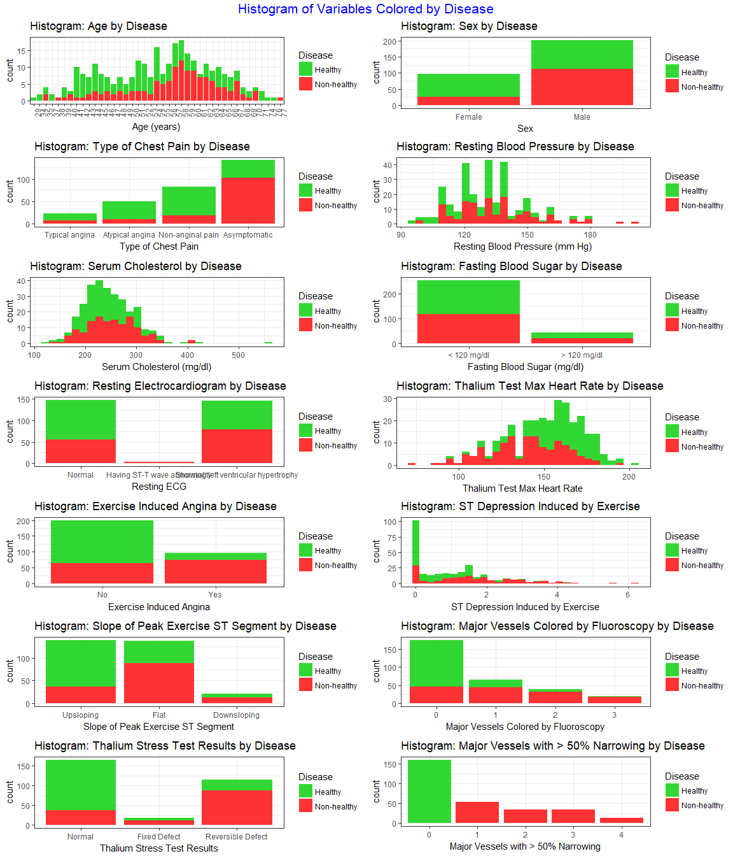

## 1.12 Mosaic Plots

############################################  
## 1.12 Mosaic Plots  
**mosaicplot**(heart.factor.names**$**Age **~** heart.factor.names**$**Disease,  
 main="Fate by Age", shade=FALSE,color=**c**(3,2),  
 xlab="Age (years)", ylab="Heart disease")

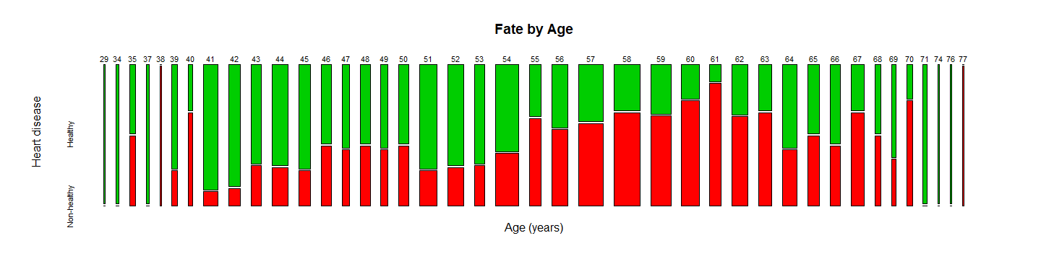

**mosaicplot**(heart.factor.names**$**Sex **~** heart.factor.names**$**Disease,  
 main="Fate by Gender", shade=FALSE,color=**c**(3,2),  
 xlab="Gender", ylab="Heart disease")

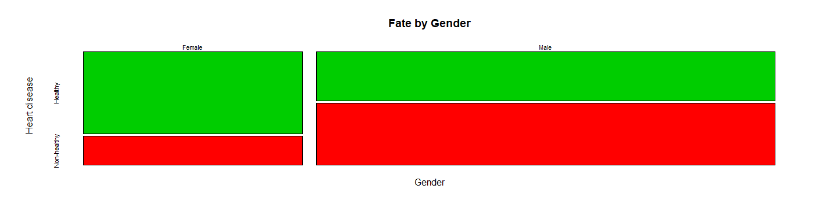

**mosaicplot**(heart.factor.names**$**CP **~** heart.factor.names**$**Disease,  
 main="Fate by Chest Pain Type", shade=FALSE,color=**c**(3,2),  
 xlab="Chest Pain Type", ylab="Heart disease")

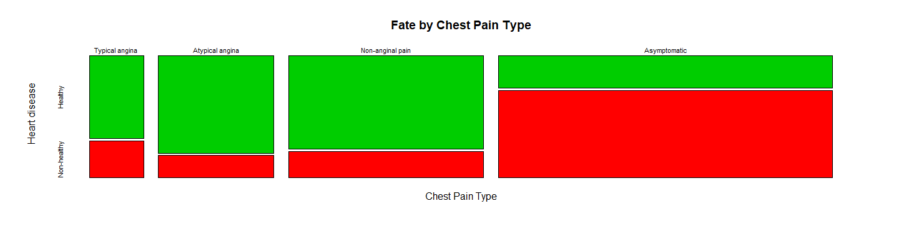

**mosaicplot**(heart.factor.names**$**Trestbps **~** heart.factor.names**$**Disease,  
 main="Fate by Resting Blood Pressure", shade=FALSE,color=**c**(3,2),  
 xlab="Resting Blood Pressure", ylab="Heart disease")

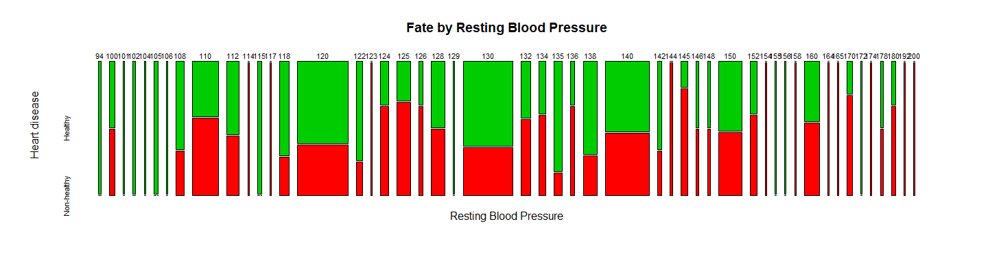

**mosaicplot**(heart.factor.names**$**Chol **~** heart.factor.names**$**Disease,  
 main="Fate by Serum Cholesterol", shade=FALSE,color=**c**(3,2),  
 xlab="Serum Cholesterol", ylab="Heart disease")

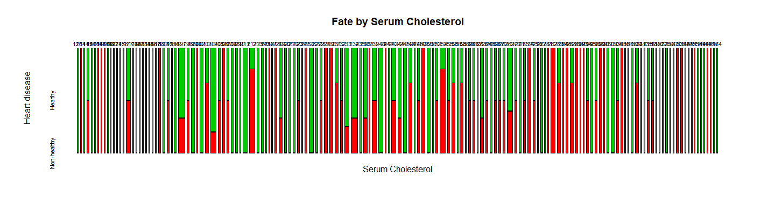

**mosaicplot**(heart.factor.names**$**Fbs **~** heart.factor.names**$**Disease,  
 main="Fate by Fasting Blood Sugar", shade=FALSE,color=**c**(3,2),  
 xlab="Fasting Blood Sugar", ylab="Heart disease")

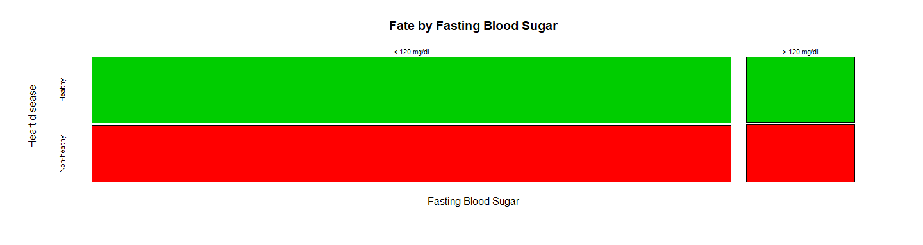

**mosaicplot**(heart.factor.names**$**Restecg **~** heart.factor.names**$**Disease,  
 main="Fate by Resting Electrocardiogram", shade=FALSE,color=**c**(3,2),  
 xlab="Resting Electrocardiogram", ylab="Heart disease")

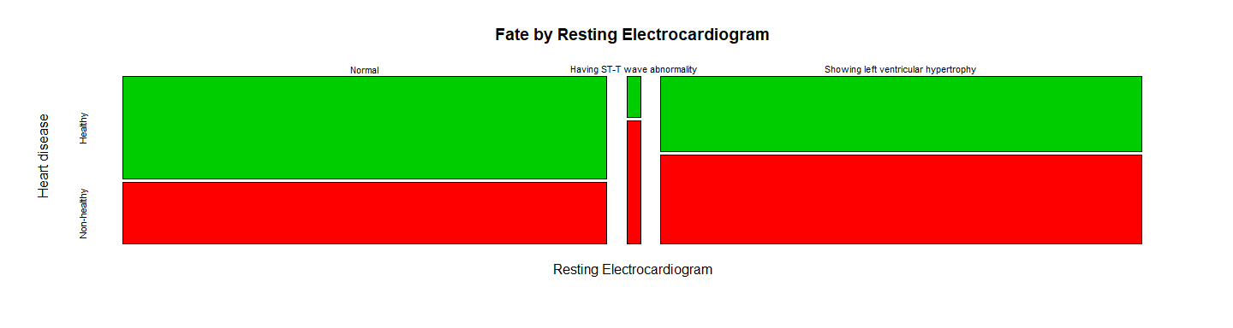

**mosaicplot**(heart.factor.names**$**Thalach **~** heart.factor.names**$**Disease,  
 main="Fate by Thalium Test Max Heart Rate", shade=FALSE,color=**c**(3,2),  
 xlab="Thalium Test Max Heart Rate", ylab="Heart disease")

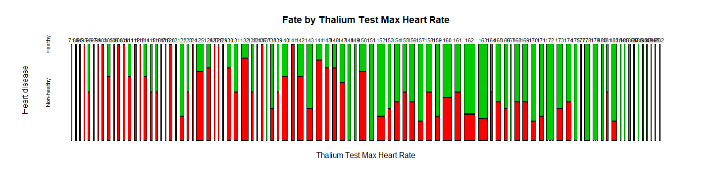

**mosaicplot**(heart.factor.names**$**Exang **~** heart.factor.names**$**Disease,  
 main="Fate by Exercise Induced Angina", shade=FALSE,color=**c**(3,2),  
 xlab="Exercise Induced Angina", ylab="Heart disease")

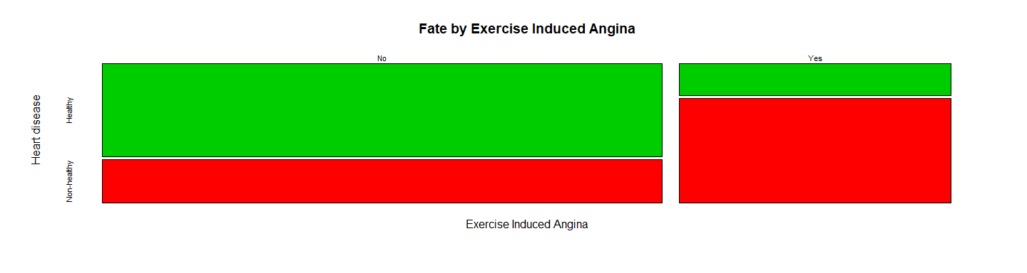

**mosaicplot**(heart.factor.names**$**Oldpeak **~** heart.factor.names**$**Disease,  
 main="Fate by ST Depression Induced by Exercise", shade=FALSE,color=**c**(3,2),  
 xlab="ST Depression Induced by Exercise", ylab="Heart disease")

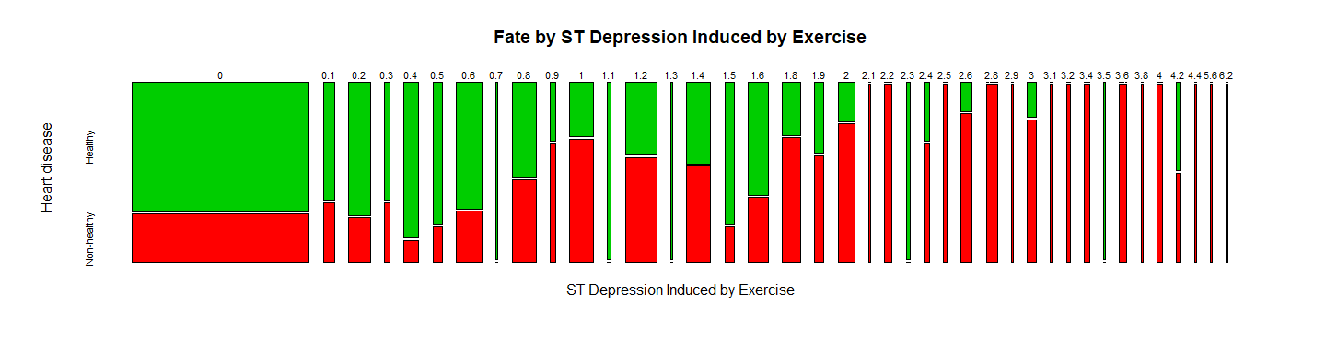

**mosaicplot**(heart.factor.names**$**Slope **~** heart.factor.names**$**Disease,  
 main="Fate by Slope of Peak Exercise ST Segment", shade=FALSE,color=**c**(3,2),  
 xlab="Slope of Peak Exercise ST Segment", ylab="Heart disease")

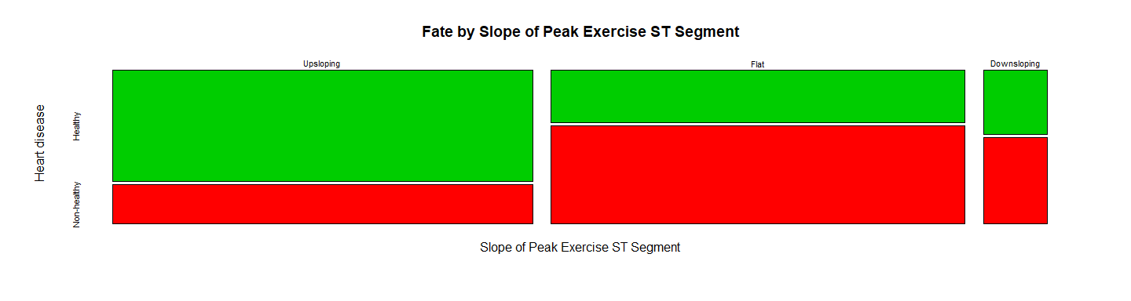

**mosaicplot**(heart.factor.names**$**Ca **~** heart.factor.names**$**Disease,  
 main="Fate by Major Vessels Colored by Fluoroscopy", shade=FALSE,color=**c**(3,2),  
 xlab="Major Vessels Colored by Fluoroscopy", ylab="Heart disease")

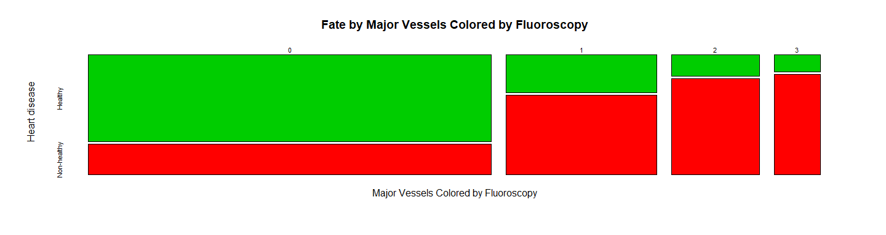

**mosaicplot**(heart.factor.names**$**Thal **~** heart.factor.names**$**Disease,  
 main="Fate by Thalium Stress Test Results", shade=FALSE,color=**c**(3,2),  
 xlab="Thalium Stress Test Results", ylab="Heart disease")

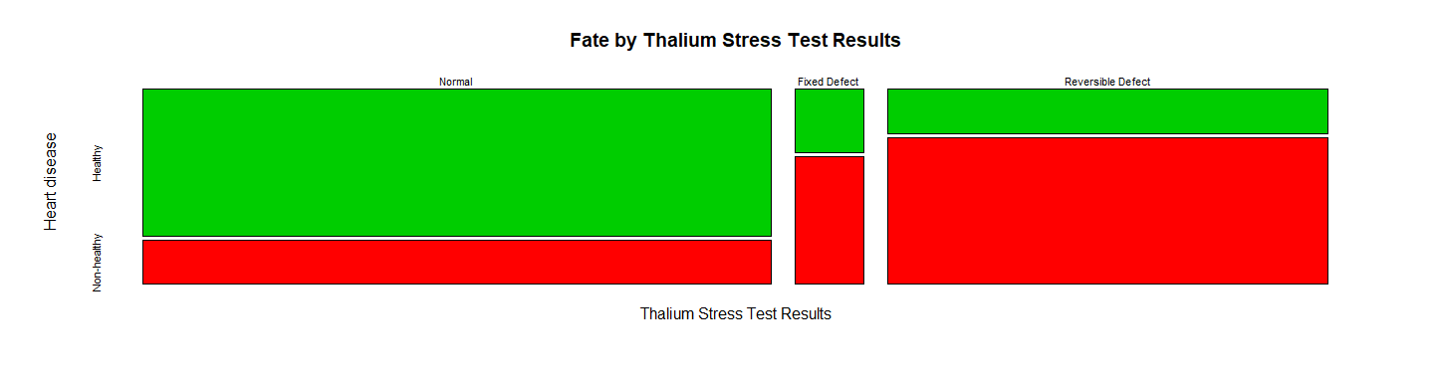

**mosaicplot**(heart.factor.names**$**Num **~** heart.factor.names**$**Disease,  
 main="Fate by Major Vessels with > 50% Narrowing", shade=FALSE,color=**c**(3,2),  
 xlab="Major Vessels with > 50% Narrowing", ylab="Heart disease")

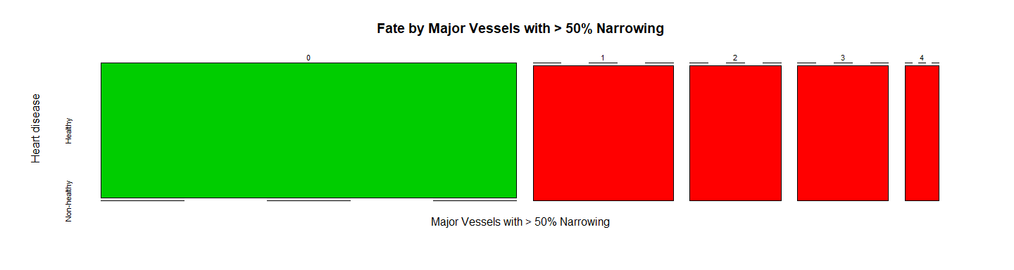

# 2. Split the Dataset into Train and Data

We will split the dataset using 1/3 for test and 2/3 for training, for each Num type (0,1,2,3)

############################################  
*# 2. Split the Dataset into Train and Data*  
(n.var <- **length**(heart.data))

## [1] 15

*# The firsts 13 variables are the predictors and the 15 is the class*  
   
inTrainRows <- **createDataPartition**(heart.data**$**Num,p=2**/**3,list=FALSE)  
trainData <- heart.data[inTrainRows,]  
trainData.factor <- heart.factor[inTrainRows,]  
trainData.factor.names <- heart.factor.names[inTrainRows,]  
  
testData <- heart.data[**-**inTrainRows,]  
testData.factor <- heart.factor[**-**inTrainRows,]  
testData.factor.names <- heart.factor.names[**-**inTrainRows,]  
  
**nrow**(trainData)**/**(**nrow**(testData)**+nrow**(trainData)) *#checking whether really 2/3 -> OK*

## [1] 0.6667

*# Distribution of each class in the train and test set*  
**summary**(trainData.factor.names**$**Num)

## 0 1 2 3 4   
## 107 35 24 24 8

**summary**(testData.factor.names**$**Num)

## 0 1 2 3 4   
## 53 19 11 11 5

*# Create the Train Set*  
X.trainData <- trainData[,1**:**13]  
X.trainData.factor <- trainData.factor[,1**:**13]  
X.trainData.factor.names <- trainData.factor.names[,1**:**13]  
X.trainData.std <- **f.data.std**(X.trainData)  
Y.trainData <- trainData[,15]  
Y.trainData.factor.names <- trainData.factor.names[,15]  
**summary**(Y.trainData.factor.names)

## Healthy Non-healthy   
## 107 91

*# Create the Test Set*  
X.testData <- testData[,1**:**13]  
X.testData.factor <- testData.factor[,1**:**13]  
X.testData.factor.names <- testData.factor.names[,1**:**13]  
X.testData.std <- **f.data.std**(X.testData)  
Y.testData <- testData[,15]  
Y.testData.factor.names <- testData.factor.names[,15]  
**summary**(Y.testData.factor.names)

## Healthy Non-healthy   
## 53 46

# 3. Mining Association Rules (apriori)

############################################  
*# 3. Mining Association Rules (apriori)*  
data.file <- **paste**(data.dir, "allfactorsclev.csv", sep="/")  
*#this is a file where all the variables are discrete factors and every level of the factor*  
*# corresponds to something (shown in the document)*  
allfactors<-**read.csv**(data.file, header = TRUE)  
*#make all variables factors so we can do association mining*  
allfactors**$**Age.Range<-**as.factor**(allfactors**$**Age.Range)  
allfactors**$**Sex<-**as.factor**(allfactors**$**Sex)  
allfactors**$**CP<-**as.factor**(allfactors**$**CP)  
allfactors**$**Trestbps.range<-**as.factor**(allfactors**$**Trestbps.range)  
allfactors**$**Chol.range<-**as.factor**(allfactors**$**Chol.range)  
allfactors**$**Fbs<-**as.factor**(allfactors**$**Fbs)  
allfactors**$**Restecg<-**as.factor**(allfactors**$**Restecg)  
allfactors**$**Thalach.range<-**as.factor**(allfactors**$**Thalach.range)  
allfactors**$**Exang<-**as.factor**(allfactors**$**Exang)  
allfactors**$**Oldpeak.range<-**as.factor**(allfactors**$**Oldpeak.range)  
allfactors**$**Slope<-**as.factor**(allfactors**$**Slope)  
allfactors**$**Ca<-**as.factor**(allfactors**$**Ca)  
allfactors**$**Thal<-**as.factor**(allfactors**$**Thal)  
allfactors**$**Num<-**as.factor**(allfactors**$**Num)  
*#partition the classification factor so we can see the distinction*  
allfactors**$**Disease <- **ifelse**((allfactors**$**Num **!=** 0),1,0)  
allfactors**$**Disease <- **factor**(allfactors**$**Disease)  
allfactors**$**Num<-NULL  
  
*#create rules for each subset*  
  
rules<-**apriori**((allfactors), appearance=**list**(rhs= **c**("Disease=0"), default="lhs"))

## Apriori  
##   
## Parameter specification:  
## confidence minval smax arem aval originalSupport maxtime support minlen  
## 0.8 0.1 1 none FALSE TRUE 5 0.1 1  
## maxlen target ext  
## 10 rules FALSE  
##   
## Algorithmic control:  
## filter tree heap memopt load sort verbose  
## 0.1 TRUE TRUE FALSE TRUE 2 TRUE  
##   
## Absolute minimum support count: 30   
##   
## set item appearances ...[1 item(s)] done [0.00s].  
## set transactions ...[44 item(s), 303 transaction(s)] done [0.00s].  
## sorting and recoding items ... [34 item(s)] done [0.00s].  
## creating transaction tree ... done [0.00s].  
## checking subsets of size 1 2 3 4 5 6 7 8 done [0.00s].  
## writing ... [859 rule(s)] done [0.00s].  
## creating S4 object ... done [0.00s].

**summary**(rules)

## set of 859 rules  
##   
## rule length distribution (lhs + rhs):sizes  
## 2 3 4 5 6 7 8   
## 1 43 200 314 222 71 8   
##   
## Min. 1st Qu. Median Mean 3rd Qu. Max.   
## 2.00 4.00 5.00 5.12 6.00 8.00   
##   
## summary of quality measures:  
## support confidence lift count   
## Min. :0.102 Min. :0.800 Min. :1.48 Min. : 31.0   
## 1st Qu.:0.112 1st Qu.:0.854 1st Qu.:1.58 1st Qu.: 34.0   
## Median :0.129 Median :0.896 Median :1.66 Median : 39.0   
## Mean :0.144 Mean :0.895 Mean :1.65 Mean : 43.6   
## 3rd Qu.:0.160 3rd Qu.:0.939 3rd Qu.:1.73 3rd Qu.: 48.5   
## Max. :0.406 Max. :1.000 Max. :1.85 Max. :123.0   
##   
## mining info:  
## data ntransactions support confidence  
## (allfactors) 303 0.1 0.8

*#sort by count/support*  
rules_count<-**sort**(rules, by='count', decreasing = T)  
**inspect**(rules_count[1**:**50])

## lhs rhs support confidence lift count  
## [1] {Oldpeak.range=1,   
## Thal=3} => {Disease=0} 0.4059 0.8146 1.505 123  
## [2] {Exang=0,   
## Thal=3} => {Disease=0} 0.3729 0.8370 1.546 113  
## [3] {Exang=0,   
## Ca=0} => {Disease=0} 0.3696 0.8485 1.568 112  
## [4] {Exang=0,   
## Oldpeak.range=1,   
## Thal=3} => {Disease=0} 0.3564 0.8640 1.596 108  
## [5] {Fbs=0,   
## Oldpeak.range=1,   
## Thal=3} => {Disease=0} 0.3564 0.8182 1.512 108  
## [6] {Exang=0,   
## Oldpeak.range=1,   
## Ca=0} => {Disease=0} 0.3465 0.8607 1.590 105  
## [7] {Ca=0,   
## Thal=3} => {Disease=0} 0.3366 0.8870 1.639 102  
## [8] {Fbs=0,   
## Exang=0,   
## Thal=3} => {Disease=0} 0.3267 0.8390 1.550 99  
## [9] {Fbs=0,   
## Exang=0,   
## Ca=0} => {Disease=0} 0.3234 0.8305 1.534 98  
## [10] {Oldpeak.range=1,   
## Ca=0,   
## Thal=3} => {Disease=0} 0.3201 0.9065 1.675 97  
## [11] {Fbs=0,   
## Exang=0,   
## Oldpeak.range=1,   
## Thal=3} => {Disease=0} 0.3135 0.8716 1.610 95  
## [12] {Exang=0,   
## Slope=1} => {Disease=0} 0.3069 0.8017 1.481 93  
## [13] {Fbs=0,   
## Exang=0,   
## Oldpeak.range=1,   
## Ca=0} => {Disease=0} 0.3069 0.8455 1.562 93  
## [14] {Exang=0,   
## Oldpeak.range=1,   
## Slope=1} => {Disease=0} 0.3036 0.8070 1.491 92  
## [15] {Fbs=0,   
## Ca=0,   
## Thal=3} => {Disease=0} 0.3036 0.8762 1.619 92  
## [16] {Exang=0,   
## Ca=0,   
## Thal=3} => {Disease=0} 0.2937 0.9082 1.678 89  
## [17] {Slope=1,   
## Thal=3} => {Disease=0} 0.2904 0.8627 1.594 88  
## [18] {Oldpeak.range=1,   
## Slope=1,   
## Thal=3} => {Disease=0} 0.2904 0.8627 1.594 88  
## [19] {Fbs=0,   
## Oldpeak.range=1,   
## Ca=0,   
## Thal=3} => {Disease=0} 0.2904 0.8980 1.659 88  
## [20] {Exang=0,   
## Oldpeak.range=1,   
## Ca=0,   
## Thal=3} => {Disease=0} 0.2805 0.9239 1.707 85  
## [21] {Restecg=0,   
## Exang=0,   
## Oldpeak.range=1} => {Disease=0} 0.2673 0.8182 1.512 81  
## [22] {Slope=1,   
## Ca=0} => {Disease=0} 0.2640 0.8696 1.607 80  
## [23] {Fbs=0,   
## Exang=0,   
## Ca=0,   
## Thal=3} => {Disease=0} 0.2640 0.8989 1.661 80  
## [24] {Exang=0,   
## Slope=1,   
## Thal=3} => {Disease=0} 0.2607 0.8681 1.604 79  
## [25] {Oldpeak.range=1,   
## Slope=1,   
## Ca=0} => {Disease=0} 0.2607 0.8681 1.604 79  
## [26] {Exang=0,   
## Oldpeak.range=1,   
## Slope=1,   
## Thal=3} => {Disease=0} 0.2607 0.8681 1.604 79  
## [27] {Thalach.range=3,   
## Exang=0,   
## Oldpeak.range=1} => {Disease=0} 0.2541 0.8021 1.482 77  
## [28] {Fbs=0,   
## Exang=0,   
## Oldpeak.range=1,   
## Ca=0,   
## Thal=3} => {Disease=0} 0.2541 0.9167 1.694 77  
## [29] {Fbs=0,   
## Slope=1,   
## Thal=3} => {Disease=0} 0.2508 0.8539 1.578 76  
## [30] {Fbs=0,   
## Oldpeak.range=1,   
## Slope=1,   
## Thal=3} => {Disease=0} 0.2508 0.8539 1.578 76  
## [31] {Thalach.range=3,   
## Ca=0} => {Disease=0} 0.2475 0.9036 1.669 75  
## [32] {Thalach.range=3,   
## Thal=3} => {Disease=0} 0.2442 0.8605 1.590 74  
## [33] {Restecg=0,   
## Thal=3} => {Disease=0} 0.2409 0.8588 1.587 73  
## [34] {Thalach.range=3,   
## Oldpeak.range=1,   
## Ca=0} => {Disease=0} 0.2376 0.9114 1.684 72  
## [35] {Thalach.range=3,   
## Oldpeak.range=1,   
## Thal=3} => {Disease=0} 0.2343 0.8659 1.600 71  
## [36] {Exang=0,   
## Slope=1,   
## Ca=0} => {Disease=0} 0.2343 0.8875 1.640 71  
## [37] {Fbs=0,   
## Slope=1,   
## Ca=0} => {Disease=0} 0.2343 0.8554 1.580 71  
## [38] {Sex=0,   
## Oldpeak.range=1} => {Disease=0} 0.2310 0.8140 1.504 70  
## [39] {Trestbps.range=3,   
## Thal=3} => {Disease=0} 0.2310 0.8140 1.504 70  
## [40] {Restecg=0,   
## Oldpeak.range=1,   
## Thal=3} => {Disease=0} 0.2310 0.8750 1.617 70  
## [41] {Exang=0,   
## Oldpeak.range=1,   
## Slope=1,   
## Ca=0} => {Disease=0} 0.2310 0.8861 1.637 70  
## [42] {Fbs=0,   
## Oldpeak.range=1,   
## Slope=1,   
## Ca=0} => {Disease=0} 0.2310 0.8537 1.577 70  
## [43] {Fbs=0,   
## Restecg=0,   
## Exang=0,   
## Oldpeak.range=1} => {Disease=0} 0.2310 0.8140 1.504 70  
## [44] {Sex=0,   
## Thal=3} => {Disease=0} 0.2277 0.8625 1.594 69  
## [45] {Thalach.range=3,   
## Slope=1} => {Disease=0} 0.2244 0.8000 1.478 68  
## [46] {Restecg=0,   
## Slope=1} => {Disease=0} 0.2244 0.8293 1.532 68  
## [47] {Thalach.range=3,   
## Oldpeak.range=1,   
## Slope=1} => {Disease=0} 0.2244 0.8095 1.496 68  
## [48] {Thalach.range=3,   
## Exang=0,   
## Thal=3} => {Disease=0} 0.2244 0.8718 1.611 68  
## [49] {Restecg=0,   
## Oldpeak.range=1,   
## Slope=1} => {Disease=0} 0.2244 0.8293 1.532 68  
## [50] {Fbs=0,   
## Exang=0,   
## Slope=1,   
## Thal=3} => {Disease=0} 0.2244 0.8608 1.590 68

*#sort by lift*  
rules_lift<-**sort**(rules, by='lift', decreasing = T)  
**inspect**(rules_lift[1**:**50])

## lhs rhs support confidence lift count  
## [1] {Sex=0,   
## CP=3,   
## Thal=3} => {Disease=0} 0.1023 1.0000 1.848 31  
## [2] {CP=3,   
## Thalach.range=3,   
## Thal=3} => {Disease=0} 0.1056 1.0000 1.848 32  
## [3] {Age.Range=2,   
## Trestbps.range=3,   
## Thal=3} => {Disease=0} 0.1386 1.0000 1.848 42  
## [4] {Sex=0,   
## CP=3,   
## Oldpeak.range=1,   
## Thal=3} => {Disease=0} 0.1023 1.0000 1.848 31  
## [5] {Age.Range=2,   
## Thalach.range=3,   
## Ca=0,   
## Thal=3} => {Disease=0} 0.1221 1.0000 1.848 37  
## [6] {Age.Range=2,   
## Trestbps.range=3,   
## Ca=0,   
## Thal=3} => {Disease=0} 0.1188 1.0000 1.848 36  
## [7] {Age.Range=2,   
## Trestbps.range=3,   
## Exang=0,   
## Thal=3} => {Disease=0} 0.1254 1.0000 1.848 38  
## [8] {Age.Range=2,   
## Trestbps.range=3,   
## Oldpeak.range=1,   
## Thal=3} => {Disease=0} 0.1320 1.0000 1.848 40  
## [9] {Age.Range=2,   
## Trestbps.range=3,   
## Fbs=0,   
## Thal=3} => {Disease=0} 0.1221 1.0000 1.848 37  
## [10] {Restecg=0,   
## Thalach.range=3,   
## Ca=0,   
## Thal=3} => {Disease=0} 0.1287 1.0000 1.848 39  
## [11] {Sex=0,   
## Fbs=0,   
## Restecg=0,   
## Exang=0,   
## Thal=3} => {Disease=0} 0.1155 1.0000 1.848 35  
## [12] {Age.Range=2,   
## Thalach.range=3,   
## Exang=0,   
## Ca=0,   
## Thal=3} => {Disease=0} 0.1089 1.0000 1.848 33  
## [13] {Age.Range=2,   
## Thalach.range=3,   
## Oldpeak.range=1,   
## Ca=0,   
## Thal=3} => {Disease=0} 0.1155 1.0000 1.848 35  
## [14] {Age.Range=2,   
## Fbs=0,   
## Thalach.range=3,   
## Ca=0,   
## Thal=3} => {Disease=0} 0.1155 1.0000 1.848 35  
## [15] {Age.Range=2,   
## Trestbps.range=3,   
## Exang=0,   
## Ca=0,   
## Thal=3} => {Disease=0} 0.1089 1.0000 1.848 33  
## [16] {Age.Range=2,   
## Trestbps.range=3,   
## Oldpeak.range=1,   
## Ca=0,   
## Thal=3} => {Disease=0} 0.1122 1.0000 1.848 34  
## [17] {Age.Range=2,   
## Trestbps.range=3,   
## Fbs=0,   
## Ca=0,   
## Thal=3} => {Disease=0} 0.1089 1.0000 1.848 33  
## [18] {Age.Range=2,   
## Trestbps.range=3,   
## Exang=0,   
## Oldpeak.range=1,   
## Thal=3} => {Disease=0} 0.1188 1.0000 1.848 36  
## [19] {Age.Range=2,   
## Trestbps.range=3,   
## Fbs=0,   
## Exang=0,   
## Thal=3} => {Disease=0} 0.1089 1.0000 1.848 33  
## [20] {Age.Range=2,   
## Trestbps.range=3,   
## Fbs=0,   
## Oldpeak.range=1,   
## Thal=3} => {Disease=0} 0.1188 1.0000 1.848 36  
## [21] {Restecg=0,   
## Thalach.range=3,   
## Slope=1,   
## Ca=0,   
## Thal=3} => {Disease=0} 0.1056 1.0000 1.848 32  
## [22] {Restecg=0,   
## Thalach.range=3,   
## Exang=0,   
## Ca=0,   
## Thal=3} => {Disease=0} 0.1188 1.0000 1.848 36  
## [23] {Restecg=0,   
## Thalach.range=3,   
## Oldpeak.range=1,   
## Ca=0,   
## Thal=3} => {Disease=0} 0.1254 1.0000 1.848 38  
## [24] {Fbs=0,   
## Restecg=0,   
## Thalach.range=3,   
## Ca=0,   
## Thal=3} => {Disease=0} 0.1221 1.0000 1.848 37  
## [25] {Sex=0,   
## Fbs=0,   
## Restecg=0,   
## Exang=0,   
## Oldpeak.range=1,   
## Thal=3} => {Disease=0} 0.1089 1.0000 1.848 33  
## [26] {Age.Range=2,   
## Thalach.range=3,   
## Exang=0,   
## Oldpeak.range=1,   
## Ca=0,   
## Thal=3} => {Disease=0} 0.1023 1.0000 1.848 31  
## [27] {Age.Range=2,   
## Fbs=0,   
## Thalach.range=3,   
## Exang=0,   
## Ca=0,   
## Thal=3} => {Disease=0} 0.1023 1.0000 1.848 31  
## [28] {Age.Range=2,   
## Fbs=0,   
## Thalach.range=3,   
## Oldpeak.range=1,   
## Ca=0,   
## Thal=3} => {Disease=0} 0.1122 1.0000 1.848 34  
## [29] {Age.Range=2,   
## Trestbps.range=3,   
## Exang=0,   
## Oldpeak.range=1,   
## Ca=0,   
## Thal=3} => {Disease=0} 0.1023 1.0000 1.848 31  
## [30] {Age.Range=2,   
## Trestbps.range=3,   
## Fbs=0,   
## Oldpeak.range=1,   
## Ca=0,   
## Thal=3} => {Disease=0} 0.1056 1.0000 1.848 32  
## [31] {Age.Range=2,   
## Trestbps.range=3,   
## Fbs=0,   
## Exang=0,   
## Oldpeak.range=1,   
## Thal=3} => {Disease=0} 0.1056 1.0000 1.848 32  
## [32] {Restecg=0,   
## Thalach.range=3,   
## Oldpeak.range=1,   
## Slope=1,   
## Ca=0,   
## Thal=3} => {Disease=0} 0.1056 1.0000 1.848 32  
## [33] {Restecg=0,   
## Thalach.range=3,   
## Exang=0,   
## Oldpeak.range=1,   
## Ca=0,   
## Thal=3} => {Disease=0} 0.1155 1.0000 1.848 35  
## [34] {Fbs=0,   
## Restecg=0,   
## Thalach.range=3,   
## Exang=0,   
## Ca=0,   
## Thal=3} => {Disease=0} 0.1122 1.0000 1.848 34  
## [35] {Fbs=0,   
## Restecg=0,   
## Thalach.range=3,   
## Oldpeak.range=1,   
## Ca=0,   
## Thal=3} => {Disease=0} 0.1188 1.0000 1.848 36  
## [36] {Fbs=0,   
## Restecg=0,   
## Thalach.range=3,   
## Exang=0,   
## Oldpeak.range=1,   
## Ca=0,   
## Thal=3} => {Disease=0} 0.1089 1.0000 1.848 33  
## [37] {Age.Range=2,   
## Oldpeak.range=1,   
## Ca=0,   
## Thal=3} => {Disease=0} 0.1716 0.9811 1.813 52  
## [38] {Age.Range=2,   
## Fbs=0,   
## Oldpeak.range=1,   
## Ca=0,   
## Thal=3} => {Disease=0} 0.1650 0.9804 1.811 50  
## [39] {Age.Range=2,   
## Exang=0,   
## Oldpeak.range=1,   
## Ca=0,   
## Thal=3} => {Disease=0} 0.1485 0.9783 1.807 45  
## [40] {Age.Range=2,   
## Fbs=0,   
## Exang=0,   
## Oldpeak.range=1,   
## Ca=0,   
## Thal=3} => {Disease=0} 0.1419 0.9773 1.806 43  
## [41] {Trestbps.range=3,   
## Slope=1,   
## Ca=0,   
## Thal=3} => {Disease=0} 0.1254 0.9744 1.800 38  
## [42] {Trestbps.range=3,   
## Oldpeak.range=1,   
## Slope=1,   
## Ca=0,   
## Thal=3} => {Disease=0} 0.1254 0.9744 1.800 38  
## [43] {Sex=0,   
## Restecg=0,   
## Exang=0,   
## Thal=3} => {Disease=0} 0.1221 0.9737 1.799 37  
## [44] {Sex=0,   
## Fbs=0,   
## Restecg=0,   
## Exang=0} => {Disease=0} 0.1188 0.9730 1.798 36  
## [45] {Trestbps.range=3,   
## Exang=0,   
## Slope=1,   
## Ca=0,   
## Thal=3} => {Disease=0} 0.1188 0.9730 1.798 36  
## [46] {Trestbps.range=3,   
## Exang=0,   
## Oldpeak.range=1,   
## Slope=1,   
## Ca=0,   
## Thal=3} => {Disease=0} 0.1188 0.9730 1.798 36  
## [47] {Age.Range=2,   
## Slope=1,   
## Ca=0,   
## Thal=3} => {Disease=0} 0.1155 0.9722 1.796 35  
## [48] {Sex=0,   
## Restecg=0,   
## Exang=0,   
## Oldpeak.range=1,   
## Thal=3} => {Disease=0} 0.1155 0.9722 1.796 35  
## [49] {Age.Range=2,   
## Oldpeak.range=1,   
## Slope=1,   
## Ca=0,   
## Thal=3} => {Disease=0} 0.1155 0.9722 1.796 35  
## [50] {Sex=0,   
## CP=3} => {Disease=0} 0.1122 0.9714 1.795 34

rules1<-**apriori**((allfactors), appearance=**list**(rhs= **c**("Disease=1"), default="lhs"))

## Apriori  
##   
## Parameter specification:  
## confidence minval smax arem aval originalSupport maxtime support minlen  
## 0.8 0.1 1 none FALSE TRUE 5 0.1 1  
## maxlen target ext  
## 10 rules FALSE  
##   
## Algorithmic control:  
## filter tree heap memopt load sort verbose  
## 0.1 TRUE TRUE FALSE TRUE 2 TRUE  
##   
## Absolute minimum support count: 30   
##   
## set item appearances ...[1 item(s)] done [0.00s].  
## set transactions ...[44 item(s), 303 transaction(s)] done [0.00s].  
## sorting and recoding items ... [34 item(s)] done [0.00s].  
## creating transaction tree ... done [0.00s].  
## checking subsets of size 1 2 3 4 5 6 7 8 done [0.00s].  
## writing ... [174 rule(s)] done [0.00s].  
## creating S4 object ... done [0.00s].

rules_1count <- **sort**(rules1, by='count', decreasing = TRUE)  
rules_1lift <- **sort**(rules1, by='lift', decreasing = TRUE)  
**summary**(rules1)

## set of 174 rules  
##   
## rule length distribution (lhs + rhs):sizes  
## 2 3 4 5 6   
## 2 24 79 65 4   
##   
## Min. 1st Qu. Median Mean 3rd Qu. Max.   
## 2.00 4.00 4.00 4.26 5.00 6.00   
##   
## summary of quality measures:  
## support confidence lift count   
## Min. :0.102 Min. :0.800 Min. :1.74 Min. :31.0   
## 1st Qu.:0.109 1st Qu.:0.834 1st Qu.:1.82 1st Qu.:33.0   
## Median :0.122 Median :0.876 Median :1.91 Median :37.0   
## Mean :0.129 Mean :0.879 Mean :1.92 Mean :39.1   
## 3rd Qu.:0.139 3rd Qu.:0.914 3rd Qu.:1.99 3rd Qu.:42.0   
## Max. :0.234 Max. :1.000 Max. :2.18 Max. :71.0   
##   
## mining info:  
## data ntransactions support confidence  
## (allfactors) 303 0.1 0.8

**inspect**(rules_1count[1**:**50])

## lhs rhs support confidence  
## [1] {CP=4,Thal=7} => {Disease=1} 0.2343 0.9103   
## [2] {CP=4,Exang=1} => {Disease=1} 0.2310 0.8750   
## [3] {CP=4,Slope=2} => {Disease=1} 0.2244 0.8095   
## [4] {Age.Range=3,CP=4} => {Disease=1} 0.2112 0.8000   
## [5] {Sex=1,Exang=1} => {Disease=1} 0.2046 0.8052   
## [6] {Slope=2,Thal=7} => {Disease=1} 0.1980 0.8571   
## [7] {Sex=1,CP=4,Thal=7} => {Disease=1} 0.1947 0.8939   
## [8] {CP=4,Fbs=0,Thal=7} => {Disease=1} 0.1947 0.9077   
## [9] {CP=4,Fbs=0,Exang=1} => {Disease=1} 0.1914 0.8529   
## [10] {Thalach.range=2,Thal=7} => {Disease=1} 0.1848 0.8116   
## [11] {Sex=1,CP=4,Exang=1} => {Disease=1} 0.1848 0.9032   
## [12] {Exang=1,Slope=2} => {Disease=1} 0.1815 0.8594   
## [13] {Exang=1,Thal=7} => {Disease=1} 0.1749 0.8983   
## [14] {Fbs=0,Slope=2,Thal=7} => {Disease=1} 0.1749 0.8548   
## [15] {Chol.range=3,Thal=7} => {Disease=1} 0.1683 0.8226   
## [16] {Sex=1,CP=4,Slope=2} => {Disease=1} 0.1683 0.8793   
## [17] {Sex=1,CP=4,Restecg=2} => {Disease=1} 0.1650 0.8621   
## [18] {Sex=1,CP=4,Fbs=0,Thal=7} => {Disease=1} 0.1650 0.8929   
## [19] {Restecg=2,Thal=7} => {Disease=1} 0.1617 0.8448   
## [20] {CP=4,Exang=1,Thal=7} => {Disease=1} 0.1617 0.9423   
## [21] {CP=4,Exang=1,Slope=2} => {Disease=1} 0.1617 0.9074   
## [22] {Sex=1,Slope=2,Thal=7} => {Disease=1} 0.1617 0.8448   
## [23] {Chol.range=3,Exang=1} => {Disease=1} 0.1584 0.8276   
## [24] {Sex=1,CP=4,Thalach.range=2} => {Disease=1} 0.1584 0.8571   
## [25] {Sex=1,CP=4,Fbs=0,Exang=1} => {Disease=1} 0.1584 0.8889   
## [26] {Fbs=0,Exang=1,Slope=2} => {Disease=1} 0.1551 0.8545   
## [27] {CP=4,Thalach.range=2,Thal=7} => {Disease=1} 0.1551 0.9592   
## [28] {Fbs=0,Thalach.range=2,Thal=7} => {Disease=1} 0.1551 0.8103   
## [29] {CP=4,Thalach.range=2,Exang=1} => {Disease=1} 0.1518 0.9020   
## [30] {CP=4,Slope=2,Thal=7} => {Disease=1} 0.1518 0.9583   
## [31] {Sex=1,CP=4,Chol.range=3} => {Disease=1} 0.1518 0.8679   
## [32] {Age.Range=3,Exang=1} => {Disease=1} 0.1485 0.8182   
## [33] {Sex=1,Exang=1,Thal=7} => {Disease=1} 0.1485 0.8824   
## [34] {Age.Range=3,Sex=1,CP=4} => {Disease=1} 0.1485 0.8491   
## [35] {Sex=1,Fbs=0,Slope=2,Thal=7} => {Disease=1} 0.1452 0.8462   
## [36] {Sex=1,CP=4,Fbs=0,Slope=2} => {Disease=1} 0.1452 0.8627   
## [37] {Oldpeak.range=2} => {Disease=1} 0.1419 0.8431   
## [38] {Fbs=0,Exang=1,Thal=7} => {Disease=1} 0.1419 0.8776   
## [39] {Age.Range=3,CP=4,Exang=1} => {Disease=1} 0.1419 0.8958   
## [40] {CP=4,Chol.range=3,Exang=1} => {Disease=1} 0.1419 0.8958   
## [41] {Age.Range=3,CP=4,Thal=7} => {Disease=1} 0.1419 0.9149   
## [42] {Age.Range=3,CP=4,Slope=2} => {Disease=1} 0.1419 0.8431   
## [43] {CP=4,Fbs=0,Exang=1,Slope=2} => {Disease=1} 0.1419 0.8958   
## [44] {Sex=1,Exang=1,Slope=2} => {Disease=1} 0.1386 0.8571   
## [45] {CP=4,Oldpeak.range=1,Thal=7} => {Disease=1} 0.1386 0.8571   
## [46] {Sex=1,Chol.range=3,Thal=7} => {Disease=1} 0.1386 0.8235   
## [47] {Chol.range=3,Fbs=0,Thal=7} => {Disease=1} 0.1386 0.8235   
## [48] {CP=4,Chol.range=3,Slope=2} => {Disease=1} 0.1386 0.8235   
## [49] {Sex=1,CP=4,Fbs=0,Restecg=2} => {Disease=1} 0.1386 0.8400   
## [50] {Sex=1,Ca=1} => {Disease=1} 0.1353 0.8200   
## lift count  
## [1] 1.984 71   
## [2] 1.907 70   
## [3] 1.765 68   
## [4] 1.744 64   
## [5] 1.755 62   
## [6] 1.868 60   
## [7] 1.949 59   
## [8] 1.979 59   
## [9] 1.859 58   
## [10] 1.769 56   
## [11] 1.969 56   
## [12] 1.873 55   
## [13] 1.958 53   
## [14] 1.863 53   
## [15] 1.793 51   
## [16] 1.917 51   
## [17] 1.879 50   
## [18] 1.946 50   
## [19] 1.842 49   
## [20] 2.054 49   
## [21] 1.978 49   
## [22] 1.842 49   
## [23] 1.804 48   
## [24] 1.868 48   
## [25] 1.938 48   
## [26] 1.863 47   
## [27] 2.091 47   
## [28] 1.766 47   
## [29] 1.966 46   
## [30] 2.089 46   
## [31] 1.892 46   
## [32] 1.784 45   
## [33] 1.923 45   
## [34] 1.851 45   
## [35] 1.844 44   
## [36] 1.881 44   
## [37] 1.838 43   
## [38] 1.913 43   
## [39] 1.953 43   
## [40] 1.953 43   
## [41] 1.994 43   
## [42] 1.838 43   
## [43] 1.953 43   
## [44] 1.868 42   
## [45] 1.868 42   
## [46] 1.795 42   
## [47] 1.795 42   
## [48] 1.795 42   
## [49] 1.831 42   
## [50] 1.787 41

**inspect**(rules_1lift[1**:**50])

## lhs rhs support confidence lift count  
## [1] {CP=4,   
## Thalach.range=2,   
## Exang=1,   
## Thal=7} => {Disease=1} 0.1155 1.0000 2.180 35  
## [2] {CP=4,   
## Thalach.range=2,   
## Slope=2,   
## Thal=7} => {Disease=1} 0.1089 1.0000 2.180 33  
## [3] {CP=4,   
## Restecg=2,   
## Thalach.range=2,   
## Thal=7} => {Disease=1} 0.1056 1.0000 2.180 32  
## [4] {CP=4,   
## Chol.range=3,   
## Thal=7} => {Disease=1} 0.1353 0.9762 2.128 41  
## [5] {CP=4,   
## Restecg=2,   
## Thal=7} => {Disease=1} 0.1320 0.9756 2.127 40  
## [6] {CP=4,   
## Fbs=0,   
## Thalach.range=2,   
## Thal=7} => {Disease=1} 0.1287 0.9750 2.125 39  
## [7] {Sex=1,   
## CP=4,   
## Chol.range=3,   
## Thal=7} => {Disease=1} 0.1089 0.9706 2.116 33  
## [8] {CP=4,   
## Chol.range=3,   
## Fbs=0,   
## Thal=7} => {Disease=1} 0.1089 0.9706 2.116 33  
## [9] {CP=4,   
## Exang=1,   
## Slope=2,   
## Thal=7} => {Disease=1} 0.1056 0.9697 2.114 32  
## [10] {Sex=1,   
## CP=4,   
## Restecg=2,   
## Thal=7} => {Disease=1} 0.1056 0.9697 2.114 32  
## [11] {CP=4,   
## Fbs=0,   
## Restecg=2,   
## Thal=7} => {Disease=1} 0.1056 0.9697 2.114 32  
## [12] {Sex=1,   
## CP=4,   
## Ca=1} => {Disease=1} 0.1023 0.9688 2.112 31  
## [13] {CP=4,   
## Trestbps.range=4,   
## Thal=7} => {Disease=1} 0.1023 0.9688 2.112 31  
## [14] {Sex=1,   
## CP=4,   
## Fbs=0,   
## Thalach.range=2,   
## Thal=7} => {Disease=1} 0.1023 0.9688 2.112 31  
## [15] {CP=4,   
## Thalach.range=2,   
## Thal=7} => {Disease=1} 0.1551 0.9592 2.091 47  
## [16] {CP=4,   
## Slope=2,   
## Thal=7} => {Disease=1} 0.1518 0.9583 2.089 46  
## [17] {CP=4,   
## Fbs=0,   
## Slope=2,   
## Thal=7} => {Disease=1} 0.1320 0.9524 2.076 40  
## [18] {Thalach.range=2,   
## Exang=1,   
## Thal=7} => {Disease=1} 0.1221 0.9487 2.068 37  
## [19] {Sex=1,   
## CP=4,   
## Thalach.range=2,   
## Thal=7} => {Disease=1} 0.1221 0.9487 2.068 37  
## [20] {Exang=1,   
## Slope=2,   
## Thal=7} => {Disease=1} 0.1188 0.9474 2.065 36  
## [21] {Sex=1,   
## CP=4,   
## Slope=2,   
## Thal=7} => {Disease=1} 0.1188 0.9474 2.065 36  
## [22] {Sex=1,   
## CP=4,   
## Thalach.range=2,   
## Exang=1} => {Disease=1} 0.1155 0.9459 2.062 35  
## [23] {Chol.range=3,   
## Exang=1,   
## Thal=7} => {Disease=1} 0.1089 0.9429 2.055 33  
## [24] {Sex=1,   
## CP=4,   
## Chol.range=3,   
## Exang=1} => {Disease=1} 0.1089 0.9429 2.055 33  
## [25] {CP=4,   
## Exang=1,   
## Thal=7} => {Disease=1} 0.1617 0.9423 2.054 49  
## [26] {CP=4,   
## Ca=1} => {Disease=1} 0.1056 0.9412 2.052 32  
## [27] {Fbs=0,   
## Exang=1,   
## Slope=2,   
## Thal=7} => {Disease=1} 0.1056 0.9412 2.052 32  
## [28] {Sex=1,   
## CP=4,   
## Restecg=2,   
## Slope=2} => {Disease=1} 0.1056 0.9412 2.052 32  
## [29] {Sex=1,   
## CP=4,   
## Fbs=0,   
## Slope=2,   
## Thal=7} => {Disease=1} 0.1056 0.9412 2.052 32  
## [30] {CP=4,   
## Fbs=0,   
## Ca=1} => {Disease=1} 0.1023 0.9394 2.048 31  
## [31] {Age.Range=3,   
## CP=4,   
## Exang=1,   
## Slope=2} => {Disease=1} 0.1023 0.9394 2.048 31  
## [32] {CP=4,   
## Chol.range=3,   
## Exang=1,   
## Slope=2} => {Disease=1} 0.1023 0.9394 2.048 31  
## [33] {Sex=1,   
## CP=4,   
## Exang=1,   
## Thal=7} => {Disease=1} 0.1353 0.9318 2.031 41  
## [34] {CP=4,   
## Fbs=0,   
## Exang=1,   
## Thal=7} => {Disease=1} 0.1320 0.9302 2.028 40  
## [35] {Sex=1,   
## CP=4,   
## Exang=1,   
## Slope=2} => {Disease=1} 0.1188 0.9231 2.012 36  
## [36] {Sex=1,   
## CP=4,   
## Restecg=2,   
## Exang=1} => {Disease=1} 0.1155 0.9211 2.008 35  
## [37] {Sex=1,   
## CP=4,   
## Fbs=0,   
## Exang=1,   
## Thal=7} => {Disease=1} 0.1155 0.9211 2.008 35  
## [38] {CP=4,   
## Oldpeak.range=2} => {Disease=1} 0.1089 0.9167 1.998 33  
## [39] {Age.Range=3,   
## Sex=1,   
## Ca=1} => {Disease=1} 0.1089 0.9167 1.998 33  
## [40] {Sex=1,   
## CP=4,   
## Fbs=0,   
## Exang=1,   
## Slope=2} => {Disease=1} 0.1089 0.9167 1.998 33  
## [41] {Age.Range=3,   
## CP=4,   
## Thal=7} => {Disease=1} 0.1419 0.9149 1.994 43  
## [42] {Fbs=0,   
## Oldpeak.range=2,   
## Slope=2} => {Disease=1} 0.1056 0.9143 1.993 32  
## [43] {Age.Range=3,   
## Sex=1,   
## CP=4,   
## Exang=1} => {Disease=1} 0.1056 0.9143 1.993 32  
## [44] {Sex=1,   
## CP=4,   
## Restecg=2,   
## Thalach.range=2} => {Disease=1} 0.1056 0.9143 1.993 32  
## [45] {Sex=1,   
## Oldpeak.range=2,   
## Slope=2} => {Disease=1} 0.1023 0.9118 1.988 31  
## [46] {Age.Range=3,   
## Exang=1,   
## Thal=7} => {Disease=1} 0.1023 0.9118 1.988 31  
## [47] {Chol.range=3,   
## Fbs=0,   
## Exang=1,   
## Slope=2} => {Disease=1} 0.1023 0.9118 1.988 31  
## [48] {Sex=1,   
## Chol.range=3,   
## Fbs=0,   
## Exang=1} => {Disease=1} 0.1023 0.9118 1.988 31  
## [49] {CP=4,   
## Thal=7} => {Disease=1} 0.2343 0.9103 1.984 71  
## [50] {Age.Range=3,   
## CP=4,   
## Restecg=2} => {Disease=1} 0.1320 0.9091 1.982 40

topRules_count<-rules_count[1**:**25]  
topRules_1count<-rules_1count[1**:**25]  
topRules_lift<-rules_lift[1**:**25]  
topRules_1lift<-rules_1lift[1**:**25]  
  
**plot**(topRules_count, method="graph")

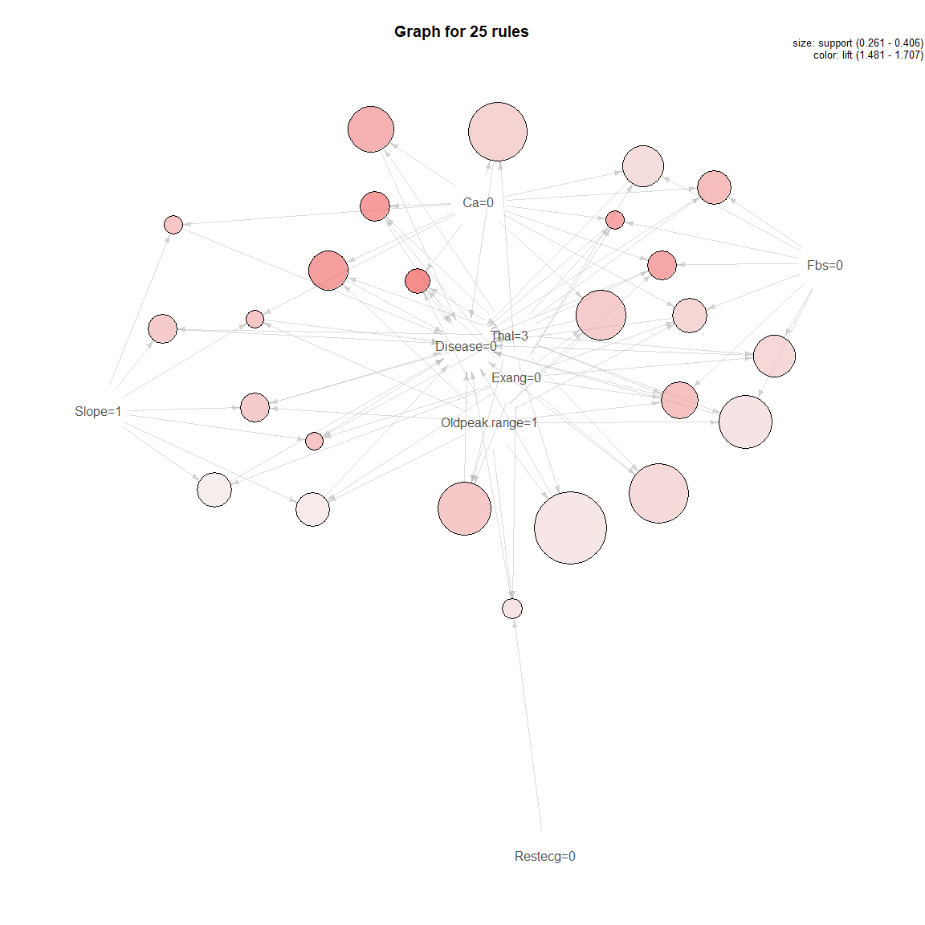

**plot**(topRules_1count, method="graph")

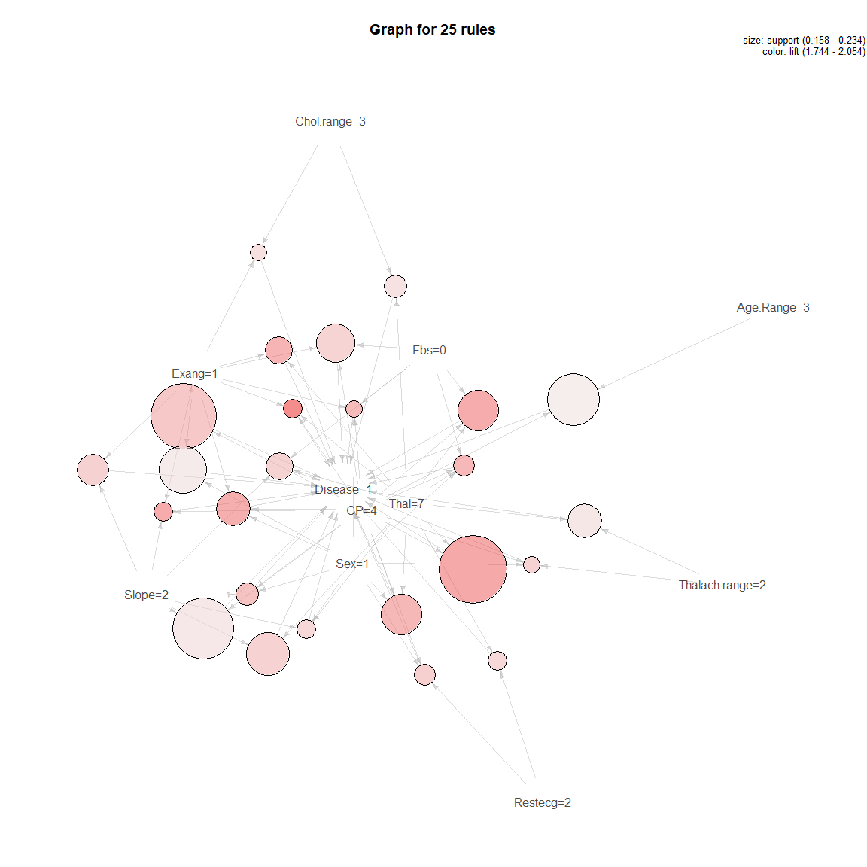

**plot**(topRules_lift, method="graph")

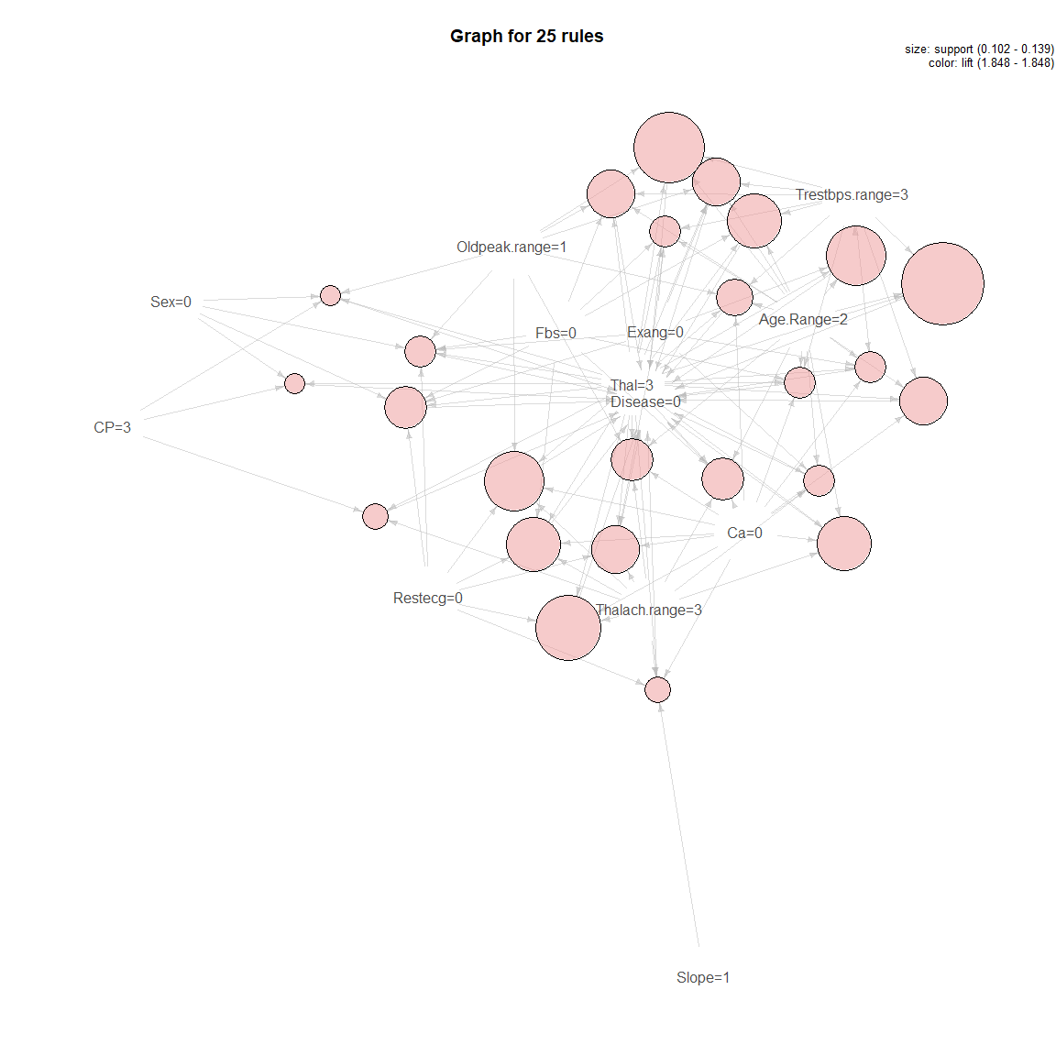

**plot**(topRules_1lift, method="graph")

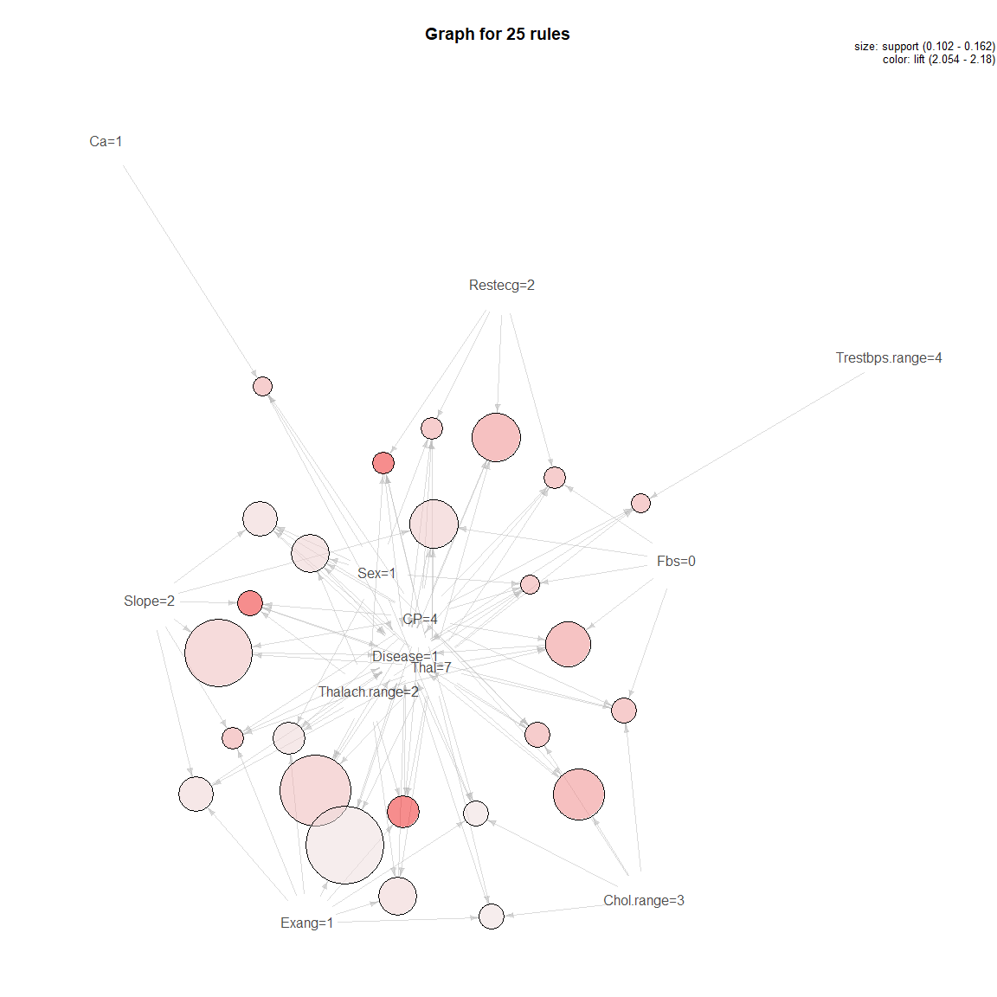

**plotly_arules**(rules1)

*#Validating the results*  
*# Split the Dataset into Train and Data*  
(n.var <- **length**(allfactors))

## [1] 14

*# The firsts 13 variables are the predictors and the 15 is the class*  
inTrainRows_m <- **createDataPartition**(allfactors**$**Disease,p=2**/**3,list=FALSE)  
trainData_m <- allfactors[inTrainRows_m,]  
testData_m <- allfactors[**-**inTrainRows_m,]  
  
*#For training data*  
rulestrain<-**apriori**((trainData_m), appearance=**list**(rhs= **c**("Disease=0"), default="lhs"))

## Apriori  
##   
## Parameter specification:  
## confidence minval smax arem aval originalSupport maxtime support minlen  
## 0.8 0.1 1 none FALSE TRUE 5 0.1 1  
## maxlen target ext  
## 10 rules FALSE  
##   
## Algorithmic control:  
## filter tree heap memopt load sort verbose  
## 0.1 TRUE TRUE FALSE TRUE 2 TRUE  
##   
## Absolute minimum support count: 20   
##   
## set item appearances ...[1 item(s)] done [0.00s].  
## set transactions ...[42 item(s), 203 transaction(s)] done [0.00s].  
## sorting and recoding items ... [33 item(s)] done [0.00s].  
## creating transaction tree ... done [0.00s].  
## checking subsets of size 1 2 3 4 5 6 7 8 done [0.00s].  
## writing ... [1000 rule(s)] done [0.00s].  
## creating S4 object ... done [0.00s].

rules_train_count<-**sort**(rulestrain, by='count', decreasing = T)  
**inspect**(rules_train_count[1**:**50])

## lhs rhs support confidence lift count  
## [1] {Oldpeak.range=1,   
## Thal=3} => {Disease=0} 0.3941 0.8000 1.476 80  
## [2] {Exang=0,   
## Ca=0} => {Disease=0} 0.3596 0.8588 1.585 73  
## [3] {Exang=0,   
## Thal=3} => {Disease=0} 0.3448 0.8434 1.556 70  
## [4] {Fbs=0,   
## Oldpeak.range=1,   
## Thal=3} => {Disease=0} 0.3399 0.8118 1.498 69  
## [5] {Exang=0,   
## Oldpeak.range=1,   
## Ca=0} => {Disease=0} 0.3399 0.8625 1.592 69  
## [6] {Exang=0,   
## Oldpeak.range=1,   
## Thal=3} => {Disease=0} 0.3350 0.8608 1.588 68  
## [7] {Ca=0,   
## Thal=3} => {Disease=0} 0.3153 0.8889 1.640 64  
## [8] {Fbs=0,   
## Exang=0,   
## Ca=0} => {Disease=0} 0.3103 0.8400 1.550 63  
## [9] {Oldpeak.range=1,   
## Ca=0,   
## Thal=3} => {Disease=0} 0.3054 0.8986 1.658 62  
## [10] {Fbs=0,   
## Exang=0,   
## Oldpeak.range=1,   
## Ca=0} => {Disease=0} 0.3005 0.8472 1.564 61  
## [11] {Fbs=0,   
## Exang=0,   
## Thal=3} => {Disease=0} 0.2956 0.8571 1.582 60  
## [12] {Restecg=0,   
## Exang=0,   
## Oldpeak.range=1} => {Disease=0} 0.2956 0.8333 1.538 60  
## [13] {Fbs=0,   
## Exang=0,   
## Oldpeak.range=1,   
## Thal=3} => {Disease=0} 0.2906 0.8806 1.625 59  
## [14] {Slope=1,   
## Thal=3} => {Disease=0} 0.2759 0.8485 1.566 56  
## [15] {Oldpeak.range=1,   
## Slope=1,   
## Thal=3} => {Disease=0} 0.2759 0.8485 1.566 56  
## [16] {Fbs=0,   
## Ca=0,   
## Thal=3} => {Disease=0} 0.2759 0.8750 1.615 56  
## [17] {Restecg=0,   
## Oldpeak.range=1,   
## Ca=0} => {Disease=0} 0.2709 0.8088 1.493 55  
## [18] {Fbs=0,   
## Oldpeak.range=1,   
## Ca=0,   
## Thal=3} => {Disease=0} 0.2709 0.8871 1.637 55  
## [19] {Exang=0,   
## Ca=0,   
## Thal=3} => {Disease=0} 0.2660 0.9153 1.689 54  
## [20] {Restecg=0,   
## Thal=3} => {Disease=0} 0.2611 0.8833 1.630 53  
## [21] {Restecg=0,   
## Oldpeak.range=1,   
## Thal=3} => {Disease=0} 0.2611 0.8833 1.630 53  
## [22] {Fbs=0,   
## Restecg=0,   
## Exang=0} => {Disease=0} 0.2611 0.8154 1.505 53  
## [23] {Fbs=0,   
## Restecg=0,   
## Exang=0,   
## Oldpeak.range=1} => {Disease=0} 0.2611 0.8413 1.553 53  
## [24] {Restecg=0,   
## Slope=1} => {Disease=0} 0.2562 0.8814 1.627 52  
## [25] {Slope=1,   
## Ca=0} => {Disease=0} 0.2562 0.9123 1.684 52  
## [26] {Restecg=0,   
## Oldpeak.range=1,   
## Slope=1} => {Disease=0} 0.2562 0.8814 1.627 52  
## [27] {Exang=0,   
## Oldpeak.range=1,   
## Ca=0,   
## Thal=3} => {Disease=0} 0.2562 0.9286 1.714 52  
## [28] {Oldpeak.range=1,   
## Slope=1,   
## Ca=0} => {Disease=0} 0.2512 0.9107 1.681 51  
## [29] {Exang=0,   
## Slope=1,   
## Thal=3} => {Disease=0} 0.2463 0.8621 1.591 50  
## [30] {Exang=0,   
## Oldpeak.range=1,   
## Slope=1,   
## Thal=3} => {Disease=0} 0.2463 0.8621 1.591 50  
## [31] {Trestbps.range=3,   
## Thal=3} => {Disease=0} 0.2414 0.8448 1.559 49  
## [32] {Fbs=0,   
## Restecg=0,   
## Oldpeak.range=1,   
## Ca=0} => {Disease=0} 0.2414 0.8033 1.482 49  
## [33] {Thalach.range=3,   
## Ca=0} => {Disease=0} 0.2365 0.9057 1.671 48  
## [34] {Age.Range=2,   
## Ca=0} => {Disease=0} 0.2365 0.8136 1.501 48  
## [35] {Age.Range=2,   
## Exang=0} => {Disease=0} 0.2365 0.8136 1.501 48  
## [36] {Trestbps.range=3,   
## Oldpeak.range=1,   
## Ca=0} => {Disease=0} 0.2365 0.8276 1.527 48  
## [37] {Fbs=0,   
## Restecg=0,   
## Thal=3} => {Disease=0} 0.2365 0.8889 1.640 48  
## [38] {Fbs=0,   
## Restecg=0,   
## Oldpeak.range=1,   
## Thal=3} => {Disease=0} 0.2365 0.8889 1.640 48  
## [39] {Sex=0,   
## Oldpeak.range=1} => {Disease=0} 0.2315 0.8103 1.495 47  
## [40] {Fbs=0,   
## Slope=1,   
## Thal=3} => {Disease=0} 0.2315 0.8393 1.549 47  
## [41] {Trestbps.range=3,   
## Oldpeak.range=1,   
## Thal=3} => {Disease=0} 0.2315 0.8545 1.577 47  
## [42] {Restecg=0,   
## Exang=0,   
## Thal=3} => {Disease=0} 0.2315 0.9400 1.735 47  
## [43] {Fbs=0,   
## Oldpeak.range=1,   
## Slope=1,   
## Thal=3} => {Disease=0} 0.2315 0.8393 1.549 47  
## [44] {Restecg=0,   
## Exang=0,   
## Oldpeak.range=1,   
## Thal=3} => {Disease=0} 0.2315 0.9400 1.735 47  
## [45] {Fbs=0,   
## Exang=0,   
## Ca=0,   
## Thal=3} => {Disease=0} 0.2315 0.9038 1.668 47  
## [46] {CP=3,   
## Oldpeak.range=1} => {Disease=0} 0.2266 0.8364 1.543 46  
## [47] {Thalach.range=3,   
## Thal=3} => {Disease=0} 0.2266 0.8679 1.602 46  
## [48] {Age.Range=2,   
## Thal=3} => {Disease=0} 0.2266 0.9020 1.665 46  
## [49] {Thalach.range=3,   
## Oldpeak.range=1,   
## Ca=0} => {Disease=0} 0.2266 0.9200 1.698 46  
## [50] {Age.Range=2,   
## Oldpeak.range=1,   
## Ca=0} => {Disease=0} 0.2266 0.8364 1.543 46

rules_train_lift<-**sort**(rulestrain, by='lift', decreasing = T)  
**inspect**(rules_train_lift[1**:**50])

## lhs rhs support confidence lift count  
## [1] {Sex=0,   
## CP=3} => {Disease=0} 0.1084 1 1.845 22  
## [2] {Sex=0,   
## CP=3,   
## Exang=0} => {Disease=0} 0.1034 1 1.845 21  
## [3] {Sex=0,   
## CP=3,   
## Oldpeak.range=1} => {Disease=0} 0.1084 1 1.845 22  
## [4] {CP=3,   
## Thalach.range=3,   
## Thal=3} => {Disease=0} 0.1084 1 1.845 22  
## [5] {CP=3,   
## Trestbps.range=3,   
## Thal=3} => {Disease=0} 0.1084 1 1.845 22  
## [6] {Chol.range=2,   
## Slope=1,   
## Ca=0} => {Disease=0} 0.1034 1 1.845 21  
## [7] {Chol.range=2,   
## Ca=0,   
## Thal=3} => {Disease=0} 0.1133 1 1.845 23  
## [8] {Age.Range=2,   
## Trestbps.range=3,   
## Thal=3} => {Disease=0} 0.1626 1 1.845 33  
## [9] {Sex=0,   
## CP=3,   
## Exang=0,   
## Oldpeak.range=1} => {Disease=0} 0.1034 1 1.845 21  
## [10] {CP=3,   
## Trestbps.range=3,   
## Exang=0,   
## Thal=3} => {Disease=0} 0.1034 1 1.845 21  
## [11] {Sex=0,   
## Fbs=0,   
## Restecg=0,   
## Exang=0} => {Disease=0} 0.1133 1 1.845 23  
## [12] {Chol.range=2,   
## Oldpeak.range=1,   
## Ca=0,   
## Thal=3} => {Disease=0} 0.1084 1 1.845 22  
## [13] {Age.Range=2,   
## Trestbps.range=3,   
## Thalach.range=3,   
## Thal=3} => {Disease=0} 0.1182 1 1.845 24  
## [14] {Age.Range=2,   
## Thalach.range=3,   
## Ca=0,   
## Thal=3} => {Disease=0} 0.1232 1 1.845 25  
## [15] {Restecg=0,   
## Thalach.range=3,   
## Slope=1,   
## Thal=3} => {Disease=0} 0.1478 1 1.845 30  
## [16] {Restecg=0,   
## Thalach.range=3,   
## Slope=1,   
## Ca=0} => {Disease=0} 0.1330 1 1.845 27  
## [17] {Sex=1,   
## Thalach.range=3,   
## Slope=1,   
## Ca=0} => {Disease=0} 0.1133 1 1.845 23  
## [18] {Trestbps.range=3,   
## Restecg=0,   
## Thalach.range=3,   
## Thal=3} => {Disease=0} 0.1182 1 1.845 24  
## [19] {Restecg=0,   
## Thalach.range=3,   
## Ca=0,   
## Thal=3} => {Disease=0} 0.1281 1 1.845 26  
## [20] {Restecg=0,   
## Thalach.range=3,   
## Exang=0,   
## Thal=3} => {Disease=0} 0.1527 1 1.845 31  
## [21] {Age.Range=2,   
## Trestbps.range=3,   
## Slope=1,   
## Thal=3} => {Disease=0} 0.1034 1 1.845 21  
## [22] {Age.Range=2,   
## Trestbps.range=3,   
## Ca=0,   
## Thal=3} => {Disease=0} 0.1429 1 1.845 29  
## [23] {Age.Range=2,   
## Trestbps.range=3,   
## Exang=0,   
## Thal=3} => {Disease=0} 0.1478 1 1.845 30  
## [24] {Age.Range=2,   
## Trestbps.range=3,   
## Oldpeak.range=1,   
## Thal=3} => {Disease=0} 0.1527 1 1.845 31  
## [25] {Age.Range=2,   
## Trestbps.range=3,   
## Fbs=0,   
## Thal=3} => {Disease=0} 0.1379 1 1.845 28  
## [26] {Trestbps.range=3,   
## Restecg=0,   
## Slope=1,   
## Thal=3} => {Disease=0} 0.1232 1 1.845 25  
## [27] {Sex=0,   
## Fbs=0,   
## Restecg=0,   
## Exang=0,   
## Thal=3} => {Disease=0} 0.1084 1 1.845 22  
## [28] {Sex=0,   
## Fbs=0,   
## Restecg=0,   
## Exang=0,   
## Oldpeak.range=1} => {Disease=0} 0.1133 1 1.845 23  
## [29] {Age.Range=2,   
## Trestbps.range=3,   
## Thalach.range=3,   
## Exang=0,   
## Thal=3} => {Disease=0} 0.1133 1 1.845 23  
## [30] {Age.Range=2,   
## Trestbps.range=3,   
## Thalach.range=3,   
## Oldpeak.range=1,   
## Thal=3} => {Disease=0} 0.1084 1 1.845 22  
## [31] {Age.Range=2,   
## Thalach.range=3,   
## Exang=0,   
## Ca=0,   
## Thal=3} => {Disease=0} 0.1133 1 1.845 23  
## [32] {Age.Range=2,   
## Thalach.range=3,   
## Oldpeak.range=1,   
## Ca=0,   
## Thal=3} => {Disease=0} 0.1133 1 1.845 23  
## [33] {Age.Range=2,   
## Fbs=0,   
## Thalach.range=3,   
## Ca=0,   
## Thal=3} => {Disease=0} 0.1133 1 1.845 23  
## [34] {Trestbps.range=3,   
## Restecg=0,   
## Thalach.range=3,   
## Slope=1,   
## Thal=3} => {Disease=0} 0.1034 1 1.845 21  
## [35] {Restecg=0,   
## Thalach.range=3,   
## Slope=1,   
## Ca=0,   
## Thal=3} => {Disease=0} 0.1084 1 1.845 22  
## [36] {Restecg=0,   
## Thalach.range=3,   
## Exang=0,   
## Slope=1,   
## Thal=3} => {Disease=0} 0.1330 1 1.845 27  
## [37] {Restecg=0,   
## Thalach.range=3,   
## Oldpeak.range=1,   
## Slope=1,   
## Thal=3} => {Disease=0} 0.1478 1 1.845 30  
## [38] {Fbs=0,   
## Restecg=0,   
## Thalach.range=3,   
## Slope=1,   
## Thal=3} => {Disease=0} 0.1379 1 1.845 28  
## [39] {Restecg=0,   
## Thalach.range=3,   
## Exang=0,   
## Slope=1,   
## Ca=0} => {Disease=0} 0.1084 1 1.845 22  
## [40] {Restecg=0,   
## Thalach.range=3,   
## Oldpeak.range=1,   
## Slope=1,   
## Ca=0} => {Disease=0} 0.1330 1 1.845 27  
## [41] {Fbs=0,   
## Restecg=0,   
## Thalach.range=3,   
## Slope=1,   
## Ca=0} => {Disease=0} 0.1232 1 1.845 25  
## [42] {Sex=1,   
## Thalach.range=3,   
## Oldpeak.range=1,   
## Slope=1,   
## Ca=0} => {Disease=0} 0.1133 1 1.845 23  
## [43] {Trestbps.range=3,   
## Restecg=0,   
## Thalach.range=3,   
## Exang=0,   
## Thal=3} => {Disease=0} 0.1084 1 1.845 22  
## [44] {Trestbps.range=3,   
## Restecg=0,   
## Thalach.range=3,   
## Oldpeak.range=1,   
## Thal=3} => {Disease=0} 0.1182 1 1.845 24  
## [45] {Trestbps.range=3,   
## Fbs=0,   
## Restecg=0,   
## Thalach.range=3,   
## Thal=3} => {Disease=0} 0.1084 1 1.845 22  
## [46] {Trestbps.range=3,   
## Restecg=0,   
## Thalach.range=3,   
## Oldpeak.range=1,   
## Ca=0} => {Disease=0} 0.1133 1 1.845 23  
## [47] {Restecg=0,   
## Thalach.range=3,   
## Exang=0,   
## Ca=0,   
## Thal=3} => {Disease=0} 0.1133 1 1.845 23  
## [48] {Restecg=0,   
## Thalach.range=3,   
## Oldpeak.range=1,   
## Ca=0,   
## Thal=3} => {Disease=0} 0.1281 1 1.845 26  
## [49] {Fbs=0,   
## Restecg=0,   
## Thalach.range=3,   
## Ca=0,   
## Thal=3} => {Disease=0} 0.1232 1 1.845 25  
## [50] {Restecg=0,   
## Thalach.range=3,   
## Exang=0,   
## Oldpeak.range=1,   
## Thal=3} => {Disease=0} 0.1527 1 1.845 31

**summary**(rulestrain)

## set of 1000 rules  
##   
## rule length distribution (lhs + rhs):sizes  
## 3 4 5 6 7 8   
## 45 205 359 283 98 10   
##   
## Min. 1st Qu. Median Mean 3rd Qu. Max.   
## 3.00 4.75 5.00 5.21 6.00 8.00   
##   
## summary of quality measures:  
## support confidence lift count   
## Min. :0.103 Min. :0.800 Min. :1.48 Min. :21.0   
## 1st Qu.:0.113 1st Qu.:0.857 1st Qu.:1.58 1st Qu.:23.0   
## Median :0.128 Median :0.906 Median :1.67 Median :26.0   
## Mean :0.142 Mean :0.904 Mean :1.67 Mean :28.8   
## 3rd Qu.:0.158 3rd Qu.:0.955 3rd Qu.:1.76 3rd Qu.:32.0   
## Max. :0.394 Max. :1.000 Max. :1.85 Max. :80.0   
##   
## mining info:  
## data ntransactions support confidence  
## (trainData_m) 203 0.1 0.8

rules1train<-**apriori**((trainData_m), appearance=**list**(rhs= **c**("Disease=1"), default="lhs"))

## Apriori  
##   
## Parameter specification:  
## confidence minval smax arem aval originalSupport maxtime support minlen  
## 0.8 0.1 1 none FALSE TRUE 5 0.1 1  
## maxlen target ext  
## 10 rules FALSE  
##   
## Algorithmic control:  
## filter tree heap memopt load sort verbose  
## 0.1 TRUE TRUE FALSE TRUE 2 TRUE  
##   
## Absolute minimum support count: 20   
##   
## set item appearances ...[1 item(s)] done [0.00s].  
## set transactions ...[42 item(s), 203 transaction(s)] done [0.00s].  
## sorting and recoding items ... [33 item(s)] done [0.00s].  
## creating transaction tree ... done [0.00s].  
## checking subsets of size 1 2 3 4 5 6 7 8 done [0.00s].  
## writing ... [192 rule(s)] done [0.00s].  
## creating S4 object ... done [0.00s].

rules_1train_count <- **sort**(rules1train, by='count', decreasing = TRUE)  
**inspect**(rules_1train_count[1**:**50])

## lhs rhs support confidence  
## [1] {Sex=1,CP=4} => {Disease=1} 0.2562 0.8125   
## [2] {CP=4,Thal=7} => {Disease=1} 0.2315 0.8868   
## [3] {CP=4,Slope=2} => {Disease=1} 0.2315 0.8246   
## [4] {CP=4,Exang=1} => {Disease=1} 0.2167 0.8462   
## [5] {Slope=2,Thal=7} => {Disease=1} 0.2167 0.8462   
## [6] {Age.Range=3,CP=4} => {Disease=1} 0.2069 0.8077   
## [7] {CP=4,Chol.range=3} => {Disease=1} 0.2069 0.8235   
## [8] {Thalach.range=2,Thal=7} => {Disease=1} 0.2020 0.8367   
## [9] {CP=4,Restecg=2} => {Disease=1} 0.2020 0.8542   
## [10] {Exang=1,Slope=2} => {Disease=1} 0.1921 0.8478   
## [11] {CP=4,Fbs=0,Thal=7} => {Disease=1} 0.1921 0.8667   
## [12] {Sex=1,CP=4,Thal=7} => {Disease=1} 0.1872 0.8636   
## [13] {Fbs=0,Slope=2,Thal=7} => {Disease=1} 0.1872 0.8444   
## [14] {Sex=1,Slope=2,Thal=7} => {Disease=1} 0.1823 0.8409   
## [15] {Chol.range=3,Thal=7} => {Disease=1} 0.1773 0.8182   
## [16] {CP=4,Fbs=0,Exang=1} => {Disease=1} 0.1773 0.8182   
## [17] {Exang=1,Thal=7} => {Disease=1} 0.1675 0.8718   
## [18] {Restecg=2,Thal=7} => {Disease=1} 0.1675 0.8500   
## [19] {CP=4,Thalach.range=2,Exang=1} => {Disease=1} 0.1675 0.8947   
## [20] {Sex=1,CP=4,Exang=1} => {Disease=1} 0.1675 0.8947   
## [21] {CP=4,Thalach.range=2,Thal=7} => {Disease=1} 0.1675 0.9714   
## [22] {Sex=1,CP=4,Slope=2} => {Disease=1} 0.1675 0.8718   
## [23] {Sex=1,CP=4,Thalach.range=2} => {Disease=1} 0.1675 0.8718   
## [24] {Chol.range=3,Exang=1} => {Disease=1} 0.1626 0.8250   
## [25] {CP=4,Exang=1,Slope=2} => {Disease=1} 0.1626 0.8919   
## [26] {CP=4,Slope=2,Thal=7} => {Disease=1} 0.1626 0.9429   
## [27] {Sex=1,Thalach.range=2,Thal=7} => {Disease=1} 0.1626 0.8250   
## [28] {Fbs=0,Thalach.range=2,Thal=7} => {Disease=1} 0.1626 0.8049   
## [29] {CP=4,Fbs=0,Restecg=2} => {Disease=1} 0.1626 0.8250   
## [30] {Fbs=0,Exang=1,Slope=2} => {Disease=1} 0.1576 0.8421   
## [31] {CP=4,Chol.range=3,Slope=2} => {Disease=1} 0.1576 0.8889   
## [32] {CP=4,Thalach.range=2,Slope=2} => {Disease=1} 0.1576 0.8205   
## [33] {Sex=1,CP=4,Fbs=0,Thal=7} => {Disease=1} 0.1576 0.8421   
## [34] {Sex=1,Fbs=0,Slope=2,Thal=7} => {Disease=1} 0.1576 0.8421   
## [35] {Age.Range=3,CP=4,Thal=7} => {Disease=1} 0.1527 0.8857   
## [36] {Sex=1,CP=4,Restecg=2} => {Disease=1} 0.1527 0.9394   
## [37] {Sex=1,Chol.range=3,Slope=2} => {Disease=1} 0.1527 0.8158   
## [38] {Sex=1,Ca=1} => {Disease=1} 0.1478 0.8571   
## [39] {CP=4,Exang=1,Thal=7} => {Disease=1} 0.1478 0.9091   
## [40] {Sex=1,Exang=1,Slope=2} => {Disease=1} 0.1478 0.8571   
## [41] {Thalach.range=2,Slope=2,Thal=7} => {Disease=1} 0.1478 0.9091   
## [42] {Age.Range=3,CP=4,Slope=2} => {Disease=1} 0.1478 0.8571   
## [43] {Sex=1,CP=4,Chol.range=3} => {Disease=1} 0.1478 0.9375   
## [44] {Sex=1,Exang=1,Thal=7} => {Disease=1} 0.1429 0.8529   
## [45] {Thalach.range=2,Exang=1,Slope=2} => {Disease=1} 0.1429 0.8286   
## [46] {Sex=1,Thalach.range=2,Exang=1} => {Disease=1} 0.1429 0.8529   
## [47] {CP=4,Chol.range=3,Thal=7} => {Disease=1} 0.1429 0.9667   
## [48] {Sex=1,Chol.range=3,Thal=7} => {Disease=1} 0.1429 0.8286   
## [49] {CP=4,Restecg=2,Thalach.range=2} => {Disease=1} 0.1429 0.8286   
## [50] {Age.Range=3,CP=4,Thalach.range=2} => {Disease=1} 0.1429 0.8286   
## lift count  
## [1] 1.774 52   
## [2] 1.936 47   
## [3] 1.800 47   
## [4] 1.847 44   
## [5] 1.847 44   
## [6] 1.763 42   
## [7] 1.798 42   
## [8] 1.826 41   
## [9] 1.864 41   
## [10] 1.851 39   
## [11] 1.892 39   
## [12] 1.885 38   
## [13] 1.843 38   
## [14] 1.836 37   
## [15] 1.786 36   
## [16] 1.786 36   
## [17] 1.903 34   
## [18] 1.855 34   
## [19] 1.953 34   
## [20] 1.953 34   
## [21] 2.120 34   
## [22] 1.903 34   
## [23] 1.903 34   
## [24] 1.801 33   
## [25] 1.947 33   
## [26] 2.058 33   
## [27] 1.801 33   
## [28] 1.757 33   
## [29] 1.801 33   
## [30] 1.838 32   
## [31] 1.940 32   
## [32] 1.791 32   
## [33] 1.838 32   
## [34] 1.838 32   
## [35] 1.933 31   
## [36] 2.051 31   
## [37] 1.781 31   
## [38] 1.871 30   
## [39] 1.984 30   
## [40] 1.871 30   
## [41] 1.984 30   
## [42] 1.871 30   
## [43] 2.046 30   
## [44] 1.862 29   
## [45] 1.809 29   
## [46] 1.862 29   
## [47] 2.110 29   
## [48] 1.809 29   
## [49] 1.809 29   
## [50] 1.809 29

rules_1train_lift <- **sort**(rules1train, by='lift', decreasing = TRUE)  
**inspect**(rules_1train_lift[1**:**50])

## lhs rhs support confidence lift count  
## [1] {CP=4,   
## Thalach.range=2,   
## Exang=1,   
## Thal=7} => {Disease=1} 0.1232 1.0000 2.183 25  
## [2] {CP=4,   
## Restecg=2,   
## Thalach.range=2,   
## Thal=7} => {Disease=1} 0.1133 1.0000 2.183 23  
## [3] {CP=4,   
## Thalach.range=2,   
## Slope=2,   
## Thal=7} => {Disease=1} 0.1182 1.0000 2.183 24  
## [4] {CP=4,   
## Chol.range=3,   
## Thalach.range=2,   
## Thal=7} => {Disease=1} 0.1034 1.0000 2.183 21  
## [5] {CP=4,   
## Thalach.range=2,   
## Thal=7} => {Disease=1} 0.1675 0.9714 2.120 34  
## [6] {CP=4,   
## Chol.range=3,   
## Thal=7} => {Disease=1} 0.1429 0.9667 2.110 29  
## [7] {CP=4,   
## Restecg=2,   
## Thal=7} => {Disease=1} 0.1379 0.9655 2.108 28  
## [8] {Thalach.range=2,   
## Exang=1,   
## Thal=7} => {Disease=1} 0.1330 0.9643 2.105 27  
## [9] {CP=4,   
## Fbs=0,   
## Thalach.range=2,   
## Thal=7} => {Disease=1} 0.1330 0.9643 2.105 27  
## [10] {Exang=1,   
## Slope=2,   
## Thal=7} => {Disease=1} 0.1281 0.9630 2.102 26  
## [11] {Age.Range=3,   
## CP=4,   
## Restecg=2} => {Disease=1} 0.1281 0.9630 2.102 26  
## [12] {Sex=1,   
## CP=4,   
## Thalach.range=2,   
## Thal=7} => {Disease=1} 0.1281 0.9630 2.102 26  
## [13] {Sex=1,   
## CP=4,   
## Thalach.range=2,   
## Exang=1} => {Disease=1} 0.1232 0.9615 2.099 25  
## [14] {Chol.range=3,   
## Exang=1,   
## Thal=7} => {Disease=1} 0.1133 0.9583 2.092 23  
## [15] {Fbs=0,   
## Exang=1,   
## Slope=2,   
## Thal=7} => {Disease=1} 0.1133 0.9583 2.092 23  
## [16] {CP=4,   
## Chol.range=3,   
## Slope=2,   
## Thal=7} => {Disease=1} 0.1133 0.9583 2.092 23  
## [17] {CP=4,   
## Exang=1,   
## Slope=2,   
## Thal=7} => {Disease=1} 0.1084 0.9565 2.088 22  
## [18] {Sex=1,   
## Exang=1,   
## Slope=2,   
## Thal=7} => {Disease=1} 0.1084 0.9565 2.088 22  
## [19] {Sex=1,   
## Thalach.range=2,   
## Exang=1,   
## Thal=7} => {Disease=1} 0.1084 0.9565 2.088 22  
## [20] {CP=4,   
## Fbs=0,   
## Restecg=2,   
## Thal=7} => {Disease=1} 0.1084 0.9565 2.088 22  
## [21] {Age.Range=3,   
## CP=4,   
## Thalach.range=2,   
## Thal=7} => {Disease=1} 0.1084 0.9565 2.088 22  
## [22] {Sex=1,   
## CP=4,   
## Chol.range=3,   
## Thal=7} => {Disease=1} 0.1084 0.9565 2.088 22  
## [23] {CP=4,   
## Chol.range=3,   
## Fbs=0,   
## Thal=7} => {Disease=1} 0.1084 0.9565 2.088 22  
## [24] {Sex=1,   
## Slope=2,   
## Ca=1} => {Disease=1} 0.1034 0.9545 2.084 21  
## [25] {Fbs=0,   
## Thalach.range=2,   
## Exang=1,   
## Thal=7} => {Disease=1} 0.1034 0.9545 2.084 21  
## [26] {Age.Range=3,   
## CP=4,   
## Fbs=0,   
## Restecg=2} => {Disease=1} 0.1034 0.9545 2.084 21  
## [27] {Sex=1,   
## CP=4,   
## Restecg=2,   
## Thalach.range=2} => {Disease=1} 0.1034 0.9545 2.084 21  
## [28] {Sex=1,   
## CP=4,   
## Restecg=2,   
## Oldpeak.range=1} => {Disease=1} 0.1034 0.9545 2.084 21  
## [29] {Sex=1,   
## CP=4,   
## Fbs=0,   
## Thalach.range=2,   
## Thal=7} => {Disease=1} 0.1034 0.9545 2.084 21  
## [30] {CP=4,   
## Slope=2,   
## Thal=7} => {Disease=1} 0.1626 0.9429 2.058 33  
## [31] {Sex=1,   
## CP=4,   
## Restecg=2} => {Disease=1} 0.1527 0.9394 2.051 31  
## [32] {Sex=1,   
## CP=4,   
## Chol.range=3} => {Disease=1} 0.1478 0.9375 2.046 30  
## [33] {CP=4,   
## Fbs=0,   
## Slope=2,   
## Thal=7} => {Disease=1} 0.1379 0.9333 2.037 28  
## [34] {Restecg=2,   
## Thalach.range=2,   
## Thal=7} => {Disease=1} 0.1281 0.9286 2.027 26  
## [35] {Sex=1,   
## CP=4,   
## Slope=2,   
## Thal=7} => {Disease=1} 0.1281 0.9286 2.027 26  
## [36] {Sex=1,   
## CP=4,   
## Fbs=0,   
## Restecg=2} => {Disease=1} 0.1281 0.9286 2.027 26  
## [37] {Sex=1,   
## Chol.range=3,   
## Exang=1} => {Disease=1} 0.1232 0.9259 2.021 25  
## [38] {Oldpeak.range=2,   
## Slope=2} => {Disease=1} 0.1182 0.9231 2.015 24  
## [39] {Age.Range=3,   
## Sex=1,   
## Ca=1} => {Disease=1} 0.1182 0.9231 2.015 24  
## [40] {Sex=1,   
## CP=4,   
## Exang=1,   
## Slope=2} => {Disease=1} 0.1182 0.9231 2.015 24  
## [41] {Sex=1,   
## CP=4,   
## Chol.range=3,   
## Fbs=0} => {Disease=1} 0.1182 0.9231 2.015 24  
## [42] {CP=4,   
## Chol.range=3,   
## Exang=1,   
## Slope=2} => {Disease=1} 0.1133 0.9200 2.008 23  
## [43] {Chol.range=3,   
## Fbs=0,   
## Exang=1,   
## Slope=2} => {Disease=1} 0.1133 0.9200 2.008 23  
## [44] {Fbs=0,   
## Oldpeak.range=2} => {Disease=1} 0.1084 0.9167 2.001 22  
## [45] {Sex=1,   
## Restecg=2,   
## Exang=1} => {Disease=1} 0.1084 0.9167 2.001 22  
## [46] {Chol.range=3,   
## Restecg=2,   
## Thal=7} => {Disease=1} 0.1084 0.9167 2.001 22  
## [47] {Sex=1,   
## CP=4,   
## Chol.range=3,   
## Slope=2} => {Disease=1} 0.1084 0.9167 2.001 22  
## [48] {Sex=1,   
## CP=4,   
## Thalach.range=2,   
## Slope=2} => {Disease=1} 0.1084 0.9167 2.001 22  
## [49] {Sex=1,   
## CP=4,   
## Chol.range=3,   
## Oldpeak.range=1} => {Disease=1} 0.1084 0.9167 2.001 22  
## [50] {Sex=1,   
## CP=4,   
## Fbs=0,   
## Slope=2,   
## Thal=7} => {Disease=1} 0.1084 0.9167 2.001 22

**summary**(rules1train)

## set of 192 rules  
##   
## rule length distribution (lhs + rhs):sizes  
## 2 3 4 5 6   
## 1 22 90 74 5   
##   
## Min. 1st Qu. Median Mean 3rd Qu. Max.   
## 2.00 4.00 4.00 4.31 5.00 6.00   
##   
## summary of quality measures:  
## support confidence lift count   
## Min. :0.103 Min. :0.800 Min. :1.75 Min. :21.0   
## 1st Qu.:0.108 1st Qu.:0.838 1st Qu.:1.83 1st Qu.:22.0   
## Median :0.123 Median :0.867 Median :1.89 Median :25.0   
## Mean :0.131 Mean :0.876 Mean :1.91 Mean :26.6   
## 3rd Qu.:0.143 3rd Qu.:0.917 3rd Qu.:2.00 3rd Qu.:29.0   
## Max. :0.256 Max. :1.000 Max. :2.18 Max. :52.0   
##   
## mining info:  
## data ntransactions support confidence  
## (trainData_m) 203 0.1 0.8

topRules_train_count<-rules_train_count[1**:**25]  
topRules_1train_count<-rules_1train_count[1**:**25]  
topRules_train_lift<-rules_train_lift[1**:**25]  
topRules_1train_lift<-rules_1train_lift[1**:**25]  
  
**plot**(topRules_train_count, method="graph")

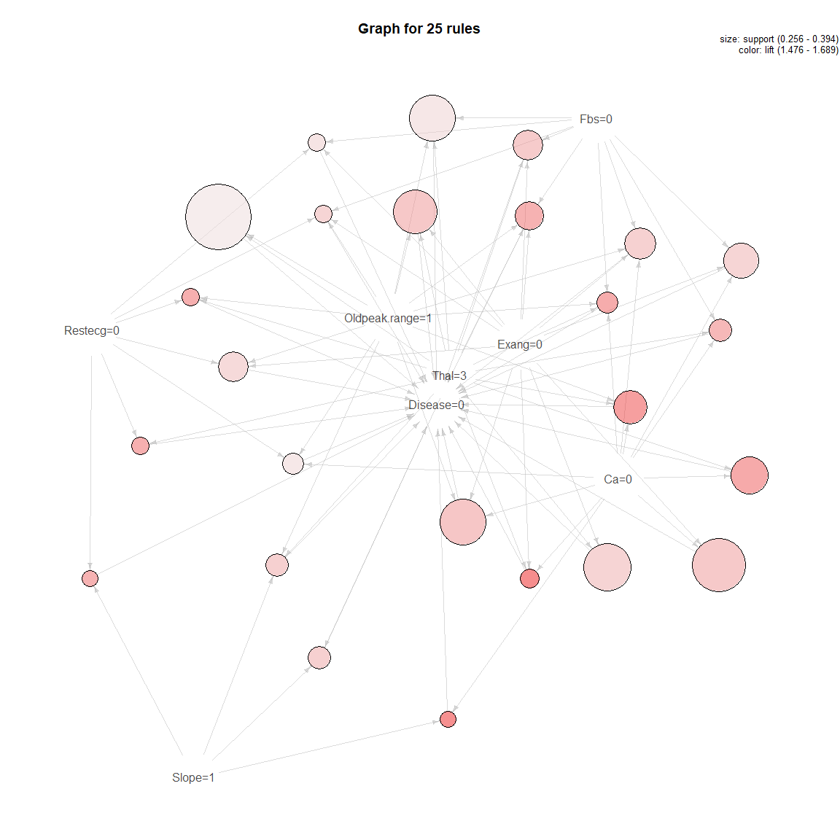

**plot**(topRules_1train_count, method="graph")

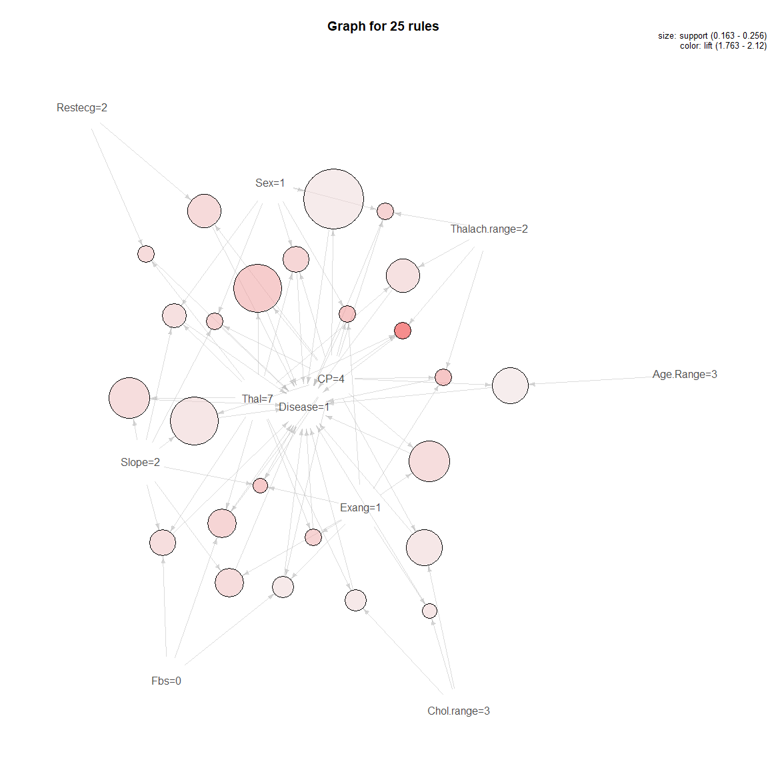

**plot**(topRules_train_lift, method="graph")

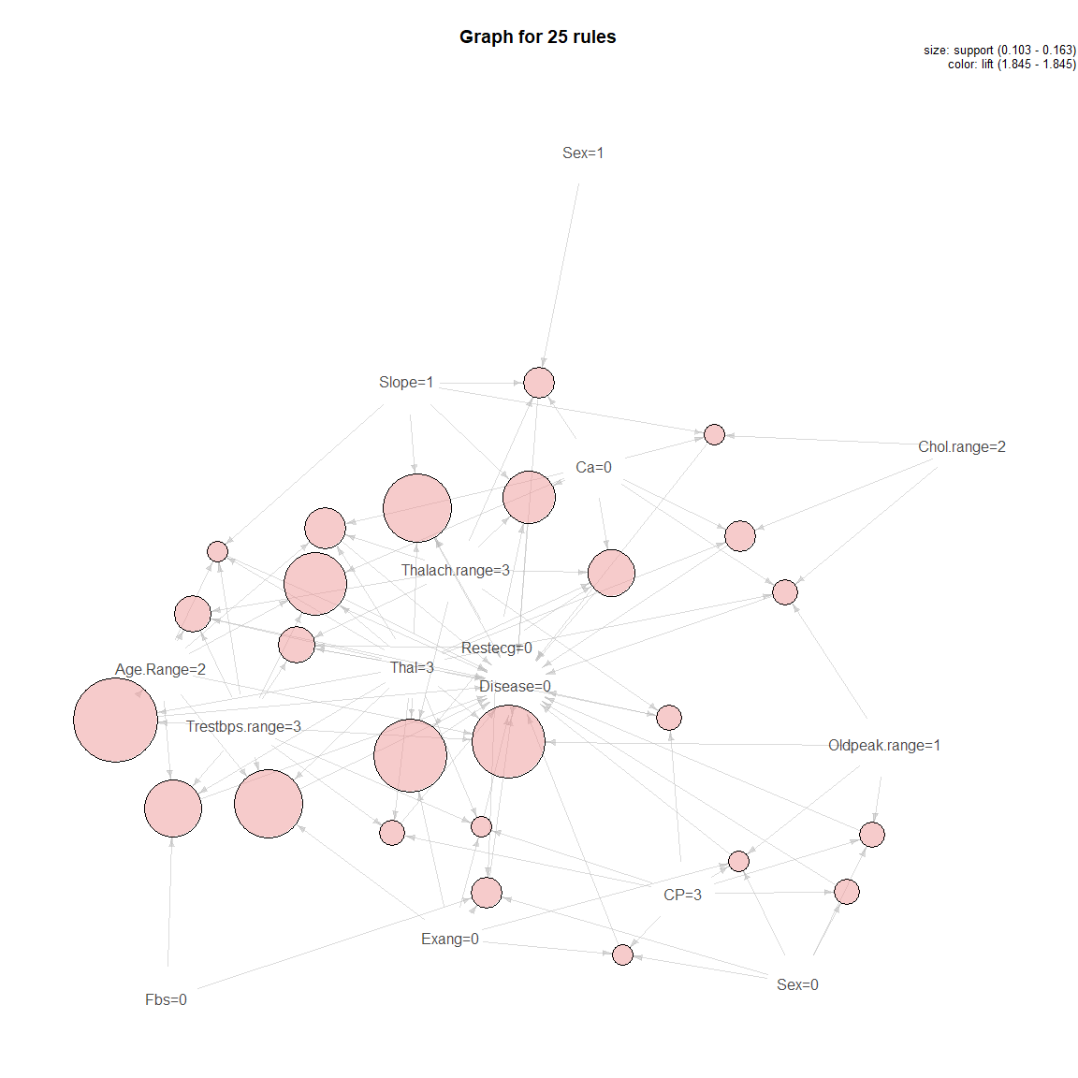

**plot**(topRules_1train_lift, method="graph")

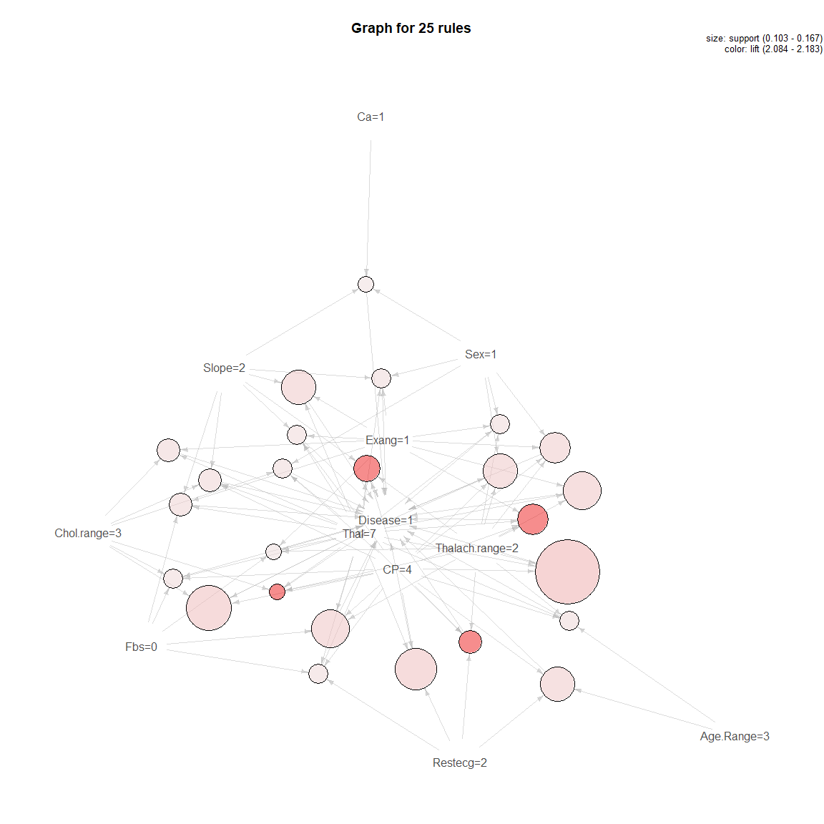

*#For test Data*  
  
rulestest<-**apriori**((testData_m), appearance=**list**(rhs= **c**("Disease=0"), default="lhs"))

## Apriori  
##   
## Parameter specification:  
## confidence minval smax arem aval originalSupport maxtime support minlen  
## 0.8 0.1 1 none FALSE TRUE 5 0.1 1  
## maxlen target ext  
## 10 rules FALSE  
##   
## Algorithmic control:  
## filter tree heap memopt load sort verbose  
## 0.1 TRUE TRUE FALSE TRUE 2 TRUE  
##   
## Absolute minimum support count: 10   
##   
## set item appearances ...[1 item(s)] done [0.00s].  
## set transactions ...[43 item(s), 100 transaction(s)] done [0.00s].  
## sorting and recoding items ... [36 item(s)] done [0.00s].  
## creating transaction tree ... done [0.00s].  
## checking subsets of size 1 2 3 4 5 6 7 8 9 done [0.00s].  
## writing ... [1193 rule(s)] done [0.00s].  
## creating S4 object ... done [0.00s].

rules_test_count<-**sort**(rulestest, by='count', decreasing = T)  
**inspect**(rules_test_count[1**:**50])

## lhs rhs support confidence lift count  
## [1] {Exang=0,   
## Thal=3} => {Disease=0} 0.43 0.8269 1.531 43  
## [2] {Oldpeak.range=1,   
## Thal=3} => {Disease=0} 0.43 0.8431 1.561 43  
## [3] {Exang=0,   
## Oldpeak.range=1,   
## Thal=3} => {Disease=0} 0.40 0.8696 1.610 40  
## [4] {Exang=0,   
## Ca=0} => {Disease=0} 0.39 0.8298 1.537 39  
## [5] {Fbs=0,   
## Exang=0,   
## Thal=3} => {Disease=0} 0.39 0.8125 1.505 39  
## [6] {Fbs=0,   
## Oldpeak.range=1,   
## Thal=3} => {Disease=0} 0.39 0.8298 1.537 39  
## [7] {Ca=0,   
## Thal=3} => {Disease=0} 0.38 0.8837 1.637 38  
## [8] {Fbs=0,   
## Ca=0,   
## Thal=3} => {Disease=0} 0.36 0.8780 1.626 36  
## [9] {Exang=0,   
## Oldpeak.range=1,   
## Ca=0} => {Disease=0} 0.36 0.8571 1.587 36  
## [10] {Fbs=0,   
## Exang=0,   
## Oldpeak.range=1,   
## Thal=3} => {Disease=0} 0.36 0.8571 1.587 36  
## [11] {Exang=0,   
## Ca=0,   
## Thal=3} => {Disease=0} 0.35 0.8974 1.662 35  
## [12] {Oldpeak.range=1,   
## Ca=0,   
## Thal=3} => {Disease=0} 0.35 0.9211 1.706 35  
## [13] {Fbs=0,   
## Exang=0,   
## Ca=0} => {Disease=0} 0.35 0.8140 1.507 35  
## [14] {Exang=0,   
## Oldpeak.range=1,   
## Ca=0,   
## Thal=3} => {Disease=0} 0.33 0.9167 1.698 33  
## [15] {Fbs=0,   
## Exang=0,   
## Ca=0,   
## Thal=3} => {Disease=0} 0.33 0.8919 1.652 33  
## [16] {Fbs=0,   
## Oldpeak.range=1,   
## Ca=0,   
## Thal=3} => {Disease=0} 0.33 0.9167 1.698 33  
## [17] {Slope=1,   
## Thal=3} => {Disease=0} 0.32 0.8889 1.646 32  
## [18] {Exang=0,   
## Slope=1} => {Disease=0} 0.32 0.8205 1.519 32  
## [19] {Oldpeak.range=1,   
## Slope=1,   
## Thal=3} => {Disease=0} 0.32 0.8889 1.646 32  
## [20] {Exang=0,   
## Oldpeak.range=1,   
## Slope=1} => {Disease=0} 0.32 0.8421 1.559 32  
## [21] {Fbs=0,   
## Exang=0,   
## Oldpeak.range=1,   
## Ca=0} => {Disease=0} 0.32 0.8421 1.559 32  
## [22] {Fbs=0,   
## Exang=0,   
## Oldpeak.range=1,   
## Ca=0,   
## Thal=3} => {Disease=0} 0.31 0.9118 1.688 31  
## [23] {Exang=0,   
## Slope=1,   
## Thal=3} => {Disease=0} 0.29 0.8788 1.627 29  
## [24] {Fbs=0,   
## Slope=1,   
## Thal=3} => {Disease=0} 0.29 0.8788 1.627 29  
## [25] {Exang=0,   
## Oldpeak.range=1,   
## Slope=1,   
## Thal=3} => {Disease=0} 0.29 0.8788 1.627 29  
## [26] {Fbs=0,   
## Oldpeak.range=1,   
## Slope=1,   
## Thal=3} => {Disease=0} 0.29 0.8788 1.627 29  
## [27] {Thalach.range=3,   
## Thal=3} => {Disease=0} 0.28 0.8485 1.571 28  
## [28] {Thalach.range=3,   
## Exang=0} => {Disease=0} 0.28 0.8000 1.481 28  
## [29] {Slope=1,   
## Ca=0} => {Disease=0} 0.28 0.8000 1.481 28  
## [30] {Oldpeak.range=1,   
## Slope=1,   
## Ca=0} => {Disease=0} 0.28 0.8000 1.481 28  
## [31] {Thalach.range=3,   
## Ca=0} => {Disease=0} 0.27 0.9000 1.667 27  
## [32] {Thalach.range=3,   
## Oldpeak.range=1,   
## Thal=3} => {Disease=0} 0.27 0.8710 1.613 27  
## [33] {Thalach.range=3,   
## Exang=0,   
## Oldpeak.range=1} => {Disease=0} 0.27 0.8438 1.562 27  
## [34] {Fbs=0,   
## Exang=0,   
## Oldpeak.range=1,   
## Slope=1} => {Disease=0} 0.27 0.8182 1.515 27  
## [35] {Thalach.range=3,   
## Oldpeak.range=1,   
## Ca=0} => {Disease=0} 0.26 0.8966 1.660 26  
## [36] {Thalach.range=3,   
## Exang=0,   
## Thal=3} => {Disease=0} 0.26 0.8387 1.553 26  
## [37] {Fbs=0,   
## Thalach.range=3,   
## Thal=3} => {Disease=0} 0.26 0.8387 1.553 26  
## [38] {Slope=1,   
## Ca=0,   
## Thal=3} => {Disease=0} 0.26 0.9286 1.720 26  
## [39] {Exang=0,   
## Slope=1,   
## Ca=0} => {Disease=0} 0.26 0.8667 1.605 26  
## [40] {Oldpeak.range=1,   
## Slope=1,   
## Ca=0,   
## Thal=3} => {Disease=0} 0.26 0.9286 1.720 26  
## [41] {Exang=0,   
## Oldpeak.range=1,   
## Slope=1,   
## Ca=0} => {Disease=0} 0.26 0.8667 1.605 26  
## [42] {Fbs=0,   
## Exang=0,   
## Slope=1,   
## Thal=3} => {Disease=0} 0.26 0.8667 1.605 26  
## [43] {Fbs=0,   
## Exang=0,   
## Oldpeak.range=1,   
## Slope=1,   
## Thal=3} => {Disease=0} 0.26 0.8667 1.605 26  
## [44] {Sex=0,   
## Thal=3} => {Disease=0} 0.25 0.8621 1.596 25  
## [45] {Thalach.range=3,   
## Slope=1,   
## Thal=3} => {Disease=0} 0.25 0.8929 1.653 25  
## [46] {Thalach.range=3,   
## Ca=0,   
## Thal=3} => {Disease=0} 0.25 0.9615 1.781 25  
## [47] {Thalach.range=3,   
## Exang=0,   
## Ca=0} => {Disease=0} 0.25 0.9259 1.715 25  
## [48] {Restecg=2,   
## Oldpeak.range=1,   
## Thal=3} => {Disease=0} 0.25 0.8333 1.543 25  
## [49] {Thalach.range=3,   
## Oldpeak.range=1,   
## Slope=1,   
## Thal=3} => {Disease=0} 0.25 0.8929 1.653 25  
## [50] {Thalach.range=3,   
## Exang=0,   
## Oldpeak.range=1,   
## Thal=3} => {Disease=0} 0.25 0.8621 1.596 25

rules_test_lift<-**sort**(rulestrain, by='lift', decreasing = T)  
**inspect**(rules_test_lift[1**:**50])

## lhs rhs support confidence lift count  
## [1] {Sex=0,   
## CP=3} => {Disease=0} 0.1084 1 1.845 22  
## [2] {Sex=0,   
## CP=3,   
## Exang=0} => {Disease=0} 0.1034 1 1.845 21  
## [3] {Sex=0,   
## CP=3,   
## Oldpeak.range=1} => {Disease=0} 0.1084 1 1.845 22  
## [4] {CP=3,   
## Thalach.range=3,   
## Thal=3} => {Disease=0} 0.1084 1 1.845 22  
## [5] {CP=3,   
## Trestbps.range=3,   
## Thal=3} => {Disease=0} 0.1084 1 1.845 22  
## [6] {Chol.range=2,   
## Slope=1,   
## Ca=0} => {Disease=0} 0.1034 1 1.845 21  
## [7] {Chol.range=2,   
## Ca=0,   
## Thal=3} => {Disease=0} 0.1133 1 1.845 23  
## [8] {Age.Range=2,   
## Trestbps.range=3,   
## Thal=3} => {Disease=0} 0.1626 1 1.845 33  
## [9] {Sex=0,   
## CP=3,   
## Exang=0,   
## Oldpeak.range=1} => {Disease=0} 0.1034 1 1.845 21  
## [10] {CP=3,   
## Trestbps.range=3,   
## Exang=0,   
## Thal=3} => {Disease=0} 0.1034 1 1.845 21  
## [11] {Sex=0,   
## Fbs=0,   
## Restecg=0,   
## Exang=0} => {Disease=0} 0.1133 1 1.845 23  
## [12] {Chol.range=2,   
## Oldpeak.range=1,   
## Ca=0,   
## Thal=3} => {Disease=0} 0.1084 1 1.845 22  
## [13] {Age.Range=2,   
## Trestbps.range=3,   
## Thalach.range=3,   
## Thal=3} => {Disease=0} 0.1182 1 1.845 24  
## [14] {Age.Range=2,   
## Thalach.range=3,   
## Ca=0,   
## Thal=3} => {Disease=0} 0.1232 1 1.845 25  
## [15] {Restecg=0,   
## Thalach.range=3,   
## Slope=1,   
## Thal=3} => {Disease=0} 0.1478 1 1.845 30  
## [16] {Restecg=0,   
## Thalach.range=3,   
## Slope=1,   
## Ca=0} => {Disease=0} 0.1330 1 1.845 27  
## [17] {Sex=1,   
## Thalach.range=3,   
## Slope=1,   
## Ca=0} => {Disease=0} 0.1133 1 1.845 23  
## [18] {Trestbps.range=3,   
## Restecg=0,   
## Thalach.range=3,   
## Thal=3} => {Disease=0} 0.1182 1 1.845 24  
## [19] {Restecg=0,   
## Thalach.range=3,   
## Ca=0,   
## Thal=3} => {Disease=0} 0.1281 1 1.845 26  
## [20] {Restecg=0,   
## Thalach.range=3,   
## Exang=0,   
## Thal=3} => {Disease=0} 0.1527 1 1.845 31  
## [21] {Age.Range=2,   
## Trestbps.range=3,   
## Slope=1,   
## Thal=3} => {Disease=0} 0.1034 1 1.845 21  
## [22] {Age.Range=2,   
## Trestbps.range=3,   
## Ca=0,   
## Thal=3} => {Disease=0} 0.1429 1 1.845 29  
## [23] {Age.Range=2,   
## Trestbps.range=3,   
## Exang=0,   
## Thal=3} => {Disease=0} 0.1478 1 1.845 30  
## [24] {Age.Range=2,   
## Trestbps.range=3,   
## Oldpeak.range=1,   
## Thal=3} => {Disease=0} 0.1527 1 1.845 31  
## [25] {Age.Range=2,   
## Trestbps.range=3,   
## Fbs=0,   
## Thal=3} => {Disease=0} 0.1379 1 1.845 28  
## [26] {Trestbps.range=3,   
## Restecg=0,   
## Slope=1,   
## Thal=3} => {Disease=0} 0.1232 1 1.845 25  
## [27] {Sex=0,   
## Fbs=0,   
## Restecg=0,   
## Exang=0,   
## Thal=3} => {Disease=0} 0.1084 1 1.845 22  
## [28] {Sex=0,   
## Fbs=0,   
## Restecg=0,   
## Exang=0,   
## Oldpeak.range=1} => {Disease=0} 0.1133 1 1.845 23  
## [29] {Age.Range=2,   
## Trestbps.range=3,   
## Thalach.range=3,   
## Exang=0,   
## Thal=3} => {Disease=0} 0.1133 1 1.845 23  
## [30] {Age.Range=2,   
## Trestbps.range=3,   
## Thalach.range=3,   
## Oldpeak.range=1,   
## Thal=3} => {Disease=0} 0.1084 1 1.845 22  
## [31] {Age.Range=2,   
## Thalach.range=3,   
## Exang=0,   
## Ca=0,   
## Thal=3} => {Disease=0} 0.1133 1 1.845 23  
## [32] {Age.Range=2,   
## Thalach.range=3,   
## Oldpeak.range=1,   
## Ca=0,   
## Thal=3} => {Disease=0} 0.1133 1 1.845 23  
## [33] {Age.Range=2,   
## Fbs=0,   
## Thalach.range=3,   
## Ca=0,   
## Thal=3} => {Disease=0} 0.1133 1 1.845 23  
## [34] {Trestbps.range=3,   
## Restecg=0,   
## Thalach.range=3,   
## Slope=1,   
## Thal=3} => {Disease=0} 0.1034 1 1.845 21  
## [35] {Restecg=0,   
## Thalach.range=3,   
## Slope=1,   
## Ca=0,   
## Thal=3} => {Disease=0} 0.1084 1 1.845 22  
## [36] {Restecg=0,   
## Thalach.range=3,   
## Exang=0,   
## Slope=1,   
## Thal=3} => {Disease=0} 0.1330 1 1.845 27  
## [37] {Restecg=0,   
## Thalach.range=3,   
## Oldpeak.range=1,   
## Slope=1,   
## Thal=3} => {Disease=0} 0.1478 1 1.845 30  
## [38] {Fbs=0,   
## Restecg=0,   
## Thalach.range=3,   
## Slope=1,   
## Thal=3} => {Disease=0} 0.1379 1 1.845 28  
## [39] {Restecg=0,   
## Thalach.range=3,   
## Exang=0,   
## Slope=1,   
## Ca=0} => {Disease=0} 0.1084 1 1.845 22  
## [40] {Restecg=0,   
## Thalach.range=3,   
## Oldpeak.range=1,   
## Slope=1,   
## Ca=0} => {Disease=0} 0.1330 1 1.845 27  
## [41] {Fbs=0,   
## Restecg=0,   
## Thalach.range=3,   
## Slope=1,   
## Ca=0} => {Disease=0} 0.1232 1 1.845 25  
## [42] {Sex=1,   
## Thalach.range=3,   
## Oldpeak.range=1,   
## Slope=1,   
## Ca=0} => {Disease=0} 0.1133 1 1.845 23  
## [43] {Trestbps.range=3,   
## Restecg=0,   
## Thalach.range=3,   
## Exang=0,   
## Thal=3} => {Disease=0} 0.1084 1 1.845 22  
## [44] {Trestbps.range=3,   
## Restecg=0,   
## Thalach.range=3,   
## Oldpeak.range=1,   
## Thal=3} => {Disease=0} 0.1182 1 1.845 24  
## [45] {Trestbps.range=3,   
## Fbs=0,   
## Restecg=0,   
## Thalach.range=3,   
## Thal=3} => {Disease=0} 0.1084 1 1.845 22  
## [46] {Trestbps.range=3,   
## Restecg=0,   
## Thalach.range=3,   
## Oldpeak.range=1,   
## Ca=0} => {Disease=0} 0.1133 1 1.845 23  
## [47] {Restecg=0,   
## Thalach.range=3,   
## Exang=0,   
## Ca=0,   
## Thal=3} => {Disease=0} 0.1133 1 1.845 23  
## [48] {Restecg=0,   
## Thalach.range=3,   
## Oldpeak.range=1,   
## Ca=0,   
## Thal=3} => {Disease=0} 0.1281 1 1.845 26  
## [49] {Fbs=0,   
## Restecg=0,   
## Thalach.range=3,   
## Ca=0,   
## Thal=3} => {Disease=0} 0.1232 1 1.845 25  
## [50] {Restecg=0,   
## Thalach.range=3,   
## Exang=0,   
## Oldpeak.range=1,   
## Thal=3} => {Disease=0} 0.1527 1 1.845 31

**summary**(rulestest)

## set of 1193 rules  
##   
## rule length distribution (lhs + rhs):sizes  
## 2 3 4 5 6 7 8 9   
## 2 42 192 372 362 180 41 2   
##   
## Min. 1st Qu. Median Mean 3rd Qu. Max.   
## 2.00 5.00 5.00 5.48 6.00 9.00   
##   
## summary of quality measures:  
## support confidence lift count   
## Min. :0.100 Min. :0.800 Min. :1.48 Min. :10.0   
## 1st Qu.:0.110 1st Qu.:0.857 1st Qu.:1.59 1st Qu.:11.0   
## Median :0.120 Median :0.909 Median :1.68 Median :12.0   
## Mean :0.137 Mean :0.901 Mean :1.67 Mean :13.7   
## 3rd Qu.:0.140 3rd Qu.:0.929 3rd Qu.:1.72 3rd Qu.:14.0   
## Max. :0.430 Max. :1.000 Max. :1.85 Max. :43.0   
##   
## mining info:  
## data ntransactions support confidence  
## (testData_m) 100 0.1 0.8

rules1test<-**apriori**((testData_m), appearance=**list**(rhs= **c**("Disease=1"), default="lhs"))

## Apriori  
##   
## Parameter specification:  
## confidence minval smax arem aval originalSupport maxtime support minlen  
## 0.8 0.1 1 none FALSE TRUE 5 0.1 1  
## maxlen target ext  
## 10 rules FALSE  
##   
## Algorithmic control:  
## filter tree heap memopt load sort verbose  
## 0.1 TRUE TRUE FALSE TRUE 2 TRUE  
##   
## Absolute minimum support count: 10   
##   
## set item appearances ...[1 item(s)] done [0.00s].  
## set transactions ...[43 item(s), 100 transaction(s)] done [0.00s].  
## sorting and recoding items ... [36 item(s)] done [0.00s].  
## creating transaction tree ... done [0.00s].  
## checking subsets of size 1 2 3 4 5 6 7 8 9 done [0.00s].  
## writing ... [252 rule(s)] done [0.00s].  
## creating S4 object ... done [0.00s].

rules_1test_count<- **sort**(rules1test, by='count', decreasing = TRUE)  
**inspect**(rules_1test_count[1**:**50])

## lhs rhs support confidence  
## [1] {Thal=7} => {Disease=1} 0.28 0.8000   
## [2] {Exang=1} => {Disease=1} 0.26 0.8387   
## [3] {CP=4,Exang=1} => {Disease=1} 0.26 0.9286   
## [4] {CP=4,Thal=7} => {Disease=1} 0.24 0.9600   
## [5] {Fbs=0,Thal=7} => {Disease=1} 0.24 0.8571   
## [6] {Sex=1,Exang=1} => {Disease=1} 0.22 0.8462   
## [7] {Fbs=0,Exang=1} => {Disease=1} 0.22 0.8148   
## [8] {Sex=1,CP=4,Exang=1} => {Disease=1} 0.22 0.9167   
## [9] {CP=4,Fbs=0,Exang=1} => {Disease=1} 0.22 0.9167   
## [10] {Sex=1,Slope=2} => {Disease=1} 0.21 0.8077   
## [11] {Sex=1,CP=4,Thal=7} => {Disease=1} 0.21 0.9545   
## [12] {Sex=1,Fbs=0,Thal=7} => {Disease=1} 0.21 0.8400   
## [13] {CP=4,Fbs=0,Thal=7} => {Disease=1} 0.20 1.0000   
## [14] {Sex=1,Fbs=0,Slope=2} => {Disease=1} 0.20 0.8333   
## [15] {Exang=1,Thal=7} => {Disease=1} 0.19 0.9500   
## [16] {CP=4,Exang=1,Thal=7} => {Disease=1} 0.19 1.0000   
## [17] {Sex=1,Fbs=0,Exang=1} => {Disease=1} 0.19 0.8261   
## [18] {Sex=1,CP=4,Fbs=0,Exang=1} => {Disease=1} 0.19 0.9048   
## [19] {Sex=1,CP=4,Fbs=0,Thal=7} => {Disease=1} 0.18 1.0000   
## [20] {Oldpeak.range=2} => {Disease=1} 0.17 0.8095   
## [21] {Sex=1,CP=4,Slope=2} => {Disease=1} 0.17 0.8947   
## [22] {Age.Range=3,Sex=1,CP=4} => {Disease=1} 0.17 0.8947   
## [23] {Fbs=0,Oldpeak.range=2} => {Disease=1} 0.16 0.8000   
## [24] {Exang=1,Slope=2} => {Disease=1} 0.16 0.8889   
## [25] {Age.Range=3,Exang=1} => {Disease=1} 0.16 0.9412   
## [26] {Slope=2,Thal=7} => {Disease=1} 0.16 0.8889   
## [27] {CP=4,Trestbps.range=4} => {Disease=1} 0.16 0.8000   
## [28] {Sex=1,Exang=1,Thal=7} => {Disease=1} 0.16 0.9412   
## [29] {CP=4,Exang=1,Slope=2} => {Disease=1} 0.16 0.9412   
## [30] {Age.Range=3,CP=4,Exang=1} => {Disease=1} 0.16 1.0000   
## [31] {CP=4,Oldpeak.range=1,Thal=7} => {Disease=1} 0.16 0.9412   
## [32] {Sex=1,CP=4,Exang=1,Thal=7} => {Disease=1} 0.16 1.0000   
## [33] {Sex=1,CP=4,Fbs=0,Slope=2} => {Disease=1} 0.16 0.8889   
## [34] {Chol.range=3,Exang=1} => {Disease=1} 0.15 0.8333   
## [35] {Chol.range=3,Thal=7} => {Disease=1} 0.15 0.8333   
## [36] {Restecg=2,Thal=7} => {Disease=1} 0.15 0.8333   
## [37] {Fbs=0,Exang=1,Thal=7} => {Disease=1} 0.15 0.9375   
## [38] {Fbs=0,Exang=1,Slope=2} => {Disease=1} 0.15 0.8824   
## [39] {CP=4,Chol.range=3,Exang=1} => {Disease=1} 0.15 0.9375   
## [40] {CP=4,Restecg=2,Exang=1} => {Disease=1} 0.15 0.8824   
## [41] {CP=4,Exang=1,Oldpeak.range=1} => {Disease=1} 0.15 0.9375   
## [42] {Fbs=0,Slope=2,Thal=7} => {Disease=1} 0.15 0.8824   
## [43] {Sex=1,Restecg=2,Thal=7} => {Disease=1} 0.15 0.8333   
## [44] {Fbs=0,Oldpeak.range=1,Thal=7} => {Disease=1} 0.15 0.8333   
## [45] {CP=4,Fbs=0,Exang=1,Thal=7} => {Disease=1} 0.15 1.0000   
## [46] {CP=4,Fbs=0,Exang=1,Slope=2} => {Disease=1} 0.15 0.9375   
## [47] {Sex=1,CP=4,Restecg=2,Exang=1} => {Disease=1} 0.15 0.8824   
## [48] {Sex=1,Oldpeak.range=2} => {Disease=1} 0.14 0.8750   
## [49] {Age.Range=3,Fbs=0,Exang=1} => {Disease=1} 0.14 0.9333   
## [50] {Chol.range=3,Fbs=0,Exang=1} => {Disease=1} 0.14 0.8235   
## lift count  
## [1] 1.739 28   
## [2] 1.823 26   
## [3] 2.019 26   
## [4] 2.087 24   
## [5] 1.863 24   
## [6] 1.839 22   
## [7] 1.771 22   
## [8] 1.993 22   
## [9] 1.993 22   
## [10] 1.756 21   
## [11] 2.075 21   
## [12] 1.826 21   
## [13] 2.174 20   
## [14] 1.812 20   
## [15] 2.065 19   
## [16] 2.174 19   
## [17] 1.796 19   
## [18] 1.967 19   
## [19] 2.174 18   
## [20] 1.760 17   
## [21] 1.945 17   
## [22] 1.945 17   
## [23] 1.739 16   
## [24] 1.932 16   
## [25] 2.046 16   
## [26] 1.932 16   
## [27] 1.739 16   
## [28] 2.046 16   
## [29] 2.046 16   
## [30] 2.174 16   
## [31] 2.046 16   
## [32] 2.174 16   
## [33] 1.932 16   
## [34] 1.812 15   
## [35] 1.812 15   
## [36] 1.812 15   
## [37] 2.038 15   
## [38] 1.918 15   
## [39] 2.038 15   
## [40] 1.918 15   
## [41] 2.038 15   
## [42] 1.918 15   
## [43] 1.812 15   
## [44] 1.812 15   
## [45] 2.174 15   
## [46] 2.038 15   
## [47] 1.918 15   
## [48] 1.902 14   
## [49] 2.029 14   
## [50] 1.790 14

rules_1test_lift<- **sort**(rules1test, by='lift', decreasing = TRUE)  
**inspect**(rules_1test_lift[1**:**50])

## lhs rhs support confidence lift count  
## [1] {Age.Range=3,   
## Thalach.range=1} => {Disease=1} 0.11 1 2.174 11  
## [2] {CP=4,   
## Thalach.range=1} => {Disease=1} 0.12 1 2.174 12  
## [3] {Sex=1,   
## Thalach.range=1} => {Disease=1} 0.11 1 2.174 11  
## [4] {Oldpeak.range=2,   
## Thal=7} => {Disease=1} 0.10 1 2.174 10  
## [5] {CP=4,   
## Ca=1} => {Disease=1} 0.12 1 2.174 12  
## [6] {Age.Range=3,   
## CP=4,   
## Thalach.range=1} => {Disease=1} 0.10 1 2.174 10  
## [7] {Sex=1,   
## CP=4,   
## Thalach.range=1} => {Disease=1} 0.11 1 2.174 11  
## [8] {CP=4,   
## Fbs=0,   
## Thalach.range=1} => {Disease=1} 0.10 1 2.174 10  
## [9] {Age.Range=3,   
## Slope=2,   
## Ca=1} => {Disease=1} 0.10 1 2.174 10  
## [10] {Fbs=0,   
## Slope=2,   
## Ca=1} => {Disease=1} 0.10 1 2.174 10  
## [11] {Age.Range=3,   
## CP=4,   
## Ca=1} => {Disease=1} 0.10 1 2.174 10  
## [12] {Sex=1,   
## CP=4,   
## Ca=1} => {Disease=1} 0.11 1 2.174 11  
## [13] {CP=4,   
## Fbs=0,   
## Ca=1} => {Disease=1} 0.12 1 2.174 12  
## [14] {CP=4,   
## Exang=1,   
## Thal=7} => {Disease=1} 0.19 1 2.174 19  
## [15] {CP=4,   
## Trestbps.range=3,   
## Exang=1} => {Disease=1} 0.11 1 2.174 11  
## [16] {Age.Range=3,   
## CP=4,   
## Exang=1} => {Disease=1} 0.16 1 2.174 16  
## [17] {CP=4,   
## Trestbps.range=4,   
## Thal=7} => {Disease=1} 0.11 1 2.174 11  
## [18] {CP=4,   
## Slope=2,   
## Thal=7} => {Disease=1} 0.13 1 2.174 13  
## [19] {CP=4,   
## Trestbps.range=3,   
## Thal=7} => {Disease=1} 0.10 1 2.174 10  
## [20] {Age.Range=3,   
## CP=4,   
## Thal=7} => {Disease=1} 0.12 1 2.174 12  
## [21] {CP=4,   
## Chol.range=3,   
## Thal=7} => {Disease=1} 0.12 1 2.174 12  
## [22] {CP=4,   
## Restecg=2,   
## Thal=7} => {Disease=1} 0.12 1 2.174 12  
## [23] {CP=4,   
## Ca=0,   
## Thal=7} => {Disease=1} 0.13 1 2.174 13  
## [24] {CP=4,   
## Fbs=0,   
## Thal=7} => {Disease=1} 0.20 1 2.174 20  
## [25] {Age.Range=3,   
## Fbs=0,   
## Slope=2,   
## Ca=1} => {Disease=1} 0.10 1 2.174 10  
## [26] {Age.Range=3,   
## CP=4,   
## Fbs=0,   
## Ca=1} => {Disease=1} 0.10 1 2.174 10  
## [27] {Sex=1,   
## CP=4,   
## Fbs=0,   
## Ca=1} => {Disease=1} 0.11 1 2.174 11  
## [28] {CP=4,   
## Exang=1,   
## Slope=2,   
## Thal=7} => {Disease=1} 0.10 1 2.174 10  
## [29] {CP=4,   
## Thalach.range=2,   
## Exang=1,   
## Thal=7} => {Disease=1} 0.10 1 2.174 10  
## [30] {Age.Range=3,   
## CP=4,   
## Exang=1,   
## Thal=7} => {Disease=1} 0.10 1 2.174 10  
## [31] {CP=4,   
## Chol.range=3,   
## Exang=1,   
## Thal=7} => {Disease=1} 0.10 1 2.174 10  
## [32] {CP=4,   
## Exang=1,   
## Ca=0,   
## Thal=7} => {Disease=1} 0.10 1 2.174 10  
## [33] {Sex=1,   
## CP=4,   
## Exang=1,   
## Thal=7} => {Disease=1} 0.16 1 2.174 16  
## [34] {CP=4,   
## Exang=1,   
## Oldpeak.range=1,   
## Thal=7} => {Disease=1} 0.12 1 2.174 12  
## [35] {CP=4,   
## Fbs=0,   
## Exang=1,   
## Thal=7} => {Disease=1} 0.15 1 2.174 15  
## [36] {Age.Range=3,   
## CP=4,   
## Exang=1,   
## Slope=2} => {Disease=1} 0.10 1 2.174 10  
## [37] {Sex=1,   
## CP=4,   
## Trestbps.range=3,   
## Exang=1} => {Disease=1} 0.10 1 2.174 10  
## [38] {CP=4,   
## Trestbps.range=3,   
## Fbs=0,   
## Exang=1} => {Disease=1} 0.10 1 2.174 10  
## [39] {Age.Range=3,   
## CP=4,   
## Chol.range=3,   
## Exang=1} => {Disease=1} 0.10 1 2.174 10  
## [40] {Age.Range=3,   
## CP=4,   
## Restecg=2,   
## Exang=1} => {Disease=1} 0.10 1 2.174 10  
## [41] {Age.Range=3,   
## Sex=1,   
## CP=4,   
## Exang=1} => {Disease=1} 0.13 1 2.174 13  
## [42] {Age.Range=3,   
## CP=4,   
## Fbs=0,   
## Exang=1} => {Disease=1} 0.14 1 2.174 14  
## [43] {Sex=1,   
## CP=4,   
## Slope=2,   
## Thal=7} => {Disease=1} 0.10 1 2.174 10  
## [44] {CP=4,   
## Fbs=0,   
## Slope=2,   
## Thal=7} => {Disease=1} 0.12 1 2.174 12  
## [45] {CP=4,   
## Fbs=0,   
## Thalach.range=2,   
## Thal=7} => {Disease=1} 0.12 1 2.174 12  
## [46] {Age.Range=3,   
## Sex=1,   
## CP=4,   
## Thal=7} => {Disease=1} 0.10 1 2.174 10  
## [47] {Age.Range=3,   
## CP=4,   
## Fbs=0,   
## Thal=7} => {Disease=1} 0.10 1 2.174 10  
## [48] {Sex=1,   
## CP=4,   
## Chol.range=3,   
## Thal=7} => {Disease=1} 0.11 1 2.174 11  
## [49] {CP=4,   
## Chol.range=3,   
## Fbs=0,   
## Thal=7} => {Disease=1} 0.11 1 2.174 11  
## [50] {Sex=1,   
## CP=4,   
## Restecg=2,   
## Thal=7} => {Disease=1} 0.12 1 2.174 12

**summary**(rules1test)

## set of 252 rules  
##   
## rule length distribution (lhs + rhs):sizes  
## 2 3 4 5 6   
## 5 35 100 91 21   
##   
## Min. 1st Qu. Median Mean 3rd Qu. Max.   
## 2.00 4.00 4.00 4.35 5.00 6.00   
##   
## summary of quality measures:  
## support confidence lift count   
## Min. :0.100 Min. :0.800 Min. :1.74 Min. :10.0   
## 1st Qu.:0.100 1st Qu.:0.846 1st Qu.:1.84 1st Qu.:10.0   
## Median :0.115 Median :0.909 Median :1.98 Median :11.5   
## Mean :0.125 Mean :0.908 Mean :1.97 Mean :12.5   
## 3rd Qu.:0.130 3rd Qu.:1.000 3rd Qu.:2.17 3rd Qu.:13.0   
## Max. :0.280 Max. :1.000 Max. :2.17 Max. :28.0   
##   
## mining info:  
## data ntransactions support confidence  
## (testData_m) 100 0.1 0.8

topRules_test_count<-rules_test_count[1**:**25]  
topRules_1test_count<-rules_1test_count[1**:**25]  
topRules_test_lift<-rules_test_lift[1**:**25]  
topRules_1test_lift<-rules_1test_lift[1**:**25]  
  
**plot**(topRules_test_count, method="graph")

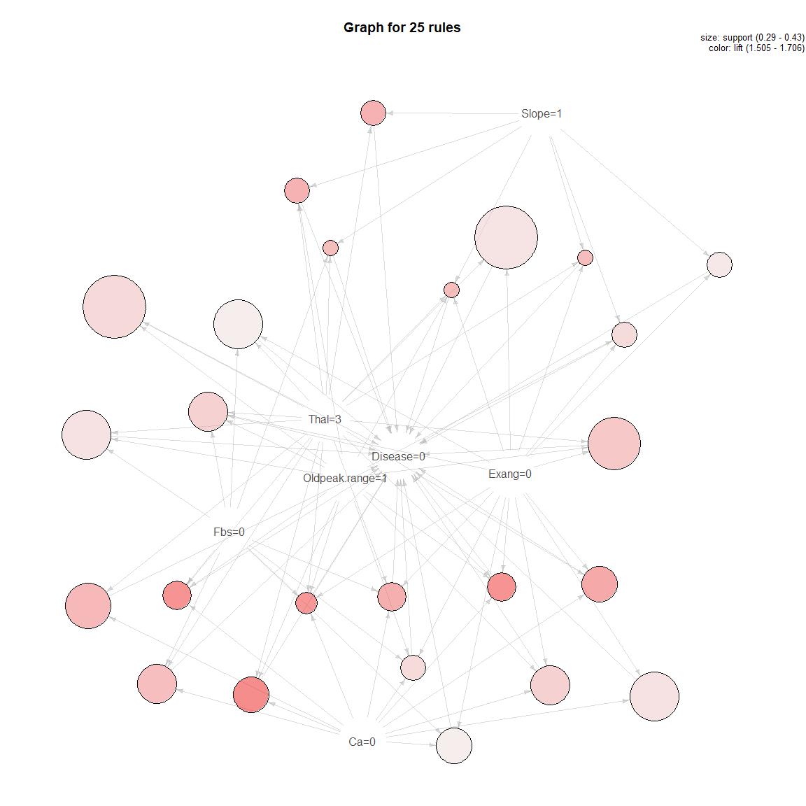

**plot**(topRules_1test_count, method="graph")

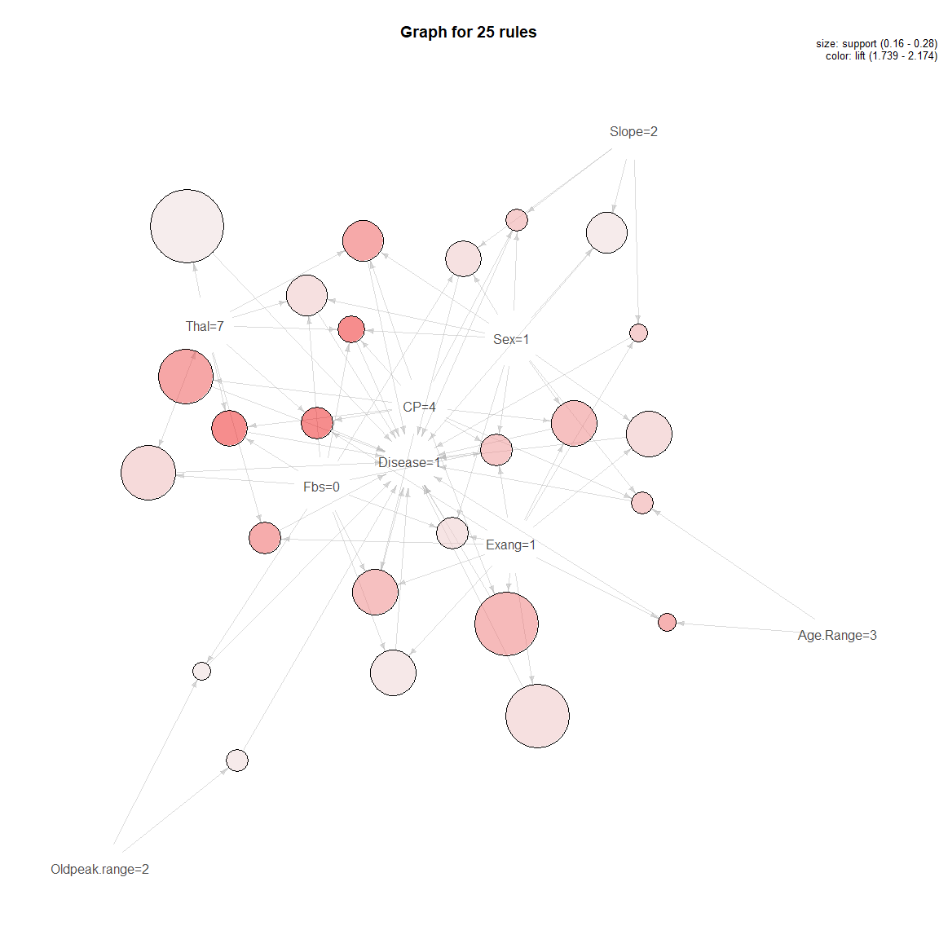

**plot**(topRules_test_lift, method="graph")

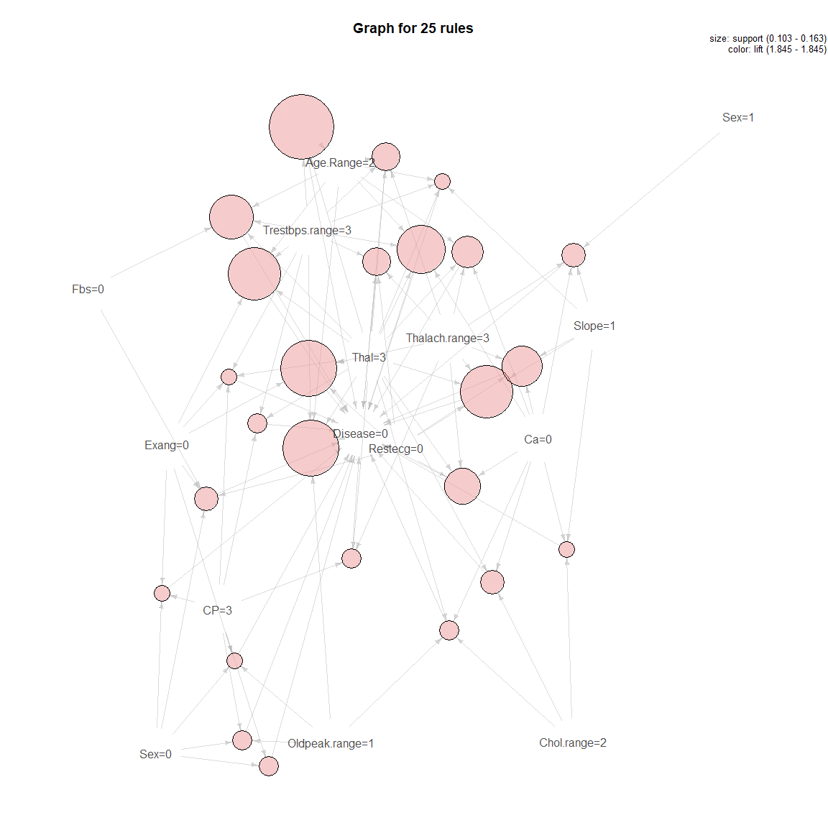

**plot**(topRules_1test_lift, method="graph")

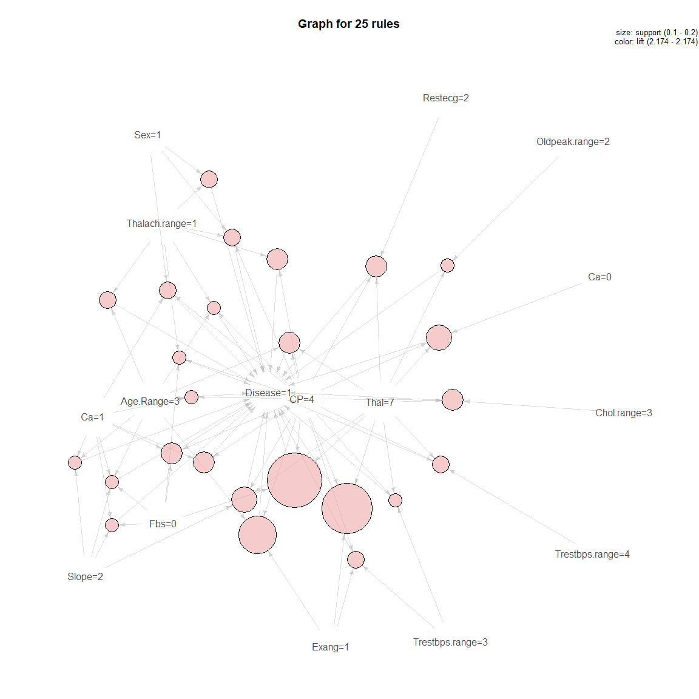

# 4. Logistic Regression (Quasibinomial) (glm)

############################################  
*# 4. Logistic Regression (Quasibinomial)*  
model.name <- "Logistic Regression (Quasibinomial) (glm)"  
model.name1 <- model.name  
file.name <- **paste**(work.dir, "logistic.Rds", sep="/")  
file.name.et <- **paste**(work.dir, "logistic-et.Rds", sep="/")  
  
**if** (**file.exists**(file.name)) {  
 **load**(file.name,.GlobalEnv)  
 **load**(file.name.et,.GlobalEnv)  
} **else** {  
   
 t1 <- **proc.time**()  
 (reg.logistic <- **train**(Disease **~** Age **+** Sex **+** CP **+** Trestbps **+** Chol **+** Fbs **+** Restecg   
 **+** Thalach **+** Exang **+** Oldpeak **+** Slope **+** Ca **+** Thal,   
 data = trainData,  
 method = "glm",   
 family = "quasibinomial"))  
 t2 <- **proc.time**()  
 et <- **elapsed_time**(t1,t2)  
 **print**(**paste0**(model.name," Executed ... time:", et))  
 **save**(reg.logistic, file = file.name)  
 **save**(et, file = file.name.et)  
}

## [1] "Logistic Regression (Quasibinomial) (glm) Executed ... time:1.3"

Let’s see the results:

reg.logistic

## Generalized Linear Model   
##   
## 198 samples  
## 13 predictor  
## 2 classes: '0', '1'   
##   
## No pre-processing  
## Resampling: Bootstrapped (25 reps)   
## Summary of sample sizes: 198, 198, 198, 198, 198, 198, ...   
## Resampling results:  
##   
## Accuracy Kappa   
## 0.8132 0.6247

**summary**(reg.logistic)

##   
## Call:  
## NULL  
##   
## Deviance Residuals:   
## Min 1Q Median 3Q Max   
## -2.713 -0.508 -0.198 0.402 2.288   
##   
## Coefficients:  
## Estimate Std. Error t value Pr(>|t|)   
## (Intercept) -7.64475 3.83052 -2.00 0.0474 *   
## Age -0.02474 0.03346 -0.74 0.4606   
## Sex 1.09851 0.62850 1.75 0.0822 .   
## CP 0.66565 0.26339 2.53 0.0123 *   
## Trestbps 0.02224 0.01394 1.59 0.1125   
## Chol 0.01113 0.00557 2.00 0.0470 *   
## Fbs -0.50169 0.69070 -0.73 0.4685   
## Restecg 0.03192 0.24187 0.13 0.8952   
## Thalach -0.02483 0.01320 -1.88 0.0616 .   
## Exang 0.66244 0.56059 1.18 0.2389   
## Oldpeak 0.22920 0.29119 0.79 0.4322   
## Slope 0.51804 0.48082 1.08 0.2827   
## Ca 1.12548 0.35527 3.17 0.0018 **  
## Thal 0.43944 0.13386 3.28 0.0012 **  
## ---  
## Signif. codes: 0 '***' 0.001 '**' 0.01 '*' 0.05 '.' 0.1 ' ' 1  
##   
## (Dispersion parameter for quasibinomial family taken to be 1.106)  
##   
## Null deviance: 273.19 on 197 degrees of freedom  
## Residual deviance: 134.08 on 184 degrees of freedom  
## AIC: NA  
##   
## Number of Fisher Scoring iterations: 6

**plot**(**varImp**(reg.logistic), main = **paste0**(model.name,"Variable Importance"))

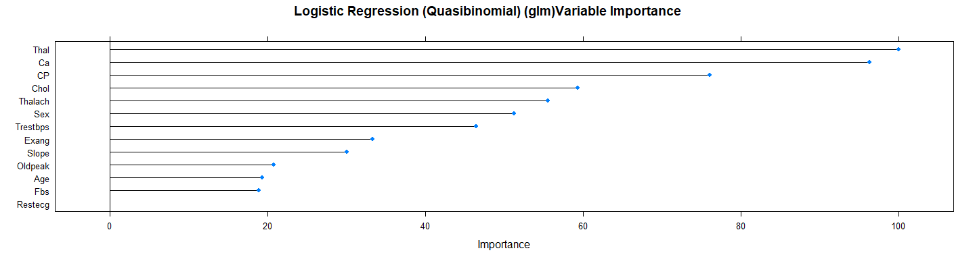

**plot**(reg.logistic**$**finalModel, main = model.name)

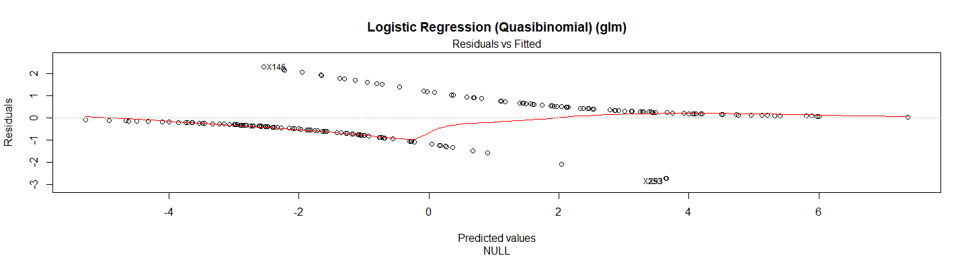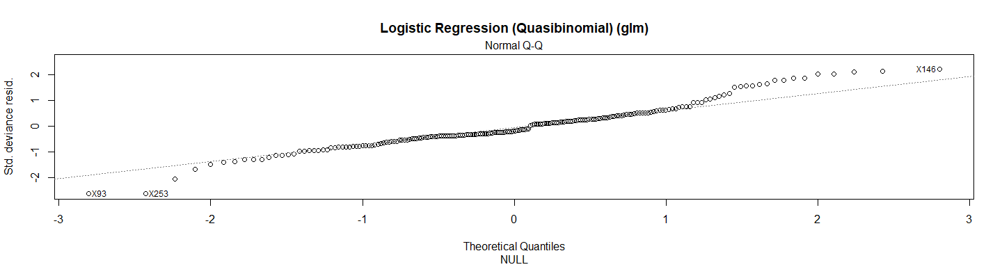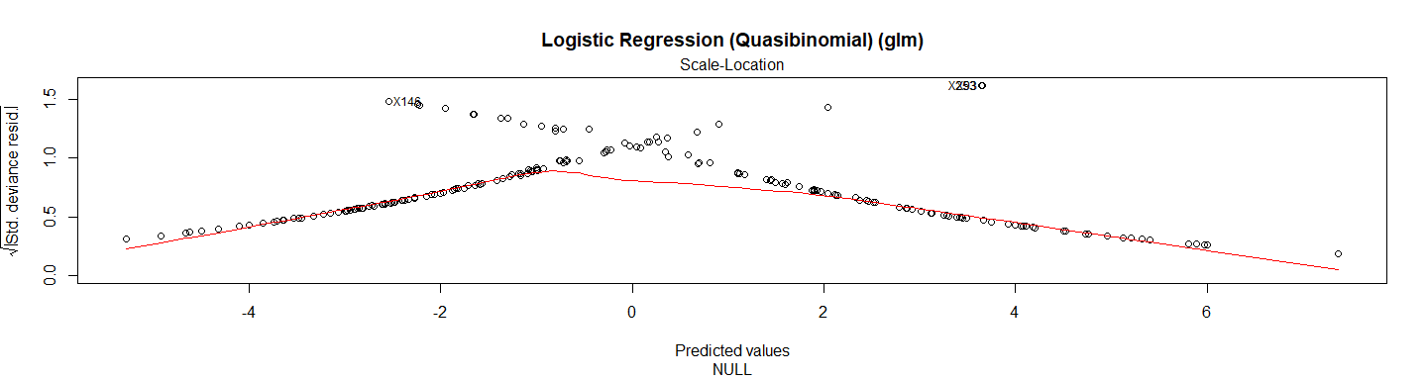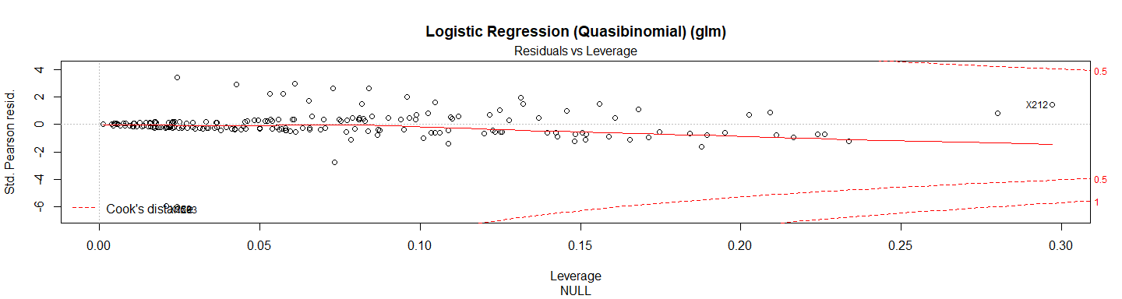

test_pred_logistic <- **predict**(reg.logistic, newdata = X.testData)  
test_pred_logistic

## [1] 1 0 0 0 1 0 0 0 0 0 1 1 0 0 1 0 0 1 0 0 1 1 1 1 1 0 0 0 0 0 0 0 1 0 0  
## [36] 1 0 1 0 1 1 0 0 1 0 0 0 0 1 0 0 0 1 1 1 1 0 1 0 0 1 1 0 0 1 1 1 1 0 1  
## [71] 1 1 0 0 1 0 1 0 1 1 0 1 0 0 0 0 1 0 0 1 1 0 1 1 1 1 0 0 0  
## Levels: 0 1

res.logistic <- **confusionMatrix**(test_pred_logistic, Y.testData)   
res.logistic

## Confusion Matrix and Statistics  
##   
## Reference  
## Prediction 0 1  
## 0 45 10  
## 1 8 36  
##   
## Accuracy : 0.818   
## 95% CI : (0.728, 0.889)  
## No Information Rate : 0.535   
## P-Value [Acc > NIR] : 3.57e-09   
##   
## Kappa : 0.633   
## Mcnemar's Test P-Value : 0.814   
##   
## Sensitivity : 0.849   
## Specificity : 0.783   
## Pos Pred Value : 0.818   
## Neg Pred Value : 0.818   
## Prevalence : 0.535   
## Detection Rate : 0.455   
## Detection Prevalence : 0.556   
## Balanced Accuracy : 0.816   
##   
## 'Positive' Class : 0   
##

*# This function is used to plot the confusion matrix*  
print_confusionm <- **function**(confmatrix, main, labels) {  
 temp <- confmatrix**$**table  
 **colnames**(temp) <- labels  
 **rownames**(temp) <- labels  
   
 **fourfoldplot**(temp, main = main, conf.level = 0)   
}  
  
**print_confusionm**(res.logistic,   
 main = **paste0**("Confusion Matrix: ",model.name," (Test Set)"),   
 labels = **c**("Healthy", "Non-Healthy"))

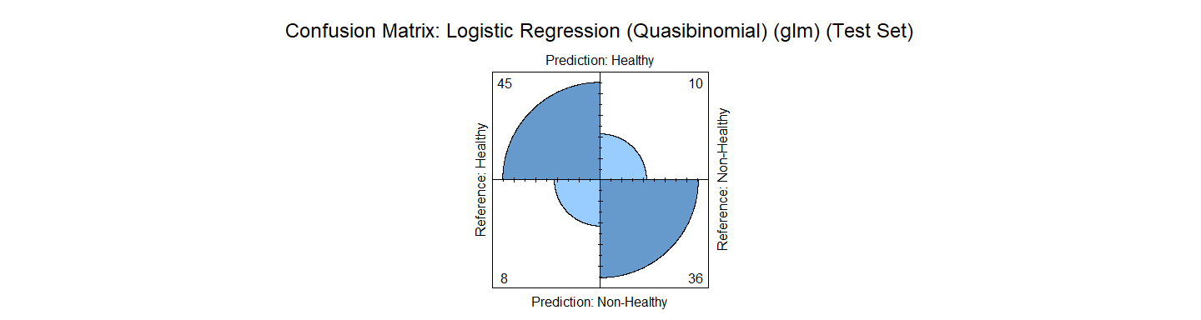

*# Let's see the Complete Classification/Missclassification considering the Type the next*  
*# function will calculate that*  
  
plot_results_by_type <- **function**(predict, real.class, main, testData) {  
   
 new.set <- **data.frame**(predict)   
 new.set**$**classification <- predict **==** real.class   
 new.set**$**type <- testData**$**Num  
 new.set**$**factorC <- **with**(new.set,   
 **interaction**(**factor**(classification), **factor**(type)))  
 **plot**(new.set**$**factorC, main = main, col = **c**(1,1,2,2,3,3,4,4,5,5))  
}  
  
main <- **paste0**(model.name," Classification/Misclassification in Test Set by\n",  
 "Heart Disease Status: number of major vessels with >50% narrowing",  
 "(0=Healthy,1,2,3, or 4)")  
  
**plot_results_by_type**(test_pred_logistic,  
 Y.testData,  
 main, testData)

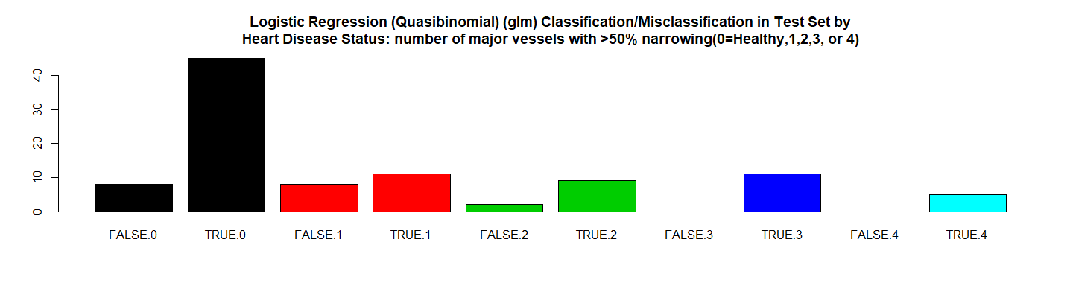

*#This function will be used to plot the results*   
  
plot_results <- **function**(X.data, Y.data, Y.predict, title,   
 var1 = NULL, var2 = NULL, labels = TRUE) {  
  
 res <- **data.frame**(X.data)  
 res**$**class <- Y.data  
 res**$**ID <- **row.names**(res)  
 res**$**predict_class <- Y.predict  
 res**$**col <- **ifelse**(res**$**class **==** res**$**predict_class, res**$**class,3)  
   
 **if** (**is.null**(var1)) {  
 var1 <- **colnames**(res)[1]  
 }  
   
 **if** (**is.null**(var2)) {  
 var2 <- **colnames**(res)[2]  
 }  
   
 g <- **ggplot**(res,  
 **aes**(res[[var1]], res[[var2]],  
 color = **as.factor**(res**$**col))) **+**   
 **scale_color_manual**(values = **c**(1,2,4),   
 name ="Classification/Missclasification Results",  
 labels =**c**("Black (Class 0)","Red (Class 1)","Blue (Missclassified)")) **+**  
 **geom_point**() **+**   
 **labs**(title = title) **+** **xlab**(var1) **+** **ylab**(var2) **+**   
 **stat_chull**(**aes**(group = **as.factor**(res**$**col)),  
 geom = "polygon", fill = NA)  
   
 **if** (labels) {  
 *# Add the labels to the graph*  
 g <- g **+** **geom_text**(**aes**(label = res**$**ID), size = 3, vjust = **-**0.7)  
 }  
 g  
}  
  
**plot_results**(X.testData, Y.testData,test_pred_logistic ,   
 **paste0**(model.name," Classification/Missclasiffication\n"),   
 "Trestbps","Chol",labels = FALSE)

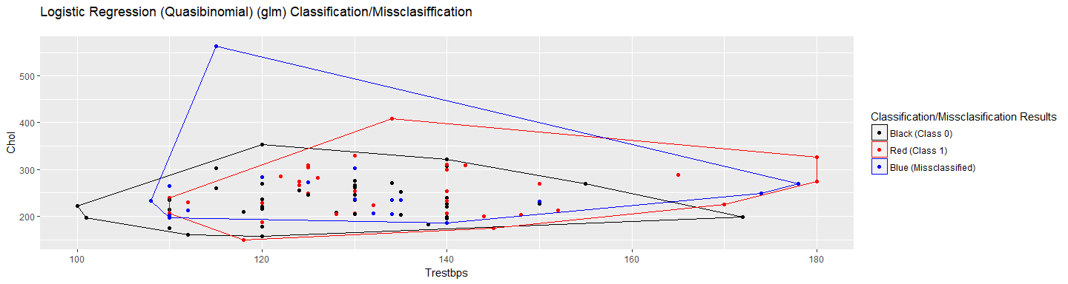

**plot_results**(X.testData, Y.testData, test_pred_logistic,   
 **paste0**(model.name," Classification/Missclasiffication\n"),  
 "Trestbps","Chol",labels = TRUE)

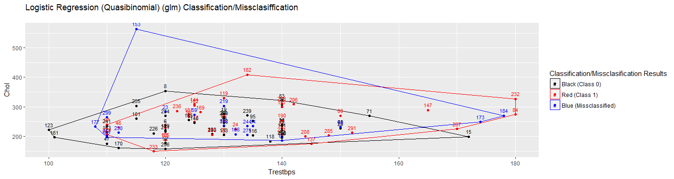

*# RMSE Resulting*  
(rmse_logistic <- **sqrt**(**mean**((**as.numeric**(test_pred_logistic)**-as.numeric**(Y.testData))**^**2)))

## [1] 0.4264

*# Residuals Plot*  
(r_logistic <- (**as.numeric**(test_pred_logistic)**-as.numeric**(Y.testData)))

## [1] 0 0 0 0 0 0 0 0 0 -1 0 0 0 0 1 0 0 0 0 0 0 0 0  
## [24] 1 0 -1 0 -1 0 -1 0 0 0 0 0 0 0 0 0 0 0 0 0 0 0 0  
## [47] 0 0 0 0 0 0 0 0 1 0 0 0 0 0 1 0 0 -1 1 0 0 1 0  
## [70] 0 0 0 0 0 1 0 0 -1 0 0 0 0 0 0 -1 0 1 0 0 0 0 -1  
## [93] 0 0 0 0 0 -1 -1

**plot**(r_logistic,   
 main = **paste0**(model.name," Residuals"),xlab = "", ylab = "")

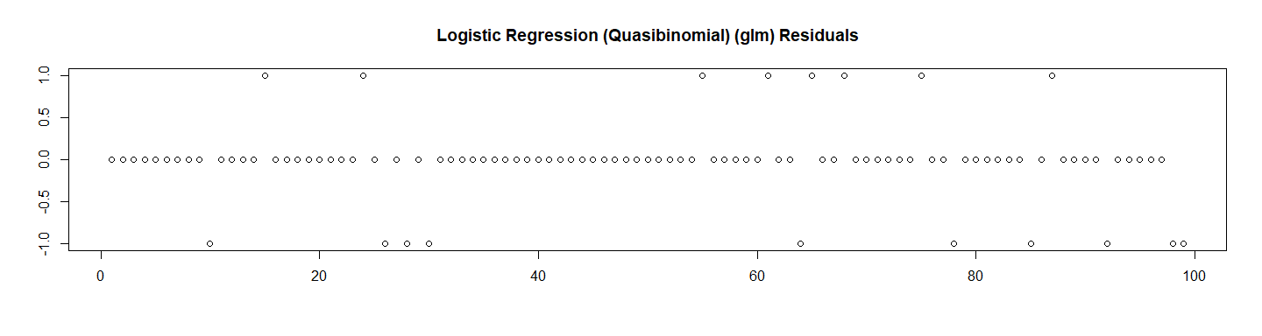

*# Let's check the probabilities and Calculate the ROC*  
test_pred_logistic_prob <- **predict**(reg.logistic, newdata = X.testData, type ="prob")[2]  
  
res.logistic.roc <- **roc**(**as.numeric**(Y.testData),  
 **as.numeric**(  
 **as.matrix**((test_pred_logistic_prob))))**$**auc  
  
*# Store the Values for Report*  
results_all <- **data.frame**("Method"= model.name,  
 "Prediction Accuracy in Training Set" =   
 reg.logistic**$**results**$**Accuracy,  
 "Prediction Accuracy in Test Set" = res.logistic**$**overall[1],  
 "RMSE Test"= rmse_logistic,  
 "ROC" = res.logistic.roc,  
 "Time Elapsed" = et,  
 stringsAsFactors = FALSE)

# 5. Logistic Regression (Binomial) (glm)

############################################  
*# 5. Logistic Regression (Binomial) (glm)*  
model.name <- "Logistic Regression (Binomial) (glm)"  
model.name2 <- model.name  
file.name <- **paste**(work.dir, "logistic2.Rds", sep="/")  
file.name.et <- **paste**(work.dir, "logistic2-et.Rds", sep="/")  
  
**if** (**file.exists**(file.name)) {  
 **load**(file.name,.GlobalEnv)  
 **load**(file.name.et,.GlobalEnv)  
} **else** {  
   
 t1 <- **proc.time**()  
 (reg.logistic2 <- **train**(**factor**(Disease) **~** Age **+** Sex **+** CP **+** Trestbps **+** Chol **+** Fbs **+** Restecg   
 **+** Thalach **+** Exang **+** Oldpeak **+** Slope **+** Ca **+** Thal,   
 data = trainData,  
 method = "glm",   
 family = "binomial"))  
 t2 <- **proc.time**()  
 et <- **elapsed_time**(t1,t2)  
 **print**(**paste0**(model.name," Executed ... time:", et))  
 **save**(reg.logistic2, file = file.name)  
 **save**(et, file = file.name.et)  
}

## [1] "Logistic Regression (Binomial) (glm) Executed ... time:1.4"

Let’s see the results:

reg.logistic2

## Generalized Linear Model   
##   
## 198 samples  
## 13 predictor  
## 2 classes: '0', '1'   
##   
## No pre-processing  
## Resampling: Bootstrapped (25 reps)   
## Summary of sample sizes: 198, 198, 198, 198, 198, 198, ...   
## Resampling results:  
##   
## Accuracy Kappa  
## 0.8021 0.598

**summary**(reg.logistic2)

##   
## Call:  
## NULL  
##   
## Deviance Residuals:   
## Min 1Q Median 3Q Max   
## -2.713 -0.508 -0.198 0.402 2.288   
##   
## Coefficients:  
## Estimate Std. Error z value Pr(>|z|)   
## (Intercept) -7.64475 3.64255 -2.10 0.03584 *   
## Age -0.02474 0.03182 -0.78 0.43678   
## Sex 1.09851 0.59766 1.84 0.06606 .   
## CP 0.66565 0.25046 2.66 0.00787 **   
## Trestbps 0.02224 0.01326 1.68 0.09351 .   
## Chol 0.01113 0.00529 2.10 0.03547 *   
## Fbs -0.50169 0.65680 -0.76 0.44496   
## Restecg 0.03192 0.23001 0.14 0.88963   
## Thalach -0.02483 0.01255 -1.98 0.04796 *   
## Exang 0.66244 0.53309 1.24 0.21400   
## Oldpeak 0.22920 0.27691 0.83 0.40784   
## Slope 0.51804 0.45723 1.13 0.25721   
## Ca 1.12548 0.33784 3.33 0.00086 ***  
## Thal 0.43944 0.12729 3.45 0.00056 ***  
## ---  
## Signif. codes: 0 '***' 0.001 '**' 0.01 '*' 0.05 '.' 0.1 ' ' 1  
##   
## (Dispersion parameter for binomial family taken to be 1)  
##   
## Null deviance: 273.19 on 197 degrees of freedom  
## Residual deviance: 134.08 on 184 degrees of freedom  
## AIC: 162.1  
##   
## Number of Fisher Scoring iterations: 6

**plot**(**varImp**(reg.logistic2),   
 main = **paste0**(model.name," Variable Importance"))

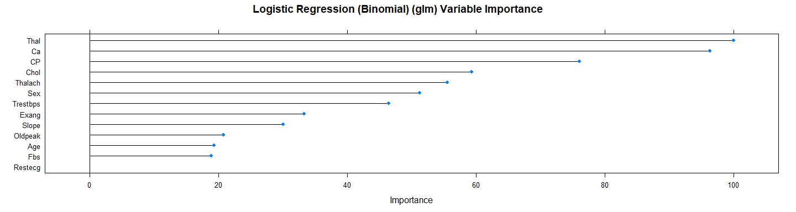

**plot**(reg.logistic2**$**finalModel, main = model.name)

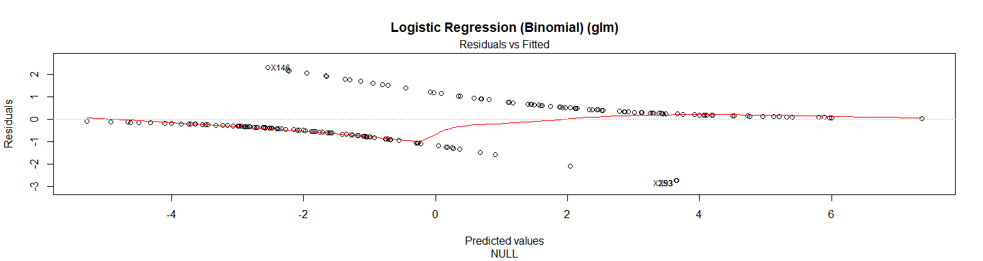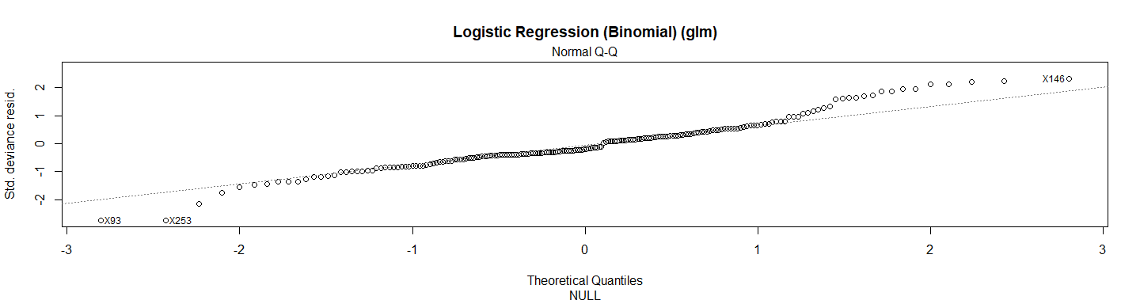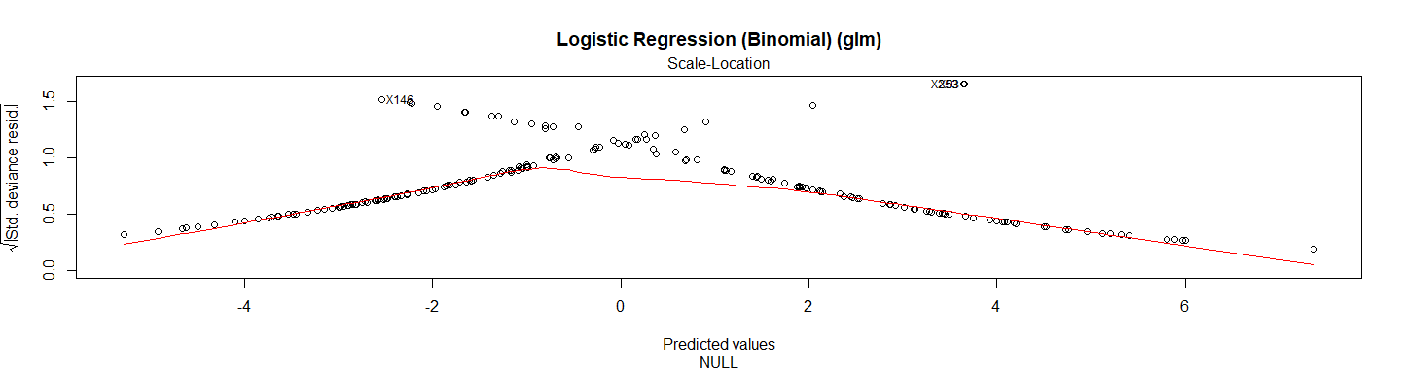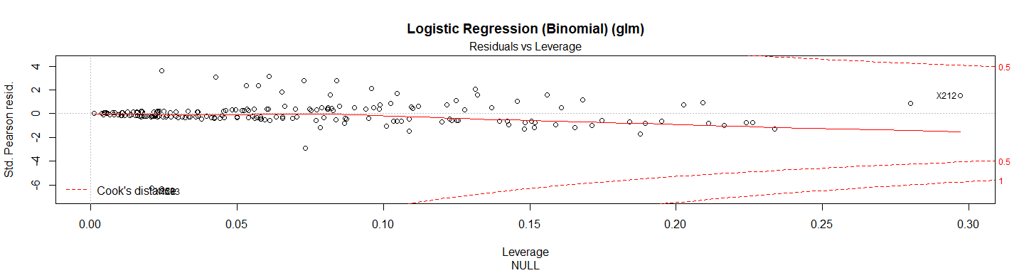

test_pred_logistic2 <- **predict**(reg.logistic2, newdata = X.testData)  
test_pred_logistic2

## [1] 1 0 0 0 1 0 0 0 0 0 1 1 0 0 1 0 0 1 0 0 1 1 1 1 1 0 0 0 0 0 0 0 1 0 0  
## [36] 1 0 1 0 1 1 0 0 1 0 0 0 0 1 0 0 0 1 1 1 1 0 1 0 0 1 1 0 0 1 1 1 1 0 1  
## [71] 1 1 0 0 1 0 1 0 1 1 0 1 0 0 0 0 1 0 0 1 1 0 1 1 1 1 0 0 0  
## Levels: 0 1

res.logistic2 <- **confusionMatrix**(test_pred_logistic2, Y.testData)   
res.logistic2

## Confusion Matrix and Statistics  
##   
## Reference  
## Prediction 0 1  
## 0 45 10  
## 1 8 36  
##   
## Accuracy : 0.818   
## 95% CI : (0.728, 0.889)  
## No Information Rate : 0.535   
## P-Value [Acc > NIR] : 3.57e-09   
##   
## Kappa : 0.633   
## Mcnemar's Test P-Value : 0.814   
##   
## Sensitivity : 0.849   
## Specificity : 0.783   
## Pos Pred Value : 0.818   
## Neg Pred Value : 0.818   
## Prevalence : 0.535   
## Detection Rate : 0.455   
## Detection Prevalence : 0.556   
## Balanced Accuracy : 0.816   
##   
## 'Positive' Class : 0   
##

**print_confusionm**(res.logistic2,   
 main = **paste0**("Confusion Matrix: ", model.name," (Test Set)"),   
 labels = **c**("Healthy", "Non-Healthy"))



main <- **paste0**(model.name, " Classification/Misclassification in Test Set by\n",  
 "Heart Disease Status: number of major vessels with >50% narrowing ",  
 "(0=Healthy,1,2,3, or 4)")  
  
**plot_results_by_type**(test_pred_logistic2,  
 Y.testData,  
 main, testData)

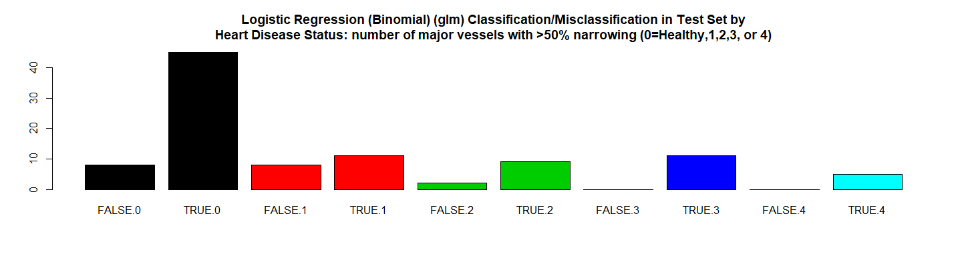

**plot_results**(X.testData, Y.testData,test_pred_logistic2 ,   
 **paste0**(model.name," Classification/Missclasiffication\n"),   
 "Trestbps","Chol",labels = FALSE)

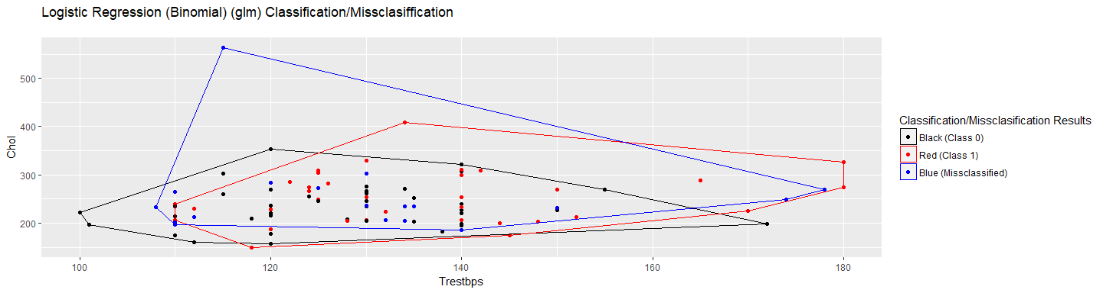

**plot_results**(X.testData, Y.testData, test_pred_logistic2,   
 **paste0**(model.name," Classification/Missclasiffication\n"),  
 "Trestbps","Chol",labels = TRUE)

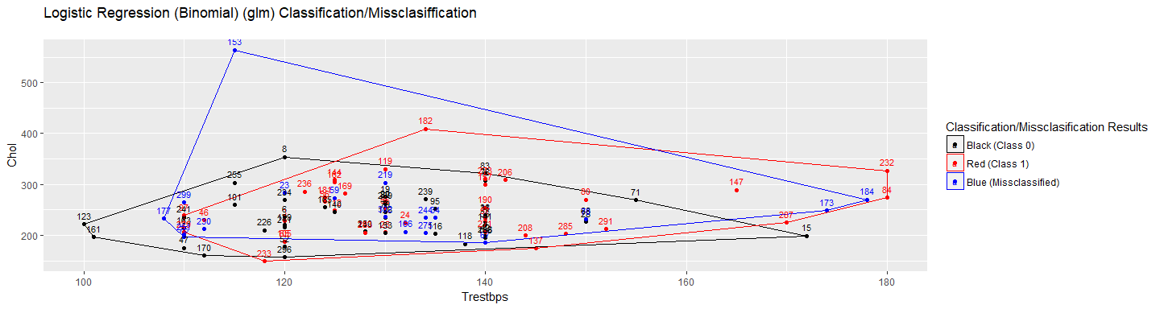

*# RMSE Resulting*  
(rmse_logistic2 <- **sqrt**(**mean**((**as.numeric**(test_pred_logistic2)**-as.numeric**(Y.testData))**^**2)))

## [1] 0.4264

*# Residuals Plot*  
(r_logistic2 <- (**as.numeric**(test_pred_logistic2)**-as.numeric**(Y.testData)))

## [1] 0 0 0 0 0 0 0 0 0 -1 0 0 0 0 1 0 0 0 0 0 0 0 0  
## [24] 1 0 -1 0 -1 0 -1 0 0 0 0 0 0 0 0 0 0 0 0 0 0 0 0  
## [47] 0 0 0 0 0 0 0 0 1 0 0 0 0 0 1 0 0 -1 1 0 0 1 0  
## [70] 0 0 0 0 0 1 0 0 -1 0 0 0 0 0 0 -1 0 1 0 0 0 0 -1  
## [93] 0 0 0 0 0 -1 -1

**plot**(r_logistic2,   
 main = **paste0**(model.name," Residuals"),xlab = "", ylab = "")

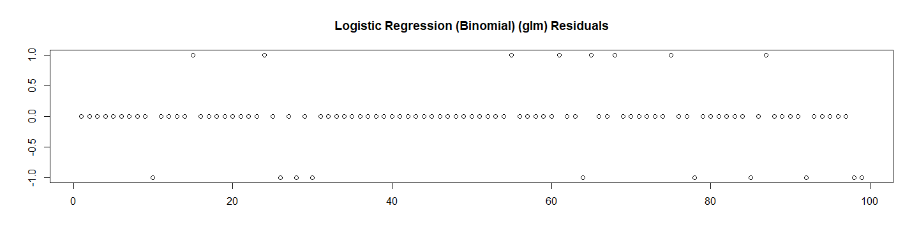

*# Let's check the probabilities and Calculate the ROC*  
test_pred_logistic2_prob <- **predict**(reg.logistic2, newdata = X.testData, type ="prob")[2]  
  
res.logistic2.roc <- **roc**(**as.numeric**(Y.testData),  
 **as.numeric**(  
 **as.matrix**((test_pred_logistic2_prob))))**$**auc  
  
*# Store the Values for Report*  
results_all <- **rbind**(results_all,  
 **data.frame**("Method"= model.name,  
 "Prediction Accuracy in Training Set" =   
 reg.logistic2**$**results**$**Accuracy,  
 "Prediction Accuracy in Test Set" =   
 res.logistic2**$**overall[1],  
 "RMSE Test"= rmse_logistic2,  
 "ROC" = res.logistic2.roc,  
 "Time Elapsed" = et,  
 stringsAsFactors = FALSE))

# 6. Logistic Regression (Binomial) with Factor Variables (glm)

############################################  
*# 6. Logistic Regression (Binomial) with Factor Variables (glm)*   
model.name <- "Logistic Regression (Binomial) with Factor Variables (glm)"   
model.name4 <- model.name  
file.name <- **paste**(work.dir, "logistic4.Rds", sep="/")  
file.name.et <- **paste**(work.dir, "logistic4-et.Rds", sep="/")  
  
**if** (**file.exists**(file.name)) {  
 **load**(file.name,.GlobalEnv)  
 **load**(file.name.et,.GlobalEnv)  
} **else** {  
   
 t1 <- **proc.time**()  
 (reg.logistic4 <- **train**(  
 **factor**(Disease) **~** **as.numeric**(Age) **+** **factor**(Sex) **+** **factor**(CP) **+**   
 **as.numeric**(Trestbps) **+** **as.numeric**(Chol) **+** **factor**(Fbs) **+**   
 **factor**(Restecg) **+** **as.numeric**(Thalach) **+** **factor**(Exang) **+**   
 **as.numeric**(Oldpeak) **+** **factor**(Slope) **+** **factor**(Ca) **+** **factor**(Thal),   
 data = trainData,  
 method = "glm",   
 family = "binomial"))  
 t2 <- **proc.time**()  
 et <- **elapsed_time**(t1,t2)  
 **print**(**paste0**(model.name," Executed ... time:", et))  
 **save**(reg.logistic4, file = file.name)  
 **save**(et, file = file.name.et)  
}

## [1] "Logistic Regression (Binomial) with Factor Variables (glm) Executed ... time:1.2"

Let’s see the results:

reg.logistic4

## Generalized Linear Model   
##   
## 198 samples  
## 13 predictor  
## 2 classes: '0', '1'   
##   
## No pre-processing  
## Resampling: Bootstrapped (25 reps)   
## Summary of sample sizes: 198, 198, 198, 198, 198, 198, ...   
## Resampling results:  
##   
## Accuracy Kappa   
## 0.8009 0.5977

**summary**(reg.logistic4)

##   
## Call:  
## NULL  
##   
## Deviance Residuals:   
## Min 1Q Median 3Q Max   
## -3.151 -0.452 -0.113 0.296 2.962   
##   
## Coefficients:  
## Estimate Std. Error z value Pr(>|z|)   
## (Intercept) -5.14e+00 3.83e+00 -1.34 0.1799   
## `as.numeric(Age)` -3.12e-02 3.52e-02 -0.89 0.3761   
## `factor(Sex)1` 1.20e+00 6.83e-01 1.76 0.0780 .   
## `factor(CP)2` 8.91e-01 1.03e+00 0.87 0.3855   
## `factor(CP)3` -5.37e-01 9.76e-01 -0.55 0.5824   
## `factor(CP)4` 2.32e+00 9.17e-01 2.53 0.0115 *   
## `as.numeric(Trestbps)` 2.20e-02 1.50e-02 1.47 0.1418   
## `as.numeric(Chol)` 1.22e-02 6.03e-03 2.03 0.0424 *   
## `factor(Fbs)1` 8.63e-02 7.60e-01 0.11 0.9096   
## `factor(Restecg)1` 1.14e+01 1.46e+03 0.01 0.9937   
## `factor(Restecg)2` -1.86e-01 5.11e-01 -0.36 0.7162   
## `as.numeric(Thalach)` -2.49e-02 1.47e-02 -1.69 0.0914 .   
## `factor(Exang)1` 3.40e-01 5.91e-01 0.57 0.5656   
## `as.numeric(Oldpeak)` 2.12e-01 3.00e-01 0.71 0.4796   
## `factor(Slope)2` 9.02e-01 6.53e-01 1.38 0.1672   
## `factor(Slope)3` 1.60e+00 1.17e+00 1.37 0.1719   
## `factor(Ca)1` 2.02e+00 6.64e-01 3.04 0.0024 **  
## `factor(Ca)2` 2.98e+00 9.67e-01 3.08 0.0021 **  
## `factor(Ca)3` 1.27e+00 1.29e+00 0.99 0.3243   
## `factor(Thal)6` 8.48e-01 9.74e-01 0.87 0.3836   
## `factor(Thal)7` 1.85e+00 5.74e-01 3.22 0.0013 **  
## ---  
## Signif. codes: 0 '***' 0.001 '**' 0.01 '*' 0.05 '.' 0.1 ' ' 1  
##   
## (Dispersion parameter for binomial family taken to be 1)  
##   
## Null deviance: 273.19 on 197 degrees of freedom  
## Residual deviance: 116.26 on 177 degrees of freedom  
## AIC: 158.3  
##   
## Number of Fisher Scoring iterations: 14

**plot**(**varImp**(reg.logistic4),   
 main = **paste0**(model.name," Importance"))

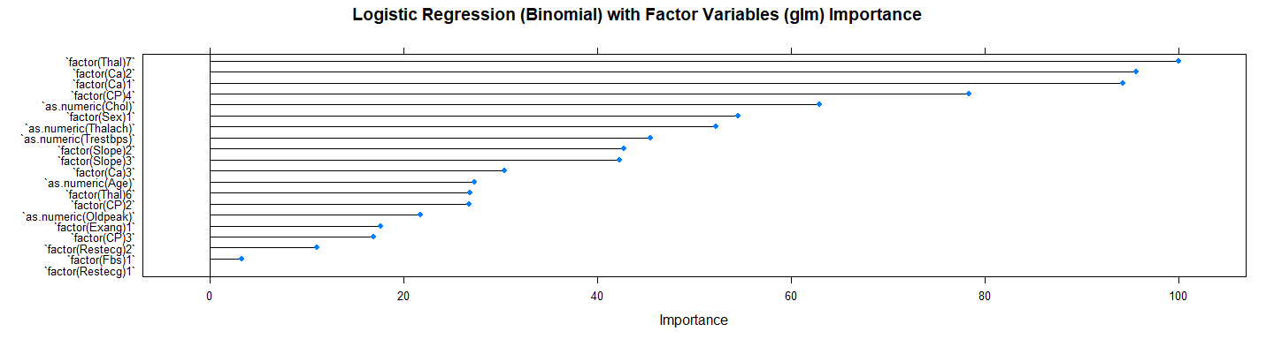

**plot**(reg.logistic4**$**finalModel,   
 main = model.name)

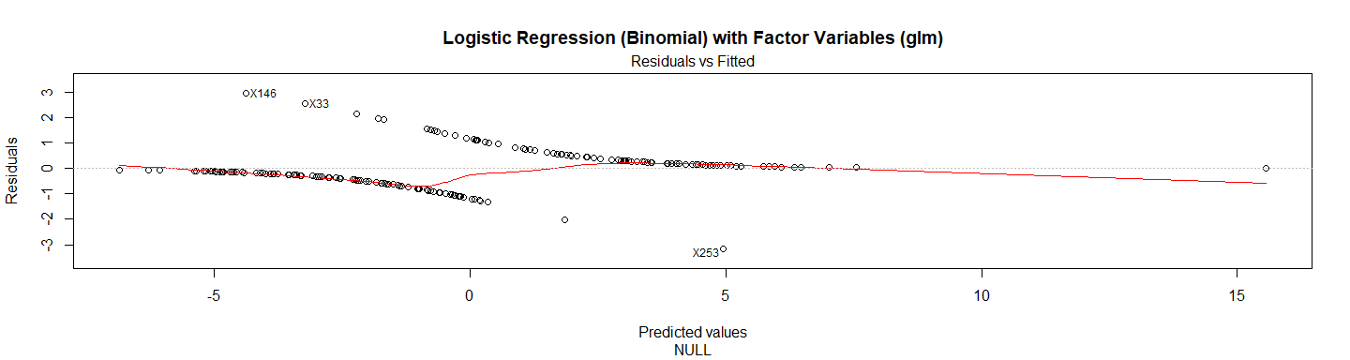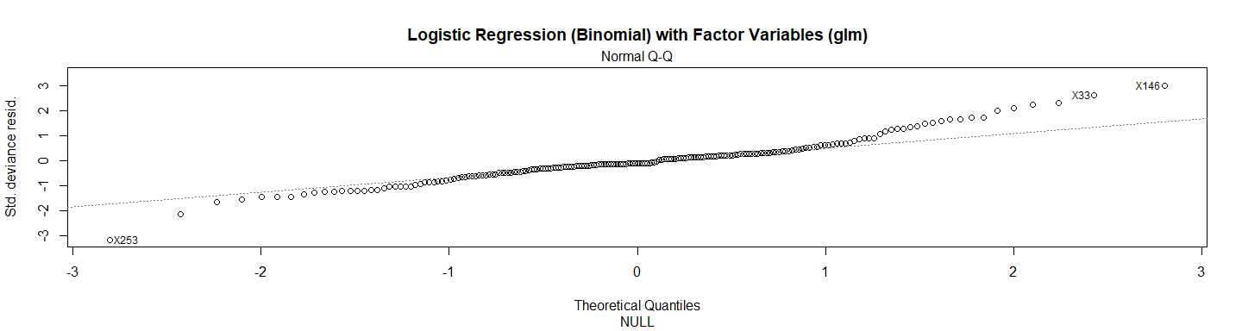

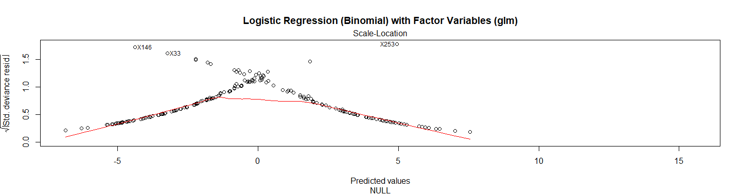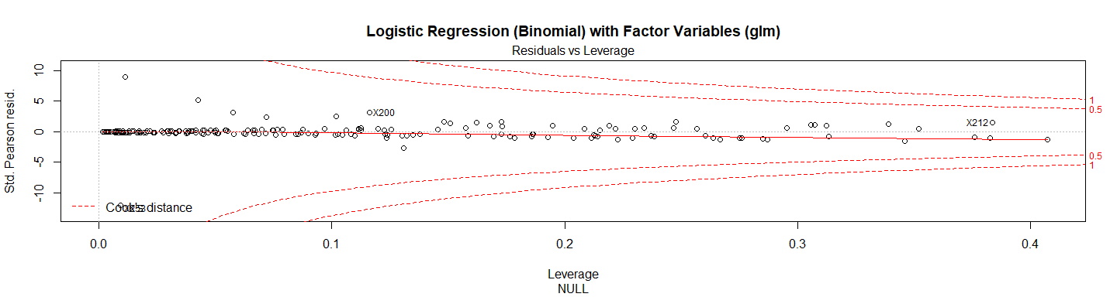

test_pred_logistic4 <- **predict**(reg.logistic4, newdata = X.testData)  
test_pred_logistic4

## [1] 1 0 0 0 1 0 0 0 0 0 1 1 0 0 1 0 0 1 0 0 1 1 1 0 1 0 0 0 0 0 0 0 1 0 0  
## [36] 1 0 1 0 0 1 0 0 1 0 0 0 0 1 0 0 0 1 1 1 1 0 0 0 0 1 1 0 0 1 1 1 1 0 1  
## [71] 1 1 0 0 1 0 1 1 1 0 0 1 0 0 1 0 1 0 1 1 1 0 1 1 1 0 0 1 0  
## Levels: 0 1

res.logistic4 <- **confusionMatrix**(test_pred_logistic4, Y.testData)   
res.logistic4

## Confusion Matrix and Statistics  
##   
## Reference  
## Prediction 0 1  
## 0 45 11  
## 1 8 35  
##   
## Accuracy : 0.808   
## 95% CI : (0.717, 0.88)  
## No Information Rate : 0.535   
## P-Value [Acc > NIR] : 1.35e-08   
##   
## Kappa : 0.613   
## Mcnemar's Test P-Value : 0.646   
##   
## Sensitivity : 0.849   
## Specificity : 0.761   
## Pos Pred Value : 0.804   
## Neg Pred Value : 0.814   
## Prevalence : 0.535   
## Detection Rate : 0.455   
## Detection Prevalence : 0.566   
## Balanced Accuracy : 0.805   
##   
## 'Positive' Class : 0   
##

**print_confusionm**(res.logistic4,   
 main = **paste0**("Confusion Matrix: ",model.name," (Test Set)"),  
 labels = **c**("Healthy", "Non-Healthy"))

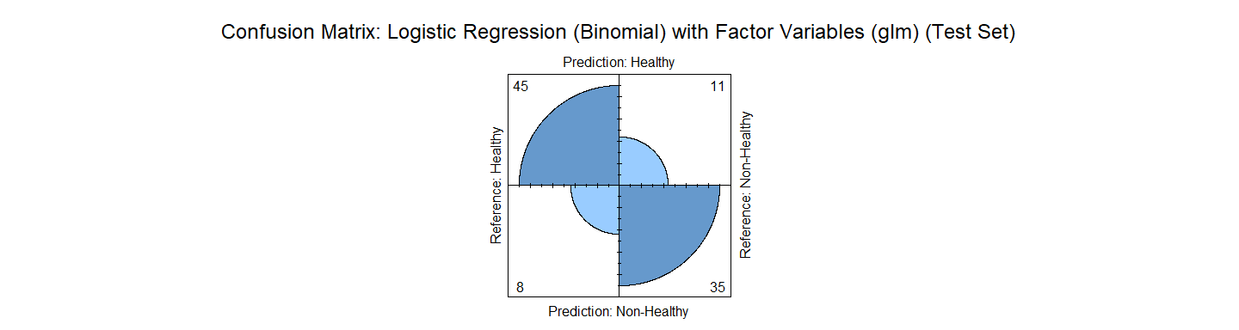

main <- **paste0**(model.name, " Classification/Misclassification in Test Set by\n",  
 "Heart Disease Status: number of major vessels with >50% narrowing ",  
 "(0=Healthy,1,2,3, or 4)")  
  
**plot_results_by_type**(test_pred_logistic4,  
 Y.testData,  
 main, testData)

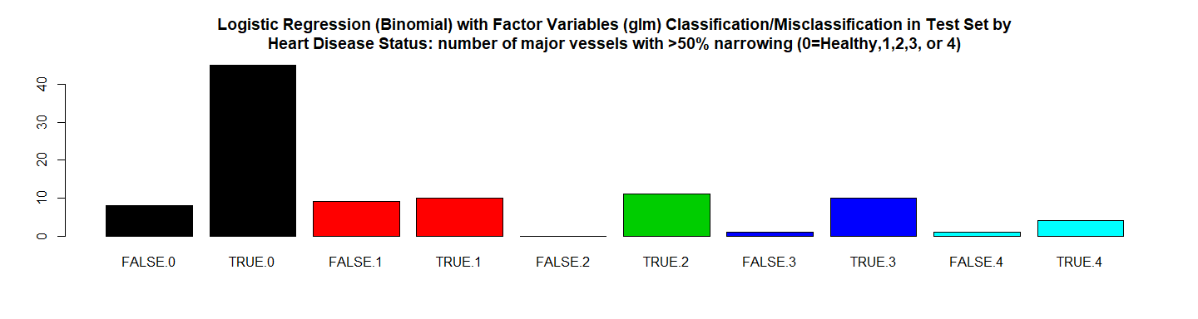

*#This function will be used to plot the results*   
  
**plot_results**(X.testData, Y.testData,test_pred_logistic4,   
 **paste0**(model.name," Classification/Missclasiffication\n"),   
 "Trestbps","Chol",labels = FALSE)

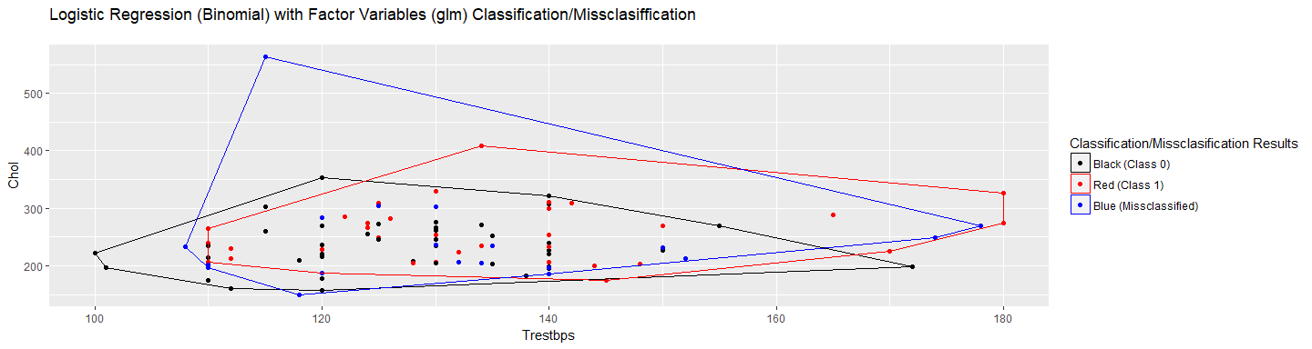

**plot_results**(X.testData, Y.testData, test_pred_logistic4,   
 **paste0**(model.name, " Classification/Missclasiffication\n"),  
 "Trestbps","Chol",labels = TRUE)

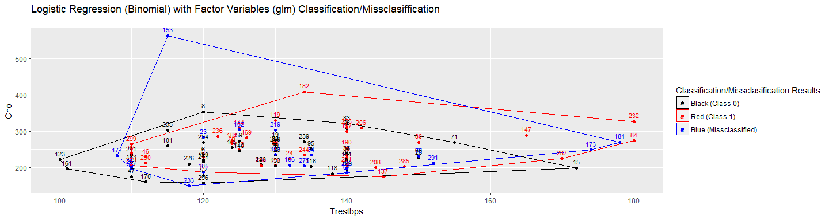

*# RMSE Resulting*  
(rmse_logistic4 <- **sqrt**(**mean**((**as.numeric**(test_pred_logistic4)**-as.numeric**(Y.testData))**^**2)))

## [1] 0.4381

*# Residuals Plot*  
(r_logistic4 <- (**as.numeric**(test_pred_logistic4)**-as.numeric**(Y.testData)))

## [1] 0 0 0 0 0 0 0 0 0 -1 0 0 0 0 1 0 0 0 0 0 0 0 0  
## [24] 0 0 -1 0 -1 0 -1 0 0 0 0 0 0 0 0 0 -1 0 0 0 0 0 0  
## [47] 0 0 0 0 0 0 0 0 1 0 0 -1 0 0 1 0 0 -1 1 0 0 1 0  
## [70] 0 0 0 0 0 1 0 0 0 0 -1 0 0 0 0 0 0 1 0 1 0 0 -1  
## [93] 0 0 0 -1 0 0 -1

**plot**(r_logistic4,   
 main = **paste0**(model.name," Residuals"),xlab = "", ylab = "")

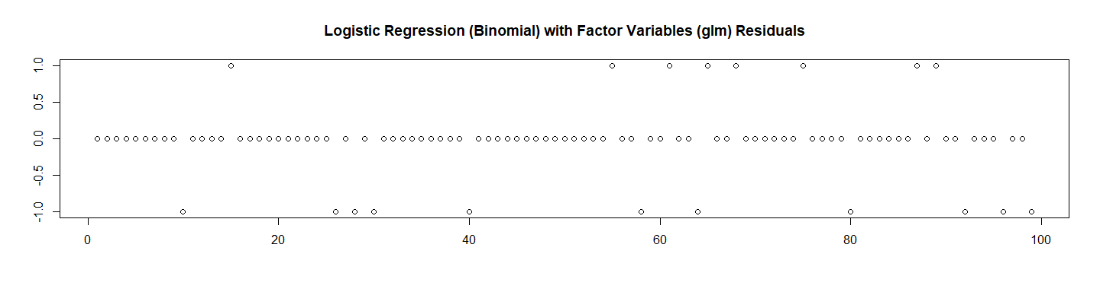

*# Let's check the probabilities and Calculate the ROC*  
test_pred_logistic4_prob <- **predict**(reg.logistic4, newdata = X.testData, type ="prob")[2]  
  
res.logistic4.roc <- **roc**(**as.numeric**(Y.testData),  
 **as.numeric**(  
 **as.matrix**((test_pred_logistic4_prob))))**$**auc  
  
*# Store the Values for Report*  
results_all <- **rbind**(results_all,  
 **data.frame**("Method"= model.name,  
 "Prediction Accuracy in Training Set" =   
 reg.logistic4**$**results**$**Accuracy,  
 "Prediction Accuracy in Test Set" =   
 res.logistic4**$**overall[1],  
 "RMSE Test"= rmse_logistic4,  
 "ROC" = res.logistic4.roc,  
 "Time Elapsed" = et,  
 stringsAsFactors = FALSE))

# 7. Linear Model with Stepwise Feature Selection (glmStepAIC)

############################################  
*# 7. Linear Model with Stepwise Feature Selection (glmStepAIC)*  
model.name <- "Linear Model with Stepwise Feature Selection (glmStepAIC)"  
model.name5 <- model.name  
file.name <- **paste**(work.dir, "glmStepAIC.Rds", sep="/")  
file.name.et <- **paste**(work.dir, "glmStepAIC-et.Rds", sep="/")  
  
**if** (**file.exists**(file.name)) {  
 **load**(file.name,.GlobalEnv)  
 **load**(file.name.et,.GlobalEnv)  
} **else** {  
   
 t1 <- **proc.time**()  
 (glmStepAIC <- **train**(**factor**(Disease) **~** Age **+** Sex **+** CP **+** Trestbps **+** Chol **+** Fbs **+** Restecg   
 **+** Thalach **+** Exang **+** Oldpeak **+** Slope **+** Ca **+** Thal, data = trainData,  
 method = "glmStepAIC",  
 preProcess = **c**("center", "scale")))  
   
 t2 <- **proc.time**()  
 et <- **elapsed_time**(t1,t2)  
 **print**(**paste0**(model.name, " Executed ... time:", et))  
 **save**(glmStepAIC, file = file.name)  
 **save**(et, file = file.name.et)  
}

## Start: AIC=184.6  
## .outcome ~ Age + Sex + CP + Trestbps + Chol + Fbs + Restecg +   
## Thalach + Exang + Oldpeak + Slope + Ca + Thal  
##   
## Df Deviance AIC  
## - Oldpeak 1 157 183  
## - Slope 1 157 183  
## - Sex 1 157 183  
## - Exang 1 158 184  
## - Chol 1 158 184  
## - Fbs 1 158 184  
## - Thalach 1 158 184  
## <none> 157 185  
## - Restecg 1 160 186  
## - Trestbps 1 162 188  
## - Age 1 163 189  
## - Thal 1 166 192  
## - CP 1 167 193  
## - Ca 1 170 196  
##   
## Step: AIC=182.8  
## .outcome ~ Age + Sex + CP + Trestbps + Chol + Fbs + Restecg +   
## Thalach + Exang + Slope + Ca + Thal  
##   
## Df Deviance AIC  
## - Sex 1 157 181  
## - Slope 1 158 182  
## - Exang 1 158 182  
## - Chol 1 158 182  
## - Fbs 1 158 182  
## <none> 157 183  
## - Thalach 1 159 183  
## - Restecg 1 160 184  
## - Trestbps 1 162 186  
## - Age 1 163 187  
## - Thal 1 167 191  
## - CP 1 168 192  
## - Ca 1 171 195  
##   
## Step: AIC=181.2  
## .outcome ~ Age + CP + Trestbps + Chol + Fbs + Restecg + Thalach +   
## Exang + Slope + Ca + Thal  
##   
## Df Deviance AIC  
## - Slope 1 158 180  
## - Chol 1 158 180  
## - Exang 1 159 181  
## - Fbs 1 159 181  
## <none> 157 181  
## - Thalach 1 159 181  
## - Restecg 1 161 183  
## - Trestbps 1 163 185  
## - Age 1 165 187  
## - CP 1 168 190  
## - Thal 1 170 192  
## - Ca 1 172 194  
##   
## Step: AIC=179.8  
## .outcome ~ Age + CP + Trestbps + Chol + Fbs + Restecg + Thalach +   
## Exang + Ca + Thal  
##   
## Df Deviance AIC  
## - Chol 1 158 178  
## - Exang 1 160 180  
## <none> 158 180  
## - Fbs 1 161 181  
## - Thalach 1 161 181  
## - Restecg 1 162 182  
## - Trestbps 1 164 184  
## - Age 1 166 186  
## - CP 1 168 188  
## - Thal 1 172 192  
## - Ca 1 173 193  
##   
## Step: AIC=178.5  
## .outcome ~ Age + CP + Trestbps + Fbs + Restecg + Thalach + Exang +   
## Ca + Thal  
##   
## Df Deviance AIC  
## - Exang 1 160 178  
## <none> 158 178  
## - Fbs 1 161 179  
## - Thalach 1 162 180  
## - Restecg 1 162 180  
## - Trestbps 1 165 183  
## - Age 1 166 184  
## - CP 1 170 188  
## - Thal 1 172 190  
## - Ca 1 174 192  
##   
## Step: AIC=178.2  
## .outcome ~ Age + CP + Trestbps + Fbs + Restecg + Thalach + Ca +   
## Thal  
##   
## Df Deviance AIC  
## <none> 160 178  
## - Fbs 1 163 179  
## - Restecg 1 164 180  
## - Thalach 1 166 182  
## - Trestbps 1 168 184  
## - Age 1 169 185  
## - Thal 1 174 190  
## - Ca 1 175 191  
## - CP 1 175 191  
## Start: AIC=144.2  
## .outcome ~ Age + Sex + CP + Trestbps + Chol + Fbs + Restecg +   
## Thalach + Exang + Oldpeak + Slope + Ca + Thal  
##   
## Df Deviance AIC  
## - Restecg 1 116 142  
## - Fbs 1 116 142  
## - Slope 1 116 142  
## - Sex 1 117 143  
## - Trestbps 1 117 143  
## - Chol 1 118 144  
## <none> 116 144  
## - CP 1 120 146  
## - Exang 1 121 147  
## - Oldpeak 1 122 148  
## - Age 1 122 148  
## - Thal 1 126 152  
## - Ca 1 128 154  
## - Thalach 1 129 155  
##   
## Step: AIC=142.2  
## .outcome ~ Age + Sex + CP + Trestbps + Chol + Fbs + Thalach +   
## Exang + Oldpeak + Slope + Ca + Thal  
##   
## Df Deviance AIC  
## - Fbs 1 116 140  
## - Slope 1 116 140  
## - Sex 1 117 141  
## - Trestbps 1 117 141  
## <none> 116 142  
## - Chol 1 118 142  
## - CP 1 120 144  
## - Exang 1 121 145  
## - Oldpeak 1 122 146  
## - Age 1 122 146  
## - Thal 1 126 150  
## - Ca 1 128 152  
## - Thalach 1 129 153  
##   
## Step: AIC=140.2  
## .outcome ~ Age + Sex + CP + Trestbps + Chol + Thalach + Exang +   
## Oldpeak + Slope + Ca + Thal  
##   
## Df Deviance AIC  
## - Slope 1 116 138  
## - Sex 1 117 139  
## - Trestbps 1 117 139  
## <none> 116 140  
## - Chol 1 118 140  
## - CP 1 120 142  
## - Exang 1 121 143  
## - Oldpeak 1 122 144  
## - Age 1 122 144  
## - Thal 1 126 148  
## - Ca 1 128 150  
## - Thalach 1 130 152  
##   
## Step: AIC=138.4  
## .outcome ~ Age + Sex + CP + Trestbps + Chol + Thalach + Exang +   
## Oldpeak + Ca + Thal  
##   
## Df Deviance AIC  
## - Sex 1 117 137  
## - Trestbps 1 118 138  
## <none> 116 138  
## - Chol 1 118 138  
## - CP 1 120 140  
## - Exang 1 121 141  
## - Age 1 122 142  
## - Oldpeak 1 122 142  
## - Thal 1 126 146  
## - Ca 1 129 149  
## - Thalach 1 130 150  
##   
## Step: AIC=137.1  
## .outcome ~ Age + CP + Trestbps + Chol + Thalach + Exang + Oldpeak +   
## Ca + Thal  
##   
## Df Deviance AIC  
## - Chol 1 119 137  
## - Trestbps 1 119 137  
## <none> 117 137  
## - CP 1 120 138  
## - Exang 1 122 140  
## - Oldpeak 1 123 141  
## - Age 1 124 142  
## - Ca 1 131 149  
## - Thalach 1 132 150  
## - Thal 1 132 150  
##   
## Step: AIC=136.6  
## .outcome ~ Age + CP + Trestbps + Thalach + Exang + Oldpeak +   
## Ca + Thal  
##   
## Df Deviance AIC  
## <none> 119 137  
## - Trestbps 1 121 137  
## - CP 1 122 138  
## - Oldpeak 1 124 140  
## - Exang 1 124 140  
## - Age 1 124 140  
## - Thalach 1 133 149  
## - Ca 1 133 149  
## - Thal 1 133 149  
## Start: AIC=137.6  
## .outcome ~ Age + Sex + CP + Trestbps + Chol + Fbs + Restecg +   
## Thalach + Exang + Oldpeak + Slope + Ca + Thal  
##   
## Df Deviance AIC  
## - Oldpeak 1 110 136  
## - Age 1 110 136  
## - Exang 1 110 136  
## - Trestbps 1 110 136  
## - Fbs 1 111 137  
## - Thalach 1 111 137  
## <none> 110 138  
## - Restecg 1 112 138  
## - CP 1 113 139  
## - Chol 1 114 140  
## - Slope 1 115 141  
## - Thal 1 117 143  
## - Sex 1 118 144  
## - Ca 1 125 151  
##   
## Step: AIC=135.7  
## .outcome ~ Age + Sex + CP + Trestbps + Chol + Fbs + Restecg +   
## Thalach + Exang + Slope + Ca + Thal  
##   
## Df Deviance AIC  
## - Age 1 110 134  
## - Exang 1 110 134  
## - Trestbps 1 111 135  
## - Fbs 1 111 135  
## - Thalach 1 111 135  
## <none> 110 136  
## - Restecg 1 112 136  
## - Chol 1 114 138  
## - CP 1 114 138  
## - Thal 1 117 141  
## - Slope 1 118 142  
## - Sex 1 119 143  
## - Ca 1 127 151  
##   
## Step: AIC=133.9  
## .outcome ~ Sex + CP + Trestbps + Chol + Fbs + Restecg + Thalach +   
## Exang + Slope + Ca + Thal  
##   
## Df Deviance AIC  
## - Exang 1 110 132  
## - Trestbps 1 111 133  
## - Fbs 1 111 133  
## - Thalach 1 111 133  
## <none> 110 134  
## - Restecg 1 112 134  
## - Chol 1 114 136  
## - CP 1 114 136  
## - Slope 1 118 140  
## - Thal 1 118 140  
## - Sex 1 120 142  
## - Ca 1 128 150  
##   
## Step: AIC=132.5  
## .outcome ~ Sex + CP + Trestbps + Chol + Fbs + Restecg + Thalach +   
## Slope + Ca + Thal  
##   
## Df Deviance AIC  
## - Trestbps 1 112 132  
## - Fbs 1 112 132  
## - Thalach 1 112 132  
## <none> 110 132  
## - Restecg 1 113 133  
## - Chol 1 114 134  
## - CP 1 117 137  
## - Slope 1 119 139  
## - Thal 1 119 139  
## - Sex 1 120 140  
## - Ca 1 128 148  
##   
## Step: AIC=131.5  
## .outcome ~ Sex + CP + Chol + Fbs + Restecg + Thalach + Slope +   
## Ca + Thal  
##   
## Df Deviance AIC  
## - Fbs 1 112 130  
## - Restecg 1 113 131  
## - Thalach 1 113 131  
## <none> 112 132  
## - Chol 1 116 134  
## - CP 1 117 135  
## - Slope 1 120 138  
## - Sex 1 121 139  
## - Thal 1 121 139  
## - Ca 1 128 146  
##   
## Step: AIC=130.4  
## .outcome ~ Sex + CP + Chol + Restecg + Thalach + Slope + Ca +   
## Thal  
##   
## Df Deviance AIC  
## - Restecg 1 114 130  
## - Thalach 1 114 130  
## <none> 112 130  
## - Chol 1 117 133  
## - CP 1 118 134  
## - Slope 1 120 136  
## - Sex 1 121 137  
## - Thal 1 123 139  
## - Ca 1 129 145  
##   
## Step: AIC=129.7  
## .outcome ~ Sex + CP + Chol + Thalach + Slope + Ca + Thal  
##   
## Df Deviance AIC  
## - Thalach 1 115 129  
## <none> 114 130  
## - Chol 1 117 131  
## - Slope 1 120 134  
## - CP 1 120 134  
## - Sex 1 121 135  
## - Thal 1 124 138  
## - Ca 1 131 145  
##   
## Step: AIC=129  
## .outcome ~ Sex + CP + Chol + Slope + Ca + Thal  
##   
## Df Deviance AIC  
## <none> 115 129  
## - Chol 1 118 130  
## - CP 1 123 135  
## - Sex 1 123 135  
## - Slope 1 124 136  
## - Thal 1 130 142  
## - Ca 1 135 147  
## Start: AIC=155.6  
## .outcome ~ Age + Sex + CP + Trestbps + Chol + Fbs + Restecg +   
## Thalach + Exang + Oldpeak + Slope + Ca + Thal  
##   
## Df Deviance AIC  
## - Oldpeak 1 128 154  
## - Age 1 128 154  
## - Fbs 1 128 154  
## - Restecg 1 128 154  
## - Exang 1 129 155  
## <none> 128 156  
## - Thal 1 130 156  
## - Sex 1 131 157  
## - Trestbps 1 132 158  
## - Slope 1 132 158  
## - Thalach 1 136 162  
## - Chol 1 137 163  
## - CP 1 137 163  
## - Ca 1 149 175  
##   
## Step: AIC=153.7  
## .outcome ~ Age + Sex + CP + Trestbps + Chol + Fbs + Restecg +   
## Thalach + Exang + Slope + Ca + Thal  
##   
## Df Deviance AIC  
## - Age 1 128 152  
## - Fbs 1 128 152  
## - Restecg 1 128 152  
## - Exang 1 129 153  
## <none> 128 154  
## - Thal 1 130 154  
## - Sex 1 131 155  
## - Trestbps 1 132 156  
## - Slope 1 133 157  
## - Thalach 1 136 160  
## - Chol 1 137 161  
## - CP 1 138 162  
## - Ca 1 152 176  
##   
## Step: AIC=151.9  
## .outcome ~ Sex + CP + Trestbps + Chol + Fbs + Restecg + Thalach +   
## Exang + Slope + Ca + Thal  
##   
## Df Deviance AIC  
## - Fbs 1 128 150  
## - Restecg 1 128 150  
## - Exang 1 129 151  
## <none> 128 152  
## - Thal 1 130 152  
## - Trestbps 1 132 154  
## - Sex 1 132 154  
## - Slope 1 133 155  
## - Thalach 1 136 158  
## - Chol 1 137 159  
## - CP 1 138 160  
## - Ca 1 153 175  
##   
## Step: AIC=150.4  
## .outcome ~ Sex + CP + Trestbps + Chol + Restecg + Thalach + Exang +   
## Slope + Ca + Thal  
##   
## Df Deviance AIC  
## - Restecg 1 129 149  
## - Exang 1 130 150  
## <none> 128 150  
## - Thal 1 131 151  
## - Sex 1 132 152  
## - Trestbps 1 132 152  
## - Slope 1 134 154  
## - Thalach 1 137 157  
## - Chol 1 137 157  
## - CP 1 141 161  
## - Ca 1 154 174  
##   
## Step: AIC=149  
## .outcome ~ Sex + CP + Trestbps + Chol + Thalach + Exang + Slope +   
## Ca + Thal  
##   
## Df Deviance AIC  
## - Exang 1 130 148  
## <none> 129 149  
## - Thal 1 132 150  
## - Sex 1 133 151  
## - Trestbps 1 134 152  
## - Slope 1 135 153  
## - Thalach 1 138 156  
## - Chol 1 139 157  
## - CP 1 141 159  
## - Ca 1 156 174  
##   
## Step: AIC=148.5  
## .outcome ~ Sex + CP + Trestbps + Chol + Thalach + Slope + Ca +   
## Thal  
##   
## Df Deviance AIC  
## <none> 130 148  
## - Sex 1 134 150  
## - Thal 1 135 151  
## - Trestbps 1 135 151  
## - Slope 1 136 152  
## - Thalach 1 140 156  
## - Chol 1 141 157  
## - CP 1 147 163  
## - Ca 1 157 173  
## Start: AIC=137.8  
## .outcome ~ Age + Sex + CP + Trestbps + Chol + Fbs + Restecg +   
## Thalach + Exang + Oldpeak + Slope + Ca + Thal  
##   
## Df Deviance AIC  
## - Age 1 110 136  
## - Restecg 1 110 136  
## - Oldpeak 1 110 136  
## - Thalach 1 111 137  
## - Sex 1 112 138  
## <none> 110 138  
## - Fbs 1 112 138  
## - Trestbps 1 112 138  
## - Slope 1 112 138  
## - Exang 1 113 139  
## - CP 1 114 140  
## - Chol 1 118 144  
## - Thal 1 120 146  
## - Ca 1 128 154  
##   
## Step: AIC=135.9  
## .outcome ~ Sex + CP + Trestbps + Chol + Fbs + Restecg + Thalach +   
## Exang + Oldpeak + Slope + Ca + Thal  
##   
## Df Deviance AIC  
## - Restecg 1 110 134  
## - Oldpeak 1 110 134  
## - Thalach 1 111 135  
## - Sex 1 112 136  
## <none> 110 136  
## - Fbs 1 112 136  
## - Trestbps 1 112 136  
## - Slope 1 112 136  
## - Exang 1 114 138  
## - CP 1 114 138  
## - Chol 1 118 142  
## - Thal 1 120 144  
## - Ca 1 128 152  
##   
## Step: AIC=134.4  
## .outcome ~ Sex + CP + Trestbps + Chol + Fbs + Thalach + Exang +   
## Oldpeak + Slope + Ca + Thal  
##   
## Df Deviance AIC  
## - Oldpeak 1 111 133  
## - Thalach 1 111 133  
## - Sex 1 112 134  
## <none> 110 134  
## - Trestbps 1 113 135  
## - Fbs 1 113 135  
## - Slope 1 113 135  
## - Exang 1 114 136  
## - CP 1 115 137  
## - Chol 1 118 140  
## - Thal 1 122 144  
## - Ca 1 128 150  
##   
## Step: AIC=132.9  
## .outcome ~ Sex + CP + Trestbps + Chol + Fbs + Thalach + Exang +   
## Slope + Ca + Thal  
##   
## Df Deviance AIC  
## - Thalach 1 112 132  
## <none> 111 133  
## - Fbs 1 113 133  
## - Sex 1 114 134  
## - Trestbps 1 114 134  
## - Exang 1 115 135  
## - CP 1 117 137  
## - Slope 1 117 137  
## - Chol 1 118 138  
## - Thal 1 122 142  
## - Ca 1 130 150  
##   
## Step: AIC=132.2  
## .outcome ~ Sex + CP + Trestbps + Chol + Fbs + Exang + Slope +   
## Ca + Thal  
##   
## Df Deviance AIC  
## <none> 112 132  
## - Sex 1 114 132  
## - Fbs 1 115 133  
## - Trestbps 1 115 133  
## - Exang 1 118 136  
## - Slope 1 119 137  
## - CP 1 120 138  
## - Chol 1 120 138  
## - Thal 1 125 143  
## - Ca 1 137 155  
## Start: AIC=182.6  
## .outcome ~ Age + Sex + CP + Trestbps + Chol + Fbs + Restecg +   
## Thalach + Exang + Oldpeak + Slope + Ca + Thal  
##   
## Df Deviance AIC  
## - Fbs 1 155 181  
## - Restecg 1 155 181  
## - Sex 1 155 181  
## - CP 1 155 181  
## - Oldpeak 1 155 181  
## - Slope 1 156 182  
## - Age 1 156 182  
## <none> 155 183  
## - Thalach 1 157 183  
## - Thal 1 158 184  
## - Chol 1 158 184  
## - Exang 1 161 187  
## - Trestbps 1 162 188  
## - Ca 1 169 195  
##   
## Step: AIC=180.9  
## .outcome ~ Age + Sex + CP + Trestbps + Chol + Restecg + Thalach +   
## Exang + Oldpeak + Slope + Ca + Thal  
##   
## Df Deviance AIC  
## - Restecg 1 155 179  
## - Sex 1 155 179  
## - Oldpeak 1 156 180  
## - Slope 1 156 180  
## - CP 1 156 180  
## - Age 1 156 180  
## <none> 155 181  
## - Thalach 1 157 181  
## - Thal 1 158 182  
## - Chol 1 158 182  
## - Exang 1 161 185  
## - Trestbps 1 162 186  
## - Ca 1 169 193  
##   
## Step: AIC=179.1  
## .outcome ~ Age + Sex + CP + Trestbps + Chol + Thalach + Exang +   
## Oldpeak + Slope + Ca + Thal  
##   
## Df Deviance AIC  
## - Sex 1 156 178  
## - Oldpeak 1 156 178  
## - CP 1 156 178  
## - Slope 1 156 178  
## - Age 1 156 178  
## <none> 155 179  
## - Thalach 1 157 179  
## - Thal 1 158 180  
## - Chol 1 158 180  
## - Exang 1 161 183  
## - Trestbps 1 163 185  
## - Ca 1 169 191  
##   
## Step: AIC=177.7  
## .outcome ~ Age + CP + Trestbps + Chol + Thalach + Exang + Oldpeak +   
## Slope + Ca + Thal  
##   
## Df Deviance AIC  
## - Slope 1 156 176  
## - CP 1 156 176  
## - Oldpeak 1 157 177  
## - Age 1 157 177  
## <none> 156 178  
## - Thalach 1 158 178  
## - Chol 1 159 179  
## - Thal 1 161 181  
## - Exang 1 162 182  
## - Trestbps 1 163 183  
## - Ca 1 169 189  
##   
## Step: AIC=176.3  
## .outcome ~ Age + CP + Trestbps + Chol + Thalach + Exang + Oldpeak +   
## Ca + Thal  
##   
## Df Deviance AIC  
## - CP 1 157 175  
## - Age 1 158 176  
## <none> 156 176  
## - Oldpeak 1 159 177  
## - Chol 1 159 177  
## - Thalach 1 160 178  
## - Thal 1 162 180  
## - Exang 1 163 181  
## - Trestbps 1 164 182  
## - Ca 1 170 188  
##   
## Step: AIC=174.8  
## .outcome ~ Age + Trestbps + Chol + Thalach + Exang + Oldpeak +   
## Ca + Thal  
##   
## Df Deviance AIC  
## - Age 1 158 174  
## <none> 157 175  
## - Chol 1 160 176  
## - Oldpeak 1 160 176  
## - Thalach 1 161 177  
## - Thal 1 162 178  
## - Trestbps 1 164 180  
## - Exang 1 166 182  
## - Ca 1 170 186  
##   
## Step: AIC=174.4  
## .outcome ~ Trestbps + Chol + Thalach + Exang + Oldpeak + Ca +   
## Thal  
##   
## Df Deviance AIC  
## <none> 158 174  
## - Chol 1 161 175  
## - Oldpeak 1 161 175  
## - Thalach 1 161 175  
## - Thal 1 164 178  
## - Trestbps 1 164 178  
## - Exang 1 168 182  
## - Ca 1 170 184  
## Start: AIC=107.3  
## .outcome ~ Age + Sex + CP + Trestbps + Chol + Fbs + Restecg +   
## Thalach + Exang + Oldpeak + Slope + Ca + Thal  
##   
## Df Deviance AIC  
## - Oldpeak 1 79.3 105  
## - Thalach 1 79.3 105  
## - Restecg 1 79.7 106  
## - Age 1 79.9 106  
## - Trestbps 1 80.3 106  
## <none> 79.3 107  
## - Sex 1 82.5 108  
## - Slope 1 83.8 110  
## - Chol 1 86.7 113  
## - Fbs 1 87.6 114  
## - Ca 1 87.7 114  
## - Exang 1 90.7 117  
## - CP 1 100.5 126  
## - Thal 1 102.7 129  
##   
## Step: AIC=105.3  
## .outcome ~ Age + Sex + CP + Trestbps + Chol + Fbs + Restecg +   
## Thalach + Exang + Slope + Ca + Thal  
##   
## Df Deviance AIC  
## - Thalach 1 79.3 103  
## - Restecg 1 79.8 104  
## - Age 1 79.9 104  
## - Trestbps 1 80.4 104  
## <none> 79.3 105  
## - Sex 1 82.7 107  
## - Slope 1 84.1 108  
## - Chol 1 86.9 111  
## - Fbs 1 87.9 112  
## - Ca 1 87.9 112  
## - Exang 1 92.3 116  
## - CP 1 100.5 124  
## - Thal 1 103.9 128  
##   
## Step: AIC=103.3  
## .outcome ~ Age + Sex + CP + Trestbps + Chol + Fbs + Restecg +   
## Exang + Slope + Ca + Thal  
##   
## Df Deviance AIC  
## - Restecg 1 79.8 102  
## - Age 1 80.1 102  
## - Trestbps 1 80.4 102  
## <none> 79.3 103  
## - Sex 1 82.7 105  
## - Slope 1 84.2 106  
## - Chol 1 87.1 109  
## - Ca 1 87.9 110  
## - Fbs 1 88.2 110  
## - Exang 1 92.8 115  
## - CP 1 103.2 125  
## - Thal 1 103.9 126  
##   
## Step: AIC=101.8  
## .outcome ~ Age + Sex + CP + Trestbps + Chol + Fbs + Exang + Slope +   
## Ca + Thal  
##   
## Df Deviance AIC  
## - Age 1 80.6 101  
## - Trestbps 1 80.6 101  
## <none> 79.8 102  
## - Sex 1 83.2 103  
## - Slope 1 84.4 104  
## - Chol 1 87.3 107  
## - Fbs 1 88.3 108  
## - Ca 1 88.9 109  
## - Exang 1 93.3 113  
## - CP 1 103.3 123  
## - Thal 1 104.5 124  
##   
## Step: AIC=100.6  
## .outcome ~ Sex + CP + Trestbps + Chol + Fbs + Exang + Slope +   
## Ca + Thal  
##   
## Df Deviance AIC  
## - Trestbps 1 81.1 99.1  
## <none> 80.6 100.6  
## - Sex 1 84.0 102.0  
## - Slope 1 84.9 102.9  
## - Chol 1 87.3 105.3  
## - Fbs 1 89.5 107.5  
## - Ca 1 89.7 107.7  
## - Exang 1 96.3 114.3  
## - CP 1 103.3 121.3  
## - Thal 1 105.2 123.2  
##   
## Step: AIC=99.1  
## .outcome ~ Sex + CP + Chol + Fbs + Exang + Slope + Ca + Thal  
##   
## Df Deviance AIC  
## <none> 81.1 99.1  
## - Sex 1 84.4 100.4  
## - Slope 1 85.0 101.0  
## - Chol 1 88.0 104.0  
## - Fbs 1 89.6 105.6  
## - Ca 1 90.6 106.6  
## - Exang 1 96.9 112.9  
## - CP 1 103.5 119.5  
## - Thal 1 105.8 121.8  
## Start: AIC=131.9  
## .outcome ~ Age + Sex + CP + Trestbps + Chol + Fbs + Restecg +   
## Thalach + Exang + Oldpeak + Slope + Ca + Thal  
##   
## Df Deviance AIC  
## - Thalach 1 104 130  
## - Oldpeak 1 105 131  
## - Restecg 1 106 132  
## <none> 104 132  
## - Chol 1 106 132  
## - Trestbps 1 107 133  
## - Slope 1 107 133  
## - Age 1 107 133  
## - Fbs 1 108 134  
## - Exang 1 108 134  
## - Sex 1 111 137  
## - Ca 1 117 143  
## - CP 1 126 152  
## - Thal 1 126 152  
##   
## Step: AIC=129.9  
## .outcome ~ Age + Sex + CP + Trestbps + Chol + Fbs + Restecg +   
## Exang + Oldpeak + Slope + Ca + Thal  
##   
## Df Deviance AIC  
## - Oldpeak 1 105 129  
## <none> 104 130  
## - Restecg 1 106 130  
## - Chol 1 106 130  
## - Trestbps 1 107 131  
## - Slope 1 107 131  
## - Fbs 1 108 132  
## - Exang 1 108 132  
## - Age 1 109 133  
## - Sex 1 112 136  
## - Ca 1 118 142  
## - Thal 1 128 152  
## - CP 1 130 154  
##   
## Step: AIC=129.2  
## .outcome ~ Age + Sex + CP + Trestbps + Chol + Fbs + Restecg +   
## Exang + Slope + Ca + Thal  
##   
## Df Deviance AIC  
## <none> 105 129  
## - Restecg 1 107 129  
## - Trestbps 1 108 130  
## - Chol 1 108 130  
## - Age 1 110 132  
## - Fbs 1 110 132  
## - Exang 1 111 133  
## - Slope 1 113 135  
## - Sex 1 114 136  
## - Ca 1 121 143  
## - Thal 1 129 151  
## - CP 1 130 152  
## Start: AIC=182  
## .outcome ~ Age + Sex + CP + Trestbps + Chol + Fbs + Restecg +   
## Thalach + Exang + Oldpeak + Slope + Ca + Thal  
##   
## Df Deviance AIC  
## - Exang 1 154 180  
## - Trestbps 1 154 180  
## - Slope 1 154 180  
## - Fbs 1 155 181  
## <none> 154 182  
## - Sex 1 156 182  
## - Thalach 1 156 182  
## - Oldpeak 1 158 184  
## - Thal 1 159 185  
## - CP 1 160 186  
## - Restecg 1 161 187  
## - Age 1 161 187  
## - Chol 1 163 189  
## - Ca 1 184 210  
##   
## Step: AIC=180.1  
## .outcome ~ Age + Sex + CP + Trestbps + Chol + Fbs + Restecg +   
## Thalach + Oldpeak + Slope + Ca + Thal  
##   
## Df Deviance AIC  
## - Slope 1 154 178  
## - Trestbps 1 154 178  
## - Fbs 1 155 179  
## <none> 154 180  
## - Sex 1 156 180  
## - Thalach 1 156 180  
## - Oldpeak 1 158 182  
## - Thal 1 159 183  
## - CP 1 160 184  
## - Age 1 161 185  
## - Restecg 1 161 185  
## - Chol 1 163 187  
## - Ca 1 184 208  
##   
## Step: AIC=178.3  
## .outcome ~ Age + Sex + CP + Trestbps + Chol + Fbs + Restecg +   
## Thalach + Oldpeak + Ca + Thal  
##   
## Df Deviance AIC  
## - Trestbps 1 154 176  
## - Fbs 1 156 178  
## <none> 154 178  
## - Sex 1 156 178  
## - Thalach 1 157 179  
## - CP 1 160 182  
## - Thal 1 160 182  
## - Oldpeak 1 161 183  
## - Age 1 161 183  
## - Restecg 1 161 183  
## - Chol 1 163 185  
## - Ca 1 184 206  
##   
## Step: AIC=176.5  
## .outcome ~ Age + Sex + CP + Chol + Fbs + Restecg + Thalach +   
## Oldpeak + Ca + Thal  
##   
## Df Deviance AIC  
## - Fbs 1 156 176  
## <none> 154 176  
## - Sex 1 156 176  
## - Thalach 1 157 177  
## - CP 1 160 180  
## - Age 1 161 181  
## - Oldpeak 1 161 181  
## - Thal 1 161 181  
## - Restecg 1 162 182  
## - Chol 1 164 184  
## - Ca 1 184 204  
##   
## Step: AIC=175.7  
## .outcome ~ Age + Sex + CP + Chol + Restecg + Thalach + Oldpeak +   
## Ca + Thal  
##   
## Df Deviance AIC  
## - Thalach 1 158 176  
## <none> 156 176  
## - Sex 1 158 176  
## - CP 1 161 179  
## - Age 1 162 180  
## - Thal 1 163 181  
## - Restecg 1 163 181  
## - Oldpeak 1 164 182  
## - Chol 1 166 184  
## - Ca 1 186 204  
##   
## Step: AIC=175.5  
## .outcome ~ Age + Sex + CP + Chol + Restecg + Oldpeak + Ca + Thal  
##   
## Df Deviance AIC  
## <none> 158 176  
## - Sex 1 160 176  
## - Age 1 162 178  
## - Restecg 1 165 181  
## - Thal 1 166 182  
## - Chol 1 167 183  
## - Oldpeak 1 167 183  
## - CP 1 168 184  
## - Ca 1 187 203  
## Start: AIC=139.9  
## .outcome ~ Age + Sex + CP + Trestbps + Chol + Fbs + Restecg +   
## Thalach + Exang + Oldpeak + Slope + Ca + Thal  
##   
## Df Deviance AIC  
## - Thalach 1 112 138  
## - Age 1 112 138  
## - Exang 1 113 139  
## - Fbs 1 113 139  
## - Thal 1 113 139  
## - Restecg 1 113 139  
## <none> 112 140  
## - Trestbps 1 114 140  
## - Slope 1 117 143  
## - Chol 1 117 143  
## - Sex 1 117 143  
## - Oldpeak 1 119 145  
## - CP 1 126 152  
## - Ca 1 130 156  
##   
## Step: AIC=138  
## .outcome ~ Age + Sex + CP + Trestbps + Chol + Fbs + Restecg +   
## Exang + Oldpeak + Slope + Ca + Thal  
##   
## Df Deviance AIC  
## - Age 1 112 136  
## - Exang 1 113 137  
## - Fbs 1 113 137  
## - Thal 1 113 137  
## - Restecg 1 113 137  
## <none> 112 138  
## - Trestbps 1 114 138  
## - Chol 1 117 141  
## - Slope 1 117 141  
## - Sex 1 117 141  
## - Oldpeak 1 120 144  
## - CP 1 128 152  
## - Ca 1 130 154  
##   
## Step: AIC=136.2  
## .outcome ~ Sex + CP + Trestbps + Chol + Fbs + Restecg + Exang +   
## Oldpeak + Slope + Ca + Thal  
##   
## Df Deviance AIC  
## - Exang 1 113 135  
## - Fbs 1 113 135  
## - Thal 1 113 135  
## - Restecg 1 114 136  
## - Trestbps 1 114 136  
## <none> 112 136  
## - Chol 1 117 139  
## - Slope 1 117 139  
## - Sex 1 118 140  
## - Oldpeak 1 120 142  
## - CP 1 128 150  
## - Ca 1 131 153  
##   
## Step: AIC=135  
## .outcome ~ Sex + CP + Trestbps + Chol + Fbs + Restecg + Oldpeak +   
## Slope + Ca + Thal  
##   
## Df Deviance AIC  
## - Fbs 1 114 134  
## - Restecg 1 114 134  
## - Thal 1 115 135  
## <none> 113 135  
## - Trestbps 1 116 136  
## - Chol 1 118 138  
## - Sex 1 118 138  
## - Slope 1 119 139  
## - Oldpeak 1 121 141  
## - Ca 1 132 152  
## - CP 1 135 155  
##   
## Step: AIC=133.9  
## .outcome ~ Sex + CP + Trestbps + Chol + Restecg + Oldpeak + Slope +   
## Ca + Thal  
##   
## Df Deviance AIC  
## - Restecg 1 115 133  
## <none> 114 134  
## - Trestbps 1 116 134  
## - Thal 1 117 135  
## - Chol 1 118 136  
## - Sex 1 118 136  
## - Slope 1 119 137  
## - Oldpeak 1 121 139  
## - Ca 1 132 150  
## - CP 1 140 158  
##   
## Step: AIC=133.2  
## .outcome ~ Sex + CP + Trestbps + Chol + Oldpeak + Slope + Ca +   
## Thal  
##   
## Df Deviance AIC  
## <none> 115 133  
## - Trestbps 1 118 134  
## - Thal 1 118 134  
## - Chol 1 119 135  
## - Sex 1 119 135  
## - Slope 1 120 136  
## - Oldpeak 1 122 138  
## - Ca 1 135 151  
## - CP 1 144 160  
## Start: AIC=151.6  
## .outcome ~ Age + Sex + CP + Trestbps + Chol + Fbs + Restecg +   
## Thalach + Exang + Oldpeak + Slope + Ca + Thal  
##   
## Df Deviance AIC  
## - Age 1 124 150  
## - Slope 1 124 150  
## - Sex 1 124 150  
## - Fbs 1 124 150  
## - Restecg 1 124 150  
## - Ca 1 125 151  
## <none> 124 152  
## - Trestbps 1 126 152  
## - Exang 1 126 152  
## - Thalach 1 127 153  
## - Oldpeak 1 129 155  
## - Chol 1 129 155  
## - CP 1 134 160  
## - Thal 1 148 174  
##   
## Step: AIC=149.6  
## .outcome ~ Sex + CP + Trestbps + Chol + Fbs + Restecg + Thalach +   
## Exang + Oldpeak + Slope + Ca + Thal  
##   
## Df Deviance AIC  
## - Slope 1 124 148  
## - Sex 1 124 148  
## - Fbs 1 124 148  
## - Restecg 1 124 148  
## - Ca 1 125 149  
## <none> 124 150  
## - Exang 1 126 150  
## - Trestbps 1 126 150  
## - Thalach 1 128 152  
## - Oldpeak 1 129 153  
## - Chol 1 129 153  
## - CP 1 134 158  
## - Thal 1 149 173  
##   
## Step: AIC=147.8  
## .outcome ~ Sex + CP + Trestbps + Chol + Fbs + Restecg + Thalach +   
## Exang + Oldpeak + Ca + Thal  
##   
## Df Deviance AIC  
## - Sex 1 124 146  
## - Fbs 1 124 146  
## - Restecg 1 124 146  
## - Ca 1 125 147  
## <none> 124 148  
## - Trestbps 1 126 148  
## - Exang 1 126 148  
## - Thalach 1 128 150  
## - Oldpeak 1 130 152  
## - Chol 1 131 153  
## - CP 1 134 156  
## - Thal 1 149 171  
##   
## Step: AIC=146.3  
## .outcome ~ CP + Trestbps + Chol + Fbs + Restecg + Thalach + Exang +   
## Oldpeak + Ca + Thal  
##   
## Df Deviance AIC  
## - Fbs 1 125 145  
## - Restecg 1 125 145  
## - Ca 1 126 146  
## <none> 124 146  
## - Trestbps 1 126 146  
## - Exang 1 127 147  
## - Thalach 1 128 148  
## - Chol 1 131 151  
## - Oldpeak 1 131 151  
## - CP 1 134 154  
## - Thal 1 158 178  
##   
## Step: AIC=144.8  
## .outcome ~ CP + Trestbps + Chol + Restecg + Thalach + Exang +   
## Oldpeak + Ca + Thal  
##   
## Df Deviance AIC  
## - Restecg 1 126 144  
## - Ca 1 126 144  
## <none> 125 145  
## - Trestbps 1 127 145  
## - Exang 1 128 146  
## - Thalach 1 129 147  
## - Chol 1 131 149  
## - Oldpeak 1 132 150  
## - CP 1 134 152  
## - Thal 1 159 177  
##   
## Step: AIC=143.5  
## .outcome ~ CP + Trestbps + Chol + Thalach + Exang + Oldpeak +   
## Ca + Thal  
##   
## Df Deviance AIC  
## - Ca 1 127 143  
## <none> 126 144  
## - Exang 1 128 144  
## - Trestbps 1 128 144  
## - Thalach 1 131 147  
## - Chol 1 132 148  
## - Oldpeak 1 134 150  
## - CP 1 135 151  
## - Thal 1 159 175  
##   
## Step: AIC=142.7  
## .outcome ~ CP + Trestbps + Chol + Thalach + Exang + Oldpeak +   
## Thal  
##   
## Df Deviance AIC  
## <none> 127 143  
## - Exang 1 129 143  
## - Trestbps 1 130 144  
## - Thalach 1 134 148  
## - Chol 1 134 148  
## - CP 1 138 152  
## - Oldpeak 1 139 153  
## - Thal 1 165 179  
## Start: AIC=138.7  
## .outcome ~ Age + Sex + CP + Trestbps + Chol + Fbs + Restecg +   
## Thalach + Exang + Oldpeak + Slope + Ca + Thal  
##   
## Df Deviance AIC  
## - Exang 1 111 137  
## - Thalach 1 111 137  
## - Age 1 111 137  
## - Restecg 1 112 138  
## - Chol 1 113 139  
## - Oldpeak 1 113 139  
## <none> 111 139  
## - Trestbps 1 113 139  
## - Sex 1 113 139  
## - Fbs 1 116 142  
## - Slope 1 118 144  
## - Thal 1 121 147  
## - CP 1 124 150  
## - Ca 1 126 152  
##   
## Step: AIC=136.7  
## .outcome ~ Age + Sex + CP + Trestbps + Chol + Fbs + Restecg +   
## Thalach + Oldpeak + Slope + Ca + Thal  
##   
## Df Deviance AIC  
## - Thalach 1 111 135  
## - Age 1 111 135  
## - Restecg 1 112 136  
## - Chol 1 113 137  
## <none> 111 137  
## - Oldpeak 1 113 137  
## - Trestbps 1 113 137  
## - Sex 1 113 137  
## - Fbs 1 116 140  
## - Slope 1 118 142  
## - Thal 1 122 146  
## - CP 1 126 150  
## - Ca 1 126 150  
##   
## Step: AIC=134.8  
## .outcome ~ Age + Sex + CP + Trestbps + Chol + Fbs + Restecg +   
## Oldpeak + Slope + Ca + Thal  
##   
## Df Deviance AIC  
## - Age 1 111 133  
## - Restecg 1 112 134  
## - Chol 1 113 135  
## <none> 111 135  
## - Oldpeak 1 113 135  
## - Trestbps 1 113 135  
## - Sex 1 113 135  
## - Fbs 1 116 138  
## - Slope 1 119 141  
## - Thal 1 122 144  
## - Ca 1 126 148  
## - CP 1 130 152  
##   
## Step: AIC=132.8  
## .outcome ~ Sex + CP + Trestbps + Chol + Fbs + Restecg + Oldpeak +   
## Slope + Ca + Thal  
##   
## Df Deviance AIC  
## - Restecg 1 112 132  
## - Chol 1 113 133  
## <none> 111 133  
## - Oldpeak 1 113 133  
## - Trestbps 1 113 133  
## - Sex 1 113 133  
## - Fbs 1 116 136  
## - Slope 1 119 139  
## - Thal 1 122 142  
## - Ca 1 127 147  
## - CP 1 130 150  
##   
## Step: AIC=132.1  
## .outcome ~ Sex + CP + Trestbps + Chol + Fbs + Oldpeak + Slope +   
## Ca + Thal  
##   
## Df Deviance AIC  
## - Chol 1 113 131  
## <none> 112 132  
## - Trestbps 1 114 132  
## - Sex 1 114 132  
## - Oldpeak 1 114 132  
## - Fbs 1 117 135  
## - Slope 1 120 138  
## - Thal 1 123 141  
## - Ca 1 128 146  
## - CP 1 131 149  
##   
## Step: AIC=131.4  
## .outcome ~ Sex + CP + Trestbps + Fbs + Oldpeak + Slope + Ca +   
## Thal  
##   
## Df Deviance AIC  
## - Sex 1 115 131  
## <none> 113 131  
## - Trestbps 1 116 132  
## - Oldpeak 1 116 132  
## - Fbs 1 119 135  
## - Slope 1 120 136  
## - Thal 1 124 140  
## - Ca 1 130 146  
## - CP 1 132 148  
##   
## Step: AIC=130.8  
## .outcome ~ CP + Trestbps + Fbs + Oldpeak + Slope + Ca + Thal  
##   
## Df Deviance AIC  
## - Trestbps 1 116 130  
## <none> 115 131  
## - Oldpeak 1 119 133  
## - Fbs 1 119 133  
## - Slope 1 121 135  
## - Ca 1 131 145  
## - CP 1 132 146  
## - Thal 1 133 147  
##   
## Step: AIC=130.3  
## .outcome ~ CP + Fbs + Oldpeak + Slope + Ca + Thal  
##   
## Df Deviance AIC  
## <none> 116 130  
## - Fbs 1 120 132  
## - Oldpeak 1 120 132  
## - Slope 1 121 133  
## - CP 1 133 145  
## - Ca 1 133 145  
## - Thal 1 134 146  
## Start: AIC=156  
## .outcome ~ Age + Sex + CP + Trestbps + Chol + Fbs + Restecg +   
## Thalach + Exang + Oldpeak + Slope + Ca + Thal  
##   
## Df Deviance AIC  
## - Oldpeak 1 128 154  
## - Restecg 1 128 154  
## - Fbs 1 128 154  
## - Exang 1 128 154  
## - Age 1 128 154  
## - Slope 1 129 155  
## - Thalach 1 129 155  
## - Trestbps 1 129 155  
## <none> 128 156  
## - Chol 1 132 158  
## - Thal 1 134 160  
## - Sex 1 137 163  
## - Ca 1 147 173  
## - CP 1 150 176  
##   
## Step: AIC=154.1  
## .outcome ~ Age + Sex + CP + Trestbps + Chol + Fbs + Restecg +   
## Thalach + Exang + Slope + Ca + Thal  
##   
## Df Deviance AIC  
## - Restecg 1 128 152  
## - Fbs 1 128 152  
## - Exang 1 128 152  
## - Age 1 128 152  
## - Slope 1 129 153  
## - Thalach 1 129 153  
## - Trestbps 1 129 153  
## <none> 128 154  
## - Chol 1 132 156  
## - Thal 1 134 158  
## - Sex 1 138 162  
## - Ca 1 148 172  
## - CP 1 151 175  
##   
## Step: AIC=152.1  
## .outcome ~ Age + Sex + CP + Trestbps + Chol + Fbs + Thalach +   
## Exang + Slope + Ca + Thal  
##   
## Df Deviance AIC  
## - Fbs 1 128 150  
## - Exang 1 128 150  
## - Age 1 128 150  
## - Slope 1 129 151  
## - Thalach 1 129 151  
## - Trestbps 1 129 151  
## <none> 128 152  
## - Chol 1 132 154  
## - Thal 1 134 156  
## - Sex 1 138 160  
## - Ca 1 148 170  
## - CP 1 151 173  
##   
## Step: AIC=150.2  
## .outcome ~ Age + Sex + CP + Trestbps + Chol + Thalach + Exang +   
## Slope + Ca + Thal  
##   
## Df Deviance AIC  
## - Exang 1 128 148  
## - Age 1 128 148  
## - Thalach 1 129 149  
## - Trestbps 1 129 149  
## - Slope 1 129 149  
## <none> 128 150  
## - Chol 1 132 152  
## - Thal 1 134 154  
## - Sex 1 138 158  
## - Ca 1 148 168  
## - CP 1 151 171  
##   
## Step: AIC=148.3  
## .outcome ~ Age + Sex + CP + Trestbps + Chol + Thalach + Slope +   
## Ca + Thal  
##   
## Df Deviance AIC  
## - Age 1 129 147  
## - Trestbps 1 129 147  
## - Thalach 1 129 147  
## - Slope 1 130 148  
## <none> 128 148  
## - Chol 1 132 150  
## - Thal 1 134 152  
## - Sex 1 139 157  
## - Ca 1 148 166  
## - CP 1 154 172  
##   
## Step: AIC=146.6  
## .outcome ~ Sex + CP + Trestbps + Chol + Thalach + Slope + Ca +   
## Thal  
##   
## Df Deviance AIC  
## - Trestbps 1 129 145  
## - Slope 1 130 146  
## - Thalach 1 130 146  
## <none> 129 147  
## - Chol 1 134 150  
## - Thal 1 134 150  
## - Sex 1 139 155  
## - Ca 1 152 168  
## - CP 1 154 170  
##   
## Step: AIC=145.2  
## .outcome ~ Sex + CP + Chol + Thalach + Slope + Ca + Thal  
##   
## Df Deviance AIC  
## - Slope 1 131 145  
## - Thalach 1 131 145  
## <none> 129 145  
## - Chol 1 134 148  
## - Thal 1 135 149  
## - Sex 1 140 154  
## - Ca 1 152 166  
## - CP 1 155 169  
##   
## Step: AIC=144.6  
## .outcome ~ Sex + CP + Chol + Thalach + Ca + Thal  
##   
## Df Deviance AIC  
## <none> 131 145  
## - Thalach 1 134 146  
## - Chol 1 134 146  
## - Thal 1 138 150  
## - Sex 1 141 153  
## - Ca 1 154 166  
## - CP 1 155 167  
## Start: AIC=150.2  
## .outcome ~ Age + Sex + CP + Trestbps + Chol + Fbs + Restecg +   
## Thalach + Exang + Oldpeak + Slope + Ca + Thal  
##   
## Df Deviance AIC  
## - Slope 1 122 148  
## - Thalach 1 122 148  
## - Chol 1 122 148  
## - Restecg 1 122 148  
## - Fbs 1 123 149  
## - Trestbps 1 123 149  
## - Sex 1 124 150  
## <none> 122 150  
## - Oldpeak 1 125 151  
## - Exang 1 125 151  
## - Age 1 126 152  
## - Thal 1 130 156  
## - CP 1 144 170  
## - Ca 1 148 174  
##   
## Step: AIC=148.2  
## .outcome ~ Age + Sex + CP + Trestbps + Chol + Fbs + Restecg +   
## Thalach + Exang + Oldpeak + Ca + Thal  
##   
## Df Deviance AIC  
## - Thalach 1 122 146  
## - Restecg 1 122 146  
## - Chol 1 122 146  
## - Fbs 1 123 147  
## - Trestbps 1 123 147  
## - Sex 1 124 148  
## <none> 122 148  
## - Oldpeak 1 125 149  
## - Exang 1 125 149  
## - Age 1 126 150  
## - Thal 1 130 154  
## - CP 1 144 168  
## - Ca 1 148 172  
##   
## Step: AIC=146.3  
## .outcome ~ Age + Sex + CP + Trestbps + Chol + Fbs + Restecg +   
## Exang + Oldpeak + Ca + Thal  
##   
## Df Deviance AIC  
## - Restecg 1 122 144  
## - Chol 1 122 144  
## - Fbs 1 123 145  
## - Trestbps 1 123 145  
## - Sex 1 124 146  
## <none> 122 146  
## - Oldpeak 1 126 148  
## - Exang 1 126 148  
## - Age 1 126 148  
## - Thal 1 131 153  
## - CP 1 147 169  
## - Ca 1 151 173  
##   
## Step: AIC=144.4  
## .outcome ~ Age + Sex + CP + Trestbps + Chol + Fbs + Exang + Oldpeak +   
## Ca + Thal  
##   
## Df Deviance AIC  
## - Chol 1 122 142  
## - Fbs 1 123 143  
## - Trestbps 1 123 143  
## <none> 122 144  
## - Sex 1 124 144  
## - Oldpeak 1 126 146  
## - Exang 1 126 146  
## - Age 1 127 147  
## - Thal 1 131 151  
## - CP 1 147 167  
## - Ca 1 152 172  
##   
## Step: AIC=142.5  
## .outcome ~ Age + Sex + CP + Trestbps + Fbs + Exang + Oldpeak +   
## Ca + Thal  
##   
## Df Deviance AIC  
## - Fbs 1 123 141  
## - Trestbps 1 123 141  
## <none> 122 142  
## - Sex 1 125 143  
## - Oldpeak 1 126 144  
## - Exang 1 126 144  
## - Age 1 127 145  
## - Thal 1 131 149  
## - CP 1 148 166  
## - Ca 1 154 172  
##   
## Step: AIC=140.8  
## .outcome ~ Age + Sex + CP + Trestbps + Exang + Oldpeak + Ca +   
## Thal  
##   
## Df Deviance AIC  
## - Trestbps 1 123 139  
## <none> 123 141  
## - Sex 1 126 142  
## - Oldpeak 1 126 142  
## - Exang 1 127 143  
## - Age 1 127 143  
## - Thal 1 132 148  
## - CP 1 148 164  
## - Ca 1 157 173  
##   
## Step: AIC=139.2  
## .outcome ~ Age + Sex + CP + Exang + Oldpeak + Ca + Thal  
##   
## Df Deviance AIC  
## <none> 123 139  
## - Sex 1 126 140  
## - Oldpeak 1 126 140  
## - Exang 1 127 141  
## - Age 1 129 143  
## - Thal 1 133 147  
## - CP 1 149 163  
## - Ca 1 157 171  
## Start: AIC=107.7  
## .outcome ~ Age + Sex + CP + Trestbps + Chol + Fbs + Restecg +   
## Thalach + Exang + Oldpeak + Slope + Ca + Thal  
##   
## Df Deviance AIC  
## - Exang 1 79.8 106  
## - Age 1 80.3 106  
## - Restecg 1 80.7 107  
## - Oldpeak 1 81.1 107  
## - Thalach 1 81.1 107  
## <none> 79.7 108  
## - Chol 1 82.8 109  
## - Slope 1 83.1 109  
## - Sex 1 85.0 111  
## - Trestbps 1 85.3 111  
## - Fbs 1 88.8 115  
## - CP 1 93.1 119  
## - Ca 1 104.4 130  
## - Thal 1 107.6 134  
##   
## Step: AIC=105.8  
## .outcome ~ Age + Sex + CP + Trestbps + Chol + Fbs + Restecg +   
## Thalach + Oldpeak + Slope + Ca + Thal  
##   
## Df Deviance AIC  
## - Age 1 80.4 104  
## - Restecg 1 81.1 105  
## - Oldpeak 1 81.1 105  
## - Thalach 1 81.1 105  
## <none> 79.8 106  
## - Slope 1 83.1 107  
## - Chol 1 83.2 107  
## - Sex 1 85.2 109  
## - Trestbps 1 85.5 110  
## - Fbs 1 88.8 113  
## - CP 1 94.3 118  
## - Ca 1 104.8 129  
## - Thal 1 107.8 132  
##   
## Step: AIC=104.4  
## .outcome ~ Sex + CP + Trestbps + Chol + Fbs + Restecg + Thalach +   
## Oldpeak + Slope + Ca + Thal  
##   
## Df Deviance AIC  
## - Oldpeak 1 81.3 103  
## - Restecg 1 82.0 104  
## <none> 80.4 104  
## - Thalach 1 83.6 106  
## - Chol 1 84.3 106  
## - Slope 1 84.4 106  
## - Sex 1 85.4 107  
## - Trestbps 1 88.0 110  
## - Fbs 1 89.2 111  
## - CP 1 94.5 116  
## - Thal 1 107.8 130  
## - Ca 1 112.9 135  
##   
## Step: AIC=103.3  
## .outcome ~ Sex + CP + Trestbps + Chol + Fbs + Restecg + Thalach +   
## Slope + Ca + Thal  
##   
## Df Deviance AIC  
## - Restecg 1 83.1 103  
## <none> 81.3 103  
## - Thalach 1 84.8 105  
## - Chol 1 85.2 105  
## - Sex 1 87.6 108  
## - Trestbps 1 89.7 110  
## - Fbs 1 89.8 110  
## - Slope 1 92.5 112  
## - CP 1 97.2 117  
## - Thal 1 107.9 128  
## - Ca 1 115.1 135  
##   
## Step: AIC=103.1  
## .outcome ~ Sex + CP + Trestbps + Chol + Fbs + Thalach + Slope +   
## Ca + Thal  
##   
## Df Deviance AIC  
## <none> 83.1 103  
## - Thalach 1 85.8 104  
## - Chol 1 86.1 104  
## - Sex 1 88.6 107  
## - Trestbps 1 90.2 108  
## - Fbs 1 90.6 109  
## - Slope 1 93.7 112  
## - CP 1 99.5 118  
## - Thal 1 110.6 129  
## - Ca 1 118.0 136  
## Start: AIC=144.1  
## .outcome ~ Age + Sex + CP + Trestbps + Chol + Fbs + Restecg +   
## Thalach + Exang + Oldpeak + Slope + Ca + Thal  
##   
## Df Deviance AIC  
## - Restecg 1 116 142  
## - Exang 1 116 142  
## - Oldpeak 1 116 142  
## - Sex 1 118 144  
## - Age 1 118 144  
## <none> 116 144  
## - Slope 1 119 145  
## - Fbs 1 120 146  
## - Trestbps 1 120 146  
## - Thalach 1 122 148  
## - CP 1 124 150  
## - Chol 1 125 151  
## - Thal 1 133 159  
## - Ca 1 138 164  
##   
## Step: AIC=142.1  
## .outcome ~ Age + Sex + CP + Trestbps + Chol + Fbs + Thalach +   
## Exang + Oldpeak + Slope + Ca + Thal  
##   
## Df Deviance AIC  
## - Exang 1 116 140  
## - Oldpeak 1 116 140  
## - Sex 1 118 142  
## - Age 1 118 142  
## <none> 116 142  
## - Slope 1 119 143  
## - Fbs 1 120 144  
## - Trestbps 1 120 144  
## - Thalach 1 122 146  
## - CP 1 124 148  
## - Chol 1 125 149  
## - Thal 1 133 157  
## - Ca 1 138 162  
##   
## Step: AIC=140.2  
## .outcome ~ Age + Sex + CP + Trestbps + Chol + Fbs + Thalach +   
## Oldpeak + Slope + Ca + Thal  
##   
## Df Deviance AIC  
## - Oldpeak 1 116 138  
## - Sex 1 118 140  
## - Age 1 118 140  
## <none> 116 140  
## - Slope 1 119 141  
## - Fbs 1 120 142  
## - Trestbps 1 120 142  
## - Thalach 1 122 144  
## - CP 1 125 147  
## - Chol 1 126 148  
## - Thal 1 136 158  
## - Ca 1 139 161  
##   
## Step: AIC=138.5  
## .outcome ~ Age + Sex + CP + Trestbps + Chol + Fbs + Thalach +   
## Slope + Ca + Thal  
##   
## Df Deviance AIC  
## - Sex 1 118 138  
## <none> 116 138  
## - Age 1 119 139  
## - Fbs 1 120 140  
## - Trestbps 1 121 141  
## - Slope 1 123 143  
## - Thalach 1 123 143  
## - Chol 1 126 146  
## - CP 1 127 147  
## - Thal 1 136 156  
## - Ca 1 142 162  
##   
## Step: AIC=138.4  
## .outcome ~ Age + CP + Trestbps + Chol + Fbs + Thalach + Slope +   
## Ca + Thal  
##   
## Df Deviance AIC  
## <none> 118 138  
## - Age 1 122 140  
## - Fbs 1 122 140  
## - Trestbps 1 123 141  
## - Slope 1 124 142  
## - Thalach 1 126 144  
## - Chol 1 126 144  
## - CP 1 127 145  
## - Ca 1 145 163  
## - Thal 1 148 166  
## Start: AIC=177.6  
## .outcome ~ Age + Sex + CP + Trestbps + Chol + Fbs + Restecg +   
## Thalach + Exang + Oldpeak + Slope + Ca + Thal  
##   
## Df Deviance AIC  
## - Restecg 1 150 176  
## - Exang 1 150 176  
## - Thal 1 150 176  
## - Oldpeak 1 150 176  
## - Age 1 151 177  
## - Fbs 1 151 177  
## <none> 150 178  
## - Slope 1 152 178  
## - Trestbps 1 153 179  
## - Chol 1 157 183  
## - Sex 1 158 184  
## - Thalach 1 158 184  
## - Ca 1 158 184  
## - CP 1 164 190  
##   
## Step: AIC=175.6  
## .outcome ~ Age + Sex + CP + Trestbps + Chol + Fbs + Thalach +   
## Exang + Oldpeak + Slope + Ca + Thal  
##   
## Df Deviance AIC  
## - Exang 1 150 174  
## - Thal 1 150 174  
## - Oldpeak 1 150 174  
## - Age 1 151 175  
## - Fbs 1 151 175  
## <none> 150 176  
## - Slope 1 152 176  
## - Trestbps 1 153 177  
## - Chol 1 158 182  
## - Sex 1 158 182  
## - Thalach 1 158 182  
## - Ca 1 158 182  
## - CP 1 164 188  
##   
## Step: AIC=173.7  
## .outcome ~ Age + Sex + CP + Trestbps + Chol + Fbs + Thalach +   
## Oldpeak + Slope + Ca + Thal  
##   
## Df Deviance AIC  
## - Thal 1 150 172  
## - Oldpeak 1 151 173  
## - Age 1 151 173  
## - Fbs 1 151 173  
## <none> 150 174  
## - Slope 1 153 175  
## - Trestbps 1 153 175  
## - Chol 1 158 180  
## - Sex 1 158 180  
## - Thalach 1 158 180  
## - Ca 1 159 181  
## - CP 1 165 187  
##   
## Step: AIC=172.5  
## .outcome ~ Age + Sex + CP + Trestbps + Chol + Fbs + Thalach +   
## Oldpeak + Slope + Ca  
##   
## Df Deviance AIC  
## - Oldpeak 1 152 172  
## - Age 1 152 172  
## - Fbs 1 152 172  
## <none> 150 172  
## - Slope 1 154 174  
## - Trestbps 1 154 174  
## - Chol 1 158 178  
## - Ca 1 160 180  
## - Thalach 1 161 181  
## - Sex 1 164 184  
## - CP 1 171 191  
##   
## Step: AIC=171.5  
## .outcome ~ Age + Sex + CP + Trestbps + Chol + Fbs + Thalach +   
## Slope + Ca  
##   
## Df Deviance AIC  
## - Age 1 153 171  
## - Fbs 1 153 171  
## <none> 152 172  
## - Trestbps 1 156 174  
## - Slope 1 159 177  
## - Chol 1 160 178  
## - Thalach 1 163 181  
## - Ca 1 165 183  
## - Sex 1 169 187  
## - CP 1 177 195  
##   
## Step: AIC=170.6  
## .outcome ~ Sex + CP + Trestbps + Chol + Fbs + Thalach + Slope +   
## Ca  
##   
## Df Deviance AIC  
## - Fbs 1 154 170  
## <none> 153 171  
## - Trestbps 1 156 172  
## - Chol 1 160 176  
## - Slope 1 161 177  
## - Thalach 1 163 179  
## - Ca 1 165 181  
## - Sex 1 172 188  
## - CP 1 178 194  
##   
## Step: AIC=169.9  
## .outcome ~ Sex + CP + Trestbps + Chol + Thalach + Slope + Ca  
##   
## Df Deviance AIC  
## <none> 154 170  
## - Trestbps 1 159 173  
## - Chol 1 162 176  
## - Slope 1 163 177  
## - Thalach 1 164 178  
## - Ca 1 168 182  
## - Sex 1 174 188  
## - CP 1 178 192  
## Start: AIC=129.9  
## .outcome ~ Age + Sex + CP + Trestbps + Chol + Fbs + Restecg +   
## Thalach + Exang + Oldpeak + Slope + Ca + Thal  
##   
## Df Deviance AIC  
## - Restecg 1 102 128  
## - Oldpeak 1 102 128  
## - Fbs 1 103 129  
## <none> 102 130  
## - Slope 1 104 130  
## - CP 1 104 130  
## - Exang 1 105 131  
## - Sex 1 105 131  
## - Trestbps 1 107 133  
## - Age 1 107 133  
## - Chol 1 108 134  
## - Thalach 1 116 142  
## - Thal 1 120 146  
## - Ca 1 124 150  
##   
## Step: AIC=128  
## .outcome ~ Age + Sex + CP + Trestbps + Chol + Fbs + Thalach +   
## Exang + Oldpeak + Slope + Ca + Thal  
##   
## Df Deviance AIC  
## - Oldpeak 1 102 126  
## - Fbs 1 103 127  
## <none> 102 128  
## - Slope 1 104 128  
## - CP 1 104 128  
## - Exang 1 105 129  
## - Sex 1 105 129  
## - Trestbps 1 107 131  
## - Age 1 107 131  
## - Chol 1 108 132  
## - Thalach 1 116 140  
## - Thal 1 121 145  
## - Ca 1 124 148  
##   
## Step: AIC=126.3  
## .outcome ~ Age + Sex + CP + Trestbps + Chol + Fbs + Thalach +   
## Exang + Slope + Ca + Thal  
##   
## Df Deviance AIC  
## - Fbs 1 103 125  
## <none> 102 126  
## - CP 1 105 127  
## - Slope 1 106 128  
## - Sex 1 107 129  
## - Exang 1 107 129  
## - Trestbps 1 108 130  
## - Age 1 108 130  
## - Chol 1 109 131  
## - Thalach 1 117 139  
## - Thal 1 121 143  
## - Ca 1 127 149  
##   
## Step: AIC=125.1  
## .outcome ~ Age + Sex + CP + Trestbps + Chol + Thalach + Exang +   
## Slope + Ca + Thal  
##   
## Df Deviance AIC  
## <none> 103 125  
## - Slope 1 107 127  
## - CP 1 107 127  
## - Exang 1 107 127  
## - Sex 1 108 128  
## - Trestbps 1 108 128  
## - Age 1 109 129  
## - Chol 1 110 130  
## - Thalach 1 118 138  
## - Thal 1 122 142  
## - Ca 1 128 148  
## Start: AIC=153.3  
## .outcome ~ Age + Sex + CP + Trestbps + Chol + Fbs + Restecg +   
## Thalach + Exang + Oldpeak + Slope + Ca + Thal  
##   
## Df Deviance AIC  
## - Slope 1 125 151  
## - Fbs 1 126 152  
## - Exang 1 126 152  
## - Sex 1 127 153  
## <none> 125 153  
## - Restecg 1 128 154  
## - Trestbps 1 128 154  
## - Age 1 128 154  
## - Oldpeak 1 129 155  
## - CP 1 133 159  
## - Chol 1 134 160  
## - Thal 1 136 162  
## - Thalach 1 136 162  
## - Ca 1 139 165  
##   
## Step: AIC=151.4  
## .outcome ~ Age + Sex + CP + Trestbps + Chol + Fbs + Restecg +   
## Thalach + Exang + Oldpeak + Ca + Thal  
##   
## Df Deviance AIC  
## - Fbs 1 126 150  
## - Exang 1 126 150  
## - Sex 1 127 151  
## <none> 125 151  
## - Restecg 1 128 152  
## - Trestbps 1 128 152  
## - Age 1 128 152  
## - Oldpeak 1 130 154  
## - CP 1 133 157  
## - Chol 1 134 158  
## - Thal 1 136 160  
## - Thalach 1 138 162  
## - Ca 1 139 163  
##   
## Step: AIC=150  
## .outcome ~ Age + Sex + CP + Trestbps + Chol + Restecg + Thalach +   
## Exang + Oldpeak + Ca + Thal  
##   
## Df Deviance AIC  
## - Exang 1 127 149  
## - Sex 1 127 149  
## <none> 126 150  
## - Restecg 1 128 150  
## - Trestbps 1 128 150  
## - Age 1 129 151  
## - Oldpeak 1 131 153  
## - CP 1 133 155  
## - Chol 1 135 157  
## - Thal 1 136 158  
## - Thalach 1 138 160  
## - Ca 1 141 163  
##   
## Step: AIC=149  
## .outcome ~ Age + Sex + CP + Trestbps + Chol + Restecg + Thalach +   
## Oldpeak + Ca + Thal  
##   
## Df Deviance AIC  
## - Sex 1 128 148  
## - Restecg 1 129 149  
## <none> 127 149  
## - Trestbps 1 129 149  
## - Age 1 130 150  
## - Oldpeak 1 131 151  
## - CP 1 134 154  
## - Chol 1 136 156  
## - Thal 1 137 157  
## - Thalach 1 138 158  
## - Ca 1 141 161  
##   
## Step: AIC=148.4  
## .outcome ~ Age + CP + Trestbps + Chol + Restecg + Thalach + Oldpeak +   
## Ca + Thal  
##   
## Df Deviance AIC  
## - Trestbps 1 130 148  
## <none> 128 148  
## - Restecg 1 131 149  
## - Age 1 132 150  
## - CP 1 134 152  
## - Oldpeak 1 134 152  
## - Chol 1 136 154  
## - Thalach 1 140 158  
## - Thal 1 142 160  
## - Ca 1 145 163  
##   
## Step: AIC=148.3  
## .outcome ~ Age + CP + Chol + Restecg + Thalach + Oldpeak + Ca +   
## Thal  
##   
## Df Deviance AIC  
## <none> 130 148  
## - Restecg 1 133 149  
## - Age 1 133 149  
## - CP 1 136 152  
## - Oldpeak 1 137 153  
## - Chol 1 138 154  
## - Thalach 1 140 156  
## - Thal 1 145 161  
## - Ca 1 147 163  
## Start: AIC=153.2  
## .outcome ~ Age + Sex + CP + Trestbps + Chol + Fbs + Restecg +   
## Thalach + Exang + Oldpeak + Slope + Ca + Thal  
##   
## Df Deviance AIC  
## - Restecg 1 125 151  
## - Fbs 1 126 152  
## - Oldpeak 1 126 152  
## - Exang 1 126 152  
## - Slope 1 126 152  
## - Age 1 127 153  
## <none> 125 153  
## - Thal 1 128 154  
## - Trestbps 1 129 155  
## - Ca 1 129 155  
## - Chol 1 130 156  
## - Thalach 1 130 156  
## - Sex 1 144 170  
## - CP 1 145 171  
##   
## Step: AIC=151.4  
## .outcome ~ Age + Sex + CP + Trestbps + Chol + Fbs + Thalach +   
## Exang + Oldpeak + Slope + Ca + Thal  
##   
## Df Deviance AIC  
## - Fbs 1 126 150  
## - Oldpeak 1 126 150  
## - Slope 1 126 150  
## - Exang 1 126 150  
## - Age 1 127 151  
## <none> 125 151  
## - Trestbps 1 129 153  
## - Ca 1 129 153  
## - Thal 1 129 153  
## - Chol 1 130 154  
## - Thalach 1 130 154  
## - Sex 1 144 168  
## - CP 1 146 170  
##   
## Step: AIC=149.7  
## .outcome ~ Age + Sex + CP + Trestbps + Chol + Thalach + Exang +   
## Oldpeak + Slope + Ca + Thal  
##   
## Df Deviance AIC  
## - Oldpeak 1 126 148  
## - Slope 1 126 148  
## - Exang 1 126 148  
## - Age 1 127 149  
## <none> 126 150  
## - Trestbps 1 129 151  
## - Thal 1 129 151  
## - Ca 1 130 152  
## - Chol 1 130 152  
## - Thalach 1 130 152  
## - Sex 1 144 166  
## - CP 1 146 168  
##   
## Step: AIC=148.3  
## .outcome ~ Age + Sex + CP + Trestbps + Chol + Thalach + Exang +   
## Slope + Ca + Thal  
##   
## Df Deviance AIC  
## - Exang 1 127 147  
## - Age 1 127 147  
## <none> 126 148  
## - Slope 1 129 149  
## - Trestbps 1 130 150  
## - Thal 1 130 150  
## - Thalach 1 131 151  
## - Chol 1 132 152  
## - Ca 1 132 152  
## - Sex 1 147 167  
## - CP 1 147 167  
##   
## Step: AIC=147.2  
## .outcome ~ Age + Sex + CP + Trestbps + Chol + Thalach + Slope +   
## Ca + Thal  
##   
## Df Deviance AIC  
## - Age 1 129 147  
## <none> 127 147  
## - Slope 1 131 149  
## - Trestbps 1 131 149  
## - Thal 1 132 150  
## - Chol 1 132 150  
## - Thalach 1 132 150  
## - Ca 1 133 151  
## - Sex 1 147 165  
## - CP 1 152 170  
##   
## Step: AIC=146.7  
## .outcome ~ Sex + CP + Trestbps + Chol + Thalach + Slope + Ca +   
## Thal  
##   
## Df Deviance AIC  
## <none> 129 147  
## - Trestbps 1 132 148  
## - Slope 1 132 148  
## - Thalach 1 133 149  
## - Chol 1 133 149  
## - Ca 1 133 149  
## - Thal 1 134 150  
## - Sex 1 152 168  
## - CP 1 160 176  
## Start: AIC=141.8  
## .outcome ~ Age + Sex + CP + Trestbps + Chol + Fbs + Restecg +   
## Thalach + Exang + Oldpeak + Slope + Ca + Thal  
##   
## Df Deviance AIC  
## - Oldpeak 1 114 140  
## - Restecg 1 114 140  
## - Slope 1 114 140  
## - Fbs 1 114 140  
## - CP 1 115 141  
## <none> 114 142  
## - Sex 1 117 143  
## - Trestbps 1 117 143  
## - Age 1 120 146  
## - Chol 1 121 147  
## - Thal 1 125 151  
## - Exang 1 125 151  
## - Thalach 1 129 155  
## - Ca 1 130 156  
##   
## Step: AIC=139.8  
## .outcome ~ Age + Sex + CP + Trestbps + Chol + Fbs + Restecg +   
## Thalach + Exang + Slope + Ca + Thal  
##   
## Df Deviance AIC  
## - Restecg 1 114 138  
## - Slope 1 114 138  
## - Fbs 1 114 138  
## - CP 1 115 139  
## <none> 114 140  
## - Sex 1 117 141  
## - Trestbps 1 117 141  
## - Age 1 120 144  
## - Chol 1 121 145  
## - Thal 1 125 149  
## - Exang 1 126 150  
## - Thalach 1 129 153  
## - Ca 1 130 154  
##   
## Step: AIC=137.9  
## .outcome ~ Age + Sex + CP + Trestbps + Chol + Fbs + Thalach +   
## Exang + Slope + Ca + Thal  
##   
## Df Deviance AIC  
## - Slope 1 114 136  
## - Fbs 1 114 136  
## - CP 1 115 137  
## <none> 114 138  
## - Sex 1 118 140  
## - Trestbps 1 118 140  
## - Age 1 120 142  
## - Chol 1 122 144  
## - Thal 1 126 148  
## - Exang 1 127 149  
## - Thalach 1 129 151  
## - Ca 1 131 153  
##   
## Step: AIC=136.1  
## .outcome ~ Age + Sex + CP + Trestbps + Chol + Fbs + Thalach +   
## Exang + Ca + Thal  
##   
## Df Deviance AIC  
## - Fbs 1 115 135  
## - CP 1 115 135  
## <none> 114 136  
## - Sex 1 118 138  
## - Trestbps 1 118 138  
## - Age 1 120 140  
## - Chol 1 123 143  
## - Thal 1 127 147  
## - Exang 1 130 150  
## - Ca 1 131 151  
## - Thalach 1 134 154  
##   
## Step: AIC=134.6  
## .outcome ~ Age + Sex + CP + Trestbps + Chol + Thalach + Exang +   
## Ca + Thal  
##   
## Df Deviance AIC  
## <none> 115 135  
## - CP 1 117 135  
## - Sex 1 118 136  
## - Trestbps 1 118 136  
## - Age 1 121 139  
## - Chol 1 123 141  
## - Thal 1 130 148  
## - Exang 1 130 148  
## - Ca 1 131 149  
## - Thalach 1 135 153  
## Start: AIC=146.4  
## .outcome ~ Age + Sex + CP + Trestbps + Chol + Fbs + Restecg +   
## Thalach + Exang + Oldpeak + Slope + Ca + Thal  
##   
## Df Deviance AIC  
## - Fbs 1 118 144  
## - Oldpeak 1 119 145  
## - Restecg 1 119 145  
## - Exang 1 120 146  
## - Slope 1 120 146  
## <none> 118 146  
## - Age 1 120 146  
## - Thal 1 122 148  
## - Trestbps 1 122 148  
## - CP 1 123 149  
## - Chol 1 128 154  
## - Sex 1 128 154  
## - Thalach 1 131 157  
## - Ca 1 136 162  
##   
## Step: AIC=144.4  
## .outcome ~ Age + Sex + CP + Trestbps + Chol + Restecg + Thalach +   
## Exang + Oldpeak + Slope + Ca + Thal  
##   
## Df Deviance AIC  
## - Oldpeak 1 119 143  
## - Restecg 1 119 143  
## - Exang 1 120 144  
## - Slope 1 120 144  
## <none> 118 144  
## - Age 1 121 145  
## - Thal 1 122 146  
## - Trestbps 1 122 146  
## - CP 1 123 147  
## - Chol 1 128 152  
## - Sex 1 128 152  
## - Thalach 1 131 155  
## - Ca 1 137 161  
##   
## Step: AIC=142.8  
## .outcome ~ Age + Sex + CP + Trestbps + Chol + Restecg + Thalach +   
## Exang + Slope + Ca + Thal  
##   
## Df Deviance AIC  
## - Restecg 1 119 141  
## - Exang 1 120 142  
## <none> 119 143  
## - Age 1 121 143  
## - Thal 1 122 144  
## - Trestbps 1 123 145  
## - Slope 1 124 146  
## - CP 1 124 146  
## - Chol 1 128 150  
## - Sex 1 130 152  
## - Thalach 1 132 154  
## - Ca 1 139 161  
##   
## Step: AIC=141.3  
## .outcome ~ Age + Sex + CP + Trestbps + Chol + Thalach + Exang +   
## Slope + Ca + Thal  
##   
## Df Deviance AIC  
## - Exang 1 121 141  
## <none> 119 141  
## - Age 1 122 142  
## - Thal 1 122 142  
## - CP 1 124 144  
## - Trestbps 1 124 144  
## - Slope 1 125 145  
## - Chol 1 129 149  
## - Sex 1 130 150  
## - Thalach 1 133 153  
## - Ca 1 140 160  
##   
## Step: AIC=141.1  
## .outcome ~ Age + Sex + CP + Trestbps + Chol + Thalach + Slope +   
## Ca + Thal  
##   
## Df Deviance AIC  
## <none> 121 141  
## - Age 1 124 142  
## - Thal 1 125 143  
## - Trestbps 1 126 144  
## - CP 1 127 145  
## - Slope 1 127 145  
## - Chol 1 131 149  
## - Sex 1 131 149  
## - Thalach 1 138 156  
## - Ca 1 142 160  
## Start: AIC=142  
## .outcome ~ Age + Sex + CP + Trestbps + Chol + Fbs + Restecg +   
## Thalach + Exang + Oldpeak + Slope + Ca + Thal  
##   
## Df Deviance AIC  
## - Restecg 1 114 140  
## - Slope 1 114 140  
## - Fbs 1 115 141  
## - Sex 1 115 141  
## - Age 1 116 142  
## <none> 114 142  
## - Exang 1 117 143  
## - Chol 1 117 143  
## - Thalach 1 118 144  
## - Oldpeak 1 120 146  
## - Trestbps 1 124 150  
## - Ca 1 127 153  
## - CP 1 134 160  
## - Thal 1 135 161  
##   
## Step: AIC=140  
## .outcome ~ Age + Sex + CP + Trestbps + Chol + Fbs + Thalach +   
## Exang + Oldpeak + Slope + Ca + Thal  
##   
## Df Deviance AIC  
## - Slope 1 114 138  
## - Fbs 1 115 139  
## - Sex 1 115 139  
## - Age 1 116 140  
## <none> 114 140  
## - Exang 1 117 141  
## - Chol 1 118 142  
## - Thalach 1 118 142  
## - Oldpeak 1 120 144  
## - Trestbps 1 125 149  
## - Ca 1 127 151  
## - CP 1 134 158  
## - Thal 1 136 160  
##   
## Step: AIC=138.3  
## .outcome ~ Age + Sex + CP + Trestbps + Chol + Fbs + Thalach +   
## Exang + Oldpeak + Ca + Thal  
##   
## Df Deviance AIC  
## - Fbs 1 115 137  
## - Sex 1 116 138  
## - Age 1 116 138  
## <none> 114 138  
## - Exang 1 117 139  
## - Thalach 1 118 140  
## - Chol 1 118 140  
## - Oldpeak 1 120 142  
## - Trestbps 1 125 147  
## - Ca 1 129 151  
## - CP 1 135 157  
## - Thal 1 137 159  
##   
## Step: AIC=137.3  
## .outcome ~ Age + Sex + CP + Trestbps + Chol + Thalach + Exang +   
## Oldpeak + Ca + Thal  
##   
## Df Deviance AIC  
## - Sex 1 117 137  
## <none> 115 137  
## - Age 1 118 138  
## - Exang 1 118 138  
## - Chol 1 119 139  
## - Thalach 1 119 139  
## - Oldpeak 1 121 141  
## - Trestbps 1 126 146  
## - Ca 1 129 149  
## - Thal 1 137 157  
## - CP 1 138 158  
##   
## Step: AIC=136.8  
## .outcome ~ Age + CP + Trestbps + Chol + Thalach + Exang + Oldpeak +   
## Ca + Thal  
##   
## Df Deviance AIC  
## <none> 117 137  
## - Age 1 119 137  
## - Chol 1 119 137  
## - Exang 1 120 138  
## - Thalach 1 121 139  
## - Oldpeak 1 123 141  
## - Trestbps 1 127 145  
## - Ca 1 132 150  
## - CP 1 138 156  
## - Thal 1 149 167  
## Start: AIC=142.6  
## .outcome ~ Age + Sex + CP + Trestbps + Chol + Fbs + Restecg +   
## Thalach + Exang + Oldpeak + Slope + Ca + Thal  
##   
## Df Deviance AIC  
## - Thalach 1 115 141  
## - Slope 1 115 141  
## - Restecg 1 115 141  
## - Age 1 115 141  
## - Chol 1 115 141  
## - Thal 1 116 142  
## - Trestbps 1 116 142  
## - Fbs 1 116 142  
## <none> 115 143  
## - Exang 1 119 145  
## - Sex 1 120 146  
## - CP 1 120 146  
## - Oldpeak 1 122 148  
## - Ca 1 136 162  
##   
## Step: AIC=140.6  
## .outcome ~ Age + Sex + CP + Trestbps + Chol + Fbs + Restecg +   
## Exang + Oldpeak + Slope + Ca + Thal  
##   
## Df Deviance AIC  
## - Restecg 1 115 139  
## - Slope 1 115 139  
## - Age 1 115 139  
## - Chol 1 115 139  
## - Thal 1 116 140  
## - Trestbps 1 116 140  
## - Fbs 1 116 140  
## <none> 115 141  
## - Exang 1 119 143  
## - Sex 1 120 144  
## - CP 1 121 145  
## - Oldpeak 1 122 146  
## - Ca 1 136 160  
##   
## Step: AIC=138.6  
## .outcome ~ Age + Sex + CP + Trestbps + Chol + Fbs + Exang + Oldpeak +   
## Slope + Ca + Thal  
##   
## Df Deviance AIC  
## - Slope 1 115 137  
## - Age 1 115 137  
## - Chol 1 115 137  
## - Thal 1 116 138  
## - Trestbps 1 116 138  
## - Fbs 1 116 138  
## <none> 115 139  
## - Exang 1 119 141  
## - Sex 1 120 142  
## - CP 1 121 143  
## - Oldpeak 1 122 144  
## - Ca 1 137 159  
##   
## Step: AIC=136.7  
## .outcome ~ Age + Sex + CP + Trestbps + Chol + Fbs + Exang + Oldpeak +   
## Ca + Thal  
##   
## Df Deviance AIC  
## - Age 1 115 135  
## - Chol 1 115 135  
## - Trestbps 1 116 136  
## - Thal 1 116 136  
## - Fbs 1 116 136  
## <none> 115 137  
## - Exang 1 119 139  
## - Sex 1 120 140  
## - CP 1 121 141  
## - Oldpeak 1 126 146  
## - Ca 1 137 157  
##   
## Step: AIC=134.9  
## .outcome ~ Sex + CP + Trestbps + Chol + Fbs + Exang + Oldpeak +   
## Ca + Thal  
##   
## Df Deviance AIC  
## - Chol 1 115 133  
## - Trestbps 1 116 134  
## - Thal 1 116 134  
## <none> 115 135  
## - Fbs 1 117 135  
## - Exang 1 120 138  
## - CP 1 121 139  
## - Sex 1 122 140  
## - Oldpeak 1 126 144  
## - Ca 1 138 156  
##   
## Step: AIC=133.4  
## .outcome ~ Sex + CP + Trestbps + Fbs + Exang + Oldpeak + Ca +   
## Thal  
##   
## Df Deviance AIC  
## - Trestbps 1 117 133  
## - Thal 1 117 133  
## - Fbs 1 117 133  
## <none> 115 133  
## - Exang 1 120 136  
## - CP 1 121 137  
## - Sex 1 122 138  
## - Oldpeak 1 127 143  
## - Ca 1 140 156  
##   
## Step: AIC=132.7  
## .outcome ~ Sex + CP + Fbs + Exang + Oldpeak + Ca + Thal  
##   
## Df Deviance AIC  
## - Thal 1 118 132  
## - Fbs 1 118 132  
## <none> 117 133  
## - CP 1 122 136  
## - Exang 1 122 136  
## - Sex 1 123 137  
## - Oldpeak 1 128 142  
## - Ca 1 146 160  
##   
## Step: AIC=132.2  
## .outcome ~ Sex + CP + Fbs + Exang + Oldpeak + Ca  
##   
## Df Deviance AIC  
## - Fbs 1 120 132  
## <none> 118 132  
## - Exang 1 125 137  
## - CP 1 125 137  
## - Sex 1 131 143  
## - Oldpeak 1 136 148  
## - Ca 1 156 168  
##   
## Step: AIC=132.1  
## .outcome ~ Sex + CP + Exang + Oldpeak + Ca  
##   
## Df Deviance AIC  
## <none> 120 132  
## - Exang 1 126 136  
## - CP 1 132 142  
## - Sex 1 133 143  
## - Oldpeak 1 138 148  
## - Ca 1 156 166  
## Start: AIC=144.7  
## .outcome ~ Age + Sex + CP + Trestbps + Chol + Fbs + Restecg +   
## Thalach + Exang + Oldpeak + Slope + Ca + Thal  
##   
## Df Deviance AIC  
## - Slope 1 117 143  
## - Restecg 1 117 143  
## - Oldpeak 1 118 144  
## - Chol 1 118 144  
## - Fbs 1 118 144  
## - CP 1 118 144  
## - Age 1 118 144  
## <none> 117 145  
## - Sex 1 120 146  
## - Trestbps 1 121 147  
## - Exang 1 125 151  
## - Ca 1 127 153  
## - Thal 1 129 155  
## - Thalach 1 129 155  
##   
## Step: AIC=142.7  
## .outcome ~ Age + Sex + CP + Trestbps + Chol + Fbs + Restecg +   
## Thalach + Exang + Oldpeak + Ca + Thal  
##   
## Df Deviance AIC  
## - Restecg 1 117 141  
## - Chol 1 118 142  
## - Fbs 1 118 142  
## - CP 1 118 142  
## - Age 1 118 142  
## - Oldpeak 1 118 142  
## <none> 117 143  
## - Sex 1 121 145  
## - Trestbps 1 121 145  
## - Exang 1 126 150  
## - Ca 1 127 151  
## - Thal 1 129 153  
## - Thalach 1 129 153  
##   
## Step: AIC=141.3  
## .outcome ~ Age + Sex + CP + Trestbps + Chol + Fbs + Thalach +   
## Exang + Oldpeak + Ca + Thal  
##   
## Df Deviance AIC  
## - Fbs 1 118 140  
## - CP 1 118 140  
## - Chol 1 118 140  
## - Oldpeak 1 119 141  
## - Age 1 119 141  
## <none> 117 141  
## - Sex 1 122 144  
## - Trestbps 1 123 145  
## - Exang 1 126 148  
## - Ca 1 128 150  
## - Thal 1 129 151  
## - Thalach 1 131 153  
##   
## Step: AIC=140.2  
## .outcome ~ Age + Sex + CP + Trestbps + Chol + Thalach + Exang +   
## Oldpeak + Ca + Thal  
##   
## Df Deviance AIC  
## - Chol 1 119 139  
## - CP 1 120 140  
## - Oldpeak 1 120 140  
## <none> 118 140  
## - Age 1 120 140  
## - Sex 1 122 142  
## - Trestbps 1 124 144  
## - Exang 1 126 146  
## - Ca 1 128 148  
## - Thal 1 130 150  
## - Thalach 1 132 152  
##   
## Step: AIC=139.1  
## .outcome ~ Age + Sex + CP + Trestbps + Thalach + Exang + Oldpeak +   
## Ca + Thal  
##   
## Df Deviance AIC  
## - CP 1 120 138  
## - Oldpeak 1 121 139  
## - Age 1 121 139  
## <none> 119 139  
## - Sex 1 123 141  
## - Trestbps 1 126 144  
## - Exang 1 127 145  
## - Ca 1 130 148  
## - Thal 1 131 149  
## - Thalach 1 133 151  
##   
## Step: AIC=138.4  
## .outcome ~ Age + Sex + Trestbps + Thalach + Exang + Oldpeak +   
## Ca + Thal  
##   
## Df Deviance AIC  
## - Oldpeak 1 122 138  
## <none> 120 138  
## - Age 1 122 138  
## - Sex 1 123 139  
## - Trestbps 1 126 142  
## - Exang 1 130 146  
## - Ca 1 133 149  
## - Thal 1 134 150  
## - Thalach 1 137 153  
##   
## Step: AIC=138  
## .outcome ~ Age + Sex + Trestbps + Thalach + Exang + Ca + Thal  
##   
## Df Deviance AIC  
## <none> 122 138  
## - Age 1 124 138  
## - Sex 1 125 139  
## - Trestbps 1 128 142  
## - Exang 1 134 148  
## - Thal 1 138 152  
## - Ca 1 139 153  
## - Thalach 1 140 154  
## Start: AIC=162.1  
## .outcome ~ Age + Sex + CP + Trestbps + Chol + Fbs + Restecg +   
## Thalach + Exang + Oldpeak + Slope + Ca + Thal  
##   
## Df Deviance AIC  
## - Restecg 1 134 160  
## - Fbs 1 135 161  
## - Age 1 135 161  
## - Oldpeak 1 135 161  
## - Slope 1 135 161  
## - Exang 1 136 162  
## <none> 134 162  
## - Trestbps 1 137 163  
## - Sex 1 138 164  
## - Thalach 1 138 164  
## - Chol 1 139 165  
## - CP 1 142 168  
## - Thal 1 147 173  
## - Ca 1 147 173  
##   
## Step: AIC=160.1  
## .outcome ~ Age + Sex + CP + Trestbps + Chol + Fbs + Thalach +   
## Exang + Oldpeak + Slope + Ca + Thal  
##   
## Df Deviance AIC  
## - Fbs 1 135 159  
## - Age 1 135 159  
## - Oldpeak 1 135 159  
## - Slope 1 135 159  
## - Exang 1 136 160  
## <none> 134 160  
## - Trestbps 1 137 161  
## - Sex 1 138 162  
## - Thalach 1 138 162  
## - Chol 1 139 163  
## - CP 1 142 166  
## - Thal 1 147 171  
## - Ca 1 147 171  
##   
## Step: AIC=158.7  
## .outcome ~ Age + Sex + CP + Trestbps + Chol + Thalach + Exang +   
## Oldpeak + Slope + Ca + Thal  
##   
## Df Deviance AIC  
## - Age 1 135 157  
## - Oldpeak 1 136 158  
## - Slope 1 136 158  
## - Exang 1 136 158  
## <none> 135 159  
## - Trestbps 1 138 160  
## - Sex 1 138 160  
## - Thalach 1 139 161  
## - Chol 1 140 162  
## - CP 1 143 165  
## - Ca 1 147 169  
## - Thal 1 148 170  
##   
## Step: AIC=157.4  
## .outcome ~ Sex + CP + Trestbps + Chol + Thalach + Exang + Oldpeak +   
## Slope + Ca + Thal  
##   
## Df Deviance AIC  
## - Slope 1 136 156  
## - Oldpeak 1 136 156  
## - Exang 1 137 157  
## <none> 135 157  
## - Trestbps 1 138 158  
## - Thalach 1 139 159  
## - Sex 1 139 159  
## - Chol 1 140 160  
## - CP 1 144 164  
## - Ca 1 147 167  
## - Thal 1 148 168  
##   
## Step: AIC=156.3  
## .outcome ~ Sex + CP + Trestbps + Chol + Thalach + Exang + Oldpeak +   
## Ca + Thal  
##   
## Df Deviance AIC  
## - Exang 1 138 156  
## <none> 136 156  
## - Trestbps 1 138 156  
## - Oldpeak 1 140 158  
## - Sex 1 140 158  
## - Chol 1 140 158  
## - Thalach 1 141 159  
## - CP 1 145 163  
## - Ca 1 148 166  
## - Thal 1 151 169  
##   
## Step: AIC=156.3  
## .outcome ~ Sex + CP + Trestbps + Chol + Thalach + Oldpeak + Ca +   
## Thal  
##   
## Df Deviance AIC  
## <none> 138 156  
## - Trestbps 1 140 156  
## - Sex 1 142 158  
## - Chol 1 142 158  
## - Oldpeak 1 143 159  
## - Thalach 1 144 160  
## - CP 1 149 165  
## - Ca 1 149 165  
## - Thal 1 154 170  
## [1] "Linear Model with Stepwise Feature Selection (glmStepAIC) Executed ... time:5.3"

Let’s see the results:

glmStepAIC

## Generalized Linear Model with Stepwise Feature Selection   
##   
## 198 samples  
## 13 predictor  
## 2 classes: '0', '1'   
##   
## Pre-processing: centered (13), scaled (13)   
## Resampling: Bootstrapped (25 reps)   
## Summary of sample sizes: 198, 198, 198, 198, 198, 198, ...   
## Resampling results:  
##   
## Accuracy Kappa   
## 0.8076 0.6117

**summary**(glmStepAIC)

##   
## Call:  
## NULL  
##   
## Deviance Residuals:   
## Min 1Q Median 3Q Max   
## -2.680 -0.535 -0.202 0.407 2.229   
##   
## Coefficients:  
## Estimate Std. Error z value Pr(>|z|)   
## (Intercept) -0.0729 0.2284 -0.32 0.74960   
## Sex 0.4871 0.2654 1.84 0.06648 .   
## CP 0.7260 0.2328 3.12 0.00181 **   
## Trestbps 0.3264 0.2211 1.48 0.13977   
## Chol 0.4631 0.2372 1.95 0.05089 .   
## Thalach -0.5805 0.2555 -2.27 0.02311 *   
## Oldpeak 0.6107 0.2803 2.18 0.02936 *   
## Ca 0.8384 0.2663 3.15 0.00164 **   
## Thal 0.9094 0.2346 3.88 0.00011 ***  
## ---  
## Signif. codes: 0 '***' 0.001 '**' 0.01 '*' 0.05 '.' 0.1 ' ' 1  
##   
## (Dispersion parameter for binomial family taken to be 1)  
##   
## Null deviance: 273.19 on 197 degrees of freedom  
## Residual deviance: 138.29 on 189 degrees of freedom  
## AIC: 156.3  
##   
## Number of Fisher Scoring iterations: 6

**plot**(**varImp**(glmStepAIC),   
 main = **paste0**(model.name," Variable Importance"))

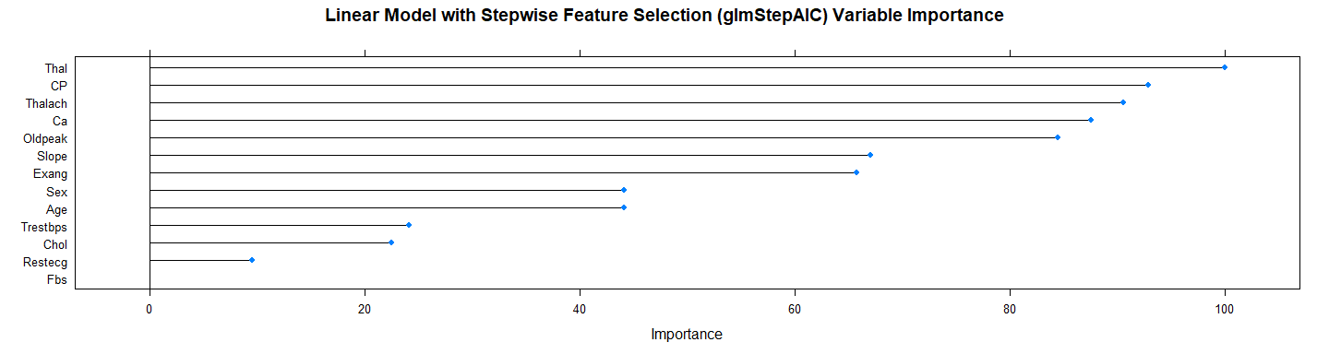

**plot**(glmStepAIC**$**finalModel,   
 main = model.name)

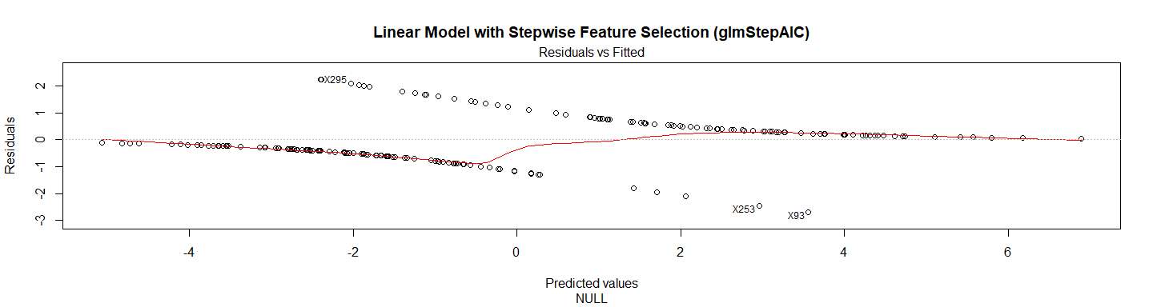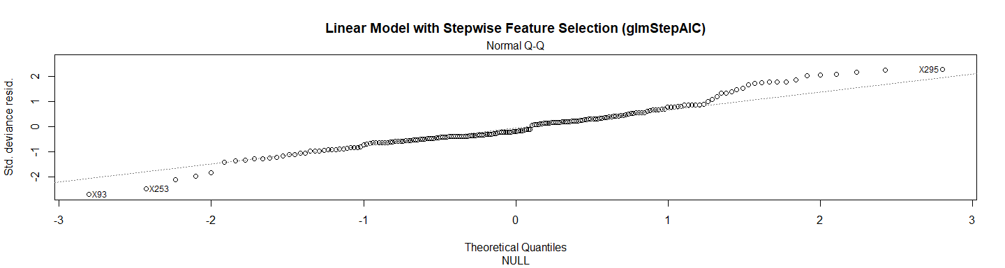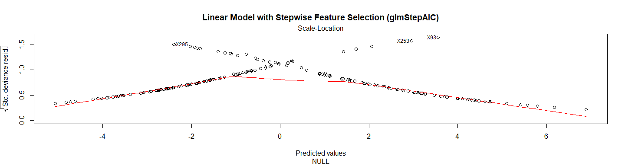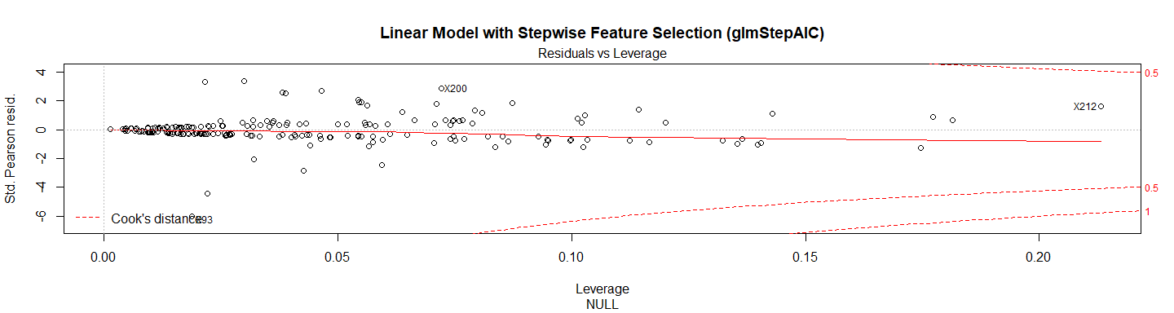

test_pred_glmStepAIC <- **predict**(glmStepAIC, newdata = X.testData)  
test_pred_glmStepAIC

## [1] 1 0 0 0 1 1 0 0 0 0 1 1 0 0 1 0 0 1 0 1 1 1 1 0 1 0 1 1 0 0 0 0 1 0 0  
## [36] 1 0 1 0 1 1 0 0 1 0 0 0 0 1 0 0 0 1 1 1 1 0 1 0 0 0 1 0 0 1 1 1 1 0 1  
## [71] 1 1 0 0 1 0 1 0 1 1 0 1 0 0 0 0 1 0 0 1 1 0 1 1 1 1 0 0 0  
## Levels: 0 1

res.glmStepAIC <- **confusionMatrix**(test_pred_glmStepAIC, Y.testData)   
res.glmStepAIC

## Confusion Matrix and Statistics  
##   
## Reference  
## Prediction 0 1  
## 0 44 9  
## 1 9 37  
##   
## Accuracy : 0.818   
## 95% CI : (0.728, 0.889)  
## No Information Rate : 0.535   
## P-Value [Acc > NIR] : 3.57e-09   
##   
## Kappa : 0.635   
## Mcnemar's Test P-Value : 1   
##   
## Sensitivity : 0.830   
## Specificity : 0.804   
## Pos Pred Value : 0.830   
## Neg Pred Value : 0.804   
## Prevalence : 0.535   
## Detection Rate : 0.444   
## Detection Prevalence : 0.535   
## Balanced Accuracy : 0.817   
##   
## 'Positive' Class : 0   
##

**print_confusionm**(res.glmStepAIC,   
 main = **paste0**("Confusion Matrix: ",model.name," (Test Set)"),   
 labels = **c**("Healthy", "Non-Healthy"))

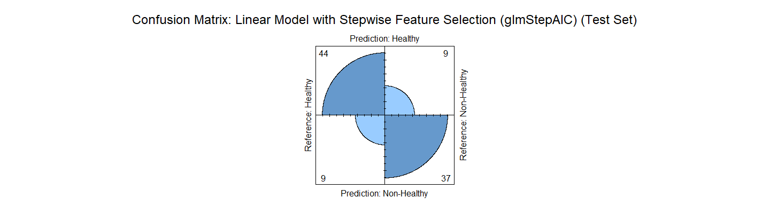

main <- **paste0**(model.name," Classification/Misclassification in Test Set by\n",  
 "Heart Disease Status: number of major vessels with >50% ",  
 "narrowing (0=Healthy,1,2,3, or 4)")  
  
**plot_results_by_type**(test_pred_glmStepAIC,  
 Y.testData,  
 main, testData)

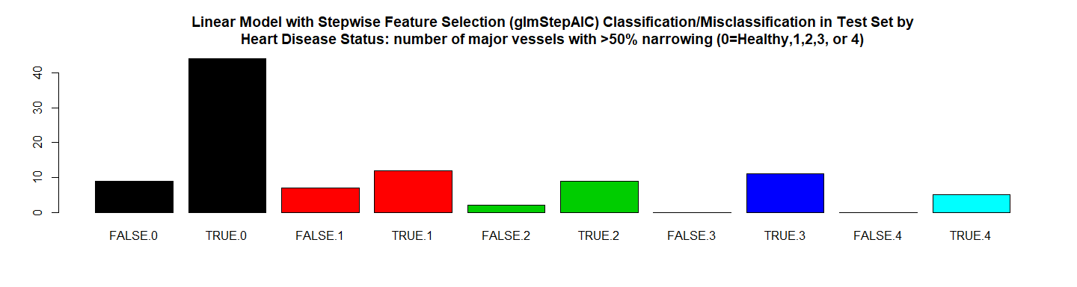

**plot_results**(X.testData, Y.testData,test_pred_glmStepAIC ,   
 **paste0**(model.name, " Classification/Missclasiffication\n"),   
 "Trestbps","Chol",labels = FALSE)

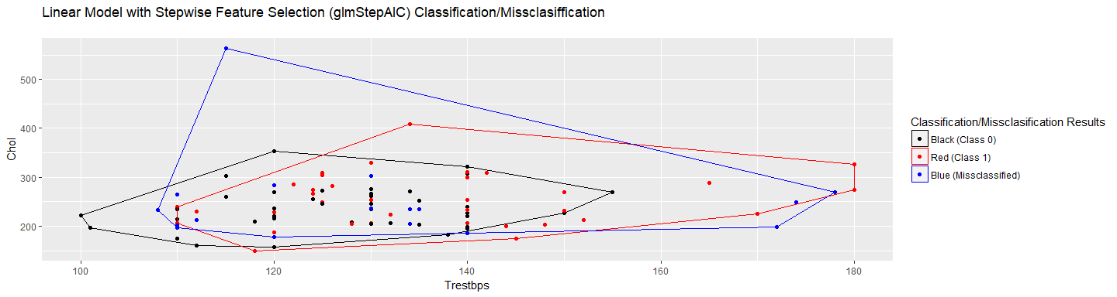

**plot_results**(X.testData, Y.testData, test_pred_glmStepAIC,   
 **paste0**(model.name," Classification/Missclasiffication\n"),  
 "Trestbps","Chol",labels = TRUE)

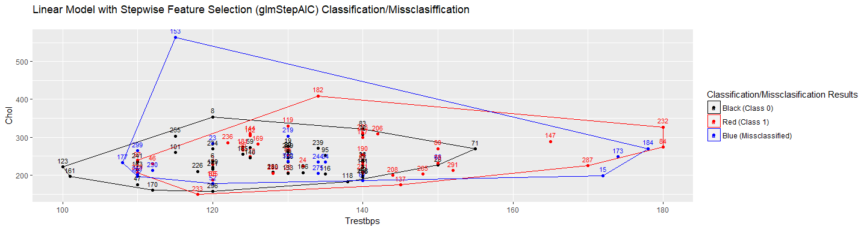

*# RMSE Resulting*  
(rmse_glmStepAIC <- **sqrt**(**mean**((**as.numeric**(test_pred_glmStepAIC)**-as.numeric**(Y.testData))**^**2)))

## [1] 0.4264

*# Residuals Plot*  
(r_glmStepAIC <- (**as.numeric**(test_pred_glmStepAIC)**-as.numeric**(Y.testData)))

## [1] 0 0 0 0 0 1 0 0 0 -1 0 0 0 0 1 0 0 0 0 1 0 0 0  
## [24] 0 0 -1 1 0 0 -1 0 0 0 0 0 0 0 0 0 0 0 0 0 0 0 0  
## [47] 0 0 0 0 0 0 0 0 1 0 0 0 0 0 0 0 0 -1 1 0 0 1 0  
## [70] 0 0 0 0 0 1 0 0 -1 0 0 0 0 0 0 -1 0 1 0 0 0 0 -1  
## [93] 0 0 0 0 0 -1 -1

**plot**(r_glmStepAIC,   
 main = **paste0**(model.name," Residuals"),xlab = "", ylab = "")

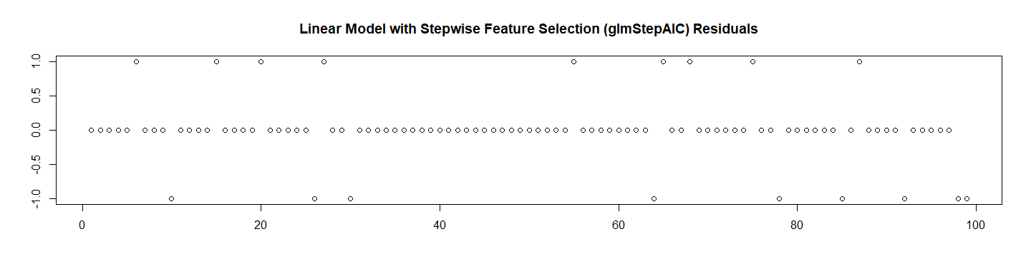

*# Let's check the probabilities and Calculate the ROC*  
test_pred_glmStepAIC_prob <- **predict**(glmStepAIC, newdata = X.testData, type ="prob")[2]  
  
res.glmStepAIC.roc <- **roc**(**as.numeric**(Y.testData),  
 **as.numeric**(  
 **as.matrix**((test_pred_glmStepAIC_prob))))**$**auc  
  
*# Store the Values for Report*  
results_all <- **rbind**(results_all,  
 **data.frame**("Method"= model.name,  
 "Prediction Accuracy in Training Set" =   
 glmStepAIC**$**results**$**Accuracy,  
 "Prediction Accuracy in Test Set" =   
 res.glmStepAIC**$**overall[1],  
 "RMSE Test"= rmse_glmStepAIC,  
 "ROC" = res.glmStepAIC.roc,  
 "Time Elapsed" = et,  
 stringsAsFactors = FALSE))

# 8. Kmeans (eclust)

## 8.1 PCA

Because the dataset don’t have many variables (only 13) let’s validate if make sense to do PCA for Kmeans:

############################################  
*# 8. Kmeans (eclust)*  
############################################  
## 8.1 PCA  
pc.train <- **prcomp**(**as.matrix**(X.trainData.std), scale = TRUE, center = TRUE)  
  
*# Eigenvalues*   
eig.val <- **get_eig**(pc.train)  
  
*# Let's see the PC*  
**kable**(eig.val)

|  |  |  |  |
| --- | --- | --- | --- |
|  | eigenvalue | variance.percent | cumulative.variance.percent |
| Dim.1 | 3.1153 | 23.964 | 23.96 |
| Dim.2 | 1.7717 | 13.629 | 37.59 |
| Dim.3 | 1.2738 | 9.798 | 47.39 |
| Dim.4 | 1.0564 | 8.126 | 55.52 |
| Dim.5 | 0.9726 | 7.482 | 63.00 |
| Dim.6 | 0.8483 | 6.525 | 69.52 |
| Dim.7 | 0.8070 | 6.208 | 75.73 |
| Dim.8 | 0.7554 | 5.810 | 81.54 |
| Dim.9 | 0.6910 | 5.316 | 86.86 |
| Dim.10 | 0.5504 | 4.234 | 91.09 |
| Dim.11 | 0.4538 | 3.491 | 94.58 |
| Dim.12 | 0.3814 | 2.933 | 97.52 |
| Dim.13 | 0.3229 | 2.484 | 100.00 |

**fviz_screeplot**(pc.train, addlabels = TRUE, ncp=13)

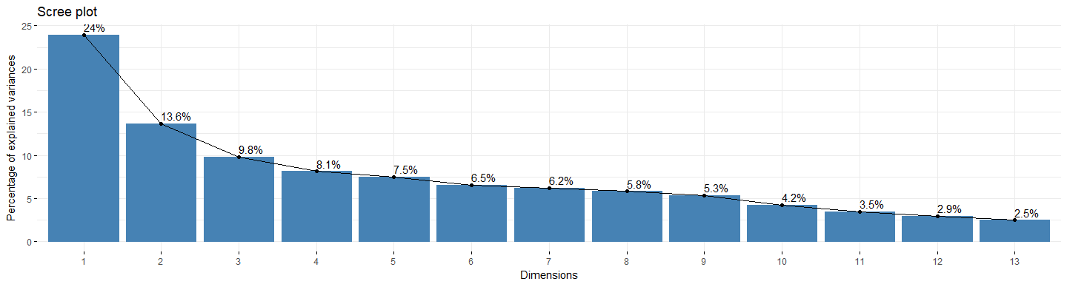

*# Extract the results for variables*  
var <- **get_pca_var**(pc.train)  
  
**print**(var)

## Principal Component Analysis Results for variables  
## ===================================================  
## Name Description   
## 1 "$coord" "Coordinates for the variables"   
## 2 "$cor" "Correlations between variables and dimensions"  
## 3 "$cos2" "Cos2 for the variables"   
## 4 "$contrib" "contributions of the variables"

*# Let see the model generated (first five dimension and 10 variables)*  
**kable**(var**$**coord)

|  |  |  |  |  |  |  |  |  |  |  |  |  |  |
| --- | --- | --- | --- | --- | --- | --- | --- | --- | --- | --- | --- | --- | --- |
|  | Dim.1 | Dim.2 | Dim.3 | Dim.4 | Dim.5 | Dim.6 | Dim.7 | Dim.8 | Dim.9 | Dim.10 | Dim.11 | Dim.12 | Dim.13 |
| Age | -0.4409 | 0.6325 | -0.1050 | 0.2379 | -0.1118 | 0.2376 | -0.1447 | 0.2133 | -0.2020 | -0.0254 | -0.0479 | -0.3927 | -0.0682 |
| Sex | -0.2522 | -0.4320 | 0.5609 | 0.3546 | 0.3395 | 0.1583 | 0.0215 | -0.0185 | -0.1595 | 0.0181 | 0.3597 | -0.0924 | 0.0678 |
| CP | -0.4974 | -0.1913 | -0.5640 | 0.0947 | 0.0137 | 0.0506 | 0.2237 | -0.0384 | 0.4171 | -0.3093 | 0.2300 | -0.1046 | 0.0347 |
| Trestbps | -0.2701 | 0.5492 | 0.3464 | -0.0745 | 0.0750 | -0.2852 | -0.0143 | 0.5297 | 0.3006 | 0.0020 | 0.1435 | 0.1328 | 0.0602 |
| Chol | -0.0430 | 0.5534 | -0.2786 | 0.0726 | 0.4079 | -0.4655 | 0.1009 | -0.2812 | -0.3321 | -0.0921 | 0.1189 | 0.0473 | 0.0395 |
| Fbs | -0.1366 | 0.3705 | 0.4597 | 0.0161 | -0.5246 | 0.0087 | 0.4990 | -0.2995 | -0.0080 | -0.1022 | 0.0641 | 0.0183 | -0.0597 |
| Restecg | -0.1608 | 0.3461 | 0.1831 | -0.4790 | 0.5438 | 0.4658 | 0.1455 | -0.1470 | 0.1277 | -0.0713 | -0.1157 | 0.0087 | -0.0334 |
| Thalach | 0.6798 | 0.0305 | 0.2720 | -0.0230 | 0.1160 | -0.3255 | -0.0881 | -0.2364 | 0.3678 | 0.0579 | -0.0590 | -0.3689 | 0.0357 |
| Exang | -0.5834 | -0.2921 | -0.1220 | -0.1168 | 0.1247 | -0.1928 | 0.5047 | 0.1541 | -0.0464 | 0.4208 | -0.1254 | -0.1400 | -0.0084 |
| Oldpeak | -0.7385 | -0.1044 | 0.0689 | -0.2714 | -0.0513 | -0.1795 | -0.3361 | -0.1972 | 0.0629 | 0.0974 | 0.1534 | 0.0010 | -0.3762 |
| Slope | -0.6591 | -0.1411 | 0.1019 | -0.5060 | -0.2162 | -0.0994 | -0.2119 | -0.0973 | -0.1453 | -0.0921 | 0.0058 | -0.0988 | 0.3591 |
| Ca | -0.5668 | 0.3080 | -0.0488 | 0.4279 | -0.0095 | 0.1319 | -0.1857 | -0.3301 | 0.2666 | 0.3323 | -0.0843 | 0.1447 | 0.1672 |
| Thal | -0.6222 | -0.2675 | 0.2850 | 0.3123 | 0.1528 | -0.2159 | -0.0099 | 0.0154 | 0.0172 | -0.3478 | -0.4088 | 0.0319 | -0.0532 |

*# Let see the contribution of each variable to each PC*  
**kable**(var**$**contrib)

|  |  |  |  |  |  |  |  |  |  |  |  |  |  |
| --- | --- | --- | --- | --- | --- | --- | --- | --- | --- | --- | --- | --- | --- |
|  | Dim.1 | Dim.2 | Dim.3 | Dim.4 | Dim.5 | Dim.6 | Dim.7 | Dim.8 | Dim.9 | Dim.10 | Dim.11 | Dim.12 | Dim.13 |
| Age | 6.2389 | 22.5788 | 0.8662 | 5.3594 | 1.2844 | 6.6542 | 2.5938 | 6.0213 | 5.9060 | 0.1172 | 0.5056 | 40.4320 | 1.4421 |
| Sex | 2.0417 | 10.5325 | 24.7012 | 11.9018 | 11.8519 | 2.9527 | 0.0570 | 0.0451 | 3.6800 | 0.0598 | 28.5105 | 2.2407 | 1.4250 |
| CP | 7.9422 | 2.0658 | 24.9694 | 0.8497 | 0.0193 | 0.3024 | 6.2006 | 0.1949 | 25.1741 | 17.3819 | 11.6590 | 2.8671 | 0.3737 |
| Trestbps | 2.3413 | 17.0249 | 9.4184 | 0.5258 | 0.5784 | 9.5861 | 0.0254 | 37.1428 | 13.0740 | 0.0008 | 4.5351 | 4.6231 | 1.1240 |
| Chol | 0.0593 | 17.2864 | 6.0925 | 0.4983 | 17.1058 | 25.5424 | 1.2624 | 10.4658 | 15.9627 | 1.5403 | 3.1149 | 0.5864 | 0.4827 |
| Fbs | 0.5988 | 7.7467 | 16.5937 | 0.0244 | 28.2902 | 0.0089 | 30.8579 | 11.8731 | 0.0092 | 1.8966 | 0.9067 | 0.0883 | 1.1054 |
| Restecg | 0.8301 | 6.7619 | 2.6325 | 21.7173 | 30.4014 | 25.5740 | 2.6246 | 2.8600 | 2.3581 | 0.9225 | 2.9520 | 0.0198 | 0.3457 |
| Thalach | 14.8335 | 0.0523 | 5.8074 | 0.0499 | 1.3834 | 12.4875 | 0.9625 | 7.3959 | 19.5709 | 0.6083 | 0.7675 | 35.6856 | 0.3952 |
| Exang | 10.9238 | 4.8161 | 1.1694 | 1.2921 | 1.5986 | 4.3822 | 31.5694 | 3.1424 | 0.3115 | 32.1672 | 3.4677 | 5.1374 | 0.0221 |
| Oldpeak | 17.5084 | 0.6152 | 0.3727 | 6.9730 | 0.2711 | 3.7983 | 14.0005 | 5.1493 | 0.5729 | 1.7252 | 5.1884 | 0.0003 | 43.8249 |
| Slope | 13.9426 | 1.1240 | 0.8146 | 24.2395 | 4.8048 | 1.1653 | 5.5613 | 1.2522 | 3.0541 | 1.5427 | 0.0075 | 2.5606 | 39.9307 |
| Ca | 10.3116 | 5.3551 | 0.1872 | 17.3336 | 0.0092 | 2.0505 | 4.2723 | 14.4257 | 10.2834 | 20.0610 | 1.5665 | 5.4912 | 8.6526 |
| Thal | 12.4278 | 4.0402 | 6.3747 | 9.2350 | 2.4016 | 5.4954 | 0.0122 | 0.0315 | 0.0430 | 21.9764 | 36.8186 | 0.2676 | 0.8760 |

*# Contributions of variables to PC1*  
**fviz_contrib**(pc.train, choice = "var", axes = 1, top = 13)

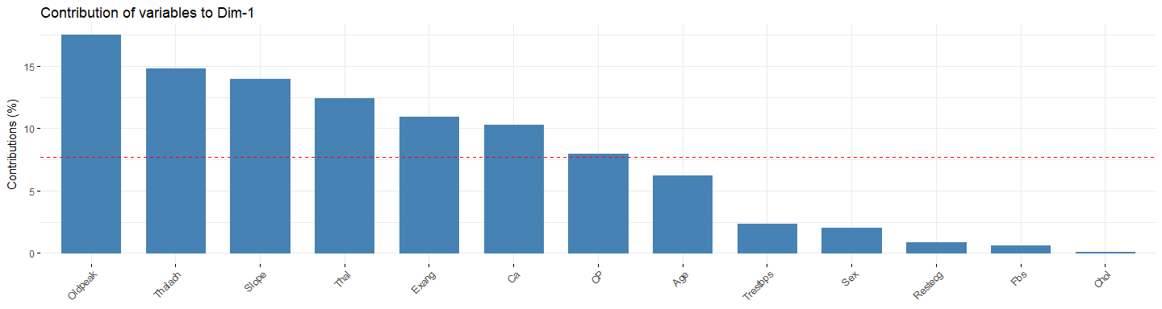

*# Contributions of variables to PC2*  
**fviz_contrib**(pc.train, choice = "var", axes = 2, top = 13)

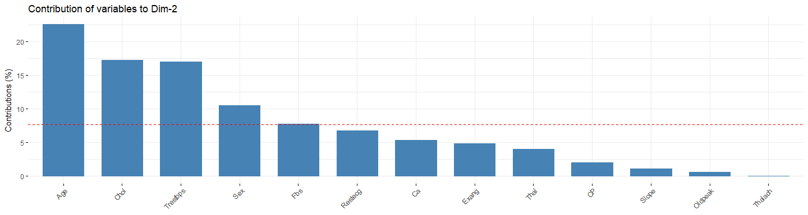

*# Contributions of variables to PC3*  
**fviz_contrib**(pc.train, choice = "var", axes = 3, top = 13)

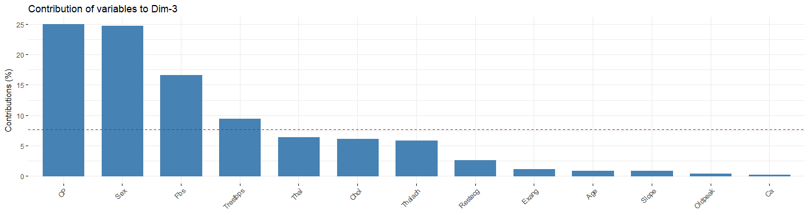

*# Extract the results for individuals*  
ind <- **get_pca_ind**(pc.train)  
  
*# Let's use the first 8 variables for the model*  
xx.pc.train <- **as.matrix**(ind**$**coord[,1**:**8])

Now let’s do clustering with K-means

min_k <- 2  
max_k <- 4  
min_seed <- 1  
max_seed <- 100  
method <- "euclidean"  
type_data <- " PCA"  
  
*# Find Best Seed and K Using the PCA Data on training*   
file.name <- **paste**(work.dir, "best_seeds_std_pca.Rds", sep="/")  
file.name.et <- **paste**(work.dir, "best_seeds_std_pca-et.Rds", sep="/")  
  
**if** (**file.exists**(file.name)) {  
 **load**(file.name,.GlobalEnv)  
 **load**(file.name.et,.GlobalEnv)  
} **else** {  
   
 t1 <- **proc.time**()  
  
 best_seeds_std_pca <- **find_best_seedv2**(xx.pc.train,  
 method,  
 min_seed,  
 max_seed,  
 min_k,  
 max_k,  
 Y.trainData)  
 t2 <- **proc.time**()  
 et <- **elapsed_time**(t1,t2)  
 **print**(**paste0**("Best Seed for Kmeans PCA Finded ... time:",et))  
 **save**(best_seeds_std_pca, file = file.name)  
 **save**(et, file = file.name.et)  
}

## [1] "Results for k=2 PCA"  
## [1] "======================="  
## [1] "Best Seed find: k=2 seed=1 errors=91 sum(whithinss)=1625.42940877136"  
## [1] ""  
## [1] "Results for k=3 PCA"  
## [1] "======================="  
## [1] "Best Seed find: k=3 seed=1 errors=140 sum(whithinss)=1455.45826953285"  
## [1] "Best Seed find: k=3 seed=3 errors=138 sum(whithinss)=1457.43620803959"  
## [1] "Best Seed find: k=3 seed=5 errors=128 sum(whithinss)=1461.48346218718"  
## [1] ""  
## [1] "Results for k=4 PCA"  
## [1] "======================="  
## [1] "Best Seed find: k=4 seed=1 errors=147 sum(whithinss)=1312.9987279498"  
## [1] "Best Seed find: k=4 seed=26 errors=132 sum(whithinss)=1338.25742471506"  
## [1] ""  
## [1] ""  
## [1] "Final Results"  
## [1] "=============="  
## [1] "Best Seed find: k=2 seed=1 errors=91 sum(whithinss)=1625.42940877136"  
## [1] "Best Seed for Kmeans PCA Finded ... time:5.8"

(k <- best_seeds_std_pca**$**best_k)

## [1] 2

(best_seed <- best_seeds_std_pca**$**best_seed)

## [1] 1

res.train.kmeans_pca <- **confusionMatrix**(best_seeds_std_pca**$**best_km**$**cluster,   
 Y.trainData)  
res.train.kmeans_pca

## Confusion Matrix and Statistics  
##   
## Reference  
## Prediction 0 1  
## 0 99 25  
## 1 8 66  
##   
## Accuracy : 0.833   
## 95% CI : (0.774, 0.882)  
## No Information Rate : 0.54   
## P-Value [Acc > NIR] : < 2e-16   
##   
## Kappa : 0.66   
## Mcnemar's Test P-Value : 0.00535   
##   
## Sensitivity : 0.925   
## Specificity : 0.725   
## Pos Pred Value : 0.798   
## Neg Pred Value : 0.892   
## Prevalence : 0.540   
## Detection Rate : 0.500   
## Detection Prevalence : 0.626   
## Balanced Accuracy : 0.825   
##   
## 'Positive' Class : 0   
##

Let’s do PCA on the test set and create the cluster with the k and best_seed:

pc.test <- **prcomp**(**as.matrix**(X.testData.std), scale = TRUE, center = TRUE)  
  
*# Eigenvalues*   
  
eig.val <- **get_eig**(pc.test)  
  
*# Let's see the PC*  
**kable**(eig.val)

|  |  |  |  |
| --- | --- | --- | --- |
|  | eigenvalue | variance.percent | cumulative.variance.percent |
| Dim.1 | 3.0958 | 23.814 | 23.81 |
| Dim.2 | 1.6122 | 12.402 | 36.22 |
| Dim.3 | 1.2515 | 9.627 | 45.84 |
| Dim.4 | 1.1936 | 9.182 | 55.02 |
| Dim.5 | 1.0383 | 7.987 | 63.01 |
| Dim.6 | 0.9871 | 7.593 | 70.60 |
| Dim.7 | 0.7340 | 5.646 | 76.25 |
| Dim.8 | 0.6911 | 5.316 | 81.57 |
| Dim.9 | 0.6449 | 4.961 | 86.53 |
| Dim.10 | 0.5447 | 4.190 | 90.72 |
| Dim.11 | 0.4523 | 3.479 | 94.20 |
| Dim.12 | 0.4070 | 3.130 | 97.33 |
| Dim.13 | 0.3475 | 2.673 | 100.00 |

**fviz_screeplot**(pc.test, addlabels = TRUE, ncp=13)

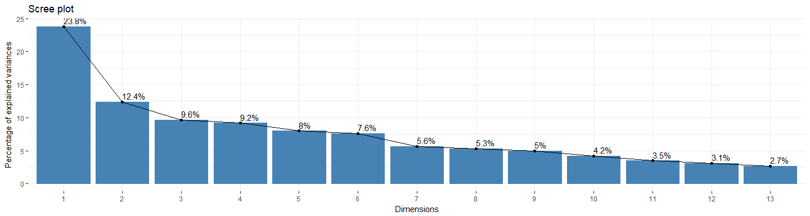

*# Extract the results for variables*  
var <- **get_pca_var**(pc.test)  
  
**print**(var)

## Principal Component Analysis Results for variables  
## ===================================================  
## Name Description   
## 1 "$coord" "Coordinates for the variables"   
## 2 "$cor" "Correlations between variables and dimensions"  
## 3 "$cos2" "Cos2 for the variables"   
## 4 "$contrib" "contributions of the variables"

*# Let see the model generated (first five dimension and 10 variables)*  
**kable**(var**$**coord)

|  |  |  |  |  |  |  |  |  |  |  |  |  |  |
| --- | --- | --- | --- | --- | --- | --- | --- | --- | --- | --- | --- | --- | --- |
|  | Dim.1 | Dim.2 | Dim.3 | Dim.4 | Dim.5 | Dim.6 | Dim.7 | Dim.8 | Dim.9 | Dim.10 | Dim.11 | Dim.12 | Dim.13 |
| Age | -0.5869 | 0.2269 | -0.0365 | 0.1200 | -0.4239 | 0.1927 | -0.0062 | -0.2683 | 0.4604 | 0.1575 | 0.1856 | -0.0848 | -0.1453 |
| Sex | -0.1198 | -0.6788 | 0.4605 | 0.0055 | 0.1767 | -0.2421 | -0.0006 | -0.1202 | 0.2742 | -0.1062 | 0.1887 | 0.2883 | 0.0575 |
| CP | -0.5210 | -0.4129 | -0.3372 | -0.2575 | 0.1561 | 0.1755 | 0.1244 | 0.1000 | -0.2765 | 0.3159 | 0.3474 | 0.0043 | -0.0217 |
| Trestbps | -0.3171 | 0.3480 | 0.1073 | 0.5072 | 0.3614 | 0.4352 | 0.1328 | -0.2685 | -0.1584 | 0.0555 | -0.0523 | 0.2553 | 0.0618 |
| Chol | -0.3243 | 0.1973 | -0.6482 | 0.1198 | 0.2716 | -0.1660 | -0.4542 | 0.1507 | 0.2241 | -0.0617 | 0.0372 | 0.1486 | 0.1164 |
| Fbs | -0.0955 | -0.3561 | 0.0600 | 0.7299 | -0.1208 | 0.1730 | 0.0677 | 0.5076 | 0.0613 | -0.0583 | 0.0372 | -0.1082 | -0.0243 |
| Restecg | -0.4297 | -0.0763 | -0.3599 | 0.2365 | 0.0830 | -0.5343 | 0.5194 | -0.1588 | 0.0545 | 0.0116 | -0.1266 | -0.1016 | 0.0851 |
| Thalach | 0.6918 | -0.1116 | -0.1824 | 0.3027 | 0.3369 | -0.1641 | -0.1013 | -0.2201 | -0.0506 | -0.0231 | 0.1295 | -0.0872 | -0.3967 |
| Exang | -0.6090 | -0.2413 | -0.2197 | -0.3055 | 0.1131 | 0.3412 | 0.1405 | 0.0190 | 0.0566 | -0.4549 | -0.1550 | 0.0170 | -0.2133 |
| Oldpeak | -0.6112 | 0.3781 | 0.3183 | 0.0715 | 0.1174 | -0.1963 | -0.1145 | -0.0462 | -0.2166 | -0.3211 | 0.3109 | -0.2402 | 0.0713 |
| Slope | -0.5337 | 0.4541 | 0.3153 | -0.1174 | 0.1212 | -0.3163 | 0.0717 | 0.3505 | 0.0047 | 0.1781 | -0.0778 | 0.1839 | -0.2852 |
| Ca | -0.4610 | -0.2838 | -0.0921 | 0.2204 | -0.5519 | -0.2124 | -0.2706 | -0.1743 | -0.3804 | -0.0361 | -0.1111 | 0.1733 | -0.0898 |
| Thal | -0.5879 | -0.3693 | 0.2624 | 0.0084 | 0.3431 | 0.0319 | -0.3143 | -0.1131 | 0.0426 | 0.2342 | -0.2901 | -0.2792 | 0.0061 |

*# Let see the contribution of each variable to each PC*  
**kable**(var**$**contrib)

|  |  |  |  |  |  |  |  |  |  |  |  |  |  |
| --- | --- | --- | --- | --- | --- | --- | --- | --- | --- | --- | --- | --- | --- |
|  | Dim.1 | Dim.2 | Dim.3 | Dim.4 | Dim.5 | Dim.6 | Dim.7 | Dim.8 | Dim.9 | Dim.10 | Dim.11 | Dim.12 | Dim.13 |
| Age | 11.1255 | 3.1925 | 0.1067 | 1.2074 | 17.3048 | 3.7615 | 0.0052 | 10.4188 | 32.8661 | 4.5535 | 7.6188 | 1.7650 | 6.0743 |
| Sex | 0.4638 | 28.5818 | 16.9435 | 0.0025 | 3.0072 | 5.9379 | 0.0000 | 2.0902 | 11.6619 | 2.0707 | 7.8699 | 20.4189 | 0.9515 |
| CP | 8.7689 | 10.5740 | 9.0850 | 5.5572 | 2.3457 | 3.1211 | 2.1073 | 1.4481 | 11.8518 | 18.3152 | 26.6858 | 0.0045 | 0.1354 |
| Trestbps | 3.2484 | 7.5096 | 0.9199 | 21.5501 | 12.5806 | 19.1887 | 2.4040 | 10.4290 | 3.8900 | 0.5647 | 0.6049 | 16.0124 | 1.0978 |
| Chol | 3.3962 | 2.4154 | 33.5721 | 1.2015 | 7.1063 | 2.7918 | 28.1036 | 3.2881 | 7.7905 | 0.6998 | 0.3060 | 5.4272 | 3.9015 |
| Fbs | 0.2945 | 7.8640 | 0.2876 | 44.6390 | 1.4064 | 3.0329 | 0.6250 | 37.2891 | 0.5835 | 0.6236 | 0.3058 | 2.8785 | 0.1702 |
| Restecg | 5.9643 | 0.3607 | 10.3522 | 4.6851 | 0.6632 | 28.9266 | 36.7502 | 3.6491 | 0.4604 | 0.0248 | 3.5456 | 2.5354 | 2.0825 |
| Thalach | 15.4603 | 0.7725 | 2.6580 | 7.6783 | 10.9325 | 2.7283 | 1.3968 | 7.0077 | 0.3972 | 0.0982 | 3.7072 | 1.8698 | 45.2933 |
| Exang | 11.9796 | 3.6130 | 3.8558 | 7.8192 | 1.2311 | 11.7969 | 2.6906 | 0.0521 | 0.4975 | 37.9921 | 5.3117 | 0.0713 | 13.0890 |
| Oldpeak | 12.0675 | 8.8681 | 8.0938 | 0.4288 | 1.3273 | 3.9030 | 1.7863 | 0.3087 | 7.2748 | 18.9305 | 21.3757 | 14.1742 | 1.4615 |
| Slope | 9.2020 | 12.7917 | 7.9458 | 1.1556 | 1.4151 | 10.1363 | 0.6997 | 17.7718 | 0.0034 | 5.8221 | 1.3383 | 8.3076 | 23.4108 |
| Ca | 6.8661 | 4.9975 | 0.6776 | 4.0694 | 29.3396 | 4.5718 | 9.9748 | 4.3979 | 22.4415 | 0.2396 | 2.7268 | 7.3761 | 2.3215 |
| Thal | 11.1628 | 8.4593 | 5.5021 | 0.0059 | 11.3403 | 0.1033 | 13.4564 | 1.8496 | 0.2816 | 10.0652 | 18.6036 | 19.1592 | 0.0108 |

*# Contributions of variables to PC1*  
**fviz_contrib**(pc.test, choice = "var", axes = 1, top = 13)

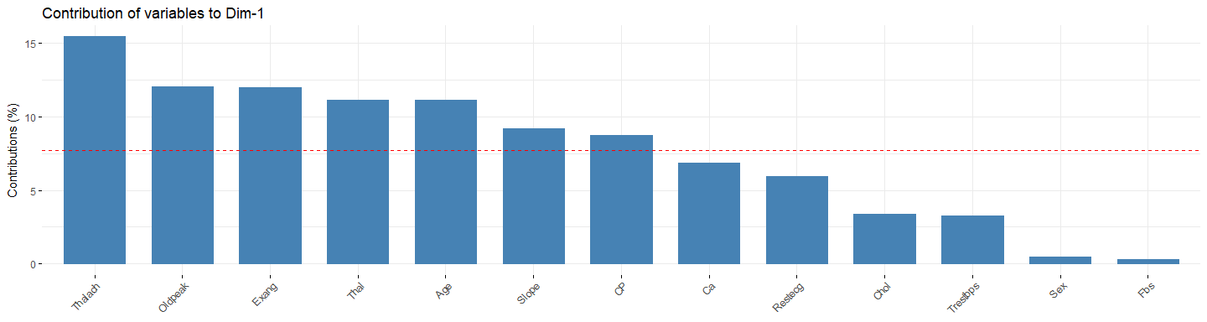

*# Contributions of variables to PC2*  
**fviz_contrib**(pc.test, choice = "var", axes = 2, top = 13)

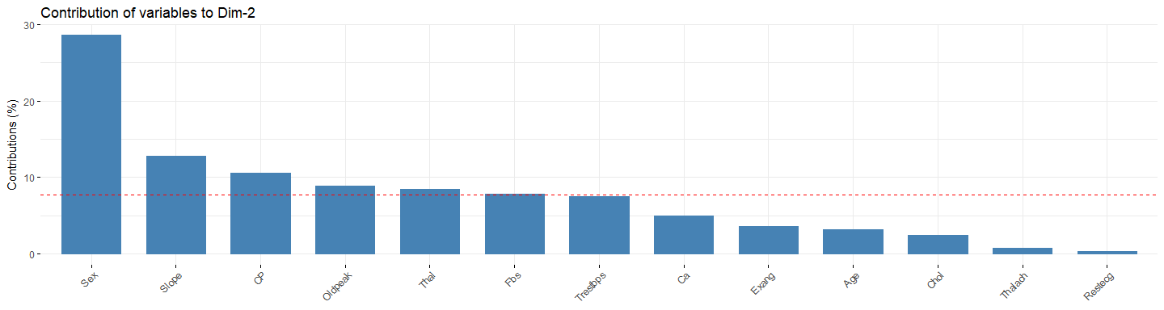

*# Contributions of variables to PC3*  
**fviz_contrib**(pc.test, choice = "var", axes = 3, top = 13)

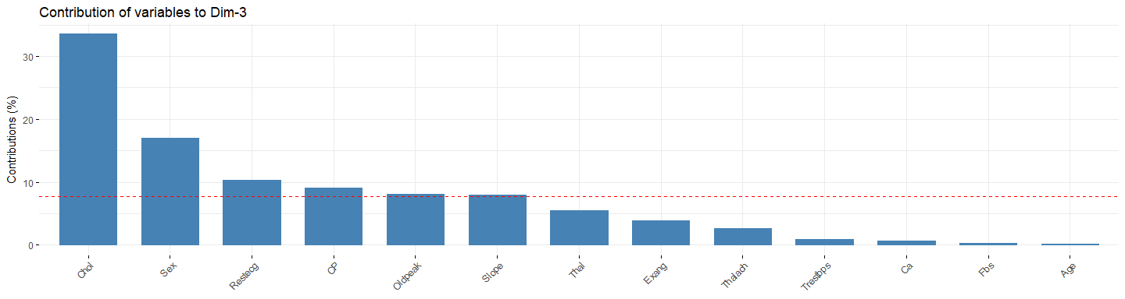

*# Extract the results for individuals*  
ind <- **get_pca_ind**(pc.test)  
  
*# Let's use the first 8 variables for the model*  
xx.pc.test <- **as.matrix**(ind**$**coord[,1**:**8])

Let’s check the K-means output

model.name <- "Kmeans PCA (8)"  
model.name6 <- model.name  
xx.km <- **eclust**(xx.pc.test,k=k,hc_method=method, nstart=10, graph = FALSE, seed = best_seed)  
kmeans_class_pca <- **correct_kmeans_ids**(Y.testData,xx.km**$**cluster)  
kmeans_class_pca <- **factor**(kmeans_class_pca)  
  
  
res.kmeans_pca <- **confusionMatrix**(kmeans_class_pca, Y.testData)  
res.kmeans_pca

## Confusion Matrix and Statistics  
##   
## Reference  
## Prediction 0 1  
## 0 45 12  
## 1 8 34  
##   
## Accuracy : 0.798   
## 95% CI : (0.705, 0.872)  
## No Information Rate : 0.535   
## P-Value [Acc > NIR] : 4.8e-08   
##   
## Kappa : 0.592   
## Mcnemar's Test P-Value : 0.502   
##   
## Sensitivity : 0.849   
## Specificity : 0.739   
## Pos Pred Value : 0.789   
## Neg Pred Value : 0.810   
## Prevalence : 0.535   
## Detection Rate : 0.455   
## Detection Prevalence : 0.576   
## Balanced Accuracy : 0.794   
##   
## 'Positive' Class : 0   
##

**print_confusionm**(res.kmeans_pca,   
 main = **paste0**("Confusion Matrix: ",model.name," (Test Set)"),   
 labels = **c**("Healthy", "Non-Healthy"))



main <- **paste0**(model.name," Classification/Misclassification in Test Set by\n",  
 "Heart Disease Status: number of major vessels with >50% narrowing ",  
 "(0=Healthy,1,2,3, or 4)")  
  
**plot_results_by_type**(kmeans_class_pca,  
 Y.testData,  
 main, testData)

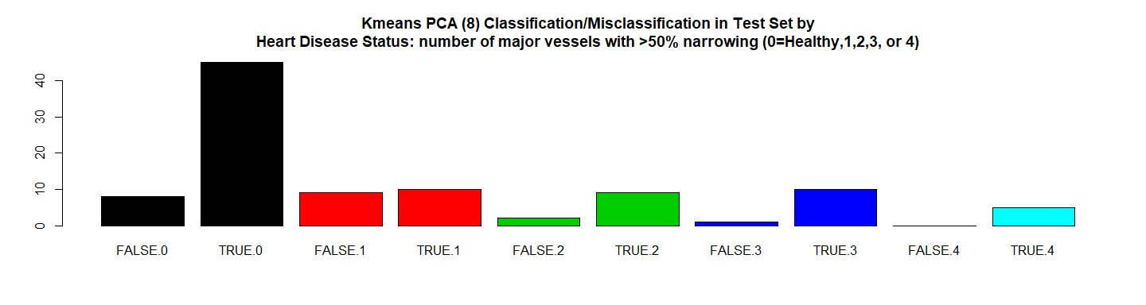

*# RMSE*  
(rmse_kmeans_pca <- **sqrt**(**mean**((**as.numeric**(kmeans_class_pca)**-as.numeric**(Y.testData))**^**2)))

## [1] 0.4495

*# Residuals Plot*  
(r_kmeans_pca <- (**as.numeric**(kmeans_class_pca)**-as.numeric**(Y.testData)))

## [1] 0 0 0 0 0 0 0 0 0 -1 0 0 1 0 0 0 0 0 0 0 0 0 -1  
## [24] 1 0 0 0 -1 0 -1 0 0 0 0 0 0 0 0 0 0 0 0 0 0 0 0  
## [47] 0 0 0 0 0 0 0 0 1 0 0 0 0 0 0 -1 0 0 0 -1 0 1 0  
## [70] 0 0 0 0 0 1 0 0 0 0 -1 1 0 0 0 -1 0 1 0 1 0 0 -1  
## [93] 0 -1 0 0 0 -1 -1

**plot**(r_kmeans_pca,   
 main = **paste0**(model.name," Residuals"),xlab = "", ylab = "")

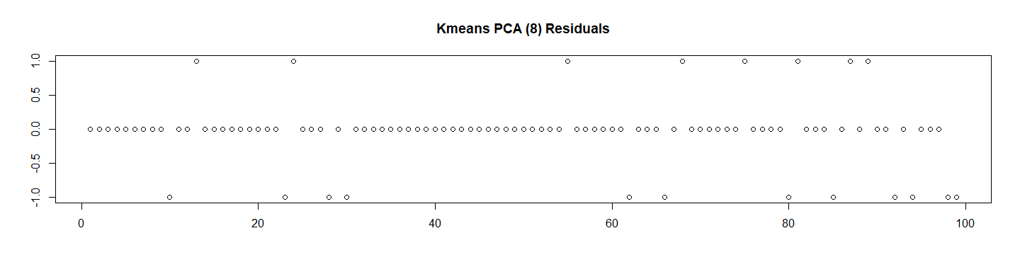

*# Let's Calculate the ROC*  
res.kmeans_pca.roc <- **roc**(**as.numeric**(Y.testData),  
 **as.numeric**(  
 **as.matrix**(kmeans_class_pca)))**$**auc  
  
  
*# Store the Values for Report*  
results_all <- **rbind**(results_all,  
 **data.frame**("Method"= model.name,  
 "Prediction Accuracy in Training Set" =   
 res.train.kmeans_pca**$**overall[1] ,  
 "Prediction Accuracy in Test Set" =   
 res.kmeans_pca**$**overall[1],  
 "RMSE Test"= rmse_kmeans_pca,  
 "ROC" = res.kmeans_pca.roc,  
 "Time Elapsed" = et,  
 stringsAsFactors = FALSE))

**fviz_cluster**(xx.km)

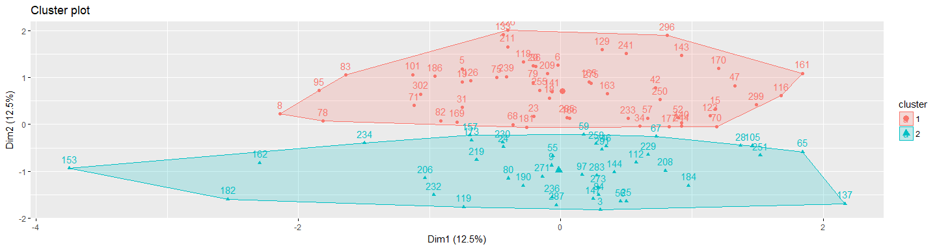

**plot_results**(xx.pc.test, Y.testData, kmeans_class_pca,   
 **paste0**("Kmeans Clustering Classification/Missclasiffication (PCA)\n"),  
 "Dim.1","Dim.2", labels = TRUE)

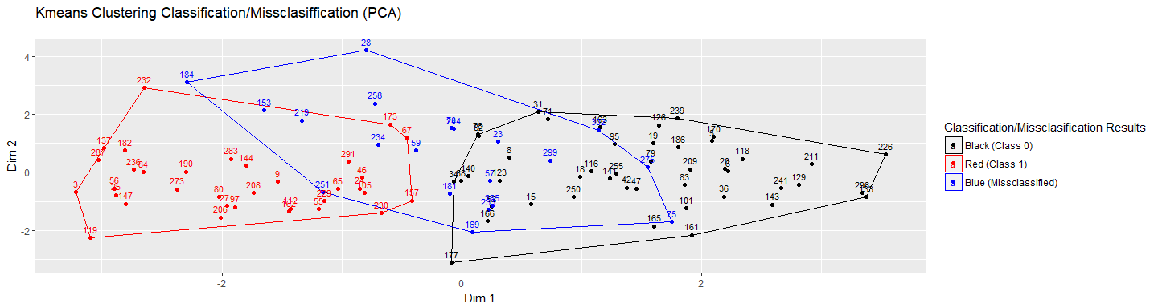

**plot_results**(xx.pc.test, Y.testData, kmeans_class_pca,   
 **paste0**("Kmeans Clustering Classification/Missclasiffication (PCA)\n"),  
 "Dim.1","Dim.2", labels = FALSE)

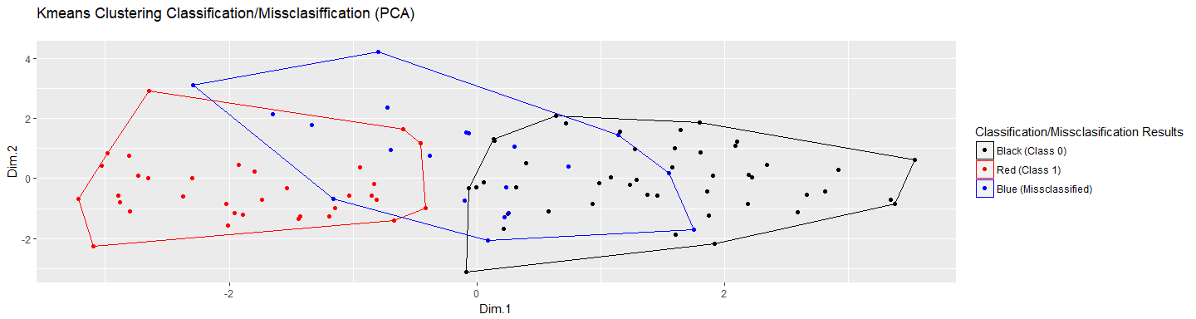

## 8.2 All Data Whithout PCA

############################################  
## 8.2 All Data Whithout PCA  
model.name <- "Kmeans (13)"  
model.name7 <- model.name  
min_k <- 2  
max_k <- 4  
min_seed <- 1  
max_seed <- 100  
method <- "euclidean"  
  
*# Find Best Seed and K and Kmeans for the all Std Data*  
file.name <- **paste**(work.dir, "best_seeds_std_m.Rds", sep="/")  
file.name.et <- **paste**(work.dir, "best_seeds_std_m-et.Rds", sep="/")  
  
**if** (**file.exists**(file.name)) {  
 **load**(file.name,.GlobalEnv)   
 **load**(file.name.et,.GlobalEnv)  
} **else** {  
 t1 <- **proc.time**()  
 best_seeds_std_m <- **find_best_seedv2**(X.trainData.std,  
 method,  
 min_seed,  
 max_seed,  
 min_k,  
 max_k,  
 Y.trainData)  
 t2 <- **proc.time**()  
 et <- **elapsed_time**(t1,t2)  
 **print**(**paste0**("Best Seed for Kmeans Finded ... time:", et))  
 **save**(best_seeds_std_m, file = file.name)  
 **save**(et, file = file.name.et)  
}

## [1] "Results for k=2 PCA"  
## [1] "======================="  
## [1] "Best Seed find: k=2 seed=1 errors=91 sum(whithinss)=2097.7357405401"  
## [1] ""  
## [1] "Results for k=3 PCA"  
## [1] "======================="  
## [1] "Best Seed find: k=3 seed=1 errors=139 sum(whithinss)=1920.4509302518"  
## [1] "Best Seed find: k=3 seed=2 errors=129 sum(whithinss)=1930.44287212597"  
## [1] "Best Seed find: k=3 seed=27 errors=127 sum(whithinss)=1930.80688693482"  
## [1] ""  
## [1] "Results for k=4 PCA"  
## [1] "======================="  
## [1] "Best Seed find: k=4 seed=1 errors=150 sum(whithinss)=1788.77207944515"  
## [1] "Best Seed find: k=4 seed=2 errors=147 sum(whithinss)=1778.61798103626"  
## [1] "Best Seed find: k=4 seed=12 errors=145 sum(whithinss)=1793.30071387004"  
## [1] "Best Seed find: k=4 seed=26 errors=143 sum(whithinss)=1796.41444368493"  
## [1] "Best Seed find: k=4 seed=61 errors=141 sum(whithinss)=1789.63176228369"  
## [1] ""  
## [1] ""  
## [1] "Final Results"  
## [1] "=============="  
## [1] "Best Seed find: k=2 seed=1 errors=91 sum(whithinss)=2097.7357405401"  
## [1] "Best Seed for Kmeans Finded ... time:4.5"

(k <- best_seeds_std_m**$**best_k)

## [1] 2

(best_seed <- best_seeds_std_m**$**best_seed)

## [1] 1

res.train.kmeans <- **confusionMatrix**(best_seeds_std_m**$**best_km**$**cluster, Y.trainData)  
res.train.kmeans

## Confusion Matrix and Statistics  
##   
## Reference  
## Prediction 0 1  
## 0 99 25  
## 1 8 66  
##   
## Accuracy : 0.833   
## 95% CI : (0.774, 0.882)  
## No Information Rate : 0.54   
## P-Value [Acc > NIR] : < 2e-16   
##   
## Kappa : 0.66   
## Mcnemar's Test P-Value : 0.00535   
##   
## Sensitivity : 0.925   
## Specificity : 0.725   
## Pos Pred Value : 0.798   
## Neg Pred Value : 0.892   
## Prevalence : 0.540   
## Detection Rate : 0.500   
## Detection Prevalence : 0.626   
## Balanced Accuracy : 0.825   
##   
## 'Positive' Class : 0   
##

*# Use the k and best seeds in the test set*  
  
xx.km2 <- **eclust**(X.testData.std,k=k,hc_method=method, nstart=10,   
 graph = FALSE, seed = best_seed)  
  
kmeans_class <- **correct_kmeans_ids**(Y.testData,xx.km2**$**cluster)  
kmeans_class <- **factor**(kmeans_class)  
  
res.kmeans <- **confusionMatrix**(kmeans_class, Y.testData)  
res.kmeans

## Confusion Matrix and Statistics  
##   
## Reference  
## Prediction 0 1  
## 0 45 10  
## 1 8 36  
##   
## Accuracy : 0.818   
## 95% CI : (0.728, 0.889)  
## No Information Rate : 0.535   
## P-Value [Acc > NIR] : 3.57e-09   
##   
## Kappa : 0.633   
## Mcnemar's Test P-Value : 0.814   
##   
## Sensitivity : 0.849   
## Specificity : 0.783   
## Pos Pred Value : 0.818   
## Neg Pred Value : 0.818   
## Prevalence : 0.535   
## Detection Rate : 0.455   
## Detection Prevalence : 0.556   
## Balanced Accuracy : 0.816   
##   
## 'Positive' Class : 0   
##

main <- **paste0**(model.name," Classification/Misclassification in Test Set by\n",  
 "Heart Disease Status: number of major vessels with >50% narrowing ",  
 "(0=Healthy,1,2,3, or 4)")  
  
**plot_results_by_type**(kmeans_class,  
 Y.testData,  
 main, testData)

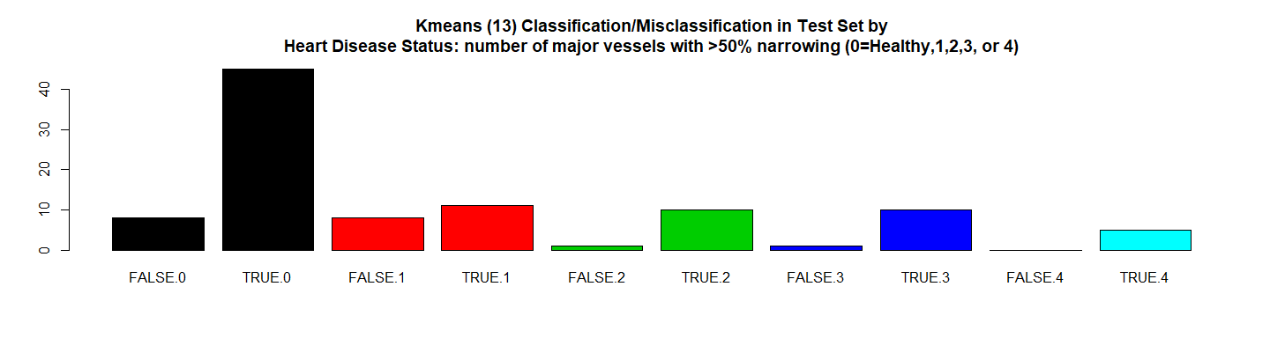

*# RMSE*  
(rmse_kmeans <- **sqrt**(**mean**((**as.numeric**(kmeans_class)**-as.numeric**(Y.testData))**^**2)))

## [1] 0.4264

*# Residuals Plot*  
(r_kmeans <- (**as.numeric**(kmeans_class)**-as.numeric**(Y.testData)))

## [1] 0 0 0 0 0 0 0 0 0 -1 0 0 1 0 0 0 0 0 0 0 0 0 -1  
## [24] 1 0 0 0 0 0 -1 0 0 0 0 0 0 0 0 0 0 0 0 0 0 0 0  
## [47] 0 0 0 0 0 0 0 0 1 0 0 0 0 0 0 -1 0 0 0 -1 0 1 0  
## [70] 0 0 0 0 0 1 0 0 0 0 -1 1 0 0 0 0 0 1 0 1 0 0 -1  
## [93] 0 -1 0 0 0 -1 -1

**plot**(r_kmeans, main = **paste0**(model.name," Residuals"),xlab = "", ylab = "")

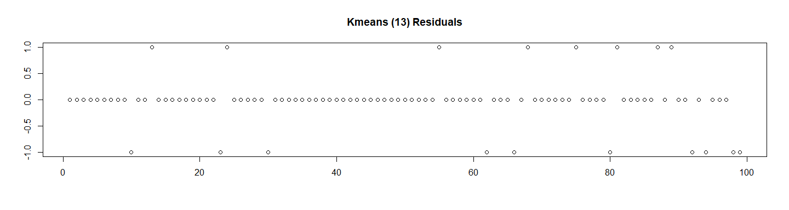

*# Let's Calculate the ROC*  
res.kmeans.roc <- **roc**(**as.numeric**(Y.testData),  
 **as.numeric**(  
 **as.matrix**(kmeans_class)))**$**auc  
  
*# Store the Values for Report*  
results_all <- **rbind**(results_all,  
 **data.frame**("Method"= model.name,  
 "Prediction Accuracy in Training Set" =  
 res.train.kmeans**$**overall[1] ,  
 "Prediction Accuracy in Test Set" =   
 res.kmeans**$**overall[1],  
 "RMSE Test"= rmse_kmeans,  
 "ROC" = res.kmeans.roc,  
 "Time Elapsed" = et,  
 stringsAsFactors = FALSE))

Let’s see the results

**fviz_cluster**(xx.km2)

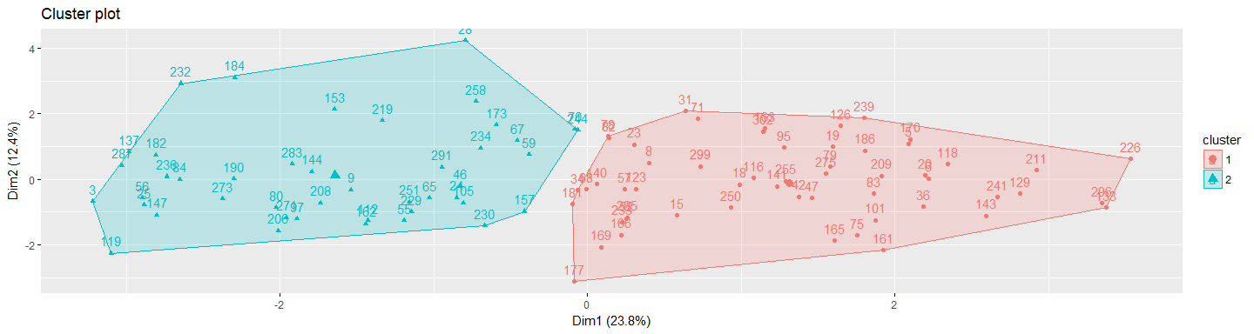

**plot_results**(X.testData.std, Y.testData, kmeans_class,   
 **paste0**("Kmeans Clustering Classification/Missclasiffication (All Data)\n"),  
 "Trestbps","Chol", labels = TRUE)

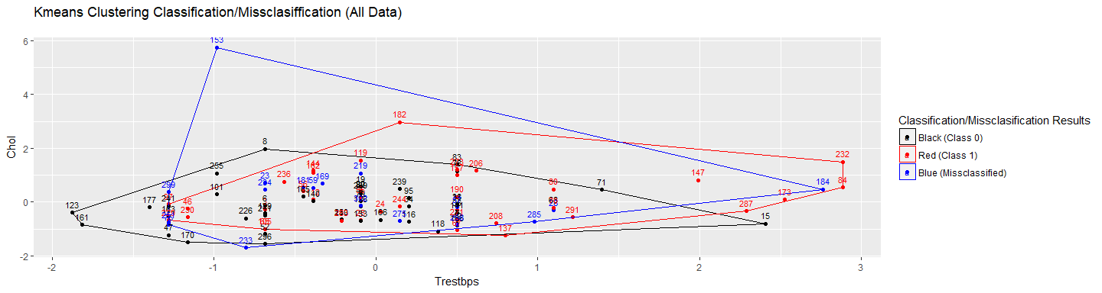

**plot_results**(X.testData.std, Y.testData, kmeans_class,   
 **paste0**("Kmeans Clustering Classification/Missclasiffication (All Data)\n"),  
 "Trestbps","Chol", labels = FALSE)

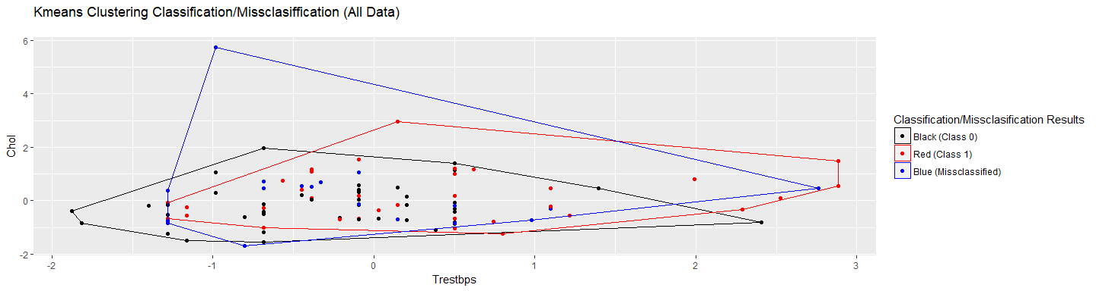

# 9. Support Vector Machine (SVM)

## 9.1 SVM Radial (svmRadial)

############################################  
*# 9. Support Vector Machine (SVM)*  
############################################  
## 9.1 SVM Radial (svmRadial)  
model.name <- "SVM Radial"  
model.name8 <- model.name  
(d <- **log2**(13))

## [1] 3.7

(sigma_values <- 2**^**(**c**(**-**d**-**3, **-**d**-**2, **-**d**-**1, **-**d, **-**d **+** 1, **-**d **+**2, **-**d**+**3)))

## [1] 0.009615 0.019231 0.038462 0.076923 0.153846 0.307692 0.615385

(c_values <- **c**(0.001, 0.01, 0.1, 1, 10, 100, 1000, 10000))

## [1] 1e-03 1e-02 1e-01 1e+00 1e+01 1e+02 1e+03 1e+04

kernel_method_type <- "svmRadial"  
*# Grid Parameters*  
(grid_radial <- **expand.grid**(C = c_values, sigma = sigma_values))

## C sigma  
## 1 1e-03 0.009615  
## 2 1e-02 0.009615  
## 3 1e-01 0.009615  
## 4 1e+00 0.009615  
## 5 1e+01 0.009615  
## 6 1e+02 0.009615  
## 7 1e+03 0.009615  
## 8 1e+04 0.009615  
## 9 1e-03 0.019231  
## 10 1e-02 0.019231  
## 11 1e-01 0.019231  
## 12 1e+00 0.019231  
## 13 1e+01 0.019231  
## 14 1e+02 0.019231  
## 15 1e+03 0.019231  
## 16 1e+04 0.019231  
## 17 1e-03 0.038462  
## 18 1e-02 0.038462  
## 19 1e-01 0.038462  
## 20 1e+00 0.038462  
## 21 1e+01 0.038462  
## 22 1e+02 0.038462  
## 23 1e+03 0.038462  
## 24 1e+04 0.038462  
## 25 1e-03 0.076923  
## 26 1e-02 0.076923  
## 27 1e-01 0.076923  
## 28 1e+00 0.076923  
## 29 1e+01 0.076923  
## 30 1e+02 0.076923  
## 31 1e+03 0.076923  
## 32 1e+04 0.076923  
## 33 1e-03 0.153846  
## 34 1e-02 0.153846  
## 35 1e-01 0.153846  
## 36 1e+00 0.153846  
## 37 1e+01 0.153846  
## 38 1e+02 0.153846  
## 39 1e+03 0.153846  
## 40 1e+04 0.153846  
## 41 1e-03 0.307692  
## 42 1e-02 0.307692  
## 43 1e-01 0.307692  
## 44 1e+00 0.307692  
## 45 1e+01 0.307692  
## 46 1e+02 0.307692  
## 47 1e+03 0.307692  
## 48 1e+04 0.307692  
## 49 1e-03 0.615385  
## 50 1e-02 0.615385  
## 51 1e-01 0.615385  
## 52 1e+00 0.615385  
## 53 1e+01 0.615385  
## 54 1e+02 0.615385  
## 55 1e+03 0.615385  
## 56 1e+04 0.615385

*# Cross Validation Parameters*  
trctrl <- **trainControl**(method = "repeatedcv",   
 number = 10,  
 repeats = 3)  
  
file.name <- **paste**(work.dir, "svm_radial.Rds", sep="/")  
file.name.et <- **paste**(work.dir, "svm_radial-et.Rds", sep="/")  
  
**if** (**file.exists**(file.name)) {  
 **load**(file.name,.GlobalEnv)   
 **load**(file.name.et,.GlobalEnv)  
} **else** {  
 t1 <- **proc.time**()  
 svm_Radial_Grid <- **train**(y = **factor**(Y.trainData),  
 x = X.trainData,  
 method = kernel_method_type,  
 trControl=trctrl,  
 preProcess = **c**("center", "scale"),   
 trace = FALSE,  
 tuneGrid = grid_radial)  
 t2 <- **proc.time**()  
 et <- **elapsed_time**(t1,t2)  
 **print**(**paste0**(model.name," Executed ... time:",et))  
 **save**(svm_Radial_Grid, file = file.name)  
 **save**(et, file = file.name.et)  
}

## [1] "SVM Radial Executed ... time:58"

We can see the main results here:

*# Let's see some details about the model*  
svm_Radial_Grid

## Support Vector Machines with Radial Basis Function Kernel   
##   
## 198 samples  
## 13 predictor  
## 2 classes: '0', '1'   
##   
## Pre-processing: centered (13), scaled (13)   
## Resampling: Cross-Validated (10 fold, repeated 3 times)   
## Summary of sample sizes: 178, 179, 179, 178, 178, 178, ...   
## Resampling results across tuning parameters:  
##   
## C sigma Accuracy Kappa   
## 1e-03 0.009615 0.5403 0.0000  
## 1e-03 0.019231 0.5403 0.0000  
## 1e-03 0.038462 0.5403 0.0000  
## 1e-03 0.076923 0.5403 0.0000  
## 1e-03 0.153846 0.5403 0.0000  
## 1e-03 0.307692 0.5403 0.0000  
## 1e-03 0.615385 0.5403 0.0000  
## 1e-02 0.009615 0.5403 0.0000  
## 1e-02 0.019231 0.5403 0.0000  
## 1e-02 0.038462 0.5403 0.0000  
## 1e-02 0.076923 0.5403 0.0000  
## 1e-02 0.153846 0.5403 0.0000  
## 1e-02 0.307692 0.5403 0.0000  
## 1e-02 0.615385 0.5403 0.0000  
## 1e-01 0.009615 0.7528 0.4821  
## 1e-01 0.019231 0.8448 0.6813  
## 1e-01 0.038462 0.8533 0.7003  
## 1e-01 0.076923 0.8516 0.6967  
## 1e-01 0.153846 0.6609 0.2801  
## 1e-01 0.307692 0.5403 0.0000  
## 1e-01 0.615385 0.5403 0.0000  
## 1e+00 0.009615 0.8501 0.6955  
## 1e+00 0.019231 0.8467 0.6888  
## 1e+00 0.038462 0.8332 0.6622  
## 1e+00 0.076923 0.8314 0.6593  
## 1e+00 0.153846 0.8164 0.6299  
## 1e+00 0.307692 0.7912 0.5830  
## 1e+00 0.615385 0.6657 0.3007  
## 1e+01 0.009615 0.8350 0.6651  
## 1e+01 0.019231 0.8168 0.6295  
## 1e+01 0.038462 0.8085 0.6127  
## 1e+01 0.076923 0.7785 0.5542  
## 1e+01 0.153846 0.7661 0.5308  
## 1e+01 0.307692 0.7625 0.5262  
## 1e+01 0.615385 0.6694 0.3157  
## 1e+02 0.009615 0.7988 0.5923  
## 1e+02 0.019231 0.7783 0.5537  
## 1e+02 0.038462 0.7411 0.4803  
## 1e+02 0.076923 0.7614 0.5205  
## 1e+02 0.153846 0.7644 0.5275  
## 1e+02 0.307692 0.7625 0.5262  
## 1e+02 0.615385 0.6694 0.3157  
## 1e+03 0.009615 0.7376 0.4729  
## 1e+03 0.019231 0.7159 0.4288  
## 1e+03 0.038462 0.7328 0.4635  
## 1e+03 0.076923 0.7614 0.5205  
## 1e+03 0.153846 0.7644 0.5275  
## 1e+03 0.307692 0.7625 0.5262  
## 1e+03 0.615385 0.6694 0.3157  
## 1e+04 0.009615 0.7088 0.4137  
## 1e+04 0.019231 0.7159 0.4288  
## 1e+04 0.038462 0.7328 0.4635  
## 1e+04 0.076923 0.7614 0.5205  
## 1e+04 0.153846 0.7644 0.5275  
## 1e+04 0.307692 0.7625 0.5262  
## 1e+04 0.615385 0.6694 0.3157  
##   
## Accuracy was used to select the optimal model using the largest value.  
## The final values used for the model were sigma = 0.03846 and C = 0.1.

**summary**(svm_Radial_Grid)

## Length Class Mode   
## 1 ksvm S4

**plot**(**varImp**(svm_Radial_Grid),   
 main = **paste0**(model.name," Variable Importance"))

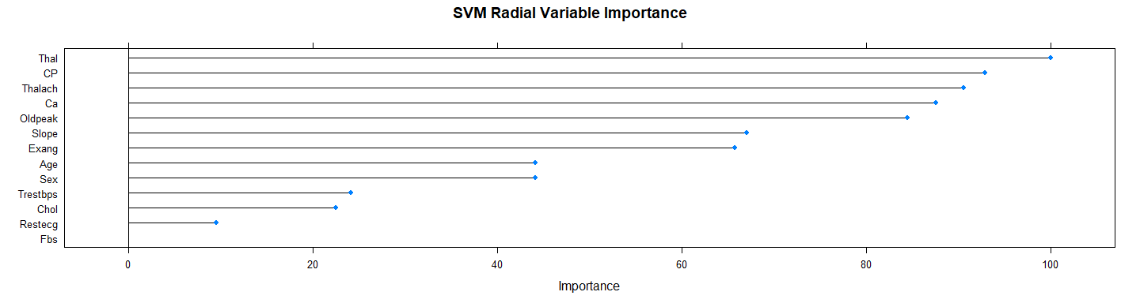

**plot**(svm_Radial_Grid, main = model.name)

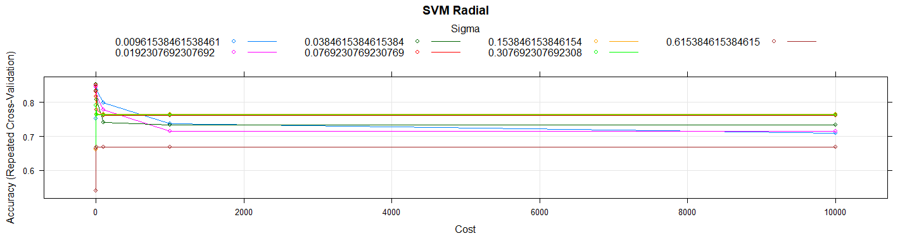

*# Let's check the detail in the Training Set*  
res.svmradial.training <- **confusionMatrix**(svm_Radial_Grid**$**finalModel**@**fitted, Y.trainData)  
res.svmradial.training

## Confusion Matrix and Statistics  
##   
## Reference  
## Prediction 0 1  
## 0 99 21  
## 1 8 70  
##   
## Accuracy : 0.854   
## 95% CI : (0.796, 0.9)  
## No Information Rate : 0.54   
## P-Value [Acc > NIR] : <2e-16   
##   
## Kappa : 0.702   
## Mcnemar's Test P-Value : 0.0259   
##   
## Sensitivity : 0.925   
## Specificity : 0.769   
## Pos Pred Value : 0.825   
## Neg Pred Value : 0.897   
## Prevalence : 0.540   
## Detection Rate : 0.500   
## Detection Prevalence : 0.606   
## Balanced Accuracy : 0.847   
##   
## 'Positive' Class : 0   
##

*# Let's use the model in test set*  
test_pred_rgrid <- **predict**(svm_Radial_Grid, newdata = X.testData)  
test_pred_rgrid

## [1] 1 0 0 0 1 0 0 0 0 0 1 1 0 0 1 0 0 1 0 0 1 1 0 0 1 0 0 0 0 0 0 0 1 0 0  
## [36] 1 0 1 0 1 1 0 0 1 0 0 0 0 1 0 0 0 1 1 1 1 0 1 0 0 1 1 0 0 1 0 1 1 0 1  
## [71] 1 1 0 0 1 0 1 1 1 0 0 1 0 0 0 0 1 0 0 1 1 0 1 0 1 1 0 0 0  
## Levels: 0 1

res.svmradial <- **confusionMatrix**(test_pred_rgrid, Y.testData)  
  
res.svmradial

## Confusion Matrix and Statistics  
##   
## Reference  
## Prediction 0 1  
## 0 46 13  
## 1 7 33  
##   
## Accuracy : 0.798   
## 95% CI : (0.705, 0.872)  
## No Information Rate : 0.535   
## P-Value [Acc > NIR] : 4.8e-08   
##   
## Kappa : 0.59   
## Mcnemar's Test P-Value : 0.264   
##   
## Sensitivity : 0.868   
## Specificity : 0.717   
## Pos Pred Value : 0.780   
## Neg Pred Value : 0.825   
## Prevalence : 0.535   
## Detection Rate : 0.465   
## Detection Prevalence : 0.596   
## Balanced Accuracy : 0.793   
##   
## 'Positive' Class : 0   
##

**print_confusionm**(res.svmradial,   
 main = **paste0**("Confusion Matrix: ",model.name," (Test Set)"),   
 labels = **c**("Healthy", "Non-Healthy"))



main <- **paste0**(model.name," Classification/Misclassification in Test Set by\n",  
 "Heart Disease Status: number of major vessels with >50% narrowing ",  
 "(0=Healthy,1,2,3, or 4)")  
  
**plot_results_by_type**(test_pred_rgrid,  
 Y.testData,  
 main, testData)

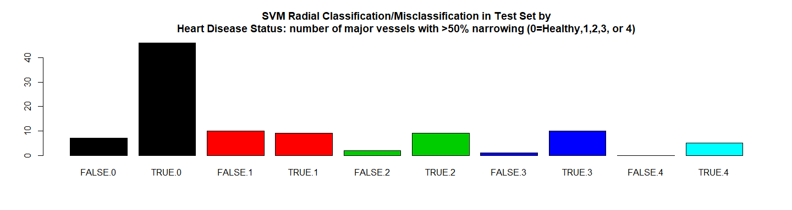

**plot_results**(X.testData, Y.testData,test_pred_rgrid ,   
 **paste0**(model.name," Classification/Missclasiffication\n"),   
 "Trestbps","Chol",labels = FALSE)

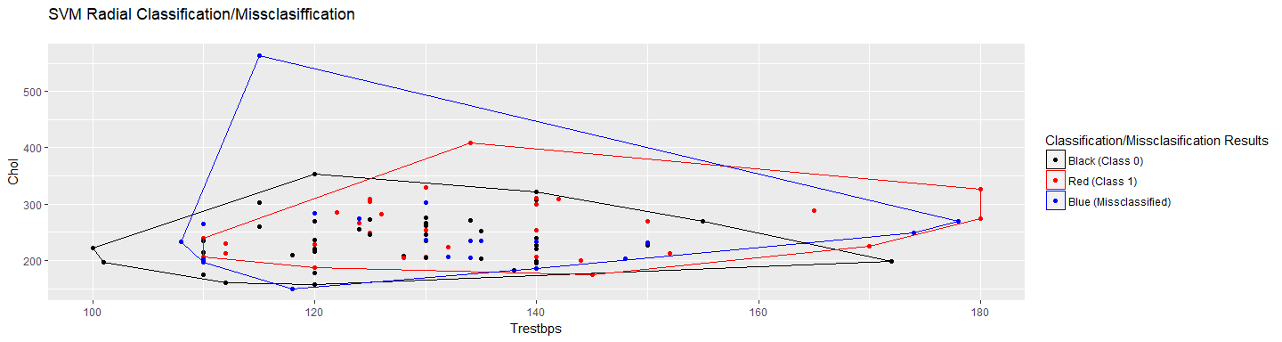

**plot_results**(X.testData, Y.testData,test_pred_rgrid,   
 **paste0**(model.name," Classification/Missclasiffication\n"),  
 "Trestbps","Chol",labels = TRUE)

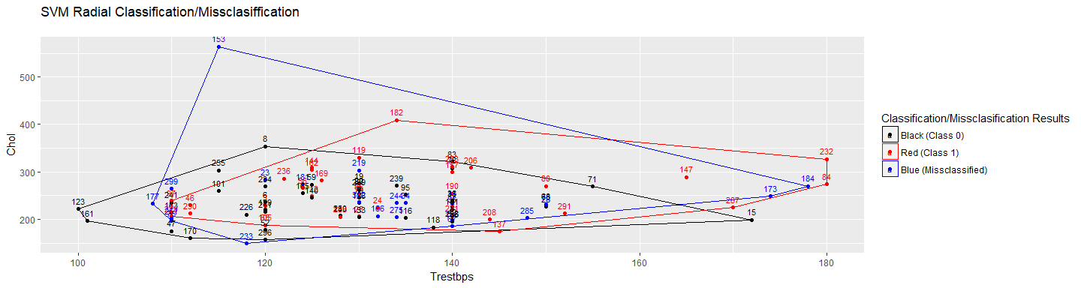

*# RMSE Resulting*  
(rmse_svmradial <- **sqrt**(**mean**((**as.numeric**(test_pred_rgrid)**-as.numeric**(Y.testData))**^**2)))

## [1] 0.4495

*# Residuals Plot*  
(r_svmradial <- (**as.numeric**(test_pred_rgrid)**-as.numeric**(Y.testData)))

## [1] 0 0 0 0 0 0 0 0 0 -1 0 0 0 0 1 0 0 0 0 0 0 0 -1  
## [24] 0 0 -1 0 -1 0 -1 0 0 0 0 0 0 0 0 0 0 0 0 0 0 0 0  
## [47] 0 0 0 0 0 0 0 0 1 0 0 0 0 0 1 0 0 -1 1 -1 0 1 0  
## [70] 0 0 0 0 0 1 0 0 0 0 -1 0 0 0 0 -1 0 1 0 0 0 0 -1  
## [93] 0 -1 0 0 0 -1 -1

**plot**(r_svmradial,   
 main = **paste0**(model.name," Residuals"),xlab = "", ylab = "")

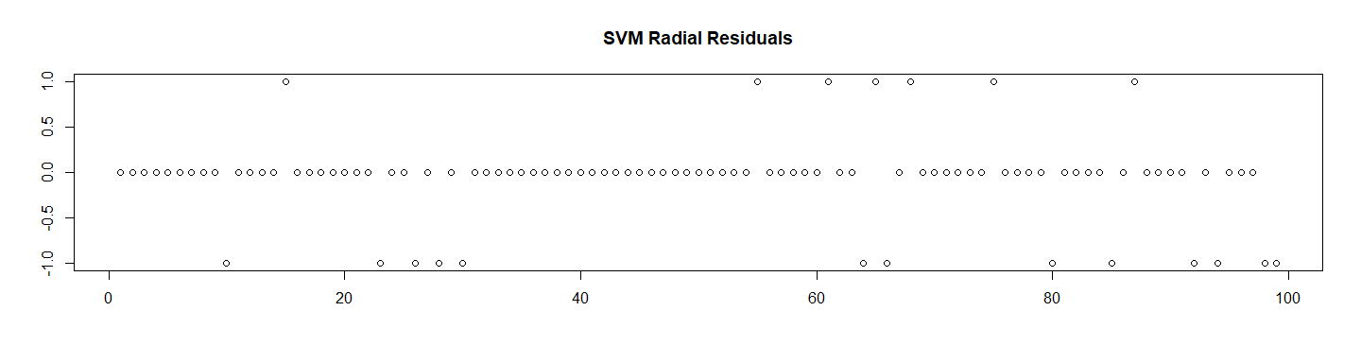

*# Store the Values for Report*  
results_all <- **rbind**(results_all,  
 **data.frame**("Method"= model.name,  
 "Prediction Accuracy in Training Set" =   
 res.svmradial.training**$**overall[1] ,  
 "Prediction Accuracy in Test Set" =   
 res.svmradial**$**overall[1],  
 "RMSE Test"= rmse_svmradial,  
 "ROC" = NA,  
 "Time Elapsed" = et,  
 stringsAsFactors = FALSE))  
  
**plot_results**(X.testData, Y.testData, test_pred_rgrid ,   
 **paste0**(model.name," Classification/Missclasiffication\n"),  
 "Trestbps","Chol",labels = TRUE)



**plot_results**(X.testData, Y.testData, test_pred_rgrid ,   
 **paste0**(model.name," Classification/Missclasiffication\n"),  
 "Trestbps","Chol", labels = FALSE)



## 9.2 Linear SVM (svmLinear)

############################################  
## 9.2 Linear SVM (svmLinear)  
*# Setting Hyperparameters According with Paper*  
model.name <- "SVM Linear"  
model.name9 <- model.name  
kernel_method_type <- "svmLinear"  
  
grid_Linear <- **expand.grid**(C = c_values)  
  
file.name <- **paste**(work.dir, "svm_linear.Rds", sep="/")  
file.name.et <- **paste**(work.dir, "svm_linear-et.Rds", sep="/")  
  
**if** (**file.exists**(file.name)) {  
 **load**(file.name,.GlobalEnv)   
 **load**(file.name.et,.GlobalEnv)  
} **else** {  
 t1 <- **proc.time**()  
 svm_Linear_Grid <- **train**(y = **factor**(Y.trainData),   
 x = X.trainData,  
 method = kernel_method_type,  
 trControl=trctrl,  
 preProcess = **c**("center", "scale"),  
 tuneGrid = grid_Linear,  
 trace = FALSE,  
 tuneLength = 10)  
 t2 <- **proc.time**()  
 et <- **elapsed_time**(t1,t2)  
 **print**(**paste0**(model.name," Executed ... time:", et))  
 **save**(svm_Linear_Grid, file = file.name)  
 **save**(et, file = file.name.et)  
}

## [1] "SVM Linear Executed ... time:169"

We can see the main results here:

*# Let's see some details about the model*  
svm_Linear_Grid

## Support Vector Machines with Linear Kernel   
##   
## 198 samples  
## 13 predictor  
## 2 classes: '0', '1'   
##   
## Pre-processing: centered (13), scaled (13)   
## Resampling: Cross-Validated (10 fold, repeated 3 times)   
## Summary of sample sizes: 178, 178, 178, 178, 178, 179, ...   
## Resampling results across tuning parameters:  
##   
## C Accuracy Kappa   
## 1e-03 0.5637 0.05547  
## 1e-02 0.8542 0.70437  
## 1e-01 0.8389 0.67409  
## 1e+00 0.8373 0.67076  
## 1e+01 0.8406 0.67737  
## 1e+02 0.8424 0.68079  
## 1e+03 0.8424 0.68079  
## 1e+04 0.8374 0.67086  
##   
## Accuracy was used to select the optimal model using the largest value.  
## The final value used for the model was C = 0.01.

**summary**(svm_Linear_Grid)

## Length Class Mode   
## 1 ksvm S4

**plot**(**varImp**(svm_Linear_Grid),   
 main = **paste0**(model.name," Variable Importance"))

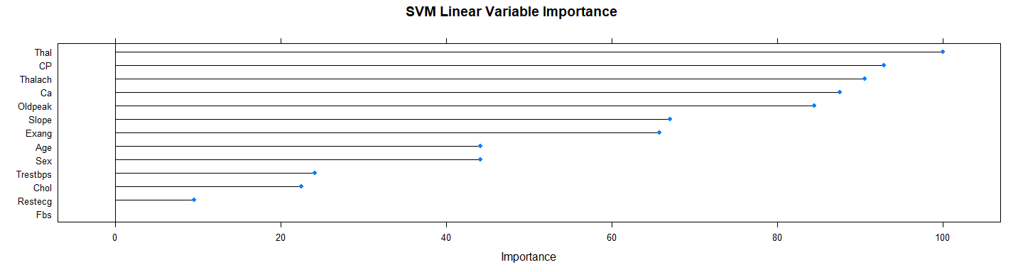

**plot**(svm_Linear_Grid, main = model.name)

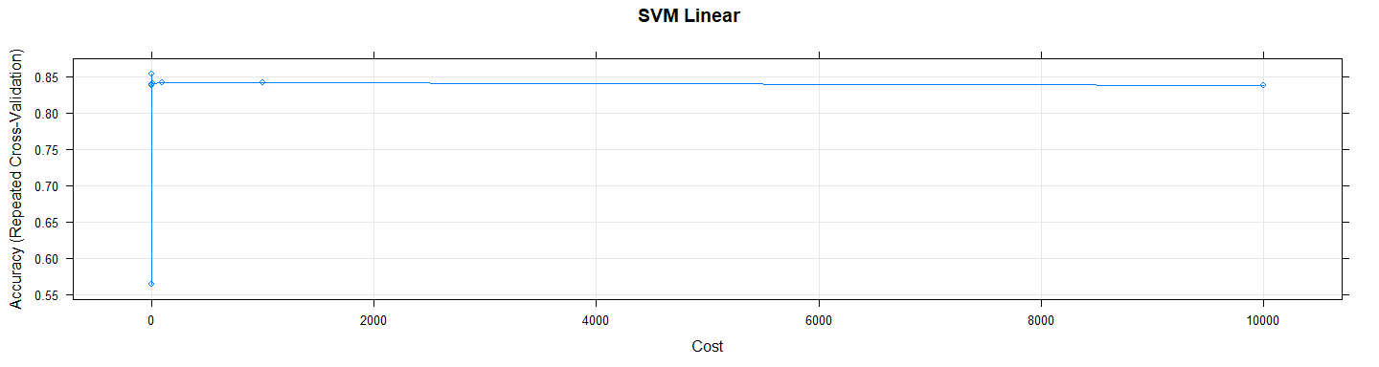

*# Let's check the detail in the Training Set*  
res.svmlinear.training <- **confusionMatrix**(svm_Linear_Grid**$**finalModel**@**fitted, Y.trainData)  
res.svmlinear.training

## Confusion Matrix and Statistics  
##   
## Reference  
## Prediction 0 1  
## 0 98 19  
## 1 9 72  
##   
## Accuracy : 0.859   
## 95% CI : (0.802, 0.904)  
## No Information Rate : 0.54   
## P-Value [Acc > NIR] : <2e-16   
##   
## Kappa : 0.713   
## Mcnemar's Test P-Value : 0.089   
##   
## Sensitivity : 0.916   
## Specificity : 0.791   
## Pos Pred Value : 0.838   
## Neg Pred Value : 0.889   
## Prevalence : 0.540   
## Detection Rate : 0.495   
## Detection Prevalence : 0.591   
## Balanced Accuracy : 0.854   
##   
## 'Positive' Class : 0   
##

*# Let's use the model in test set*  
  
test_pred_lgrid <- **predict**(svm_Linear_Grid, newdata = X.testData)  
test_pred_lgrid

## [1] 1 0 0 0 1 0 0 0 0 0 1 1 0 0 1 0 0 1 0 1 1 1 1 0 1 0 0 0 0 0 0 0 1 0 0  
## [36] 1 0 1 0 1 1 0 0 1 0 0 0 0 1 0 0 0 1 1 1 1 0 1 0 0 1 1 0 0 1 1 1 1 0 1  
## [71] 1 1 0 0 1 0 1 1 1 1 0 1 0 0 0 0 1 0 0 1 1 0 1 1 1 0 0 0 0  
## Levels: 0 1

res.svmlinear <- **confusionMatrix**(test_pred_lgrid, Y.testData)  
  
res.svmlinear

## Confusion Matrix and Statistics  
##   
## Reference  
## Prediction 0 1  
## 0 45 10  
## 1 8 36  
##   
## Accuracy : 0.818   
## 95% CI : (0.728, 0.889)  
## No Information Rate : 0.535   
## P-Value [Acc > NIR] : 3.57e-09   
##   
## Kappa : 0.633   
## Mcnemar's Test P-Value : 0.814   
##   
## Sensitivity : 0.849   
## Specificity : 0.783   
## Pos Pred Value : 0.818   
## Neg Pred Value : 0.818   
## Prevalence : 0.535   
## Detection Rate : 0.455   
## Detection Prevalence : 0.556   
## Balanced Accuracy : 0.816   
##   
## 'Positive' Class : 0   
##

**print_confusionm**(res.svmlinear,   
 main = **paste0**("Confusion Matrix: ",model.name," (Test Set)"),   
 labels = **c**("Healthy", "Non-Healthy"))



main <- **paste0**(model.name," Classification/Misclassification in Test Set by\n",  
 "Heart Disease Status: number of major vessels with >50% narrowing ",  
 "(0=Healthy,1,2,3, or 4)")  
  
**plot_results_by_type**(test_pred_lgrid,  
 Y.testData,  
 main, testData)

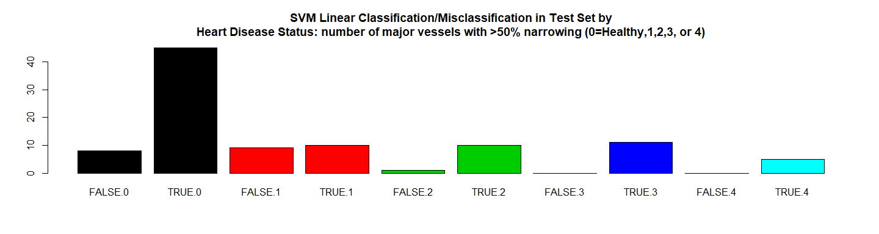

*# RMSE Resulting*  
(rmse_svmlinear <- **sqrt**(**mean**((**as.numeric**(test_pred_lgrid)**-as.numeric**(Y.testData))**^**2)))

## [1] 0.4264

*# Residuals Plot*  
(r_svmlinear <- (**as.numeric**(test_pred_lgrid)**-as.numeric**(Y.testData)))

## [1] 0 0 0 0 0 0 0 0 0 -1 0 0 0 0 1 0 0 0 0 1 0 0 0  
## [24] 0 0 -1 0 -1 0 -1 0 0 0 0 0 0 0 0 0 0 0 0 0 0 0 0  
## [47] 0 0 0 0 0 0 0 0 1 0 0 0 0 0 1 0 0 -1 1 0 0 1 0  
## [70] 0 0 0 0 0 1 0 0 0 0 0 0 0 0 0 -1 0 1 0 0 0 0 -1  
## [93] 0 0 0 -1 0 -1 -1

**plot**(r_svmlinear, main = **paste0**(model.name," Residuals"),xlab = "", ylab = "")

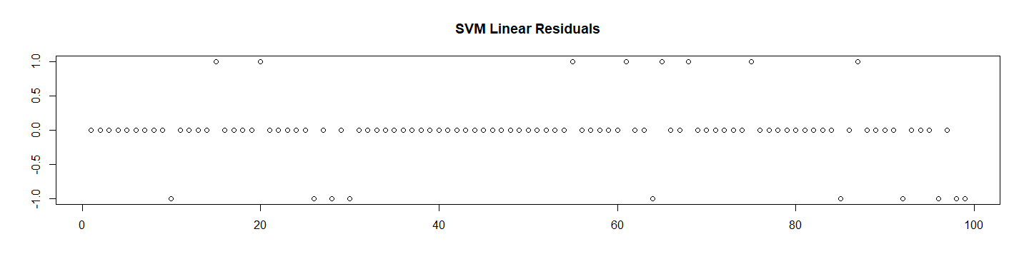

*# Store the Values for Report*  
results_all <- **rbind**(results_all,  
 **data.frame**("Method"= model.name,  
 "Prediction Accuracy in Training Set" =   
 res.svmlinear.training**$**overall[1] ,  
 "Prediction Accuracy in Test Set" =   
 res.svmlinear**$**overall[1],  
 "RMSE Test"= rmse_svmlinear,  
 "ROC" = NA,  
   
 "Time Elapsed" = et,  
 stringsAsFactors = FALSE))

# 10. Neural Networks (nnet)

############################################  
*# 10. Neural Networks*  
model.name <- "Neural Networks (nnet)"  
model.name10 <- model.name  
file.name <- **paste**(work.dir, "nnet.Rds", sep="/")  
file.name.et <- **paste**(work.dir, "nnet-et.Rds", sep="/")  
  
**if** (**file.exists**(file.name)) {  
 **load**(file.name,.GlobalEnv)  
 **load**(file.name.et,.GlobalEnv)  
} **else** {  
   
 grid_n_net <- **expand.grid**(decay = **c**(0.0005, 0.005, 0.05), size = **c**(0,1,2,3))  
 t1 <- **proc.time**()  
 n_net <- **train**(y = **factor**(Y.trainData),   
 x = X.trainData,  
 method="nnet",  
 preProcess = **c**("center", "scale"),  
 tuneGrid = grid_n_net,  
 trace = FALSE,  
 maxit = 500)  
 t2 <- **proc.time**()  
 et <- **elapsed_time**(t1,t2)  
 **print**(**paste0**(model.name," Executed ... time:", et))  
 **save**(n_net, file = file.name)  
 **save**(et, file = file.name.et)  
}

## [1] "Neural Networks (nnet) Executed ... time:9.5"

Let’s see the results:

*# Let's see some details about the model*  
n_net

## Neural Network   
##   
## 198 samples  
## 13 predictor  
## 2 classes: '0', '1'   
##   
## Pre-processing: centered (13), scaled (13)   
## Resampling: Bootstrapped (25 reps)   
## Summary of sample sizes: 198, 198, 198, 198, 198, 198, ...   
## Resampling results across tuning parameters:  
##   
## decay size Accuracy Kappa   
## 5e-04 0 NaN NaN  
## 5e-04 1 0.7953 0.5853  
## 5e-04 2 0.7851 0.5672  
## 5e-04 3 0.7681 0.5324  
## 5e-03 0 NaN NaN  
## 5e-03 1 0.7939 0.5821  
## 5e-03 2 0.7723 0.5430  
## 5e-03 3 0.7815 0.5608  
## 5e-02 0 NaN NaN  
## 5e-02 1 0.7918 0.5789  
## 5e-02 2 0.7715 0.5391  
## 5e-02 3 0.7714 0.5407  
##   
## Accuracy was used to select the optimal model using the largest value.  
## The final values used for the model were size = 1 and decay = 5e-04.

**summary**(n_net)

## a 13-1-1 network with 16 weights  
## options were - entropy fitting decay=5e-04  
## b->h1 i1->h1 i2->h1 i3->h1 i4->h1 i5->h1 i6->h1 i7->h1 i8->h1   
## -10.64 -9.53 -2.59 8.73 3.29 -0.43 -7.41 1.40 -5.27   
## i9->h1 i10->h1 i11->h1 i12->h1 i13->h1   
## -2.98 8.22 8.19 24.62 20.17   
## b->o h1->o   
## -1.89 5.57

**plot**(**varImp**(n_net), main = **paste0**(model.name, " Variable Importance"))

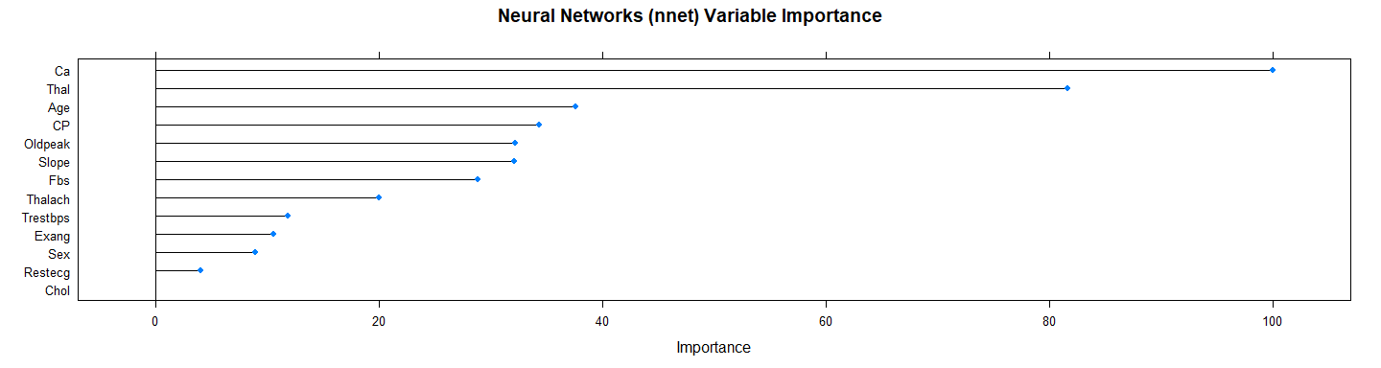

**plot**(n_net, main = model.name)

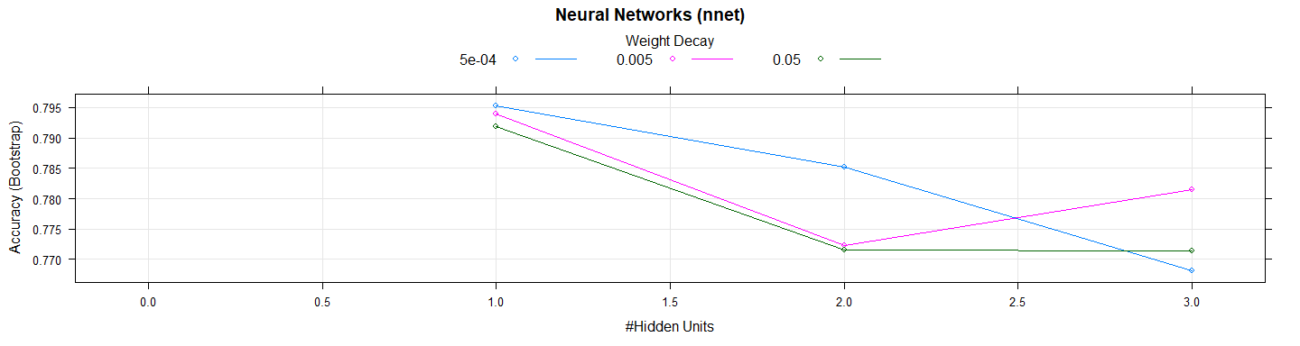

*# Let's use the model in test set*  
test_pred_n_net <- **predict**(n_net, newdata = X.testData)  
test_pred_n_net

## [1] 1 0 0 0 1 0 0 0 0 0 1 1 0 0 0 0 0 1 0 0 1 1 1 0 1 0 0 0 0 0 0 0 0 0 0  
## [36] 0 0 1 0 1 0 0 0 1 0 0 0 0 1 0 0 0 0 1 0 0 0 0 0 0 0 1 0 0 1 1 1 1 0 1  
## [71] 1 1 0 0 1 0 0 0 0 1 0 1 0 0 0 0 0 0 0 1 1 0 1 1 1 0 0 0 0  
## Levels: 0 1

res.n_net <- **confusionMatrix**(test_pred_n_net, Y.testData)  
res.n_net

## Confusion Matrix and Statistics  
##   
## Reference  
## Prediction 0 1  
## 0 50 19  
## 1 3 27  
##   
## Accuracy : 0.778   
## 95% CI : (0.683, 0.855)  
## No Information Rate : 0.535   
## P-Value [Acc > NIR] : 5.07e-07   
##   
## Kappa : 0.543   
## Mcnemar's Test P-Value : 0.00138   
##   
## Sensitivity : 0.943   
## Specificity : 0.587   
## Pos Pred Value : 0.725   
## Neg Pred Value : 0.900   
## Prevalence : 0.535   
## Detection Rate : 0.505   
## Detection Prevalence : 0.697   
## Balanced Accuracy : 0.765   
##   
## 'Positive' Class : 0   
##

**print_confusionm**(res.n_net,   
 main = **paste0**("Confusion Matrix: ",model.name," (Test Set)"),   
 labels = **c**("Healthy", "Non-Healthy"))



main <- **paste0**(model.name," Classification/Misclassification in Test Set by\n",  
 "Heart Disease Status: number of major vessels with >50% narrowing ",  
 "(0=Healthy,1,2,3, or 4)")  
  
  
**plot_results_by_type**(test_pred_n_net,  
 Y.testData,  
 main, testData)

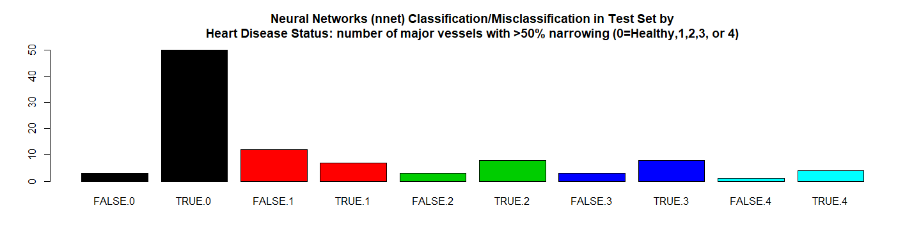

*# RMSE Resulting*  
(rmse_n_net <- **sqrt**(**mean**((**as.numeric**(test_pred_n_net)**-as.numeric**(Y.testData))**^**2)))

## [1] 0.4714

*# Residuals Plot*  
(r_n_net <- (**as.numeric**(test_pred_n_net)**-as.numeric**(Y.testData)))

## [1] 0 0 0 0 0 0 0 0 0 -1 0 0 0 0 0 0 0 0 0 0 0 0 0  
## [24] 0 0 -1 0 -1 0 -1 0 0 -1 0 0 -1 0 0 0 0 -1 0 0 0 0 0  
## [47] 0 0 0 0 0 0 -1 0 0 -1 0 -1 0 0 0 0 0 -1 1 0 0 1 0  
## [70] 0 0 0 0 0 1 0 -1 -1 -1 0 0 0 0 0 -1 0 0 0 0 0 0 -1  
## [93] 0 0 0 -1 0 -1 -1

**plot**(r_n_net, main = **paste0**(model.name," Residuals"),xlab = "", ylab = "")

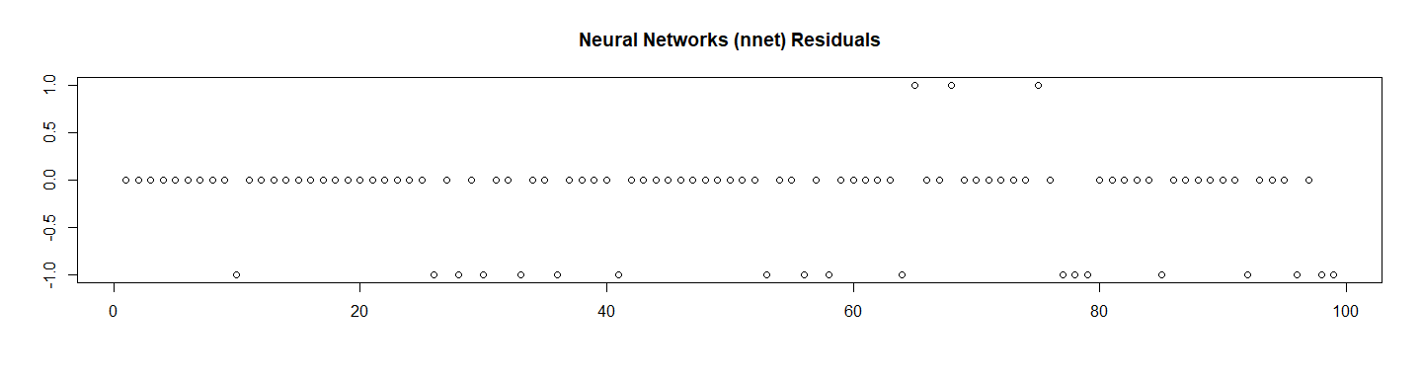

*# Let's check the probabilities and Calculate the ROC*  
test_pred_n_net_prob <- **predict**(n_net, newdata = X.testData, type ="prob")[2]  
  
res.n_net.roc <- **roc**(**as.numeric**(Y.testData),  
 **as.numeric**(  
 **as.matrix**(test_pred_n_net_prob)))**$**auc  
  
*# Store the Values for Report*  
results_all <- **rbind**(results_all,  
 **data.frame**("Method"= model.name,  
 "Prediction Accuracy in Training Set" =   
 **max**(n_net**$**results**$**Accuracy, na.rm = TRUE),  
 "Prediction Accuracy in Test Set" = res.n_net**$**overall[1],  
 "RMSE Test"= rmse_n_net,  
 "ROC" = res.n_net.roc,  
 "Time Elapsed" = et,  
 stringsAsFactors = FALSE))

# 11. K-Nearest Neighbors (knn)

############################################  
*# 11. K-Nearest Neighbors*  
model.name <- "K-Nearest Neighbors (knn)"  
model.name11 <- model.name  
file.name <- **paste**(work.dir, "knn.Rds", sep="/")  
file.name.et <- **paste**(work.dir, "knn-et.Rds", sep="/")  
  
**if** (**file.exists**(file.name)) {  
 **load**(file.name,.GlobalEnv)  
 **load**(file.name.et,.GlobalEnv)  
} **else** {  
   
 grid_knn <- **expand.grid**(k = **c**(1,2,3,4,5,6,7,8,9,10,11,12,13))  
 t1 <- **proc.time**()  
 knn <- **train**(y = **factor**(Y.trainData),   
 x = X.trainData,  
 method="knn",  
 preProcess = **c**("center", "scale"),  
 trControl=trctrl,  
 tuneGrid = grid_knn)  
 t2 <- **proc.time**()  
 et <- **elapsed_time**(t1,t2)  
 **print**(**paste0**(model.name," Executed ... time:", et))  
 **save**(knn, file = file.name)  
 **save**(et, file = file.name.et)  
}

## [1] "K-Nearest Neighbors (knn) Executed ... time:6.9"

Let’s see the results:

*# Let's see some details about the model*  
knn

## k-Nearest Neighbors   
##   
## 198 samples  
## 13 predictor  
## 2 classes: '0', '1'   
##   
## Pre-processing: centered (13), scaled (13)   
## Resampling: Cross-Validated (10 fold, repeated 3 times)   
## Summary of sample sizes: 178, 179, 178, 178, 178, 178, ...   
## Resampling results across tuning parameters:  
##   
## k Accuracy Kappa   
## 1 0.7643 0.5284  
## 2 0.7860 0.5702  
## 3 0.8070 0.6115  
## 4 0.8102 0.6159  
## 5 0.8201 0.6358  
## 6 0.8118 0.6181  
## 7 0.8218 0.6377  
## 8 0.8166 0.6282  
## 9 0.8135 0.6206  
## 10 0.8133 0.6194  
## 11 0.8251 0.6442  
## 12 0.8299 0.6545  
## 13 0.8165 0.6264  
##   
## Accuracy was used to select the optimal model using the largest value.  
## The final value used for the model was k = 12.

**summary**(knn)

## Length Class Mode   
## learn 2 -none- list   
## k 1 -none- numeric   
## theDots 0 -none- list   
## xNames 13 -none- character  
## problemType 1 -none- character  
## tuneValue 1 data.frame list   
## obsLevels 2 -none- character  
## param 0 -none- list

**plot**(**varImp**(knn),   
 main = **paste0**(model.name," Variable Importance"))

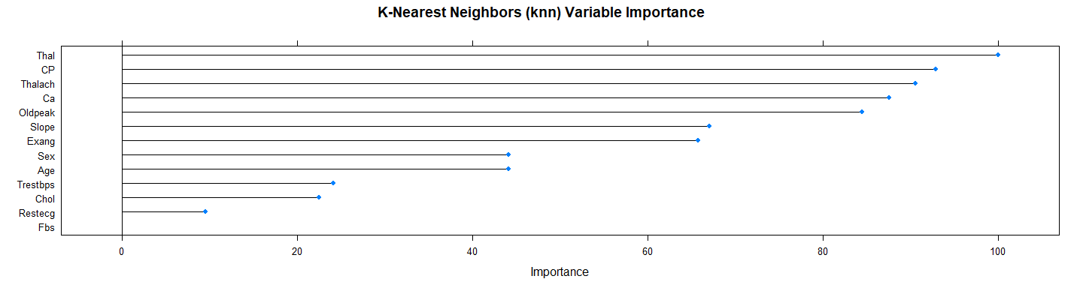

**plot**(knn, main = model.name)

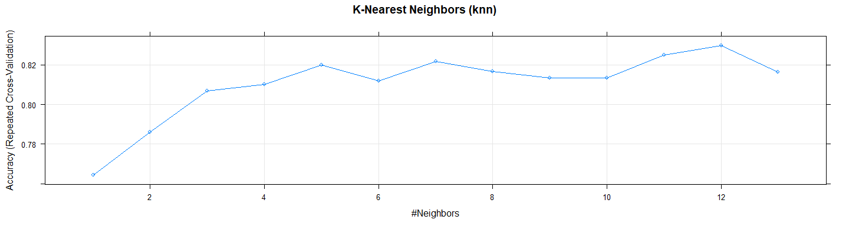

*# Let's use the model in test set*  
test_pred_knn <- **predict**(knn, newdata = X.testData)  
test_pred_knn

## [1] 1 0 0 0 1 0 0 0 0 0 1 1 0 0 1 0 0 1 0 0 1 1 0 0 1 0 1 0 0 0 0 0 1 0 0  
## [36] 1 0 1 0 1 1 0 0 1 0 0 0 0 1 0 0 0 1 1 0 1 0 1 0 0 0 1 0 1 1 1 1 0 0 1  
## [71] 1 1 0 0 1 0 1 1 1 1 0 1 0 0 0 0 1 0 0 1 1 0 1 1 1 0 0 0 0  
## Levels: 0 1

res.knn <- **confusionMatrix**(test_pred_knn, Y.testData)  
res.knn

## Confusion Matrix and Statistics  
##   
## Reference  
## Prediction 0 1  
## 0 48 10  
## 1 5 36  
##   
## Accuracy : 0.848   
## 95% CI : (0.762, 0.913)  
## No Information Rate : 0.535   
## P-Value [Acc > NIR] : 4.39e-11   
##   
## Kappa : 0.693   
## Mcnemar's Test P-Value : 0.302   
##   
## Sensitivity : 0.906   
## Specificity : 0.783   
## Pos Pred Value : 0.828   
## Neg Pred Value : 0.878   
## Prevalence : 0.535   
## Detection Rate : 0.485   
## Detection Prevalence : 0.586   
## Balanced Accuracy : 0.844   
##   
## 'Positive' Class : 0   
##

**print_confusionm**(res.knn,   
 main = **paste0**("Confusion Matrix: ",model.name," (Test Set)"),   
 labels = **c**("Healthy", "Non-Healthy"))



main <- **paste0**(model.name," Classification/Misclassification in Test Set by\n",  
 "Heart Disease Status: number of major vessels with >50% narrowing ",  
 "(0=Healthy,1,2,3, or 4)")  
  
  
**plot_results_by_type**(test_pred_knn,  
 Y.testData,  
 main, testData)

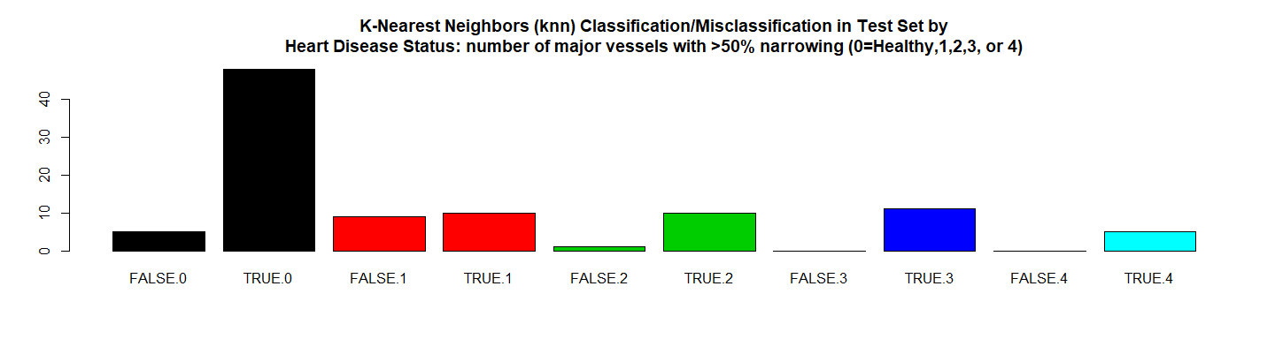

*# RMSE Resulting*  
(rmse_knn <- **sqrt**(**mean**((**as.numeric**(test_pred_knn)**-as.numeric**(Y.testData))**^**2)))

## [1] 0.3892

*# Residuals Plot*  
(r_knn <- (**as.numeric**(test_pred_knn)**-as.numeric**(Y.testData)))

## [1] 0 0 0 0 0 0 0 0 0 -1 0 0 0 0 1 0 0 0 0 0 0 0 -1  
## [24] 0 0 -1 1 -1 0 -1 0 0 0 0 0 0 0 0 0 0 0 0 0 0 0 0  
## [47] 0 0 0 0 0 0 0 0 0 0 0 0 0 0 0 0 0 0 1 0 0 0 0  
## [70] 0 0 0 0 0 1 0 0 0 0 0 0 0 0 0 -1 0 1 0 0 0 0 -1  
## [93] 0 0 0 -1 0 -1 -1

**plot**(r_knn, main = **paste0**(model.name," Residuals"),xlab = "", ylab = "")

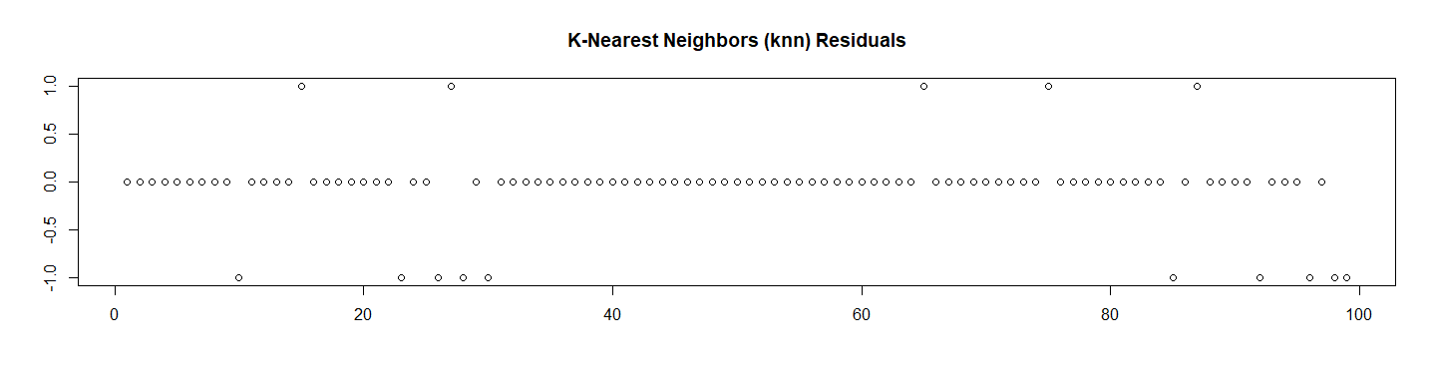

*# Let's check the probabilities and Calculate the ROC*  
test_pred_knn_prob <- **predict**(knn, newdata = X.testData, type ="prob")[2]  
  
res.knn.roc <- **roc**(**as.numeric**(Y.testData),  
 **as.numeric**(  
 **as.matrix**(test_pred_knn_prob)))**$**auc  
  
*# Store the Values for Report*  
results_all <- **rbind**(results_all,  
 **data.frame**("Method"= model.name,  
 "Prediction Accuracy in Training Set" =   
 **max**(knn**$**results**$**Accuracy, na.rm = TRUE),  
 "Prediction Accuracy in Test Set" = res.knn**$**overall[1],  
 "RMSE Test"= rmse_knn,  
 "ROC" = res.knn.roc,  
 "Time Elapsed" = et,  
 stringsAsFactors = FALSE))

# 12. Random Forest

## 12.1 Random Forest with Tuning Parameters (rf)

############################################  
*# 12. Random Forest*  
############################################  
## 12.1 Random Forest with Tuning Parameters (rf)  
model.name <- "Random Forest with Tuning Parameters (rf)"  
model.name12 <- model.name  
file.name <- **paste**(work.dir, "ramdonf.Rds", sep="/")  
file.name.et <- **paste**(work.dir, "randomf-et.Rds", sep="/")  
  
**if** (**file.exists**(file.name)) {  
 **load**(file.name,.GlobalEnv)  
 **load**(file.name.et,.GlobalEnv)  
} **else** {  
   
 grid_randomf <- **expand.grid**(mtry = **c**(1,2,3,4,5,6,7,8,9,10,11,12,13))  
 t1 <- **proc.time**()  
 randomf <- **train**(y = **factor**(Y.trainData),   
 x = X.trainData,  
 method="rf",  
 preProcess = **c**("center", "scale"),  
 trControl=trctrl,   
 importance = TRUE,  
 tuneGrid = grid_randomf)  
 t2 <- **proc.time**()  
 et <- **elapsed_time**(t1,t2)  
 **print**(**paste0**(model.name," Executed ... time:", et))  
 **save**(randomf, file = file.name)  
 **save**(et, file = file.name.et)  
}

## [1] "Random Forest with Tuning Parameters (rf) Executed ... time:52"

Let’s see the results:

*# Let's see some details about the model*  
randomf

## Random Forest   
##   
## 198 samples  
## 13 predictor  
## 2 classes: '0', '1'   
##   
## Pre-processing: centered (13), scaled (13)   
## Resampling: Cross-Validated (10 fold, repeated 3 times)   
## Summary of sample sizes: 178, 178, 178, 178, 179, 178, ...   
## Resampling results across tuning parameters:  
##   
## mtry Accuracy Kappa   
## 1 0.8449 0.6824  
## 2 0.8314 0.6567  
## 3 0.8298 0.6536  
## 4 0.8177 0.6299  
## 5 0.8110 0.6168  
## 6 0.8179 0.6302  
## 7 0.8126 0.6196  
## 8 0.8178 0.6302  
## 9 0.8109 0.6167  
## 10 0.8109 0.6164  
## 11 0.8059 0.6066  
## 12 0.8093 0.6129  
## 13 0.8143 0.6228  
##   
## Accuracy was used to select the optimal model using the largest value.  
## The final value used for the model was mtry = 1.

**summary**(randomf)

## Length Class Mode   
## call 5 -none- call   
## type 1 -none- character  
## predicted 198 factor numeric   
## err.rate 1500 -none- numeric   
## confusion 6 -none- numeric   
## votes 396 matrix numeric   
## oob.times 198 -none- numeric   
## classes 2 -none- character  
## importance 52 -none- numeric   
## importanceSD 39 -none- numeric   
## localImportance 0 -none- NULL   
## proximity 0 -none- NULL   
## ntree 1 -none- numeric   
## mtry 1 -none- numeric   
## forest 14 -none- list   
## y 198 factor numeric   
## test 0 -none- NULL   
## inbag 0 -none- NULL   
## xNames 13 -none- character  
## problemType 1 -none- character  
## tuneValue 1 data.frame list   
## obsLevels 2 -none- character  
## param 1 -none- list

**plot**(**varImp**(randomf), main = **paste0**(model.name," Variable Importance"))

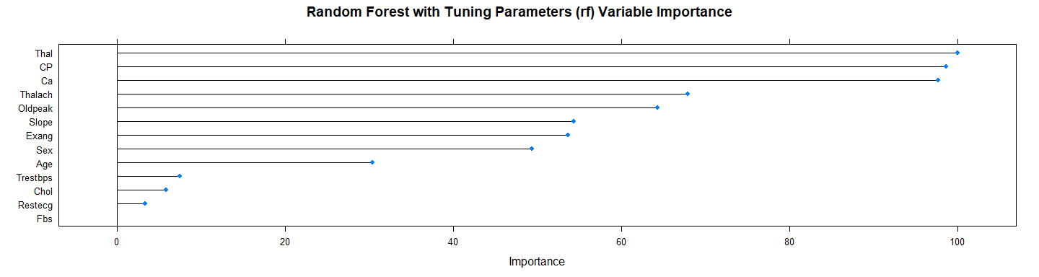

**plot**(**varImp**(randomf**$**finalModel), main = **paste0**(model.name," Variable Importance"))

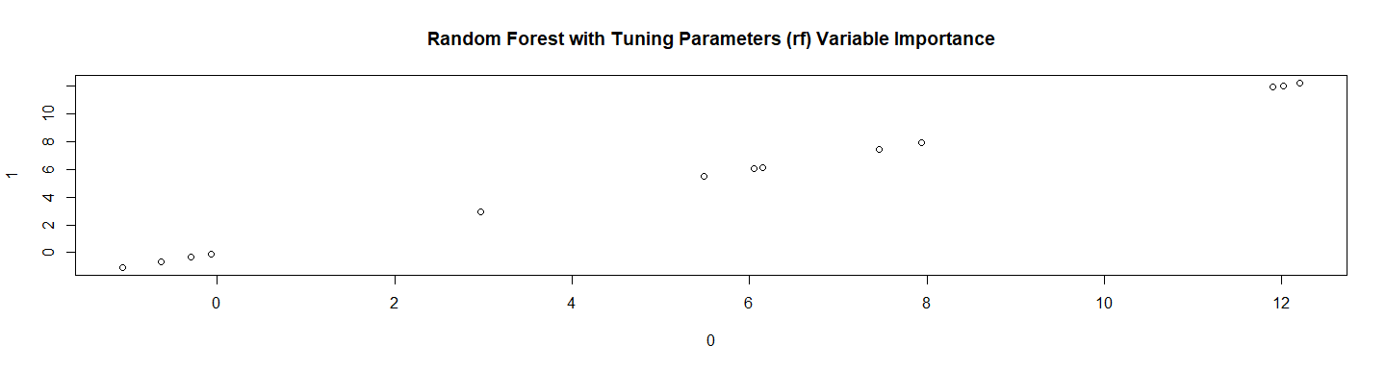

**plot**(randomf, main = model.name)

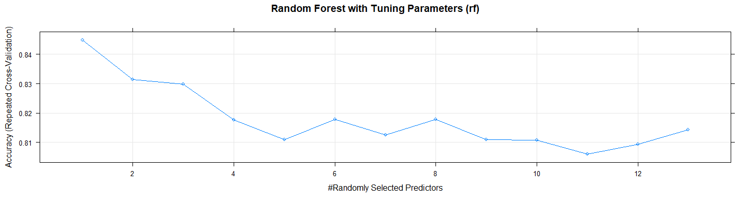

*# Let's use the model in test set*  
test_pred_randomf <- **predict**(randomf, newdata = X.testData)  
test_pred_randomf

## [1] 1 0 0 0 1 0 0 0 0 0 1 1 0 0 0 0 0 1 0 0 1 1 0 0 1 0 0 0 0 0 0 0 1 0 0  
## [36] 1 0 1 0 1 1 0 0 1 0 0 0 0 1 0 0 0 1 1 0 1 0 1 0 0 0 1 0 0 1 0 1 1 0 1  
## [71] 1 1 0 0 1 0 1 1 1 0 0 1 0 0 1 0 1 0 0 1 1 0 1 1 1 0 0 0 0  
## Levels: 0 1

res.randomf <- **confusionMatrix**(test_pred_randomf, Y.testData)  
res.randomf

## Confusion Matrix and Statistics  
##   
## Reference  
## Prediction 0 1  
## 0 49 12  
## 1 4 34  
##   
## Accuracy : 0.838   
## 95% CI : (0.751, 0.905)  
## No Information Rate : 0.535   
## P-Value [Acc > NIR] : 2.04e-10   
##   
## Kappa : 0.671   
## Mcnemar's Test P-Value : 0.0801   
##   
## Sensitivity : 0.925   
## Specificity : 0.739   
## Pos Pred Value : 0.803   
## Neg Pred Value : 0.895   
## Prevalence : 0.535   
## Detection Rate : 0.495   
## Detection Prevalence : 0.616   
## Balanced Accuracy : 0.832   
##   
## 'Positive' Class : 0   
##

**print_confusionm**(res.randomf,   
 main = **paste0**("Confusion Matrix: ",model.name," (Test Set)"),   
 labels = **c**("Healthy", "Non-Healthy"))

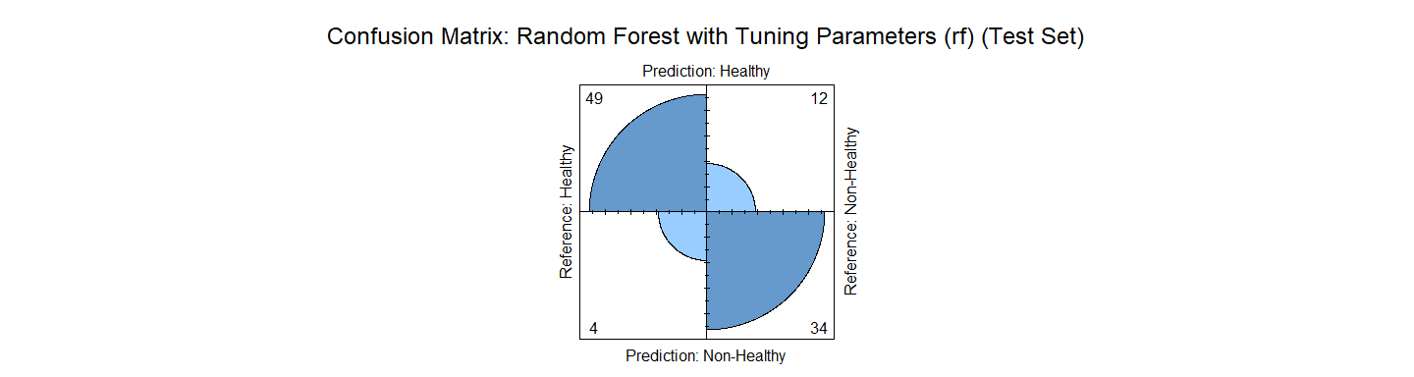

main <- **paste0**(model.name," Classification/Misclassification in Test Set by\n",  
 "Heart Disease Status: number of major vessels with >50% narrowing ",  
 "(0=Healthy,1,2,3, or 4)")  
  
  
**plot_results_by_type**(test_pred_randomf,  
 Y.testData,  
 main, testData)

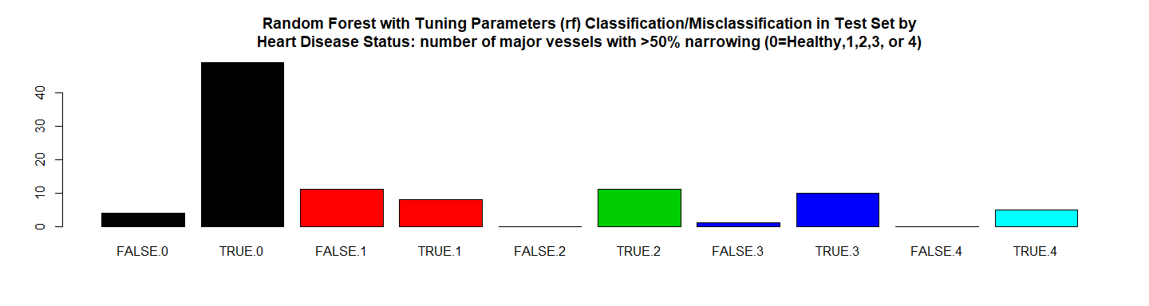

*# RMSE Resulting*  
(rmse_randomf <- **sqrt**(**mean**((**as.numeric**(test_pred_randomf)**-as.numeric**(Y.testData))**^**2)))

## [1] 0.402

*# Residuals Plot*  
(r_randomf <- (**as.numeric**(test_pred_randomf)**-as.numeric**(Y.testData)))

## [1] 0 0 0 0 0 0 0 0 0 -1 0 0 0 0 0 0 0 0 0 0 0 0 -1  
## [24] 0 0 -1 0 -1 0 -1 0 0 0 0 0 0 0 0 0 0 0 0 0 0 0 0  
## [47] 0 0 0 0 0 0 0 0 0 0 0 0 0 0 0 0 0 -1 1 -1 0 1 0  
## [70] 0 0 0 0 0 1 0 0 0 0 -1 0 0 0 0 0 0 1 0 0 0 0 -1  
## [93] 0 0 0 -1 0 -1 -1

**plot**(r_randomf, main = model.name,xlab = "", ylab = "")

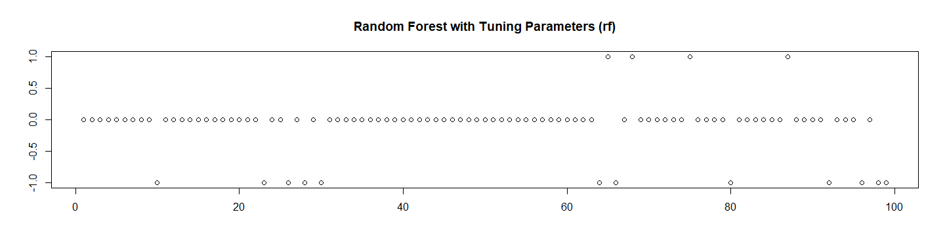

*# Let's check the probabilities and Calculate the ROC*  
test_pred_randomf_prob <- **predict**(randomf, newdata = X.testData, type ="prob")[2]  
  
res.randomf.roc <- **roc**(**as.numeric**(Y.testData),  
 **as.numeric**(  
 **as.matrix**(test_pred_randomf_prob)))**$**auc  
  
*# Store the Values for Report*  
results_all <- **rbind**(results_all,  
 **data.frame**("Method"= model.name,  
 "Prediction Accuracy in Training Set" =   
 **max**(randomf**$**results**$**Accuracy, na.rm = TRUE),  
 "Prediction Accuracy in Test Set" = res.randomf**$**overall[1],  
 "RMSE Test"= rmse_randomf,  
 "ROC" = res.randomf.roc,  
 "Time Elapsed" = et,  
 stringsAsFactors = FALSE))

## 12.2 Random Forest Boosted Tree (bstTree)

############################################  
## 12.2 Random Forest Boosted Tree (bstTree)  
model.name <- "Random Forest Boosted Tree (bstTree)"  
model.name13 <- model.name  
file.name <- **paste**(work.dir, "ramdonf2.Rds", sep="/")   
file.name.et <- **paste**(work.dir, "randomf2-et.Rds", sep="/")  
  
**if** (**file.exists**(file.name)) {  
 **load**(file.name,.GlobalEnv)  
 **load**(file.name.et,.GlobalEnv)  
} **else** {  
   
 t1 <- **proc.time**()  
 grid_randomf2 <- **expand.grid**(maxdepth = **c**(1,2,3), mstop = **c**(50,100,150,200), nu = **c**(0.1,0.2,0.3))  
 randomf2 <- **train**(y = **factor**(Y.trainData),   
 x = X.trainData,  
 method="bstTree",  
 preProcess = **c**("center", "scale"),  
 tuneGrid = grid_randomf2,  
 trControl=trctrl)   
   
 t2 <- **proc.time**()  
 et <- **elapsed_time**(t1,t2)  
 **print**(**paste0**(model.name," Executed ... time:", et))  
 **save**(randomf2, file = file.name)  
 **save**(et, file = file.name.et)  
}

## [1] "Random Forest Boosted Tree (bstTree) Executed ... time:425"

Let’s see the results:

*# Let's see some details about the model*  
randomf2

## Boosted Tree   
##   
## 198 samples  
## 13 predictor  
## 2 classes: '0', '1'   
##   
## Pre-processing: centered (13), scaled (13)   
## Resampling: Cross-Validated (10 fold, repeated 3 times)   
## Summary of sample sizes: 178, 179, 178, 179, 178, 178, ...   
## Resampling results across tuning parameters:  
##   
## maxdepth nu mstop Accuracy Kappa   
## 1 0.1 50 0.7339 0.4646  
## 1 0.1 100 0.7339 0.4646  
## 1 0.1 150 0.7339 0.4646  
## 1 0.1 200 0.7372 0.4709  
## 1 0.2 50 0.7339 0.4646  
## 1 0.2 100 0.7339 0.4646  
## 1 0.2 150 0.7645 0.5238  
## 1 0.2 200 0.8096 0.6148  
## 1 0.3 50 0.7355 0.4678  
## 1 0.3 100 0.7610 0.5173  
## 1 0.3 150 0.8165 0.6288  
## 1 0.3 200 0.8283 0.6530  
## 2 0.1 50 0.7976 0.5866  
## 2 0.1 100 0.8094 0.6121  
## 2 0.1 150 0.8178 0.6294  
## 2 0.1 200 0.8126 0.6194  
## 2 0.2 50 0.8128 0.6199  
## 2 0.2 100 0.8178 0.6301  
## 2 0.2 150 0.8078 0.6100  
## 2 0.2 200 0.8047 0.6036  
## 2 0.3 50 0.8062 0.6064  
## 2 0.3 100 0.8146 0.6235  
## 2 0.3 150 0.8014 0.5973  
## 2 0.3 200 0.7997 0.5943  
## 3 0.1 50 0.8230 0.6419  
## 3 0.1 100 0.8248 0.6455  
## 3 0.1 150 0.8162 0.6288  
## 3 0.1 200 0.8079 0.6121  
## 3 0.2 50 0.8247 0.6453  
## 3 0.2 100 0.8063 0.6090  
## 3 0.2 150 0.8048 0.6059  
## 3 0.2 200 0.8014 0.5995  
## 3 0.3 50 0.8282 0.6523  
## 3 0.3 100 0.8145 0.6255  
## 3 0.3 150 0.7927 0.5816  
## 3 0.3 200 0.7880 0.5727  
##   
## Accuracy was used to select the optimal model using the largest value.  
## The final values used for the model were mstop = 200, maxdepth = 1 and  
## nu = 0.3.

**summary**(randomf2)

## Length Class Mode   
## y 198 -none- numeric   
## x 13 data.frame list   
## cost 1 -none- numeric   
## family 1 -none- character  
## learner 1 -none- character  
## yhat 198 -none- numeric   
## offset 1 -none- numeric   
## ens 200 -none- list   
## control.tree 1 -none- list   
## risk 200 -none- numeric   
## ctrl 19 bst_control list   
## maxdepth 1 -none- numeric   
## xselect 9 -none- numeric   
## coef 200 -none- logical   
## ensemble 200 -none- list   
## ml.fit 14 rpart list   
## meanx 198 -none- numeric   
## int 0 -none- NULL   
## call 7 -none- call   
## xNames 13 -none- character  
## problemType 1 -none- character  
## tuneValue 3 data.frame list   
## obsLevels 2 -none- character  
## param 0 -none- list

**plot**(**varImp**(randomf2), main = **paste0**(model.name," Variable Importance"))

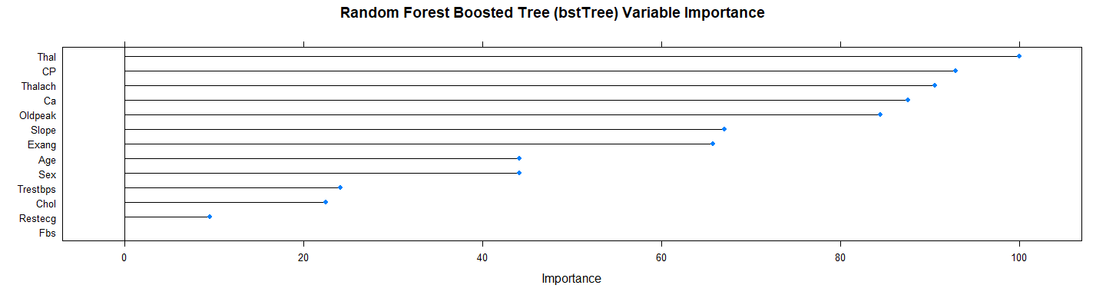

**plot**(randomf2, main = model.name)

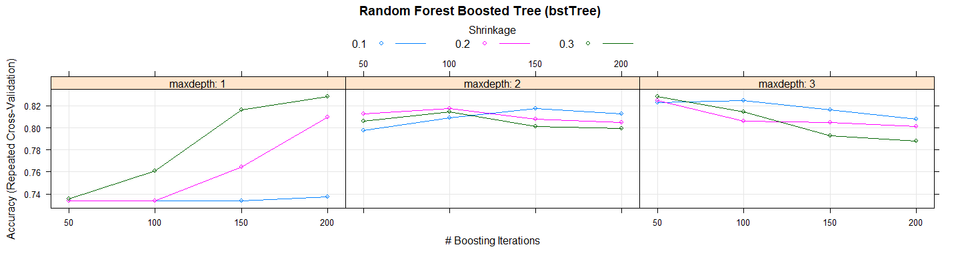

*# Let's use the model in test set*  
test_pred_randomf2 <- **predict**(randomf2, newdata = X.testData)  
test_pred_randomf2

## [1] 1 0 0 0 1 0 0 0 0 0 1 1 0 0 1 0 0 1 0 1 1 1 1 0 1 0 0 0 0 0 0 0 1 0 0  
## [36] 0 0 1 0 1 1 0 0 1 0 0 0 0 1 0 0 0 0 1 0 1 0 0 0 0 1 1 0 0 1 1 1 1 0 1  
## [71] 1 1 0 0 1 0 1 0 1 0 0 1 0 0 0 0 1 0 0 1 1 0 1 1 1 0 0 0 0  
## Levels: 0 1

res.randomf2 <- **confusionMatrix**(test_pred_randomf2, Y.testData)  
res.randomf2

## Confusion Matrix and Statistics  
##   
## Reference  
## Prediction 0 1  
## 0 46 15  
## 1 7 31  
##   
## Accuracy : 0.778   
## 95% CI : (0.683, 0.855)  
## No Information Rate : 0.535   
## P-Value [Acc > NIR] : 5.07e-07   
##   
## Kappa : 0.548   
## Mcnemar's Test P-Value : 0.136   
##   
## Sensitivity : 0.868   
## Specificity : 0.674   
## Pos Pred Value : 0.754   
## Neg Pred Value : 0.816   
## Prevalence : 0.535   
## Detection Rate : 0.465   
## Detection Prevalence : 0.616   
## Balanced Accuracy : 0.771   
##   
## 'Positive' Class : 0   
##

**print_confusionm**(res.randomf2,   
 main = **paste0**("Confusion Matrix: ",model.name," (Test Set)"),   
 labels = **c**("Healthy", "Non-Healthy"))

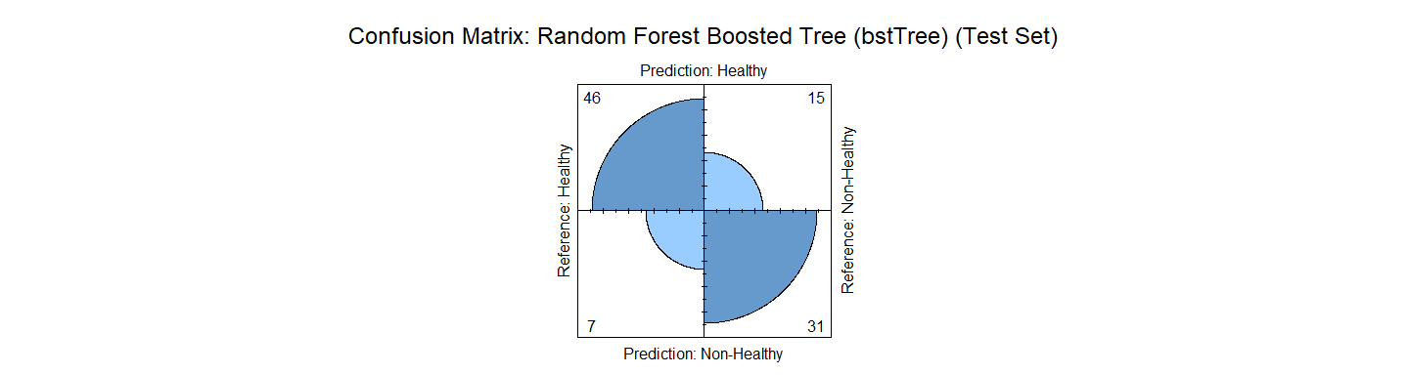

main <- **paste0**(model.name," Classification/Misclassification in Test Set by\n",  
 "Heart Disease Status: number of major vessels with >50% narrowing ",  
 "(0=Healthy,1,2,3, or 4)")  
  
  
**plot_results_by_type**(test_pred_randomf2,   
 Y.testData,  
 main, testData)

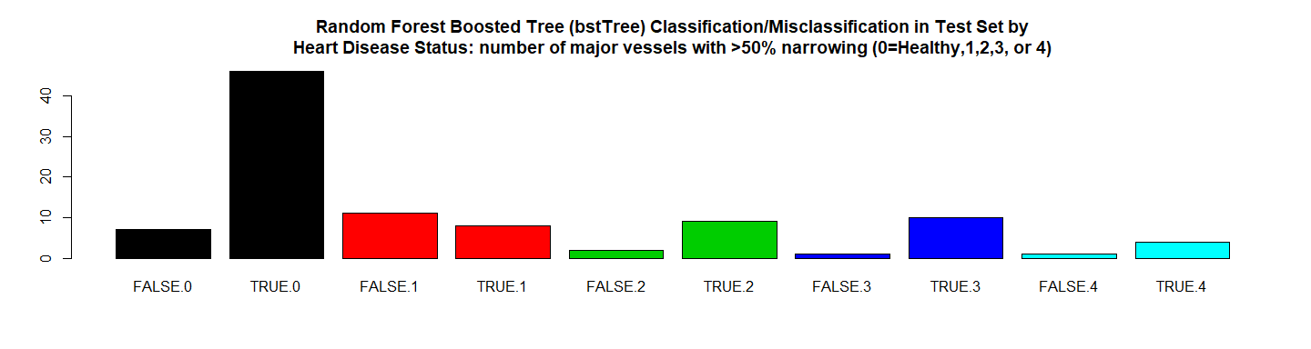

*# RMSE Resulting*  
(rmse_randomf2 <- **sqrt**(**mean**((**as.numeric**(test_pred_randomf2)**-as.numeric**(Y.testData))**^**2)))

## [1] 0.4714

*# Residuals Plot*  
(r_randomf2 <- (**as.numeric**(test_pred_randomf2)**-as.numeric**(Y.testData)))

## [1] 0 0 0 0 0 0 0 0 0 -1 0 0 0 0 1 0 0 0 0 1 0 0 0  
## [24] 0 0 -1 0 -1 0 -1 0 0 0 0 0 -1 0 0 0 0 0 0 0 0 0 0  
## [47] 0 0 0 0 0 0 -1 0 0 0 0 -1 0 0 1 0 0 -1 1 0 0 1 0  
## [70] 0 0 0 0 0 1 0 0 -1 0 -1 0 0 0 0 -1 0 1 0 0 0 0 -1  
## [93] 0 0 0 -1 0 -1 -1

**plot**(r_randomf2, main = model.name,xlab = "", ylab = "")

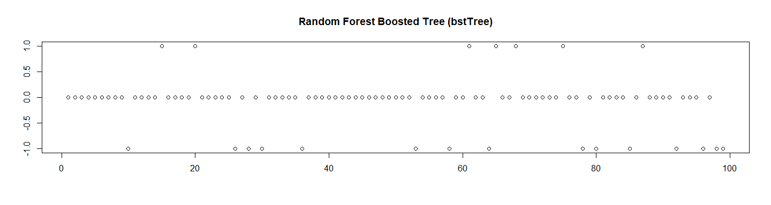

*# Store the Values for Report*  
results_all <- **rbind**(results_all,  
 **data.frame**("Method"= model.name,  
 "Prediction Accuracy in Training Set" =   
 **max**(randomf2**$**results**$**Accuracy, na.rm = TRUE),  
 "Prediction Accuracy in Test Set" = res.randomf2**$**overall[1],  
 "RMSE Test"= rmse_randomf2,  
 "ROC" = NA,  
 "Time Elapsed" = et,  
 stringsAsFactors = FALSE))

## 12.3 Random Forest Boost with Tuning Parameters (gbm)

############################################  
## 12.3 Random Forest Boost with Tuning Parameters (gbm)  
model.name <- "Random Forest Boost with Tuning Parameters (gbm)"  
model.name14 <- model.name  
file.name <- **paste**(work.dir, "ramdonf3.Rds", sep="/")  
file.name.et <- **paste**(work.dir, "randomf3-et.Rds", sep="/")  
  
**if** (**file.exists**(file.name)) {  
 **load**(file.name,.GlobalEnv)  
 **load**(file.name.et,.GlobalEnv)  
} **else** {  
 objControl <- **trainControl**(method='cv', number=10, repeats = 10)  
 grid_randomf3 <- **expand.grid**(interaction.depth = **c**(1, 5, 9),  
 n.trees = (1**:**30)**\***50,  
 shrinkage = 0.1,  
 n.minobsinnode =10)  
   
 t1 <- **proc.time**()  
 randomf3 <- **train**(y = **factor**(Y.trainData),   
 x = X.trainData,  
 method="gbm",  
 trControl=trctrl,   
 tuneGrid = grid_randomf3,  
 verbose=FALSE)  
 t2 <- **proc.time**()  
 et <- **elapsed_time**(t1,t2)  
 **print**(**paste0**(model.name, " Executed ... time:", et))  
 **save**(randomf3, file = file.name)  
 **save**(et, file = file.name.et)  
}

## [1] "Random Forest Boost with Tuning Parameters (gbm) Executed ... time:29"

Let’s see the results:

*# Let's see some details about the model*  
randomf3

## Stochastic Gradient Boosting   
##   
## 198 samples  
## 13 predictor  
## 2 classes: '0', '1'   
##   
## No pre-processing  
## Resampling: Cross-Validated (10 fold, repeated 3 times)   
## Summary of sample sizes: 178, 179, 178, 179, 177, 178, ...   
## Resampling results across tuning parameters:  
##   
## interaction.depth n.trees Accuracy Kappa   
## 1 50 0.8386 0.6739  
## 1 100 0.8469 0.6908  
## 1 150 0.8282 0.6531  
## 1 200 0.8114 0.6206  
## 1 250 0.8011 0.5998  
## 1 300 0.8011 0.6000  
## 1 350 0.8077 0.6128  
## 1 400 0.8045 0.6072  
## 1 450 0.8043 0.6069  
## 1 500 0.7977 0.5931  
## 1 550 0.7995 0.5970  
## 1 600 0.7879 0.5750  
## 1 650 0.7912 0.5808  
## 1 700 0.7912 0.5807  
## 1 750 0.7811 0.5603  
## 1 800 0.7794 0.5572  
## 1 850 0.7828 0.5641  
## 1 900 0.7760 0.5506  
## 1 950 0.7745 0.5473  
## 1 1000 0.7675 0.5336  
## 1 1050 0.7710 0.5400  
## 1 1100 0.7710 0.5398  
## 1 1150 0.7691 0.5360  
## 1 1200 0.7675 0.5325  
## 1 1250 0.7759 0.5493  
## 1 1300 0.7709 0.5397  
## 1 1350 0.7710 0.5398  
## 1 1400 0.7742 0.5462  
## 1 1450 0.7741 0.5463  
## 1 1500 0.7692 0.5364  
## 5 50 0.8197 0.6372  
## 5 100 0.7945 0.5860  
## 5 150 0.7778 0.5531  
## 5 200 0.7758 0.5490  
## 5 250 0.7842 0.5656  
## 5 300 0.7842 0.5651  
## 5 350 0.7743 0.5456  
## 5 400 0.7726 0.5424  
## 5 450 0.7760 0.5491  
## 5 500 0.7827 0.5627  
## 5 550 0.7810 0.5592  
## 5 600 0.7695 0.5362  
## 5 650 0.7693 0.5362  
## 5 700 0.7744 0.5454  
## 5 750 0.7676 0.5325  
## 5 800 0.7675 0.5330  
## 5 850 0.7727 0.5435  
## 5 900 0.7676 0.5327  
## 5 950 0.7643 0.5260  
## 5 1000 0.7693 0.5360  
## 5 1050 0.7676 0.5326  
## 5 1100 0.7709 0.5393  
## 5 1150 0.7709 0.5392  
## 5 1200 0.7742 0.5456  
## 5 1250 0.7743 0.5466  
## 5 1300 0.7793 0.5571  
## 5 1350 0.7776 0.5531  
## 5 1400 0.7760 0.5497  
## 5 1450 0.7742 0.5458  
## 5 1500 0.7761 0.5495  
## 9 50 0.8095 0.6159  
## 9 100 0.7943 0.5853  
## 9 150 0.7944 0.5856  
## 9 200 0.7959 0.5888  
## 9 250 0.7892 0.5750  
## 9 300 0.7891 0.5752  
## 9 350 0.7839 0.5646  
## 9 400 0.7872 0.5711  
## 9 450 0.7922 0.5818  
## 9 500 0.7856 0.5688  
## 9 550 0.7840 0.5649  
## 9 600 0.7824 0.5622  
## 9 650 0.7891 0.5761  
## 9 700 0.7841 0.5656  
## 9 750 0.7857 0.5690  
## 9 800 0.7891 0.5762  
## 9 850 0.7927 0.5829  
## 9 900 0.7942 0.5862  
## 9 950 0.7909 0.5795  
## 9 1000 0.7959 0.5897  
## 9 1050 0.7892 0.5760  
## 9 1100 0.7909 0.5794  
## 9 1150 0.7927 0.5830  
## 9 1200 0.7927 0.5830  
## 9 1250 0.7960 0.5897  
## 9 1300 0.7961 0.5899  
## 9 1350 0.7945 0.5865  
## 9 1400 0.7977 0.5933  
## 9 1450 0.7977 0.5933  
## 9 1500 0.7944 0.5862  
##   
## Tuning parameter 'shrinkage' was held constant at a value of 0.1  
##   
## Tuning parameter 'n.minobsinnode' was held constant at a value of 10  
## Accuracy was used to select the optimal model using the largest value.  
## The final values used for the model were n.trees = 100,  
## interaction.depth = 1, shrinkage = 0.1 and n.minobsinnode = 10.

**summary**(randomf3)

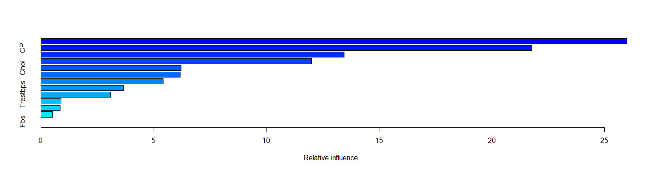

## var rel.inf  
## Thal Thal 25.9931  
## CP CP 21.7730  
## Ca Ca 13.4401  
## Thalach Thalach 12.0016  
## Chol Chol 6.2083  
## Oldpeak Oldpeak 6.1773  
## Age Age 5.4220  
## Exang Exang 3.6567  
## Trestbps Trestbps 3.0648  
## Slope Slope 0.8892  
## Sex Sex 0.8579  
## Restecg Restecg 0.5160  
## Fbs Fbs 0.0000

**plot**(**varImp**(randomf3),   
 main = **paste0**(model.name," Variable Importance"))

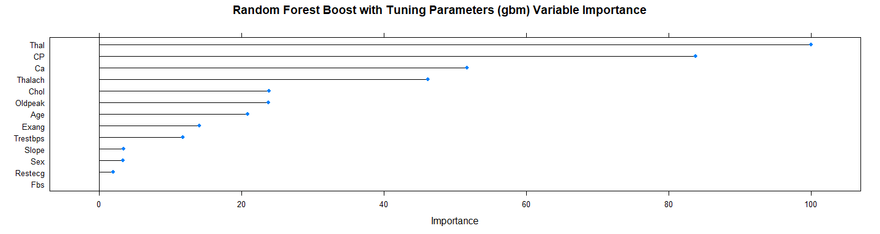

**plot**(randomf3, main = model.name)

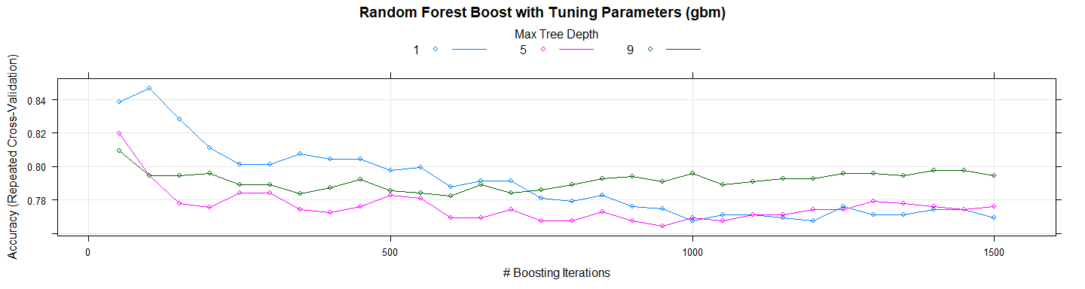

*# Let's use the model in test set*  
test_pred_randomf3 <- **predict**(randomf3, newdata = X.testData)  
test_pred_randomf3

## [1] 1 0 0 0 1 0 0 0 0 0 1 1 0 0 1 0 0 1 0 0 1 1 1 0 1 0 0 0 0 0 0 0 1 0 0  
## [36] 0 0 1 0 1 1 0 0 1 0 0 0 0 1 0 0 0 1 1 0 1 0 1 0 0 1 1 0 1 1 1 1 1 0 1  
## [71] 1 1 0 0 1 0 1 0 1 0 0 1 0 0 1 0 1 0 0 1 1 0 1 1 1 0 0 1 0  
## Levels: 0 1

res.randomf3 <- **confusionMatrix**(test_pred_randomf3, Y.testData)  
res.randomf3

## Confusion Matrix and Statistics  
##   
## Reference  
## Prediction 0 1  
## 0 47 10  
## 1 6 36  
##   
## Accuracy : 0.838   
## 95% CI : (0.751, 0.905)  
## No Information Rate : 0.535   
## P-Value [Acc > NIR] : 2.04e-10   
##   
## Kappa : 0.673   
## Mcnemar's Test P-Value : 0.453   
##   
## Sensitivity : 0.887   
## Specificity : 0.783   
## Pos Pred Value : 0.825   
## Neg Pred Value : 0.857   
## Prevalence : 0.535   
## Detection Rate : 0.475   
## Detection Prevalence : 0.576   
## Balanced Accuracy : 0.835   
##   
## 'Positive' Class : 0   
##

**print_confusionm**(res.randomf3,   
 main = **paste0**("Confusion Matrix: ",model.name," (Test Set)"),   
 labels = **c**("Healthy", "Non-Healthy"))

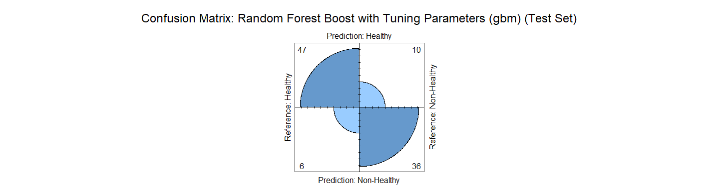

main <- **paste0**(model.name," Classification/Misclassification in Test Set by\n",  
 "Heart Disease Status: number of major vessels with >50% narrowing ",  
 "(0=Healthy,1,2,3, or 4)")  
  
  
**plot_results_by_type**(test_pred_randomf3,  
 Y.testData,  
 main, testData)

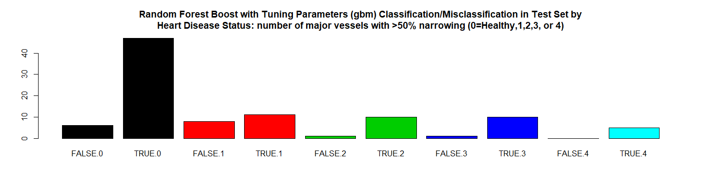

*# RMSE Resulting*  
(rmse_randomf3 <- **sqrt**(**mean**((**as.numeric**(test_pred_randomf3)**-as.numeric**(Y.testData))**^**2)))

## [1] 0.402

*# Residuals Plot*  
(r_randomf3 <- (**as.numeric**(test_pred_randomf3)**-as.numeric**(Y.testData)))

## [1] 0 0 0 0 0 0 0 0 0 -1 0 0 0 0 1 0 0 0 0 0 0 0 0  
## [24] 0 0 -1 0 -1 0 -1 0 0 0 0 0 -1 0 0 0 0 0 0 0 0 0 0  
## [47] 0 0 0 0 0 0 0 0 0 0 0 0 0 0 1 0 0 0 1 0 0 1 0  
## [70] 0 0 0 0 0 1 0 0 -1 0 -1 0 0 0 0 0 0 1 0 0 0 0 -1  
## [93] 0 0 0 -1 0 0 -1

**plot**(r_randomf3, main = model.name,xlab = "", ylab = "")

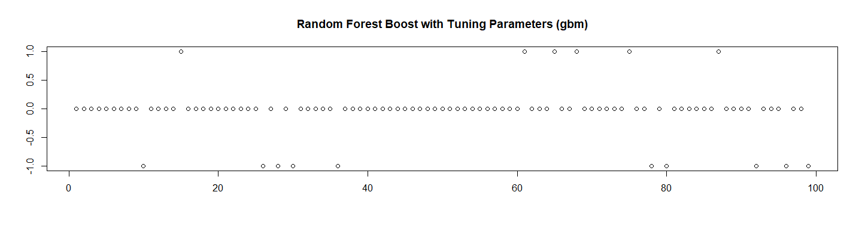

*# Let's check the probabilities and Calculate the ROC*  
test_pred_randomf3_prob <- **predict**(randomf3, newdata = X.testData, type ="prob")[2]  
  
res.randomf3.roc <- **roc**(**as.numeric**(Y.testData),  
 **as.numeric**(  
 **as.matrix**(test_pred_randomf3_prob)))**$**auc  
  
*# Store the Values for Report*  
results_all <- **rbind**(results_all,  
 **data.frame**("Method"= model.name,  
 "Prediction Accuracy in Training Set" =   
 **max**(randomf3**$**results**$**Accuracy, na.rm = TRUE),  
 "Prediction Accuracy in Test Set" = res.randomf3**$**overall[1],  
 "RMSE Test"= rmse_randomf3,  
 "ROC" = res.randomf3.roc,  
 "Time Elapsed" = et,  
 stringsAsFactors = FALSE))

## 12.4 Random Forest with Stochastic Gradient Boost (gbm)

############################################  
## 12.4 Random Forest with Stochastic Gradient Boost (gbm)  
model.name <- "Random Forest with Stochastic Gradient Boost (gbm)"  
model.name15 <- model.name  
file.name <- **paste**(work.dir, "ramdonf4.Rds", sep="/")  
file.name.et <- **paste**(work.dir, "randomf4-et.Rds", sep="/")  
Y.trainData.names <- **factor**(**make.names**(Y.trainData))  
Y.testData.names <- **factor**(**make.names**(Y.testData))  
  
**if** (**file.exists**(file.name)) {  
 **load**(file.name,.GlobalEnv)  
 **load**(file.name.et,.GlobalEnv)  
} **else** {  
 grid_randomf4 <- **expand.grid**(interaction.depth = **c**(1, 5, 9),  
 n.trees = (1**:**30)**\***50,  
 shrinkage = 0.1,  
 n.minobsinnode =10)  
 trctrl2 <- **trainControl**(method = "repeatedcv",  
 number = 10,  
 repeats = 10,  
 ## Estimate class probabilities  
 classProbs = TRUE,  
 ## Evaluate performance using  
 ## the following function  
 summaryFunction = twoClassSummary)  
   
 t1 <- **proc.time**()  
 randomf4 <- **train**(y = **factor**(Y.trainData.names),   
 x = X.trainData,  
 method="gbm",  
 trControl=trctrl2,   
 tuneGrid = grid_randomf4,  
 verbose=FALSE,  
 metric = "ROC")  
 t2 <- **proc.time**()  
 et <- **elapsed_time**(t1,t2)  
 **print**(**paste0**(model.name," Executed ... time:", et))  
 **save**(randomf4, file = file.name)  
 **save**(et, file = file.name.et)  
}

## [1] "Random Forest with Stochastic Gradient Boost (gbm) Executed ... time:96"

Let’s see the results:

*# Let's see some details about the model*  
randomf4

## Stochastic Gradient Boosting   
##   
## 198 samples  
## 13 predictor  
## 2 classes: 'X0', 'X1'   
##   
## No pre-processing  
## Resampling: Cross-Validated (10 fold, repeated 10 times)   
## Summary of sample sizes: 178, 178, 177, 178, 179, 178, ...   
## Resampling results across tuning parameters:  
##   
## interaction.depth n.trees ROC Sens Spec   
## 1 50 0.9053 0.8954 0.7850  
## 1 100 0.9032 0.8891 0.7886  
## 1 150 0.9032 0.8697 0.7930  
## 1 200 0.8978 0.8614 0.7864  
## 1 250 0.8941 0.8462 0.7920  
## 1 300 0.8894 0.8366 0.7919  
## 1 350 0.8873 0.8293 0.7890  
## 1 400 0.8804 0.8273 0.7811  
## 1 450 0.8764 0.8170 0.7778  
## 1 500 0.8739 0.8132 0.7767  
## 1 550 0.8736 0.8107 0.7733  
## 1 600 0.8688 0.8079 0.7712  
## 1 650 0.8653 0.8095 0.7681  
## 1 700 0.8646 0.8134 0.7659  
## 1 750 0.8611 0.8050 0.7616  
## 1 800 0.8582 0.8051 0.7604  
## 1 850 0.8561 0.8096 0.7614  
## 1 900 0.8538 0.8024 0.7498  
## 1 950 0.8529 0.8051 0.7494  
## 1 1000 0.8514 0.8041 0.7541  
## 1 1050 0.8516 0.8041 0.7452  
## 1 1100 0.8501 0.7976 0.7441  
## 1 1150 0.8497 0.8022 0.7508  
## 1 1200 0.8485 0.8005 0.7463  
## 1 1250 0.8454 0.7995 0.7397  
## 1 1300 0.8454 0.7985 0.7440  
## 1 1350 0.8441 0.8004 0.7374  
## 1 1400 0.8412 0.7968 0.7398  
## 1 1450 0.8409 0.7966 0.7386  
## 1 1500 0.8388 0.7938 0.7410  
## 5 50 0.8897 0.8551 0.7643  
## 5 100 0.8825 0.8281 0.7621  
## 5 150 0.8763 0.8311 0.7611  
## 5 200 0.8723 0.8225 0.7536  
## 5 250 0.8683 0.8185 0.7469  
## 5 300 0.8671 0.8133 0.7459  
## 5 350 0.8649 0.8197 0.7417  
## 5 400 0.8634 0.8123 0.7450  
## 5 450 0.8622 0.8122 0.7417  
## 5 500 0.8609 0.8104 0.7417  
## 5 550 0.8602 0.8059 0.7437  
## 5 600 0.8606 0.8050 0.7427  
## 5 650 0.8590 0.8049 0.7394  
## 5 700 0.8583 0.8021 0.7472  
## 5 750 0.8572 0.8069 0.7461  
## 5 800 0.8560 0.8050 0.7397  
## 5 850 0.8558 0.8052 0.7427  
## 5 900 0.8552 0.8051 0.7439  
## 5 950 0.8556 0.8114 0.7426  
## 5 1000 0.8553 0.8067 0.7396  
## 5 1050 0.8566 0.8078 0.7406  
## 5 1100 0.8563 0.8067 0.7416  
## 5 1150 0.8552 0.8028 0.7427  
## 5 1200 0.8544 0.8029 0.7404  
## 5 1250 0.8539 0.8076 0.7372  
## 5 1300 0.8542 0.8085 0.7372  
## 5 1350 0.8554 0.8029 0.7404  
## 5 1400 0.8530 0.8029 0.7406  
## 5 1450 0.8528 0.8067 0.7426  
## 5 1500 0.8516 0.8020 0.7437  
## 9 50 0.8906 0.8618 0.7676  
## 9 100 0.8792 0.8336 0.7511  
## 9 150 0.8710 0.8262 0.7511  
## 9 200 0.8662 0.8234 0.7447  
## 9 250 0.8656 0.8274 0.7402  
## 9 300 0.8632 0.8198 0.7436  
## 9 350 0.8638 0.8144 0.7401  
## 9 400 0.8620 0.8227 0.7413  
## 9 450 0.8628 0.8144 0.7447  
## 9 500 0.8620 0.8108 0.7446  
## 9 550 0.8616 0.8116 0.7478  
## 9 600 0.8613 0.8125 0.7424  
## 9 650 0.8596 0.8116 0.7402  
## 9 700 0.8604 0.8096 0.7392  
## 9 750 0.8613 0.8050 0.7404  
## 9 800 0.8606 0.8069 0.7393  
## 9 850 0.8606 0.8095 0.7414  
## 9 900 0.8611 0.8088 0.7437  
## 9 950 0.8607 0.8080 0.7403  
## 9 1000 0.8606 0.8134 0.7470  
## 9 1050 0.8602 0.8070 0.7459  
## 9 1100 0.8588 0.8100 0.7437  
## 9 1150 0.8593 0.8051 0.7417  
## 9 1200 0.8590 0.8144 0.7394  
## 9 1250 0.8572 0.8095 0.7417  
## 9 1300 0.8582 0.8135 0.7407  
## 9 1350 0.8588 0.8162 0.7449  
## 9 1400 0.8577 0.8171 0.7503  
## 9 1450 0.8584 0.8189 0.7504  
## 9 1500 0.8585 0.8162 0.7481  
##   
## Tuning parameter 'shrinkage' was held constant at a value of 0.1  
##   
## Tuning parameter 'n.minobsinnode' was held constant at a value of 10  
## ROC was used to select the optimal model using the largest value.  
## The final values used for the model were n.trees = 50, interaction.depth  
## = 1, shrinkage = 0.1 and n.minobsinnode = 10.

**summary**(randomf4)

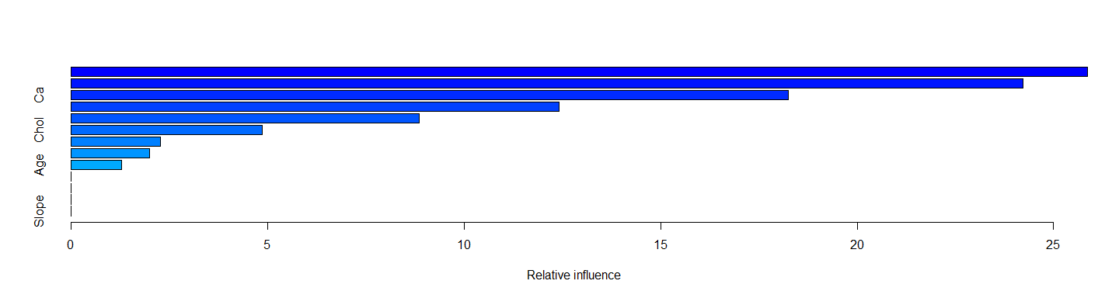

## var rel.inf  
## CP CP 25.864  
## Thal Thal 24.216  
## Ca Ca 18.252  
## Thalach Thalach 12.409  
## Oldpeak Oldpeak 8.851  
## Chol Chol 4.859  
## Trestbps Trestbps 2.271  
## Exang Exang 2.000  
## Age Age 1.279  
## Sex Sex 0.000  
## Fbs Fbs 0.000  
## Restecg Restecg 0.000  
## Slope Slope 0.000

**plot**(**varImp**(randomf4), main = **paste0**(model.name," Variable Importance"))

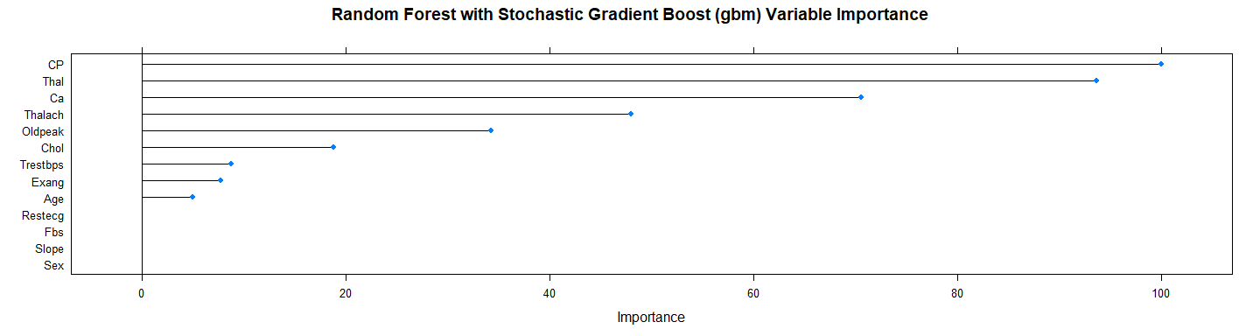

**plot**(randomf4, main = model.name)

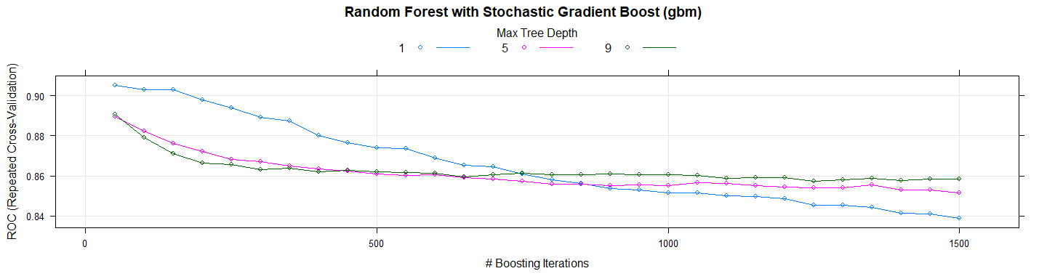

*# Let's use the model in test set*  
test_pred_randomf4 <- **predict**(randomf4, newdata = X.testData)  
test_pred_randomf4

## [1] X1 X0 X0 X0 X1 X0 X0 X0 X0 X0 X1 X1 X0 X0 X1 X0 X0 X1 X0 X1 X1 X1 X0  
## [24] X0 X1 X0 X0 X0 X0 X0 X0 X0 X1 X0 X0 X1 X0 X1 X0 X1 X1 X0 X0 X1 X0 X0  
## [47] X0 X0 X1 X0 X0 X0 X1 X1 X0 X1 X0 X1 X0 X0 X0 X1 X0 X0 X1 X1 X1 X1 X0  
## [70] X1 X1 X1 X0 X0 X1 X0 X1 X1 X1 X0 X0 X1 X0 X0 X0 X0 X1 X0 X0 X1 X1 X0  
## [93] X1 X1 X1 X0 X0 X0 X0  
## Levels: X0 X1

res.randomf4 <- **confusionMatrix**(test_pred_randomf4, Y.testData.names)  
res.randomf4

## Confusion Matrix and Statistics  
##   
## Reference  
## Prediction X0 X1  
## X0 47 12  
## X1 6 34  
##   
## Accuracy : 0.818   
## 95% CI : (0.728, 0.889)  
## No Information Rate : 0.535   
## P-Value [Acc > NIR] : 3.57e-09   
##   
## Kappa : 0.631   
## Mcnemar's Test P-Value : 0.239   
##   
## Sensitivity : 0.887   
## Specificity : 0.739   
## Pos Pred Value : 0.797   
## Neg Pred Value : 0.850   
## Prevalence : 0.535   
## Detection Rate : 0.475   
## Detection Prevalence : 0.596   
## Balanced Accuracy : 0.813   
##   
## 'Positive' Class : X0   
##

**print_confusionm**(res.randomf4,   
 main = **paste0**("Confusion Matrix: ", model.name," (Test Set)"),   
 labels = **c**("Healthy", "Non-Healthy"))

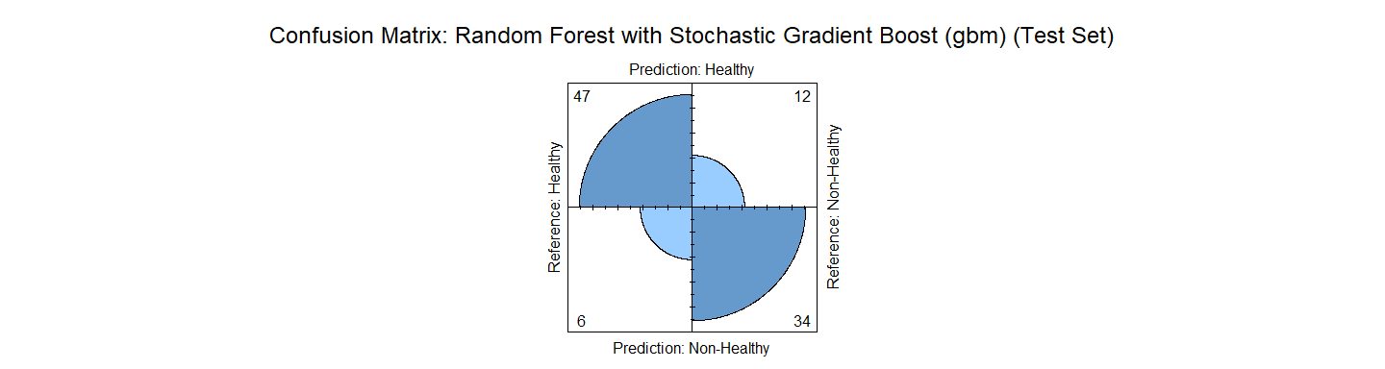

main <- **paste0**(model.name," Classification/Misclassification in Test Set by\n",  
 "Heart Disease Status: number of major vessels with >50% narrowing ",  
 "(0=Healthy,1,2,3, or 4)")  
  
**plot_results_by_type**(test_pred_randomf4,  
 **factor**(Y.testData.names),  
 main, testData)

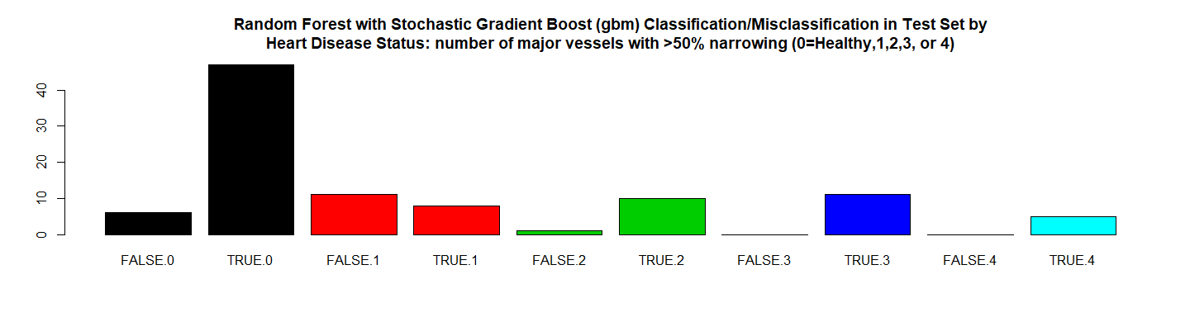

*# RMSE Resulting*  
(rmse_randomf4 <- **sqrt**(**mean**((**as.numeric**(test_pred_randomf4)**-as.numeric**(Y.testData.names))**^**2)))

## [1] 0.4264

*# Residuals Plot*  
(r_randomf4 <- (**as.numeric**(test_pred_randomf4)**-as.numeric**(Y.testData.names)))

## [1] 0 0 0 0 0 0 0 0 0 -1 0 0 0 0 1 0 0 0 0 1 0 0 -1  
## [24] 0 0 -1 0 -1 0 -1 0 0 0 0 0 0 0 0 0 0 0 0 0 0 0 0  
## [47] 0 0 0 0 0 0 0 0 0 0 0 0 0 0 0 0 0 -1 1 0 0 1 0  
## [70] 0 0 0 0 0 1 0 0 0 0 -1 0 0 0 0 -1 0 1 0 0 0 0 -1  
## [93] 0 0 0 -1 0 -1 -1

**plot**(r_randomf4, main = model.name,xlab = "", ylab = "")

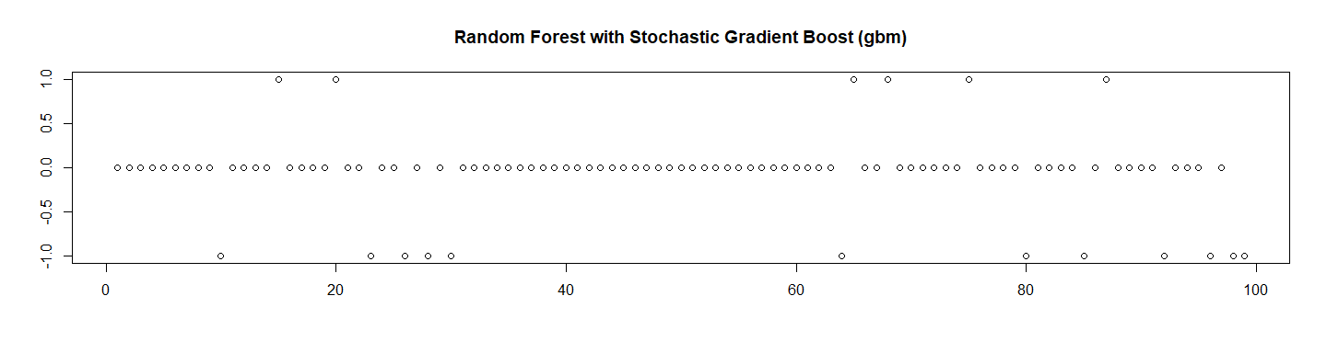

*# Let's check the probabilities and Calculate the ROC*  
test_pred_randomf4_prob <- **predict**(randomf4, newdata = X.testData, type ="prob")[2]  
  
res.randomf4.roc <- **roc**(**as.numeric**(Y.testData.names),  
 **as.numeric**(  
 **as.matrix**(test_pred_randomf4_prob)))**$**auc  
  
*# Store the Values for Report*  
results_all <- **rbind**(results_all,  
 **data.frame**("Method"= model.name,  
 "Prediction Accuracy in Training Set" =   
 **max**(randomf4**$**results**$**ROC, na.rm = TRUE),  
 "Prediction Accuracy in Test Set" = res.randomf4**$**overall[1],  
 "RMSE Test"= rmse_randomf4,  
 "ROC" = res.randomf4.roc,  
 "Time Elapsed" = et,  
 stringsAsFactors = FALSE))

# 13. Classification Tree (rpart)

############################################  
*# 13. Classification Tree (rpart)*  
model.name <- "Classification Tree (rpart)"  
model.name16 <- model.name  
heart.tree <- **rpart**(**factor**(Disease) **~** Age **+** Sex **+** CP **+** Trestbps **+** Chol **+** Fbs **+** Restecg **+**   
 Thalach **+** Exang **+** Oldpeak **+** Slope **+** Ca **+** Thal, method = "class",   
 data = trainData)  
  
heart.tree

## n= 198   
##   
## node), split, n, loss, yval, (yprob)  
## * denotes terminal node  
##   
## 1) root 198 91 0 (0.54040 0.45960)   
## 2) Thal< 4.5 108 22 0 (0.79630 0.20370)   
## 4) CP< 3.5 71 6 0 (0.91549 0.08451) *  
## 5) CP>=3.5 37 16 0 (0.56757 0.43243)   
## 10) Ca< 0.5 24 5 0 (0.79167 0.20833) *  
## 11) Ca>=0.5 13 2 1 (0.15385 0.84615) *  
## 3) Thal>=4.5 90 21 1 (0.23333 0.76667)   
## 6) CP< 3.5 28 12 0 (0.57143 0.42857)   
## 12) Thalach>=144 20 5 0 (0.75000 0.25000) *  
## 13) Thalach< 144 8 1 1 (0.12500 0.87500) *  
## 7) CP>=3.5 62 5 1 (0.08065 0.91935) *

**summary**(heart.tree)

## Call:  
## rpart(formula = factor(Disease) ~ Age + Sex + CP + Trestbps +   
## Chol + Fbs + Restecg + Thalach + Exang + Oldpeak + Slope +   
## Ca + Thal, data = trainData, method = "class")  
## n= 198   
##   
## CP nsplit rel error xerror xstd  
## 1 0.52747 0 1.0000 1.0000 0.07706  
## 2 0.05495 1 0.4725 0.5714 0.06805  
## 3 0.04945 3 0.3626 0.4945 0.06480  
## 4 0.01000 5 0.2637 0.4176 0.06089  
##   
## Variable importance  
## Thal CP Thalach Oldpeak Sex Slope Ca Age   
## 26 20 17 10 9 8 6 2   
## Chol Exang Trestbps   
## 1 1 1   
##   
## Node number 1: 198 observations, complexity param=0.5275  
## predicted class=0 expected loss=0.4596 P(node) =1  
## class counts: 107 91  
## probabilities: 0.540 0.460   
## left son=2 (108 obs) right son=3 (90 obs)  
## Primary splits:  
## Thal < 4.5 to the left, improve=31.12, (0 missing)  
## CP < 3.5 to the left, improve=30.56, (0 missing)  
## Thalach < 145.5 to the right, improve=21.79, (0 missing)  
## Ca < 0.5 to the left, improve=20.74, (0 missing)  
## Oldpeak < 1.95 to the left, improve=17.30, (0 missing)  
## Surrogate splits:  
## Thalach < 147.5 to the right, agree=0.697, adj=0.333, (0 split)  
## Sex < 0.5 to the left, agree=0.682, adj=0.300, (0 split)  
## Oldpeak < 1.7 to the left, agree=0.677, adj=0.289, (0 split)  
## CP < 3.5 to the left, agree=0.672, adj=0.278, (0 split)  
## Slope < 1.5 to the left, agree=0.672, adj=0.278, (0 split)  
##   
## Node number 2: 108 observations, complexity param=0.04945  
## predicted class=0 expected loss=0.2037 P(node) =0.5455  
## class counts: 86 22  
## probabilities: 0.796 0.204   
## left son=4 (71 obs) right son=5 (37 obs)  
## Primary splits:  
## CP < 3.5 to the left, improve=5.889, (0 missing)  
## Age < 58.5 to the left, improve=5.539, (0 missing)  
## Thalach < 127.5 to the right, improve=5.471, (0 missing)  
## Ca < 0.5 to the left, improve=4.971, (0 missing)  
## Chol < 267.5 to the left, improve=2.943, (0 missing)  
## Surrogate splits:  
## Thalach < 127.5 to the right, agree=0.722, adj=0.189, (0 split)  
## Exang < 0.5 to the left, agree=0.713, adj=0.162, (0 split)  
## Age < 60.5 to the left, agree=0.704, adj=0.135, (0 split)  
## Oldpeak < 2.1 to the left, agree=0.694, adj=0.108, (0 split)  
## Ca < 1.5 to the left, agree=0.685, adj=0.081, (0 split)  
##   
## Node number 3: 90 observations, complexity param=0.05495  
## predicted class=1 expected loss=0.2333 P(node) =0.4545  
## class counts: 21 69  
## probabilities: 0.233 0.767   
## left son=6 (28 obs) right son=7 (62 obs)  
## Primary splits:  
## CP < 3.5 to the left, improve=9.292, (0 missing)  
## Thalach < 145.5 to the right, improve=5.648, (0 missing)  
## Oldpeak < 0.9 to the left, improve=4.721, (0 missing)  
## Ca < 0.5 to the left, improve=4.635, (0 missing)  
## Exang < 0.5 to the left, improve=3.492, (0 missing)  
## Surrogate splits:  
## Thalach < 172 to the right, agree=0.756, adj=0.214, (0 split)  
## Trestbps < 109 to the left, agree=0.711, adj=0.071, (0 split)  
## Age < 67.5 to the right, agree=0.700, adj=0.036, (0 split)  
## Oldpeak < 0.7 to the left, agree=0.700, adj=0.036, (0 split)  
##   
## Node number 4: 71 observations  
## predicted class=0 expected loss=0.08451 P(node) =0.3586  
## class counts: 65 6  
## probabilities: 0.915 0.085   
##   
## Node number 5: 37 observations, complexity param=0.04945  
## predicted class=0 expected loss=0.4324 P(node) =0.1869  
## class counts: 21 16  
## probabilities: 0.568 0.432   
## left son=10 (24 obs) right son=11 (13 obs)  
## Primary splits:  
## Ca < 0.5 to the left, improve=6.861, (0 missing)  
## Age < 59.5 to the left, improve=4.952, (0 missing)  
## Oldpeak < 0.75 to the left, improve=3.668, (0 missing)  
## Thalach < 128 to the right, improve=2.722, (0 missing)  
## Chol < 266.5 to the left, improve=2.091, (0 missing)  
## Surrogate splits:  
## Oldpeak < 1.7 to the left, agree=0.784, adj=0.385, (0 split)  
## Thalach < 120 to the right, agree=0.757, adj=0.308, (0 split)  
## Age < 66.5 to the left, agree=0.703, adj=0.154, (0 split)  
## Chol < 266.5 to the left, agree=0.703, adj=0.154, (0 split)  
## Slope < 2.5 to the left, agree=0.703, adj=0.154, (0 split)  
##   
## Node number 6: 28 observations, complexity param=0.05495  
## predicted class=0 expected loss=0.4286 P(node) =0.1414  
## class counts: 16 12  
## probabilities: 0.571 0.429   
## left son=12 (20 obs) right son=13 (8 obs)  
## Primary splits:  
## Thalach < 144 to the right, improve=4.464, (0 missing)  
## Ca < 0.5 to the left, improve=2.381, (0 missing)  
## Chol < 228 to the left, improve=1.524, (0 missing)  
## Trestbps < 122 to the left, improve=1.339, (0 missing)  
## Slope < 1.5 to the left, improve=1.129, (0 missing)  
## Surrogate splits:  
## Sex < 0.5 to the right, agree=0.786, adj=0.250, (0 split)  
## Age < 58.5 to the left, agree=0.750, adj=0.125, (0 split)  
## Thal < 6.5 to the right, agree=0.750, adj=0.125, (0 split)  
##   
## Node number 7: 62 observations  
## predicted class=1 expected loss=0.08065 P(node) =0.3131  
## class counts: 5 57  
## probabilities: 0.081 0.919   
##   
## Node number 10: 24 observations  
## predicted class=0 expected loss=0.2083 P(node) =0.1212  
## class counts: 19 5  
## probabilities: 0.792 0.208   
##   
## Node number 11: 13 observations  
## predicted class=1 expected loss=0.1538 P(node) =0.06566  
## class counts: 2 11  
## probabilities: 0.154 0.846   
##   
## Node number 12: 20 observations  
## predicted class=0 expected loss=0.25 P(node) =0.101  
## class counts: 15 5  
## probabilities: 0.750 0.250   
##   
## Node number 13: 8 observations  
## predicted class=1 expected loss=0.125 P(node) =0.0404  
## class counts: 1 7  
## probabilities: 0.125 0.875

**prp**(heart.tree, extra = 100, main = model.name)

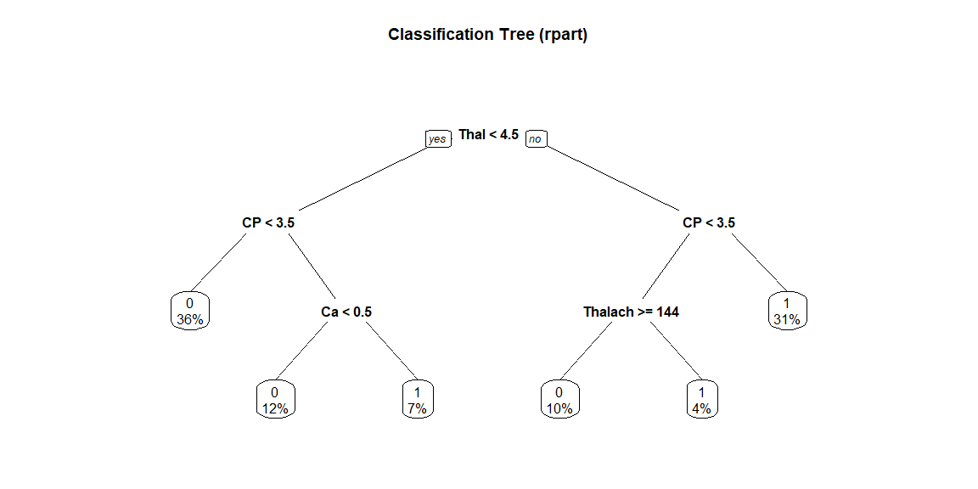

*# Let's use the model in test set*  
test_pred_classtree <- **predict**(heart.tree,newdata = testData, type = "class")  
test_pred_classtree

## 3 5 6 8 9 15 18 19 20 23 24 25 28 31 34 36 42 46   
## 1 0 0 0 1 0 0 0 0 0 0 1 0 0 1 0 0 0   
## 47 52 55 56 57 59 65 67 68 70 71 75 78 79 80 82 83 84   
## 0 1 1 1 0 0 1 0 0 0 0 1 0 0 1 0 0 0   
## 95 97 101 105 112 116 118 119 123 126 129 133 137 140 141 143 144 147   
## 0 1 0 1 1 1 0 1 0 0 0 0 1 0 0 0 1 1   
## 153 157 161 162 163 165 166 169 170 173 177 181 182 184 186 190 206 208   
## 0 1 0 1 0 0 1 1 0 0 1 1 1 0 0 0 1 1   
## 209 211 219 226 229 230 232 233 234 236 239 241 244 250 251 255 258 271   
## 0 0 1 0 1 1 0 0 0 1 0 0 0 0 1 0 0 1   
## 273 275 283 285 287 291 296 299 302   
## 1 0 1 1 1 0 0 1 0   
## Levels: 0 1

res.classtree <- **confusionMatrix**(test_pred_classtree, Y.testData)  
res.classtree

## Confusion Matrix and Statistics  
##   
## Reference  
## Prediction 0 1  
## 0 46 15  
## 1 7 31  
##   
## Accuracy : 0.778   
## 95% CI : (0.683, 0.855)  
## No Information Rate : 0.535   
## P-Value [Acc > NIR] : 5.07e-07   
##   
## Kappa : 0.548   
## Mcnemar's Test P-Value : 0.136   
##   
## Sensitivity : 0.868   
## Specificity : 0.674   
## Pos Pred Value : 0.754   
## Neg Pred Value : 0.816   
## Prevalence : 0.535   
## Detection Rate : 0.465   
## Detection Prevalence : 0.616   
## Balanced Accuracy : 0.771   
##   
## 'Positive' Class : 0   
##

**print_confusionm**(res.classtree,   
 main = **paste0**("Confusion Matrix: ", model.name," (Test Set)"),   
 labels = **c**("Healthy", "Non-Healthy"))



main <- **paste0**(model.name," Classification/Misclassification in Test Set by\n",  
 "Heart Disease Status: number of major vessels with >50% narrowing ",  
 "(0=Healthy,1,2,3, or 4)")  
  
**plot_results_by_type**(test_pred_classtree,  
 Y.testData,  
 main, testData)

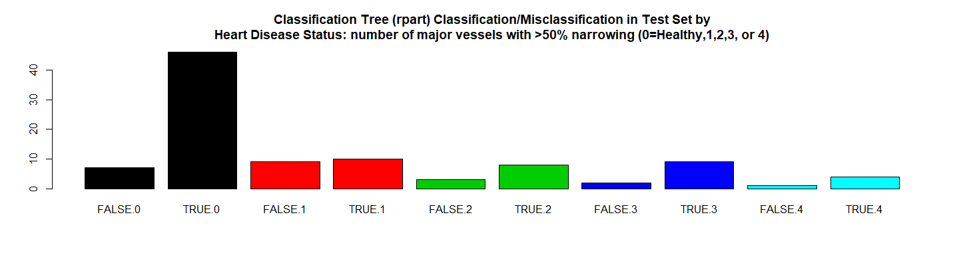

*# RMSE Resulting*  
(rmse_classtree <- **sqrt**(**mean**((**as.numeric**(test_pred_classtree)**-as.numeric**(Y.testData))**^**2)))

## [1] 0.4714

*# Residuals Plot*  
(r_classtree <- (**as.numeric**(test_pred_classtree)**-as.numeric**(Y.testData)))

## [1] 0 0 0 0 0 0 0 0 0 -1 -1 0 0 0 1 0 0 -1 0 1 0 0 -1  
## [24] 0 0 -1 0 -1 0 0 0 0 0 0 0 -1 0 0 0 0 0 1 0 0 0 0  
## [47] 0 0 0 0 0 0 0 0 0 0 0 0 0 0 1 0 0 -1 1 0 0 0 0  
## [70] -1 0 0 0 0 1 0 0 0 -1 -1 0 0 0 0 -1 0 1 0 0 0 0 -1  
## [93] 0 0 0 -1 0 0 -1

**plot**(r_classtree, main = model.name,xlab = "", ylab = "")

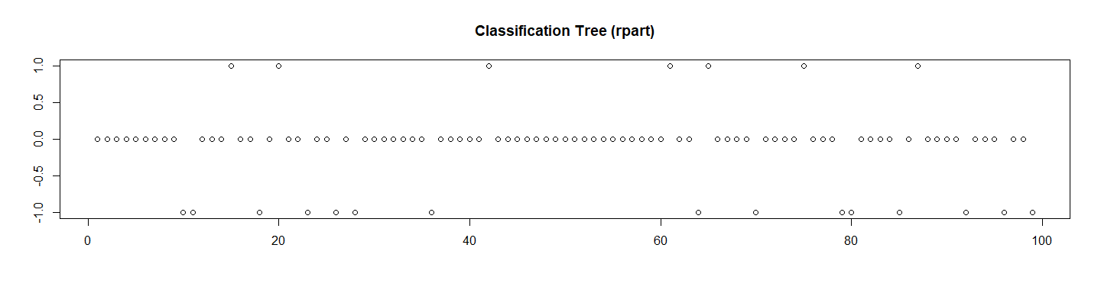

*# Let's check the probabilities and Calculate the ROC*  
test_pred_classtree_prob <- **predict**(heart.tree, newdata = X.testData, type ="prob")[,2]  
  
res.classtree.roc <- **roc**(**as.numeric**(Y.testData),  
 **as.numeric**(  
 **as.matrix**(test_pred_classtree_prob)))**$**auc  
  
*# Store the Values for Report*  
results_all <- **rbind**(results_all,  
 **data.frame**("Method"= model.name,  
 "Prediction Accuracy in Training Set" =   
 NA,  
 "Prediction Accuracy in Test Set" =   
 res.classtree**$**overall[1],  
 "RMSE Test"= rmse_classtree,  
 "ROC" = res.classtree.roc,  
 "Time Elapsed" = et,  
 stringsAsFactors = FALSE))

# 14. Fast-and-Frugal Decision Trees (FFTrees)

############################################  
*# 14. Fast-and-Frugal Decision Trees (FFTrees)*  
model.name <- "Fast-and-Frugal Decision Trees (FFTrees)"  
model.name17 <- model.name  
  
trainDataF <- trainData  
testDataF <- testData  
  
*# Make Disease Boolean*  
trainDataF**$**Disease <- **ifelse**(trainDataF**$**Disease **==** 1,TRUE,FALSE)   
testDataF**$**Disease <- **ifelse**(testDataF**$**Disease **==** 1,TRUE,FALSE)  
  
*# Create an FFTrees object called `heart_FFT`*  
heart_FFT <- **FFTrees**(formula = Disease **~** Age **+** Sex **+** CP **+** Trestbps **+**   
 Chol **+** Fbs **+** Restecg **+** Thalach **+** Exang **+**   
 Oldpeak **+** Slope **+** Ca **+** Thal,  
 data = trainDataF,  
 data.test = testDataF,  
 main = "ER Decisions",  
 decision.labels = **c**("Stable", "H Attack"))

## Growing FFTs with ifan

## Fitting non-FFTrees algorithms for comparison (you can turn this off with do.comp = FALSE) ...

*# Print the summary statistics*  
heart_FFT

## ER Decisions  
## FFT #1 predicts Disease using 3 cues: {Thal,CP,Ca}  
##   
## [1] If Thal > 3, predict H Attack.  
## [2] If CP <= 3, predict Stable.  
## [3] If Ca <= 0, predict Stable, otherwise, predict H Attack.  
##   
## train test  
## cases :n 198.00 99.00  
## speed :mcu 1.73 1.73  
## frugality :pci 0.88 0.88  
## accuracy :acc 0.83 0.78  
## weighted :wacc 0.83 0.78  
## sensitivity :sens 0.88 0.80  
## specificity :spec 0.79 0.75  
##   
## pars: algorithm = 'ifan', goal = 'wacc', goal.chase = 'bacc', sens.w = 0.5, max.levels = 4

*# Visualise the tree applied to the test data heart.test*  
**plot**(heart_FFT, data = "test")

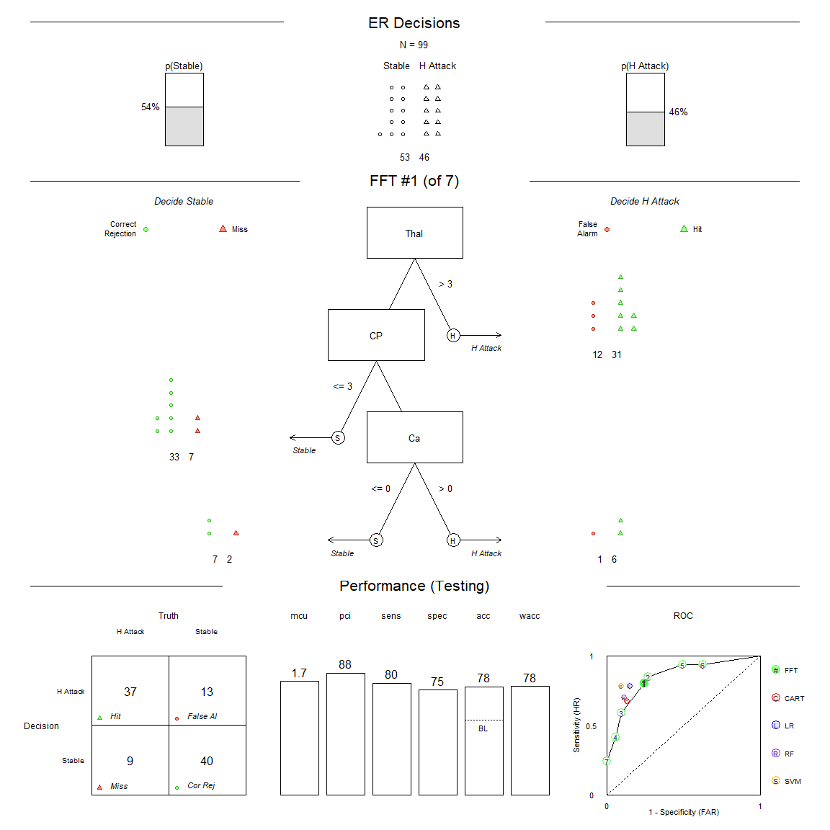

**plot**(heart_FFT, stats = FALSE)

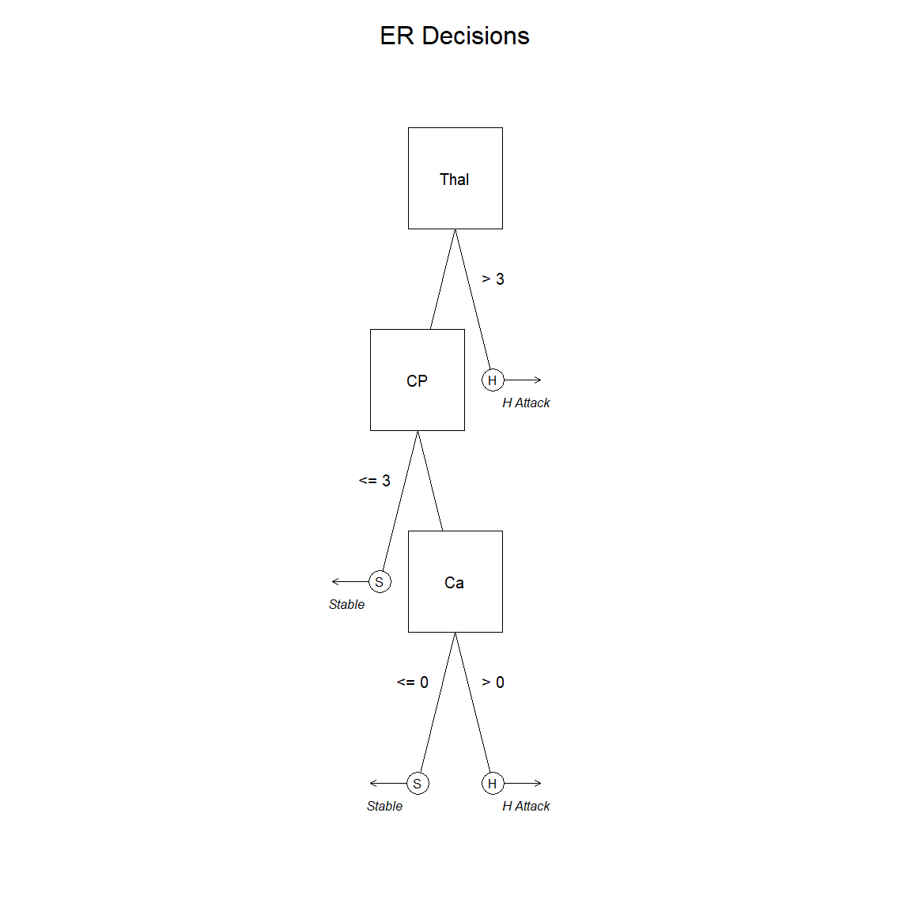

Let’s see the results:

*# Let's use the model in test set*  
test_pred_fft <- **predict**(heart_FFT,newdata = testDataF, type = "class")  
test_pred_fft

## [1] TRUE FALSE FALSE FALSE TRUE TRUE FALSE FALSE FALSE FALSE TRUE  
## [12] TRUE FALSE FALSE TRUE FALSE TRUE TRUE FALSE TRUE TRUE TRUE  
## [23] TRUE FALSE TRUE FALSE TRUE FALSE FALSE TRUE FALSE FALSE TRUE  
## [34] FALSE FALSE TRUE FALSE TRUE FALSE TRUE TRUE TRUE FALSE TRUE  
## [45] FALSE FALSE FALSE FALSE TRUE FALSE FALSE FALSE TRUE TRUE TRUE  
## [56] TRUE TRUE TRUE FALSE FALSE TRUE TRUE FALSE FALSE TRUE TRUE  
## [67] TRUE TRUE FALSE TRUE TRUE TRUE FALSE FALSE TRUE FALSE TRUE  
## [78] TRUE FALSE FALSE FALSE TRUE FALSE FALSE FALSE FALSE TRUE FALSE  
## [89] FALSE TRUE TRUE FALSE TRUE TRUE TRUE TRUE FALSE TRUE FALSE

res.fft <- **confusionMatrix**(test_pred_fft, testDataF**$**Disease)  
res.fft

## Confusion Matrix and Statistics  
##   
## Reference  
## Prediction FALSE TRUE  
## FALSE 40 9  
## TRUE 13 37  
##   
## Accuracy : 0.778   
## 95% CI : (0.683, 0.855)  
## No Information Rate : 0.535   
## P-Value [Acc > NIR] : 5.07e-07   
##   
## Kappa : 0.556   
## Mcnemar's Test P-Value : 0.522   
##   
## Sensitivity : 0.755   
## Specificity : 0.804   
## Pos Pred Value : 0.816   
## Neg Pred Value : 0.740   
## Prevalence : 0.535   
## Detection Rate : 0.404   
## Detection Prevalence : 0.495   
## Balanced Accuracy : 0.780   
##   
## 'Positive' Class : FALSE   
##

**print_confusionm**(res.fft,   
 main = **paste0**("Confusion Matrix: ", model.name," (Test Set)"),   
 labels = **c**("Healthy", "Non-Healthy"))

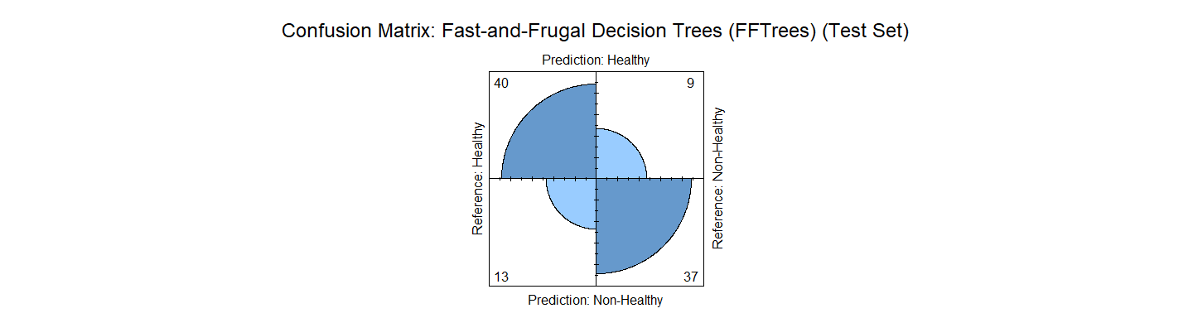

main <- **paste0**(model.name," Classification/Misclassification in Test Set by\n",  
 "Heart Disease Status: number of major vessels with >50% narrowing ",  
 "(0=Healthy,1,2,3, or 4)")  
  
**plot_results_by_type**(test_pred_fft,  
 testDataF**$**Disease,  
 main, testDataF)

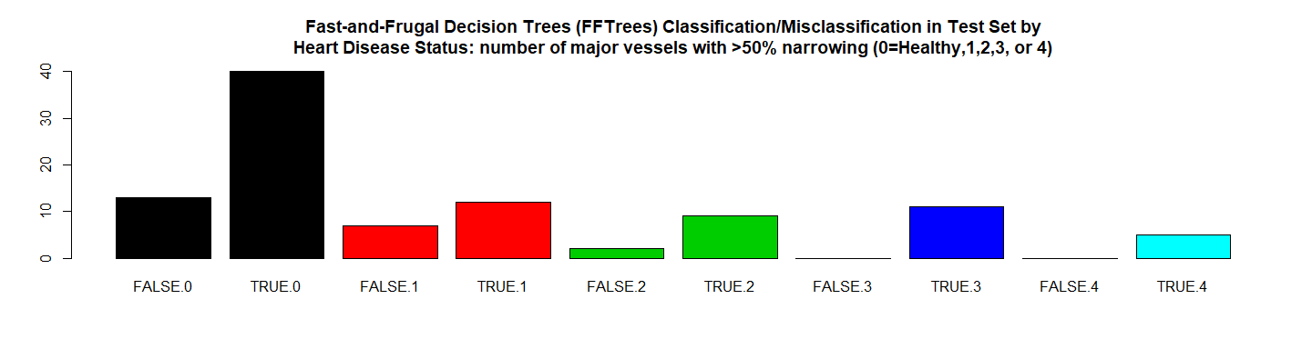

*# RMSE Resulting*  
(rmse_fft <- **sqrt**(**mean**((**as.numeric**(test_pred_fft)**-as.numeric**(testDataF**$**Disease))**^**2)))

## [1] 0.4714

*# Residuals Plot*  
(r_fft <- (**as.numeric**(test_pred_fft)**-as.numeric**(testDataF**$**Disease)))

## [1] 0 0 0 0 0 1 0 0 0 -1 0 0 0 0 1 0 1 0 0 1 0 0 0  
## [24] 0 0 -1 1 -1 0 0 0 0 0 0 0 0 0 0 0 0 0 1 0 0 0 0  
## [47] 0 0 0 0 0 0 0 0 1 0 1 0 0 0 1 0 0 -1 1 0 0 1 0  
## [70] 0 0 0 0 0 1 0 0 0 -1 -1 0 0 0 0 -1 0 1 0 0 0 0 -1  
## [93] 0 0 0 0 0 0 -1

**plot**(r_fft, main = model.name,xlab = "", ylab = "")

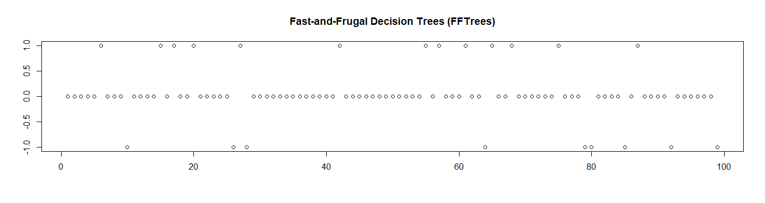

*# Let's check the probabilities and Calculate the ROC*  
test_pred_fft_prob <- **predict**(heart_FFT, newdata = testDataF, type ="prob")[,2]  
  
res.fft.roc <- **roc**(**as.numeric**(testDataF**$**Disease),  
 **as.numeric**(  
 **as.matrix**(test_pred_fft_prob)))**$**auc  
  
*# Store the Values for Report*  
results_all <- **rbind**(results_all,  
 **data.frame**("Method"= model.name,  
 "Prediction Accuracy in Training Set" =   
 **max**(heart_FFT**$**tree.stats**$**train**$**acc,na.rm = TRUE),  
 "Prediction Accuracy in Test Set" =   
 res.fft**$**overall[1],  
 "RMSE Test"= rmse_fft,  
 "ROC" = res.fft.roc,  
 "Time Elapsed" = et,  
 stringsAsFactors = FALSE))

# 15. Custom Fast-and-Frugal Decision Trees (FFTrees)

############################################  
*# 15. Custom Fast-and-Frugal Decision Trees (FFTrees)*  
model.name <- "Custom Fast-and-Frugal Decision Trees (FFTrees)"  
model.name18 <- model.name  
  
*# Create a Custom an FFTrees object called `custom__FFT`*  
  
custom_FFT <- **FFTrees**(formula = Disease **~** Age **+** Sex **+** CP **+** Trestbps **+**   
 Chol **+** Fbs **+** Restecg **+** Thalach **+** Exang **+**   
 Oldpeak **+** Slope **+** Ca **+** Thal,   
 data = trainDataF,   
 data.test = testDataF,   
 main = "Custom's Tree",   
 decision.labels = **c**("Stable", "Attack",   
 sens.w = 0.99,  
 goal = "acc"))

## Growing FFTs with ifan

## Fitting non-FFTrees algorithms for comparison (you can turn this off with do.comp = FALSE) ...

*# Print the summary statistics*  
custom_FFT

## Custom's Tree  
## FFT #1 predicts Disease using 3 cues: {Thal,CP,Ca}  
##   
## [1] If Thal > 3, predict Attack.  
## [2] If CP <= 3, predict Stable.  
## [3] If Ca <= 0, predict Stable, otherwise, predict Attack.  
##   
## train test  
## cases :n 198.00 99.00  
## speed :mcu 1.73 1.73  
## frugality :pci 0.88 0.88  
## accuracy :acc 0.83 0.78  
## weighted :wacc 0.83 0.78  
## sensitivity :sens 0.88 0.80  
## specificity :spec 0.79 0.75  
##   
## pars: algorithm = 'ifan', goal = 'wacc', goal.chase = 'bacc', sens.w = 0.5, max.levels = 4

*# Visualise the tree applied to the test data heart.test*  
**plot**(custom_FFT, data = "test")

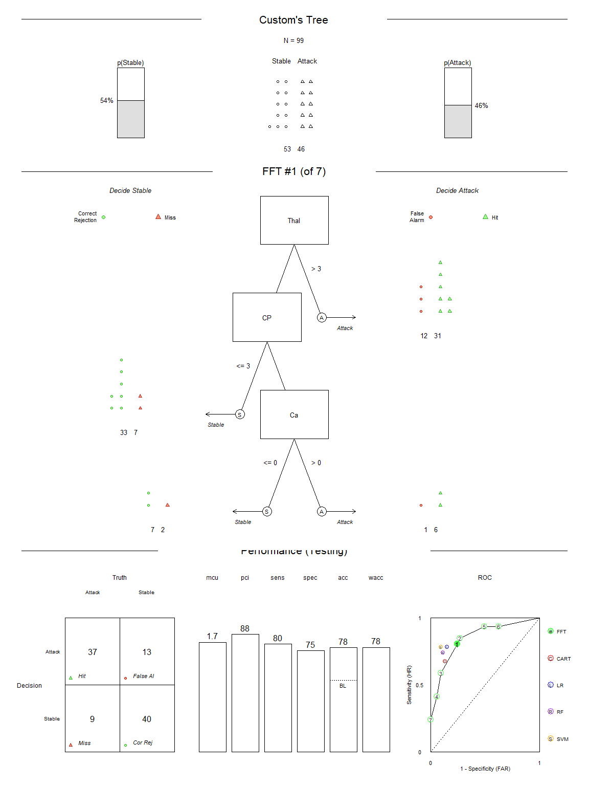

**plot**(custom_FFT, stats = FALSE)

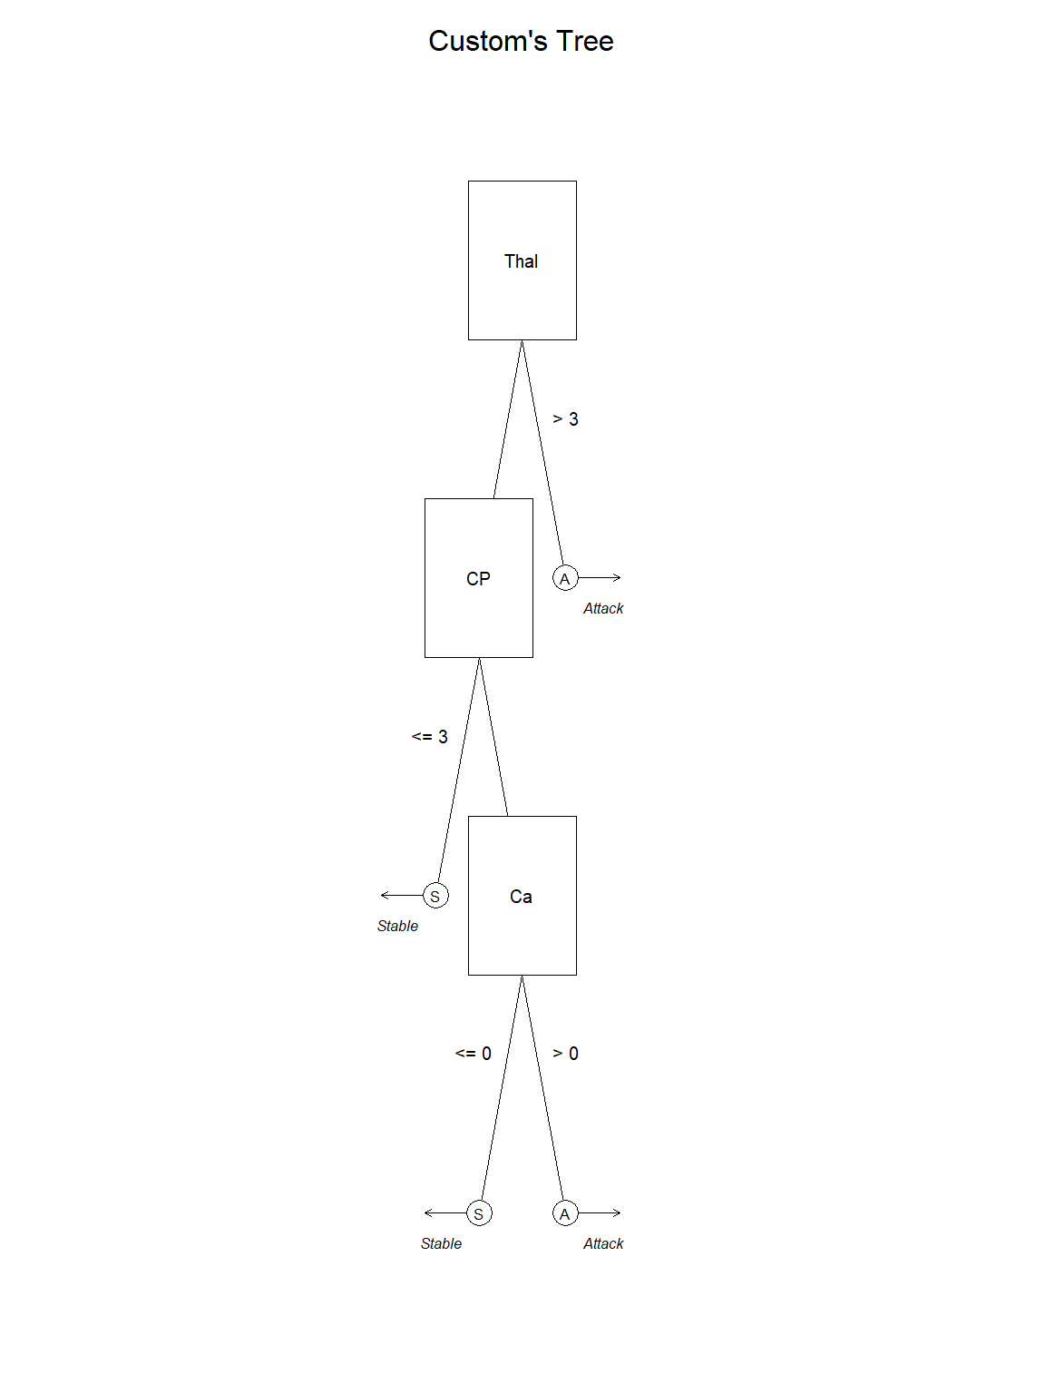

Let’s see the results:

*# Let's use the model in test set*  
test_pred_cfft <- **predict**(custom_FFT,newdata = testDataF, type = "class")  
test_pred_cfft

## [1] TRUE FALSE FALSE FALSE TRUE TRUE FALSE FALSE FALSE FALSE TRUE  
## [12] TRUE FALSE FALSE TRUE FALSE TRUE TRUE FALSE TRUE TRUE TRUE  
## [23] TRUE FALSE TRUE FALSE TRUE FALSE FALSE TRUE FALSE FALSE TRUE  
## [34] FALSE FALSE TRUE FALSE TRUE FALSE TRUE TRUE TRUE FALSE TRUE  
## [45] FALSE FALSE FALSE FALSE TRUE FALSE FALSE FALSE TRUE TRUE TRUE  
## [56] TRUE TRUE TRUE FALSE FALSE TRUE TRUE FALSE FALSE TRUE TRUE  
## [67] TRUE TRUE FALSE TRUE TRUE TRUE FALSE FALSE TRUE FALSE TRUE  
## [78] TRUE FALSE FALSE FALSE TRUE FALSE FALSE FALSE FALSE TRUE FALSE  
## [89] FALSE TRUE TRUE FALSE TRUE TRUE TRUE TRUE FALSE TRUE FALSE

res.cfft <- **confusionMatrix**(test_pred_cfft, testDataF**$**Disease)  
res.cfft

## Confusion Matrix and Statistics  
##   
## Reference  
## Prediction FALSE TRUE  
## FALSE 40 9  
## TRUE 13 37  
##   
## Accuracy : 0.778   
## 95% CI : (0.683, 0.855)  
## No Information Rate : 0.535   
## P-Value [Acc > NIR] : 5.07e-07   
##   
## Kappa : 0.556   
## Mcnemar's Test P-Value : 0.522   
##   
## Sensitivity : 0.755   
## Specificity : 0.804   
## Pos Pred Value : 0.816   
## Neg Pred Value : 0.740   
## Prevalence : 0.535   
## Detection Rate : 0.404   
## Detection Prevalence : 0.495   
## Balanced Accuracy : 0.780   
##   
## 'Positive' Class : FALSE   
##

**print_confusionm**(res.cfft,   
 main = **paste0**("Confusion Matrix: ", model.name," (Test Set)"),   
 labels = **c**("Healthy", "Non-Healthy"))

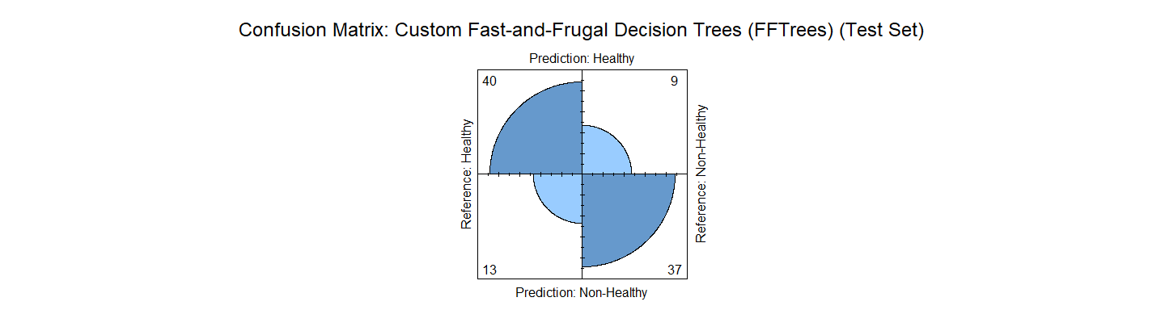

main <- **paste0**(model.name," Classification/Misclassification in Test Set by\n",  
 "Heart Disease Status: number of major vessels with >50% narrowing ",  
 "(0=Healthy,1,2,3, or 4)")  
  
**plot_results_by_type**(test_pred_cfft,  
 testDataF**$**Disease,  
 main, testDataF)

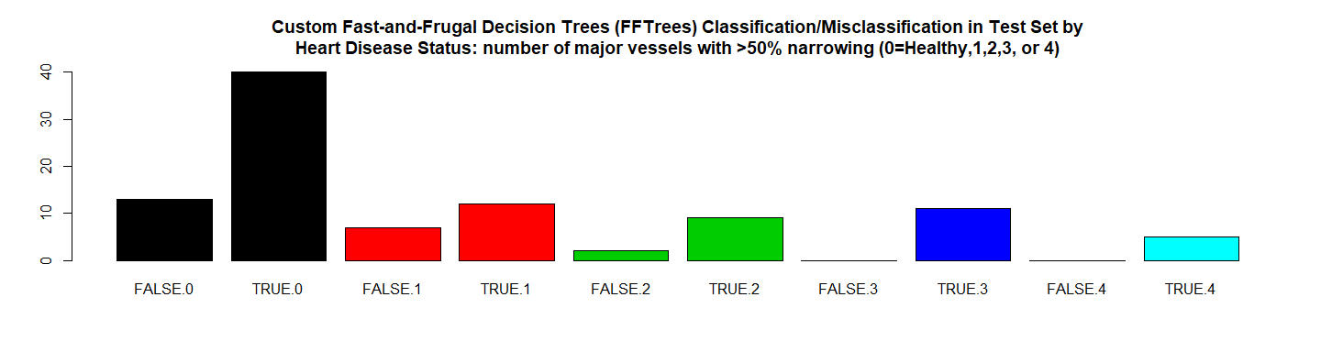

*# RMSE Resulting*  
(rmse_cfft <- **sqrt**(**mean**((**as.numeric**(test_pred_cfft)**-as.numeric**(testDataF**$**Disease))**^**2)))

## [1] 0.4714

*# Residuals Plot*  
(r_cfft <- (**as.numeric**(test_pred_cfft)**-as.numeric**(testDataF**$**Disease)))

## [1] 0 0 0 0 0 1 0 0 0 -1 0 0 0 0 1 0 1 0 0 1 0 0 0  
## [24] 0 0 -1 1 -1 0 0 0 0 0 0 0 0 0 0 0 0 0 1 0 0 0 0  
## [47] 0 0 0 0 0 0 0 0 1 0 1 0 0 0 1 0 0 -1 1 0 0 1 0  
## [70] 0 0 0 0 0 1 0 0 0 -1 -1 0 0 0 0 -1 0 1 0 0 0 0 -1  
## [93] 0 0 0 0 0 0 -1

**plot**(r_cfft, main = model.name,xlab = "", ylab = "")

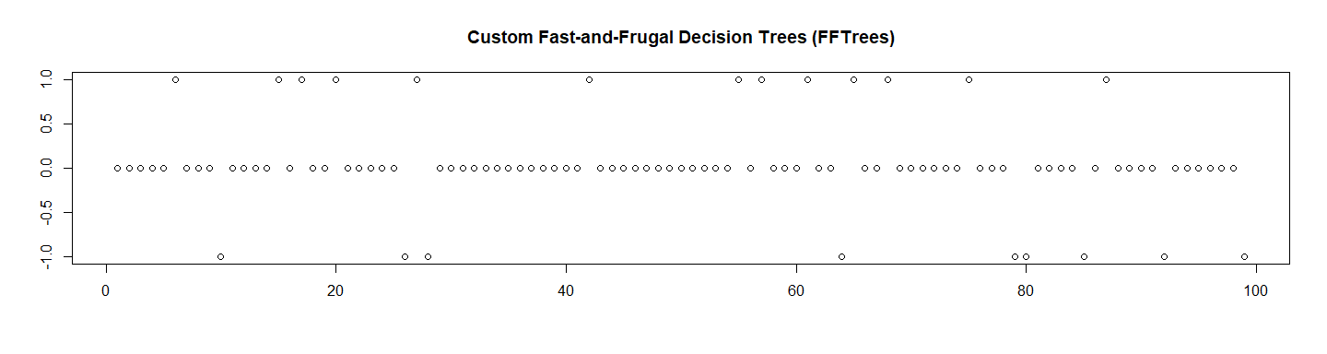

*# Let's check the probabilities and Calculate the ROC*  
test_pred_cfft_prob <- **predict**(custom_FFT, newdata = testDataF, type ="prob")[,2]  
  
res.cfft.roc <- **roc**(**as.numeric**(testDataF**$**Disease),  
 **as.numeric**(  
 **as.matrix**(test_pred_cfft_prob)))**$**auc  
  
*# Store the Values for Report*  
results_all <- **rbind**(results_all,  
 **data.frame**("Method"= model.name,  
 "Prediction Accuracy in Training Set" =   
 **max**(custom_FFT**$**tree.stats**$**train**$**acc,na.rm = TRUE),  
 "Prediction Accuracy in Test Set" =   
 res.cfft**$**overall[1],  
 "RMSE Test"= rmse_cfft,  
 "ROC" = res.cfft.roc,  
 "Time Elapsed" = et,  
 stringsAsFactors = FALSE))

# 16. Forest of Fast-and-Frugal Decision Trees (FFForest)

############################################  
*# 16. Forest of Fast-and-Frugal Decision Trees (FFFOrest)*   
model.name <- "Forest of Fast-and-Frugal Decision Trees (FFForest)"  
model.name19 <- model.name  
num_trees <- 100  
  
file.name <- **paste**(work.dir, "heart_fff.Rds", sep="/")  
file.name.et <- **paste**(work.dir, "heart_fff-et.Rds", sep="/")  
  
**if** (**file.exists**(file.name)) {  
 **load**(file.name,.GlobalEnv)  
 **load**(file.name.et,.GlobalEnv)  
} **else** {  
   
 t1 <- **proc.time**()  
 *# Create an FFForest object (can take a few minutes)*  
 heart_fff <- **FFForest**(formula = Disease **~** Age **+** Sex **+** CP **+** Trestbps **+**   
 Chol **+** Fbs **+** Restecg **+** Thalach **+** Exang **+**   
 Oldpeak **+** Slope **+** Ca **+** Thal,  
 data = **rbind**(trainDataF,testDataF),  
 ntree = num_trees,   
 train.p = 2**/**3,  
 verbose = FALSE)  
 t2 <- **proc.time**()  
 et <- **elapsed_time**(t1,t2)  
 **print**(**paste0**(model.name," Executed ... time:", et))  
 **save**(heart_fff, file = file.name)  
 **save**(et, file = file.name.et)  
}  
  
## [1] "Forest of Fast-and-Frugal Decision Trees (FFForest) Executed ... time:127"

Let’s see the results:

*# Visualise the tree applied to the test data heart.test*  
**plot**(heart_fff, data = "test")

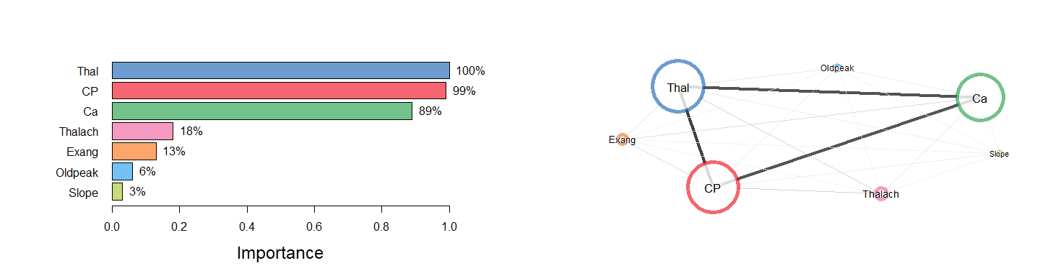

**plot**(heart_fff, stats = FALSE)



**plot**(heart_fff)  
  
*# Let's choose the best tree*  
  
best <- 0  
tree_id <- 0  
  
**print**("Accuracy Results for Trees")

## [1] "Accuracy Results for Trees"

**for** (i **in** 1**:**num_trees) {  
   
 fff_tree <- (heart_fff**$**fft.models[i])[[1]]  
   
 test_pred_fff <- **predict**(fff_tree, data = testDataF)  
 test_pred_fff  
   
 res.fff <- **confusionMatrix**(test_pred_fff, testDataF**$**Disease)  
   
 fff_tre_acc <- res.fff**$**overall[1]  
 **print**(**paste0**("Tree:",i," Accuracy:",fff_tre_acc))  
   
   
 **if** ( (best**==**0) **||** (fff_tre_acc **>** best) ) {  
   
 best <- fff_tre_acc  
 tree_id <- i  
 }  
}

## [1] "Tree:1 Accuracy:0.777777777777778"  
## [1] "Tree:2 Accuracy:0.747474747474748"  
## [1] "Tree:3 Accuracy:0.757575757575758"  
## [1] "Tree:4 Accuracy:0.757575757575758"  
## [1] "Tree:5 Accuracy:0.777777777777778"  
## [1] "Tree:6 Accuracy:0.787878787878788"  
## [1] "Tree:7 Accuracy:0.797979797979798"  
## [1] "Tree:8 Accuracy:0.777777777777778"  
## [1] "Tree:9 Accuracy:0.767676767676768"  
## [1] "Tree:10 Accuracy:0.787878787878788"  
## [1] "Tree:11 Accuracy:0.757575757575758"  
## [1] "Tree:12 Accuracy:0.777777777777778"  
## [1] "Tree:13 Accuracy:0.777777777777778"  
## [1] "Tree:14 Accuracy:0.777777777777778"  
## [1] "Tree:15 Accuracy:0.767676767676768"  
## [1] "Tree:16 Accuracy:0.777777777777778"  
## [1] "Tree:17 Accuracy:0.767676767676768"  
## [1] "Tree:18 Accuracy:0.777777777777778"  
## [1] "Tree:19 Accuracy:0.767676767676768"  
## [1] "Tree:20 Accuracy:0.777777777777778"  
## [1] "Tree:21 Accuracy:0.777777777777778"  
## [1] "Tree:22 Accuracy:0.777777777777778"  
## [1] "Tree:23 Accuracy:0.757575757575758"  
## [1] "Tree:24 Accuracy:0.777777777777778"  
## [1] "Tree:25 Accuracy:0.757575757575758"  
## [1] "Tree:26 Accuracy:0.777777777777778"  
## [1] "Tree:27 Accuracy:0.777777777777778"  
## [1] "Tree:28 Accuracy:0.777777777777778"  
## [1] "Tree:29 Accuracy:0.767676767676768"  
## [1] "Tree:30 Accuracy:0.777777777777778"  
## [1] "Tree:31 Accuracy:0.787878787878788"  
## [1] "Tree:32 Accuracy:0.757575757575758"  
## [1] "Tree:33 Accuracy:0.777777777777778"  
## [1] "Tree:34 Accuracy:0.757575757575758"  
## [1] "Tree:35 Accuracy:0.767676767676768"  
## [1] "Tree:36 Accuracy:0.777777777777778"  
## [1] "Tree:37 Accuracy:0.777777777777778"  
## [1] "Tree:38 Accuracy:0.757575757575758"  
## [1] "Tree:39 Accuracy:0.767676767676768"  
## [1] "Tree:40 Accuracy:0.787878787878788"  
## [1] "Tree:41 Accuracy:0.777777777777778"  
## [1] "Tree:42 Accuracy:0.747474747474748"  
## [1] "Tree:43 Accuracy:0.777777777777778"  
## [1] "Tree:44 Accuracy:0.767676767676768"  
## [1] "Tree:45 Accuracy:0.777777777777778"  
## [1] "Tree:46 Accuracy:0.777777777777778"  
## [1] "Tree:47 Accuracy:0.747474747474748"  
## [1] "Tree:48 Accuracy:0.767676767676768"  
## [1] "Tree:49 Accuracy:0.777777777777778"  
## [1] "Tree:50 Accuracy:0.777777777777778"  
## [1] "Tree:51 Accuracy:0.777777777777778"  
## [1] "Tree:52 Accuracy:0.777777777777778"  
## [1] "Tree:53 Accuracy:0.757575757575758"  
## [1] "Tree:54 Accuracy:0.777777777777778"  
## [1] "Tree:55 Accuracy:0.767676767676768"  
## [1] "Tree:56 Accuracy:0.787878787878788"  
## [1] "Tree:57 Accuracy:0.787878787878788"  
## [1] "Tree:58 Accuracy:0.767676767676768"  
## [1] "Tree:59 Accuracy:0.757575757575758"  
## [1] "Tree:60 Accuracy:0.777777777777778"  
## [1] "Tree:61 Accuracy:0.767676767676768"  
## [1] "Tree:62 Accuracy:0.757575757575758"  
## [1] "Tree:63 Accuracy:0.757575757575758"  
## [1] "Tree:64 Accuracy:0.787878787878788"  
## [1] "Tree:65 Accuracy:0.777777777777778"  
## [1] "Tree:66 Accuracy:0.767676767676768"  
## [1] "Tree:67 Accuracy:0.777777777777778"  
## [1] "Tree:68 Accuracy:0.767676767676768"  
## [1] "Tree:69 Accuracy:0.787878787878788"  
## [1] "Tree:70 Accuracy:0.777777777777778"  
## [1] "Tree:71 Accuracy:0.777777777777778"  
## [1] "Tree:72 Accuracy:0.747474747474748"  
## [1] "Tree:73 Accuracy:0.787878787878788"  
## [1] "Tree:74 Accuracy:0.777777777777778"  
## [1] "Tree:75 Accuracy:0.757575757575758"  
## [1] "Tree:76 Accuracy:0.757575757575758"  
## [1] "Tree:77 Accuracy:0.727272727272727"  
## [1] "Tree:78 Accuracy:0.767676767676768"  
## [1] "Tree:79 Accuracy:0.777777777777778"  
## [1] "Tree:80 Accuracy:0.727272727272727"  
## [1] "Tree:81 Accuracy:0.767676767676768"  
## [1] "Tree:82 Accuracy:0.777777777777778"  
## [1] "Tree:83 Accuracy:0.757575757575758"  
## [1] "Tree:84 Accuracy:0.777777777777778"  
## [1] "Tree:85 Accuracy:0.787878787878788"  
## [1] "Tree:86 Accuracy:0.777777777777778"  
## [1] "Tree:87 Accuracy:0.777777777777778"  
## [1] "Tree:88 Accuracy:0.777777777777778"  
## [1] "Tree:89 Accuracy:0.777777777777778"  
## [1] "Tree:90 Accuracy:0.787878787878788"  
## [1] "Tree:91 Accuracy:0.777777777777778"  
## [1] "Tree:92 Accuracy:0.777777777777778"  
## [1] "Tree:93 Accuracy:0.777777777777778"  
## [1] "Tree:94 Accuracy:0.777777777777778"  
## [1] "Tree:95 Accuracy:0.787878787878788"  
## [1] "Tree:96 Accuracy:0.787878787878788"  
## [1] "Tree:97 Accuracy:0.767676767676768"  
## [1] "Tree:98 Accuracy:0.757575757575758"  
## [1] "Tree:99 Accuracy:0.787878787878788"  
## [1] "Tree:100 Accuracy:0.747474747474748"

**print**(**paste0**("Best Tree id:",tree_id, " accuracy:", fff_tre_acc))

## [1] "Best Tree id:7 accuracy:0.747474747474748"

*# Select the best Tree for calculations*  
fff_tree <- (heart_fff**$**fft.models[tree_id])[[1]]  
  
test_pred_fff <- **predict**(fff_tree, data = testDataF)  
test_pred_fff

## [1] TRUE FALSE FALSE FALSE TRUE FALSE FALSE FALSE FALSE FALSE TRUE  
## [12] TRUE FALSE TRUE TRUE FALSE TRUE TRUE FALSE TRUE TRUE TRUE  
## [23] TRUE TRUE TRUE FALSE FALSE FALSE FALSE TRUE TRUE FALSE TRUE  
## [34] FALSE FALSE TRUE FALSE TRUE FALSE TRUE TRUE FALSE FALSE TRUE  
## [45] FALSE FALSE FALSE FALSE TRUE FALSE FALSE FALSE TRUE TRUE FALSE  
## [56] TRUE FALSE TRUE FALSE TRUE TRUE TRUE FALSE FALSE TRUE TRUE  
## [67] TRUE FALSE TRUE TRUE TRUE TRUE FALSE FALSE TRUE FALSE TRUE  
## [78] TRUE FALSE TRUE TRUE TRUE FALSE FALSE TRUE FALSE TRUE FALSE  
## [89] FALSE TRUE TRUE TRUE TRUE TRUE TRUE FALSE FALSE FALSE TRUE

res.fff <- **confusionMatrix**(test_pred_fff, testDataF**$**Disease)  
res.fff

## Confusion Matrix and Statistics  
##   
## Reference  
## Prediction FALSE TRUE  
## FALSE 40 7  
## TRUE 13 39  
##   
## Accuracy : 0.798   
## 95% CI : (0.705, 0.872)  
## No Information Rate : 0.535   
## P-Value [Acc > NIR] : 4.8e-08   
##   
## Kappa : 0.597   
## Mcnemar's Test P-Value : 0.264   
##   
## Sensitivity : 0.755   
## Specificity : 0.848   
## Pos Pred Value : 0.851   
## Neg Pred Value : 0.750   
## Prevalence : 0.535   
## Detection Rate : 0.404   
## Detection Prevalence : 0.475   
## Balanced Accuracy : 0.801   
##   
## 'Positive' Class : FALSE   
##

**print_confusionm**(res.fff,   
 main = **paste0**("Confusion Matrix: ", model.name," (Test Set)"),   
 labels = **c**("Healthy", "Non-Healthy"))  
  
main <- **paste0**(model.name," Classification/Misclassification in Test Set by\n",  
 "Heart Disease Status: number of major vessels with >50% narrowing ",  
 "(0=Healthy,1,2,3, or 4)")  
  
**plot_results_by_type**(test_pred_fff,  
 testDataF**$**Disease,  
 main, testDataF)

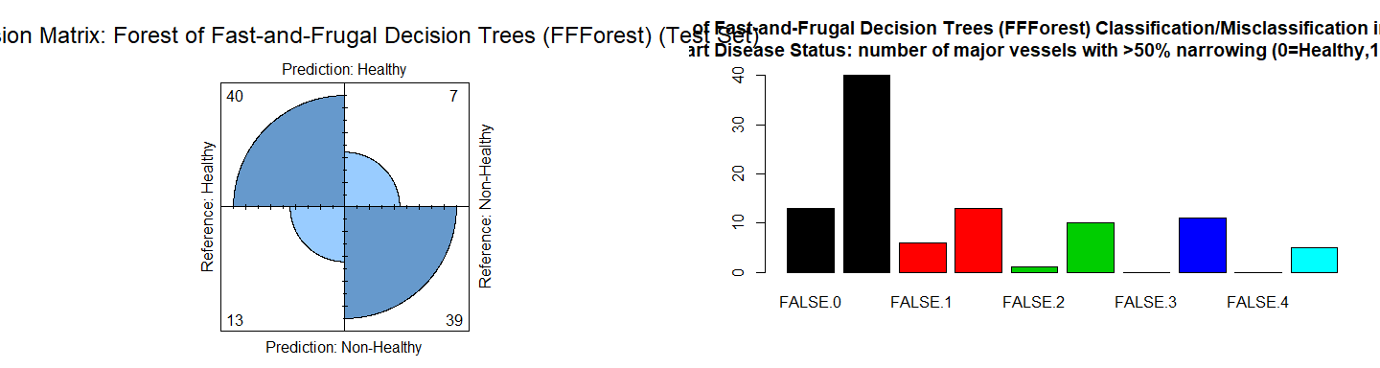

*# RMSE Resulting*  
(rmse_fff <- **sqrt**(**mean**((**as.numeric**(test_pred_fff)**-as.numeric**(testDataF**$**Disease))**^**2)))

## [1] 0.4495

*# Residuals Plot*  
(r_fff <- (**as.numeric**(test_pred_fff)**-as.numeric**(testDataF**$**Disease)))

## [1] 0 0 0 0 0 0 0 0 0 -1 0 0 0 1 1 0 1 0 0 1 0 0 0  
## [24] 1 0 -1 0 -1 0 0 1 0 0 0 0 0 0 0 0 0 0 0 0 0 0 0  
## [47] 0 0 0 0 0 0 0 0 0 0 0 0 0 1 1 0 0 -1 1 0 0 0 1  
## [70] 0 0 0 0 0 1 0 0 0 -1 0 1 0 0 0 0 0 1 0 0 0 0 0  
## [93] 0 0 0 -1 0 -1 0

**plot**(r_fff, main = model.name,xlab = "", ylab = "")  
  
*# Let's check the probabilities and Calculate the ROC*  
test_pred_fff_prob <- **predict**(fff_tree, data = testDataF, type ="prob")[,2]  
  
res.fff.roc <- **roc**(**as.numeric**(testDataF**$**Disease),  
 **as.numeric**(  
 **as.matrix**(test_pred_fff_prob)))**$**auc  
  
*# Store the Values for Report*  
results_all <- **rbind**(results_all,  
 **data.frame**("Method"= model.name,  
 "Prediction Accuracy in Training Set" =   
 **max**(fff_tree**$**tree.stats**$**train**$**acc,na.rm = TRUE),  
 "Prediction Accuracy in Test Set" =   
 res.fff**$**overall[1],  
 "RMSE Test"= rmse_fff,  
 "ROC" = res.fff.roc,  
 "Time Elapsed" = et,  
 stringsAsFactors = FALSE))

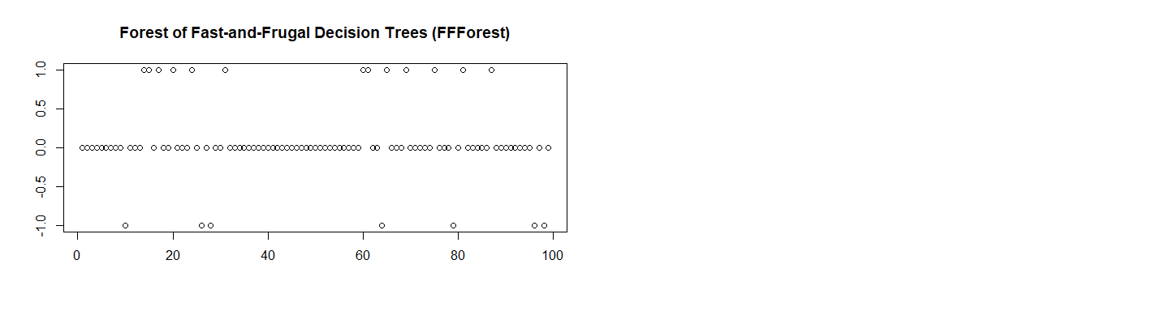

# 17. Optimizing Cost

############################################  
*# 17. Optimizing Cost*  
model.name <- "Optimizing Cost"  
  
## Specifying Cost  
heart.cue.cost <- **data.frame**("cue" =   
 **c**("age", "sex", "cp", "trestbps", "chol", "fbs", "restecg",  
 "thalach", "exang", "oldpeak", "slope", "ca", "thal"),  
 "cost" = **c**(1, 1, 1, 1, 7.27, 5.2, 15.5, 102.9, 87.3, 87.3,   
 87.3, 100.9, 102.9))  
*# Specify the following costs for heart disease diagnosis:*  
*# cost(Hit) = 0, cost(False Alarm) = 100, cost(Miss) = 200, cost(correct rejection) = 0*  
heart.cost.outcomes <- **c**(0, 500, 1000, 0)  
  
heart.costA.fft <- **FFTrees**(formula = Disease **~**.,  
 data = **rbind**(trainDataF,testDataF),  
 cost.outcomes = heart.cost.outcomes,  
 cost.cues = heart.cue.cost,  
 goal = "bacc",  
 goal.chase = "bacc")

## Growing FFTs with ifan

## Fitting non-FFTrees algorithms for comparison (you can turn this off with do.comp = FALSE) ...

**summary**(heart.costA.fft)**$**train[1,]

## tree n hi mi fa cr sens spec ppv npv far acc bacc wacc  
## 1 1 297 137 0 10 150 1 0.9375 0.932 1 0.0625 0.9663 0.8145 0.9688  
## bpv dprime cost pci mcu  
## 1 0.966 4.198 248.8519 0.89 1.65

heart.costB.fft <- **FFTrees**(formula = Disease **~**.,  
 data = **rbind**(trainDataF,testDataF),  
 cost.outcomes = heart.cost.outcomes,  
 cost.cues = heart.cue.cost,  
 goal = "cost",  
 goal.chase = "cost")

## Growing FFTs with ifan  
## Fitting non-FFTrees algorithms for comparison (you can turn this off with do.comp = FALSE) ...

**summary**(heart.costB.fft)**$**train[1,]

## tree n hi mi fa cr sens spec ppv npv far acc bacc wacc  
## 1 1 297 137 0 10 150 1 0.9375 0.932 1 0.0625 0.9663 0.7318 0.9688  
## bpv dprime cost pci mcu  
## 1 0.966 4.198 151.5152 0.8887 1.67

# 18. Results

## 18.1 Mining Association Rules

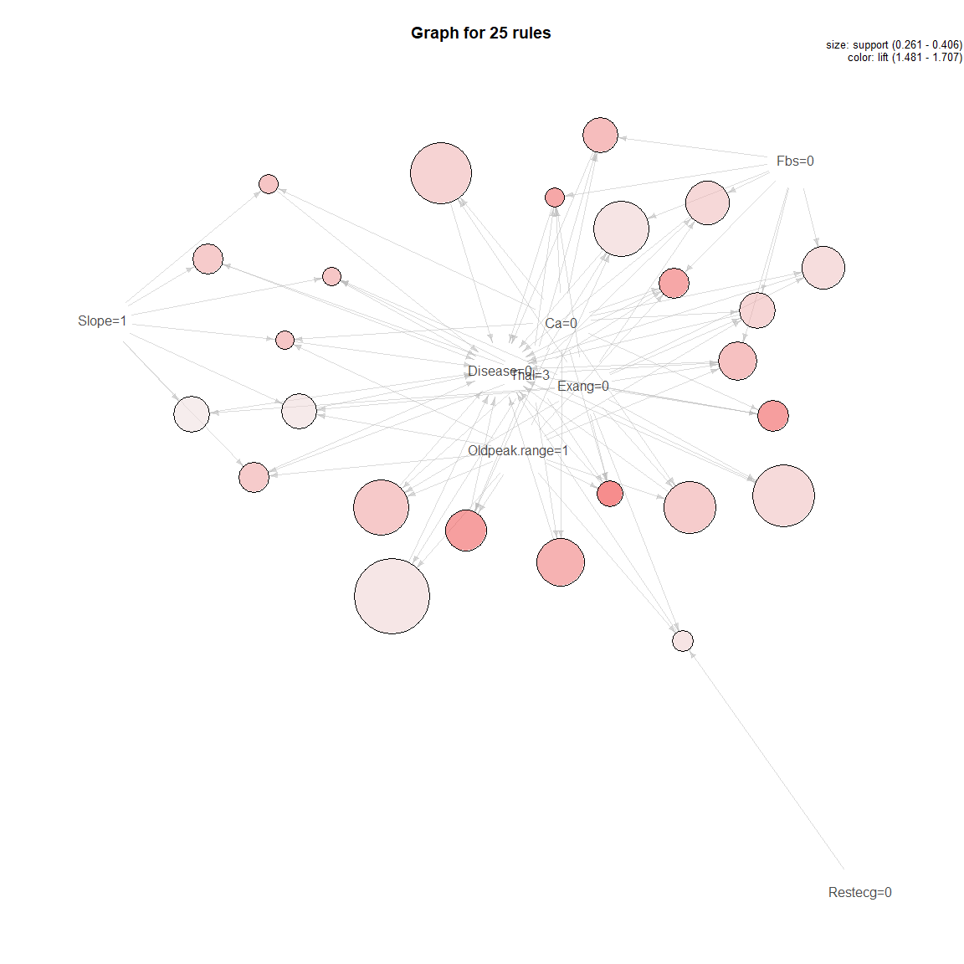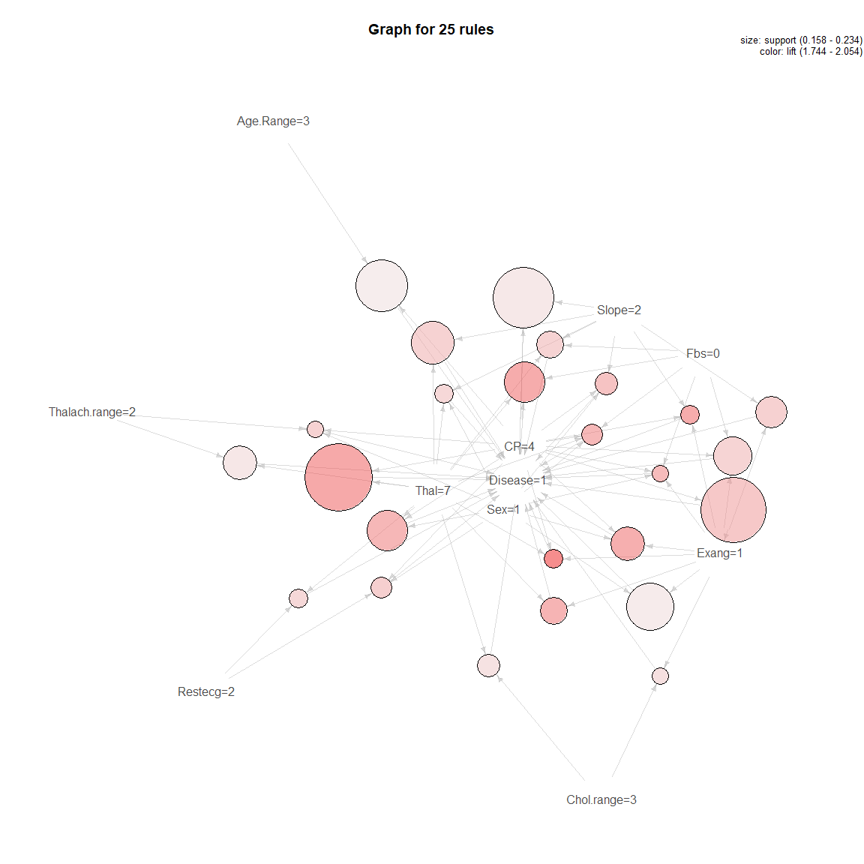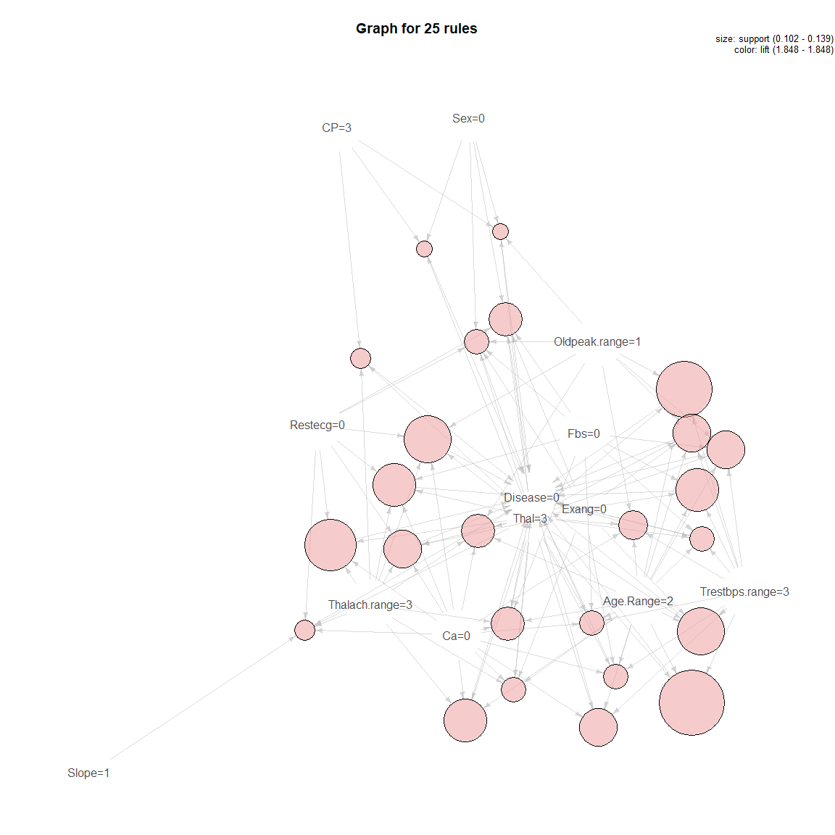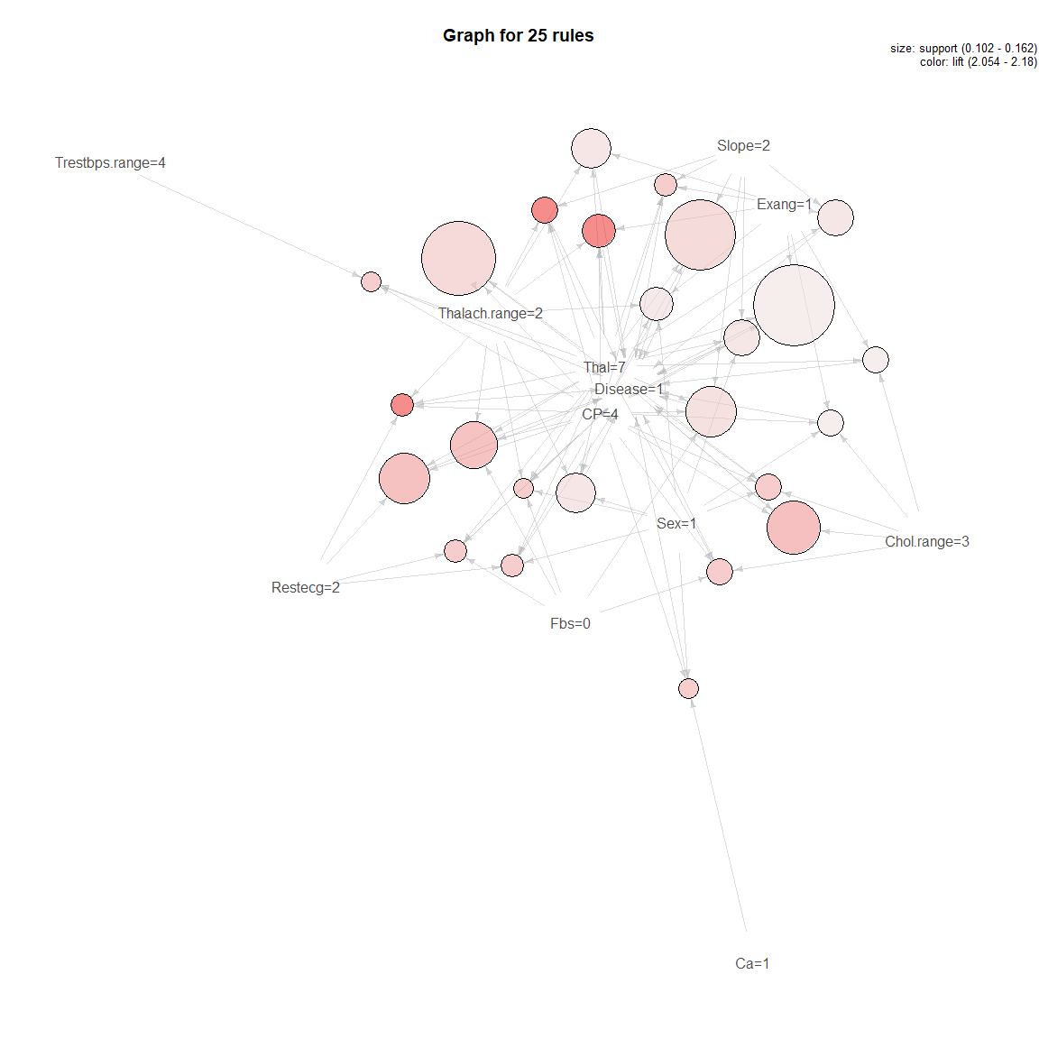

### Train Set

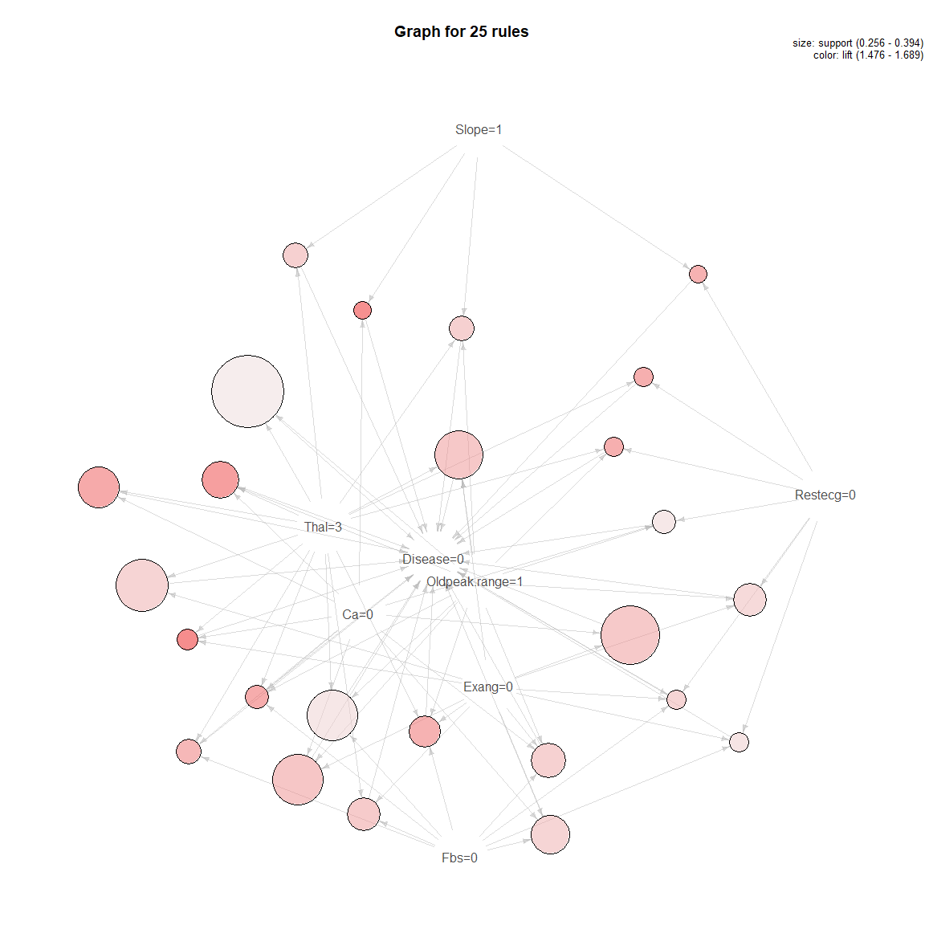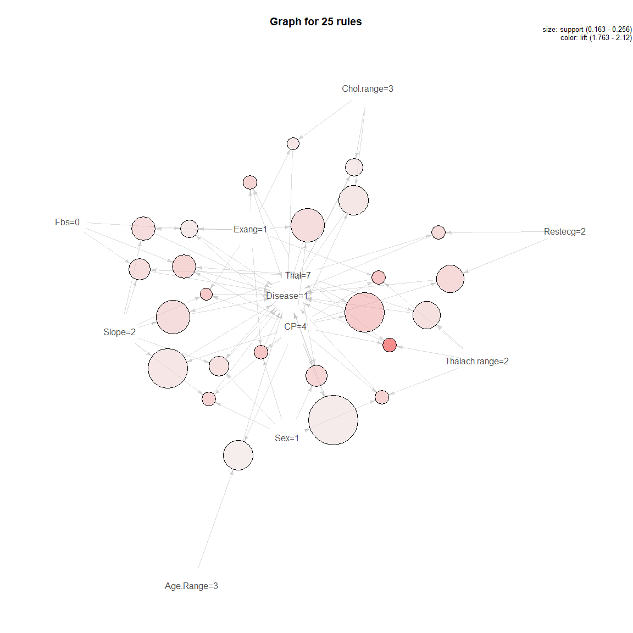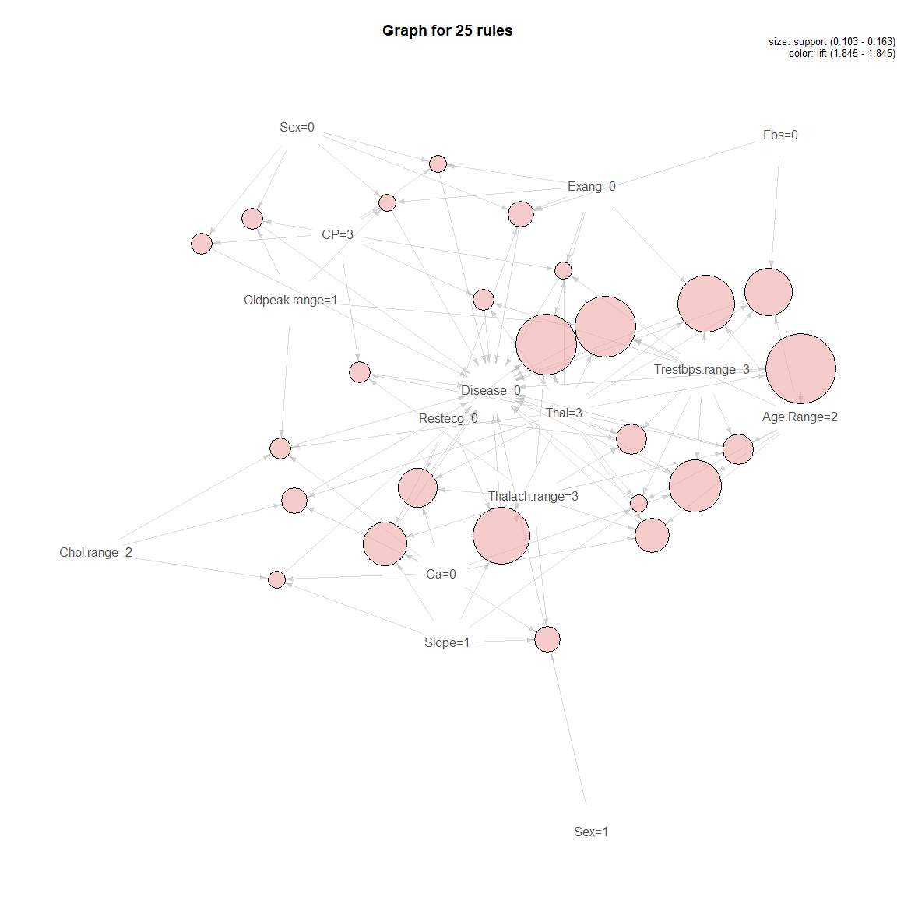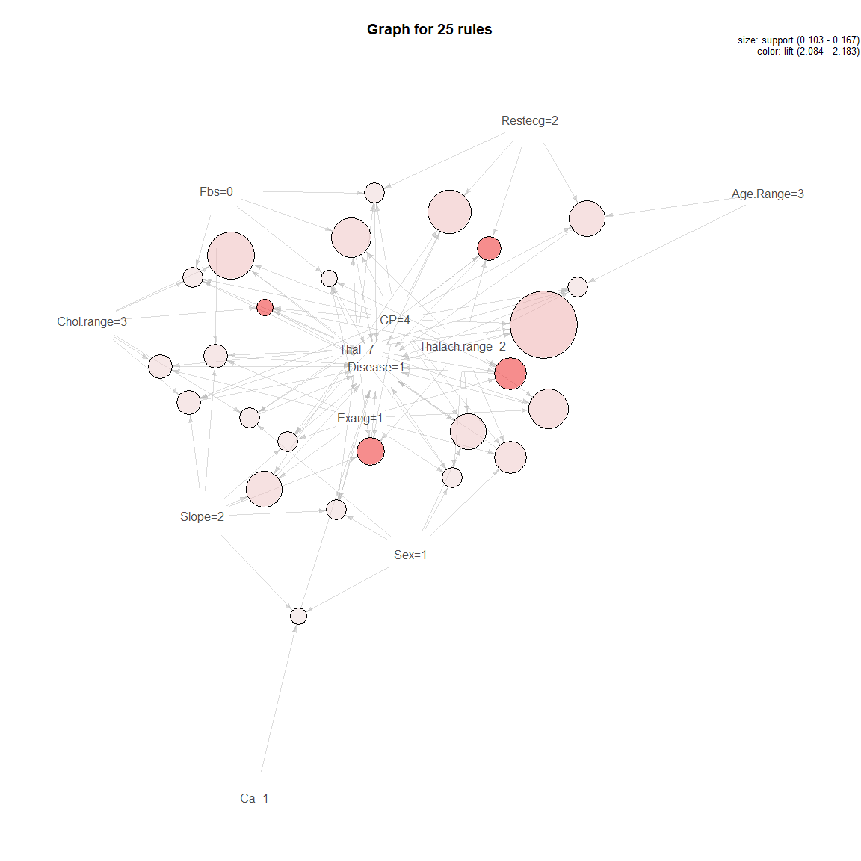

### Test Set

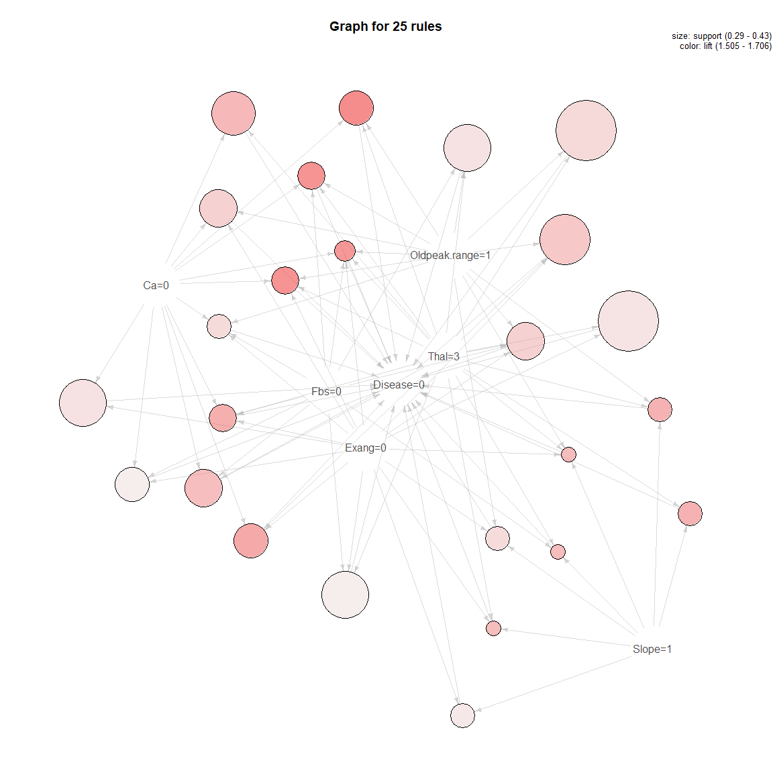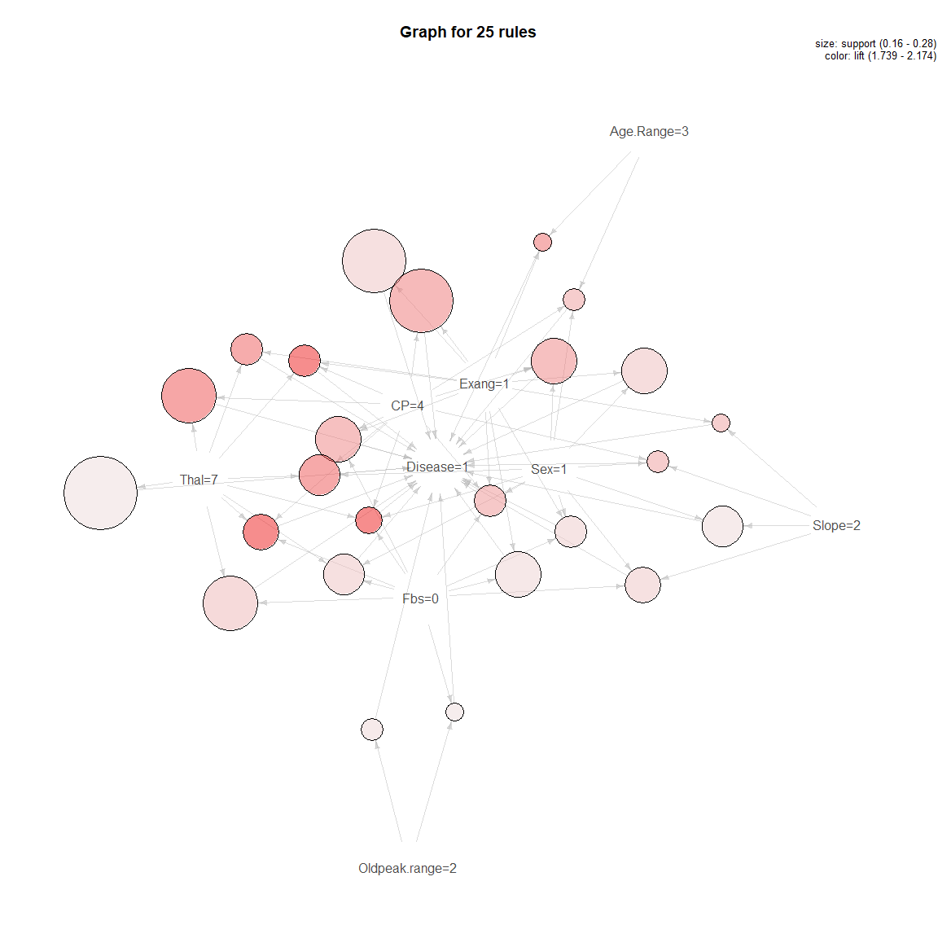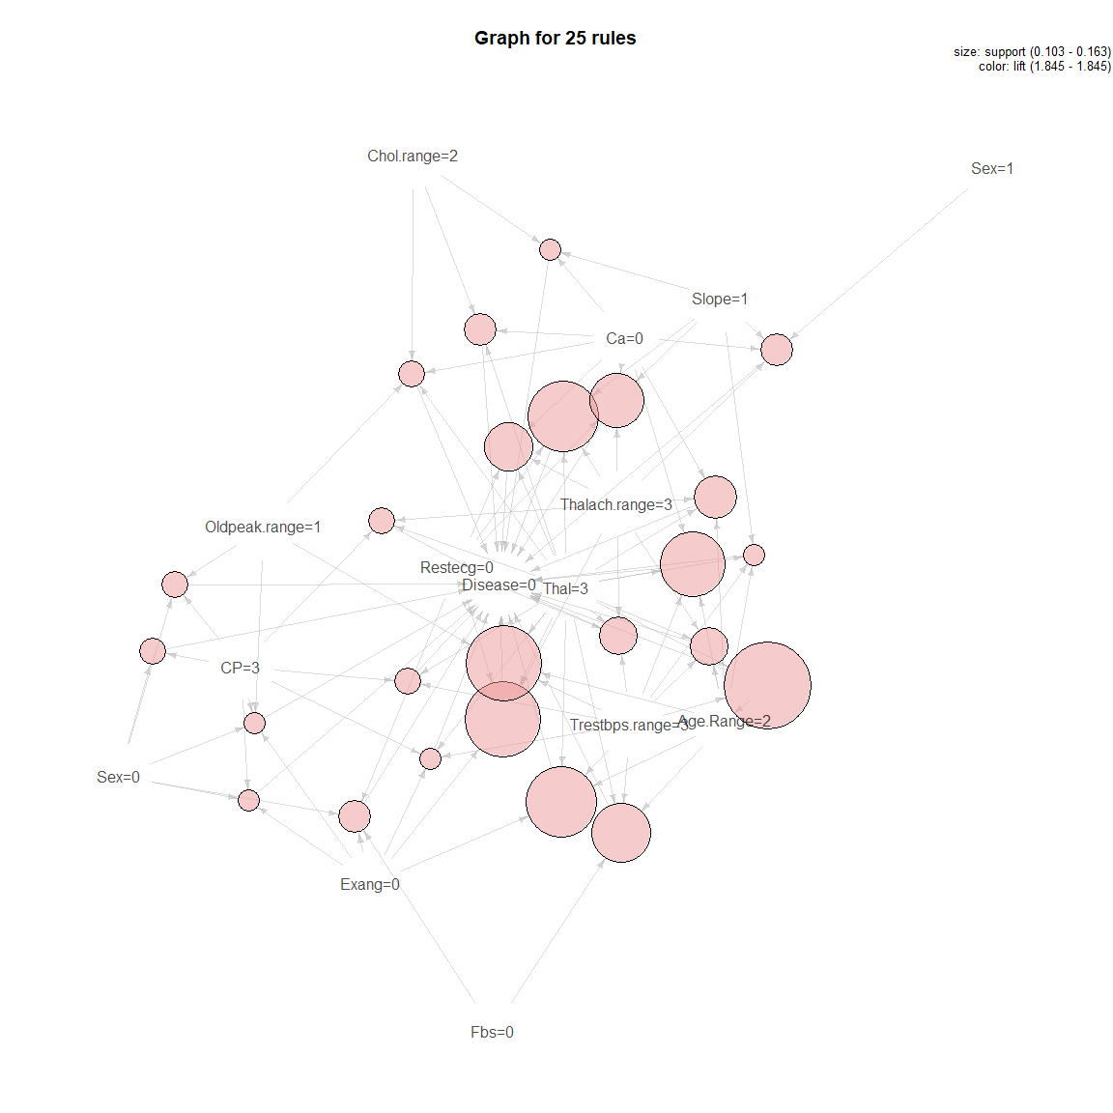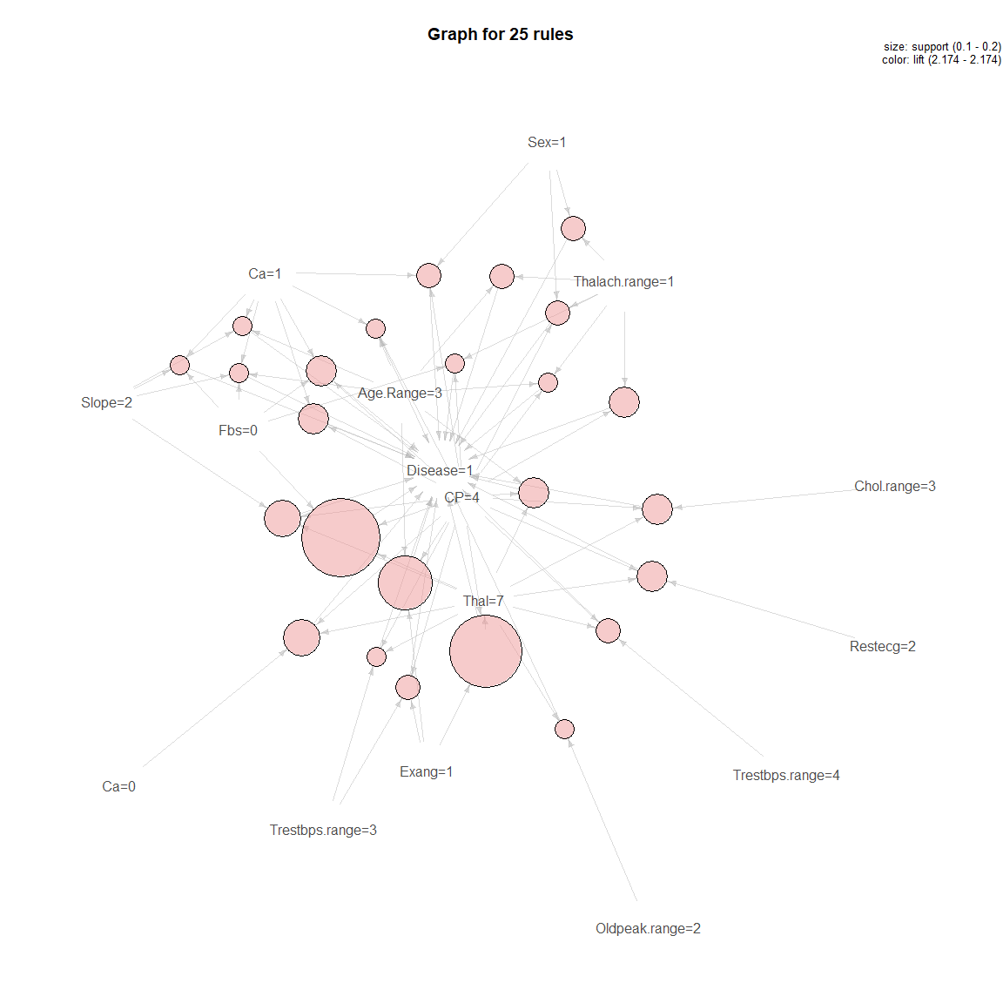

## 17.2 All Prediction Models Results

|  |  |  |  |  |  |
| --- | --- | --- | --- | --- | --- |
| Method | Prediction Accuracy in Training Set | Prediction Accuracy in Test Set | RMSE Test | ROC | Time Elapsed |
| Logistic Regression (Quasibinomial) (glm) | 0.8132 | 0.8182 | 0.4264 | 0.9036 | 1.3 |
| Logistic Regression (Binomial) (glm) | 0.8021 | 0.8182 | 0.4264 | 0.9036 | 1.4 |
| Logistic Regression (Binomial) with Factor Variables (glm) | 0.8009 | 0.8081 | 0.4381 | 0.8720 | 1.2 |
| Linear Model with Stepwise Feature Selection (glmStepAIC) | 0.8076 | 0.8182 | 0.4264 | 0.8925 | 5.3 |
| Kmeans PCA (8) | 0.8333 | 0.7980 | 0.4495 | 0.7941 | 5.8 |
| Kmeans (13) | 0.8333 | 0.8182 | 0.4264 | 0.8158 | 4.5 |
| SVM Radial | 0.8535 | 0.7980 | 0.4495 |  | 58 |
| SVM Linear | 0.8586 | 0.8182 | 0.4264 |  | 169 |
| Neural Networks (nnet) | 0.7953 | 0.7778 | 0.4714 | 0.8376 | 9.5 |
| K-Nearest Neighbors (knn) | 0.8299 | 0.8485 | 0.3892 | 0.9100 | 6.9 |
| Random Forest with Tuning Parameters (rf) | 0.8449 | 0.8384 | 0.4020 | 0.9182 | 52 |
| Random Forest Boosted Tree (bstTree) | 0.8283 | 0.7778 | 0.4714 |  | 425 |
| Random Forest Boost with Tuning Parameters (gbm) | 0.8469 | 0.8384 | 0.4020 | 0.8897 | 29 |
| Random Forest with Stochastic Gradient Boost (gbm) | 0.9053 | 0.8182 | 0.4264 | 0.8819 | 96 |
| Classification Tree (rpart) |  | 0.7778 | 0.4714 | 0.8117 | 96 |
| Fast-and-Frugal Decision Trees (FFTrees) | 0.8283 | 0.7778 | 0.4714 | 0.7914 | 96 |
| Custom Fast-and-Frugal Decision Trees (FFTrees) | 0.8283 | 0.7778 | 0.4714 | 0.7914 | 96 |
| Forest of Fast-and-Frugal Decision Trees (FFForest) | 0.8283 | 0.7980 | 0.4495 | 0.8273 | 127 |

### Confusion Matrix (Test Set)

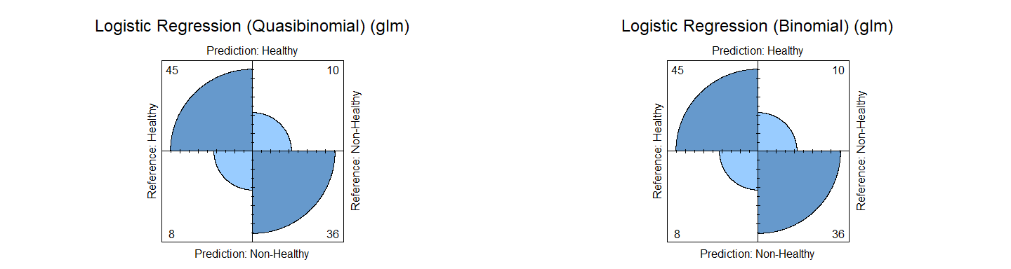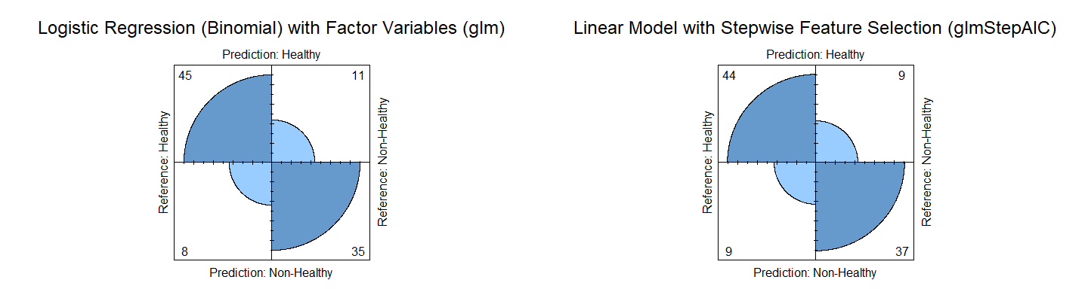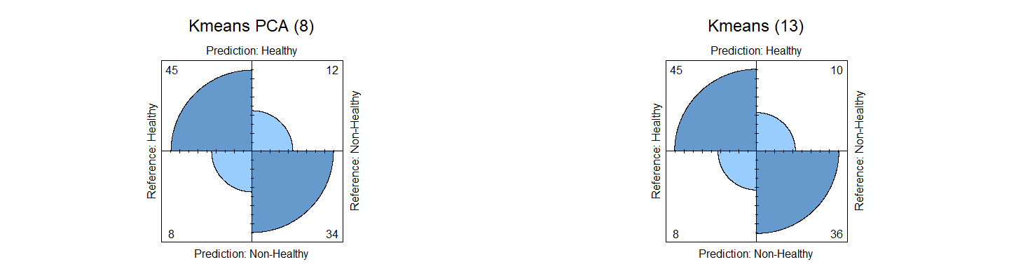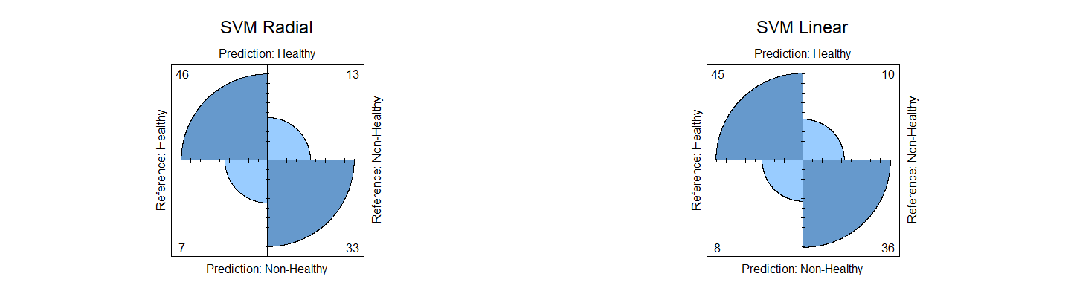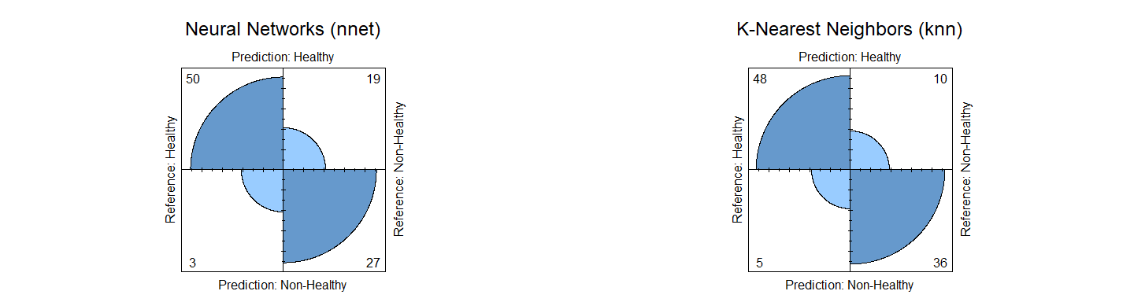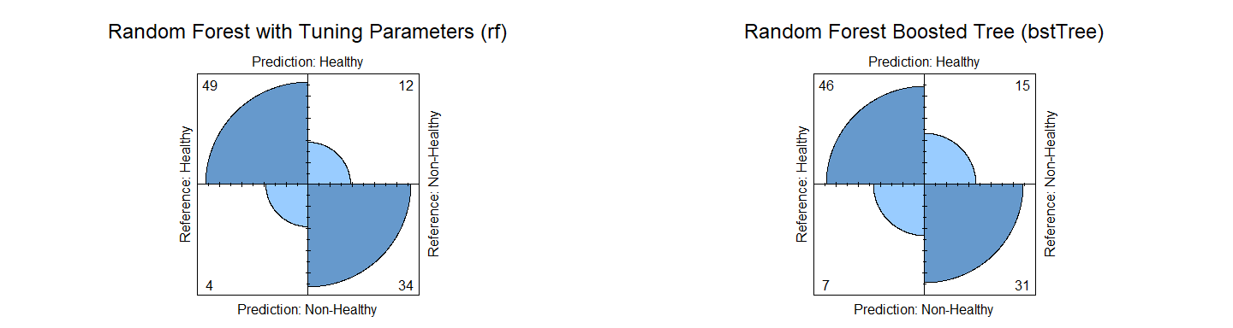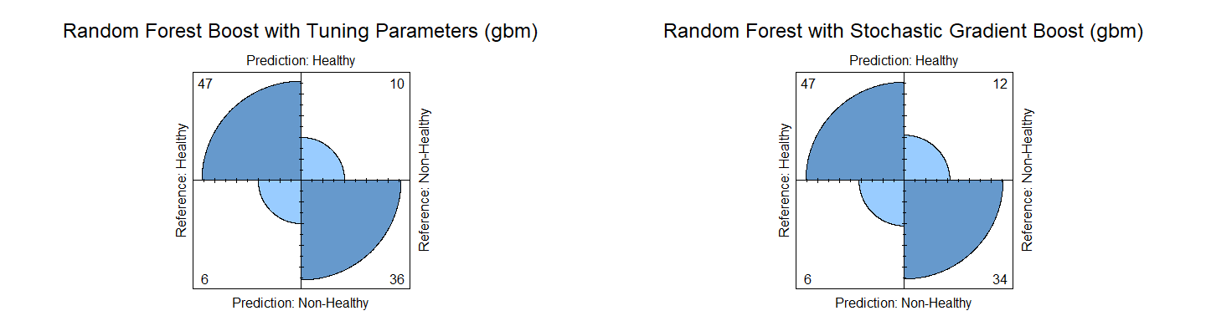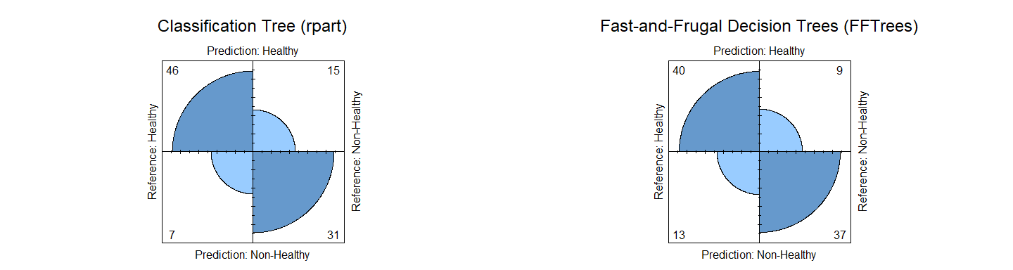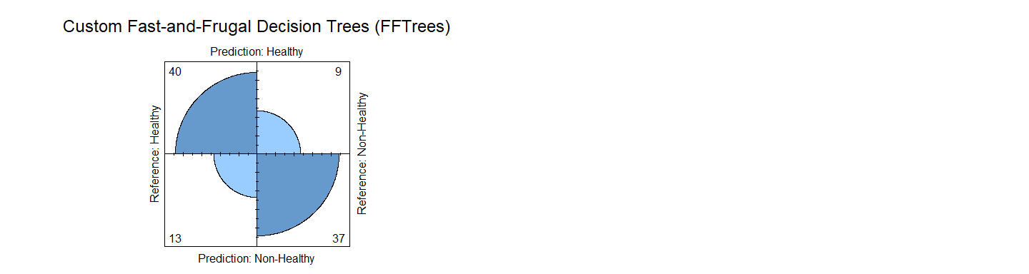

### Models Accuracy

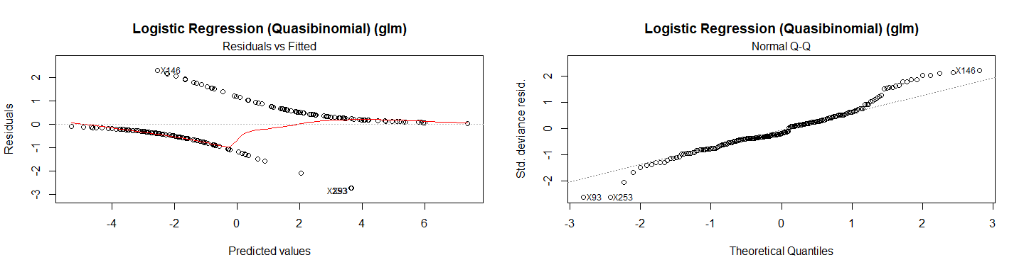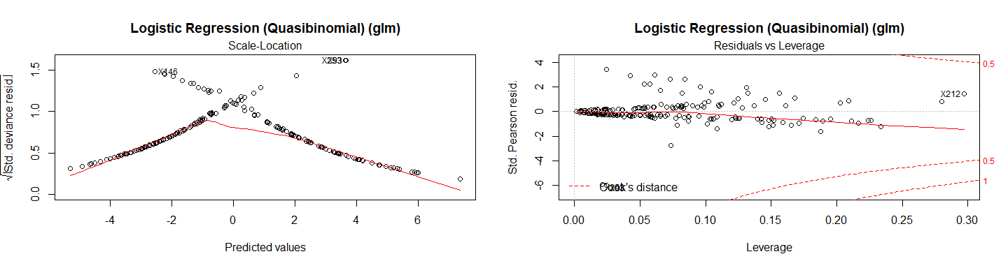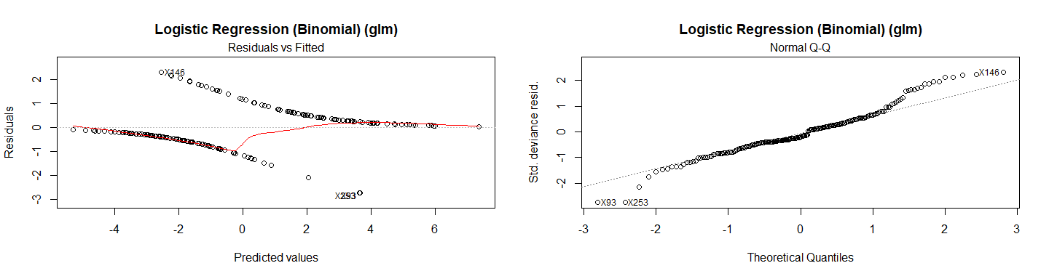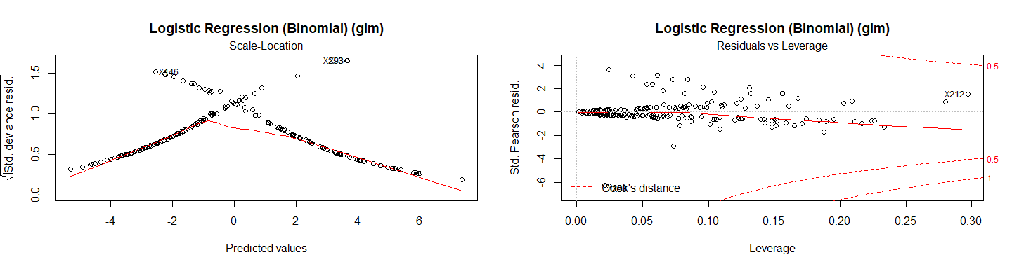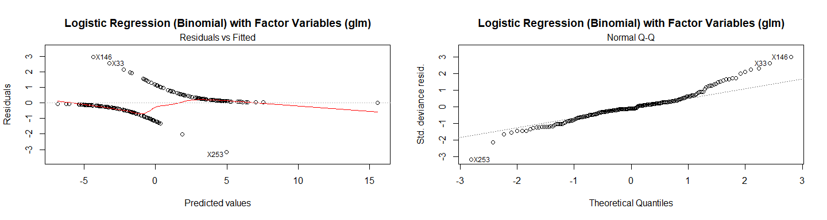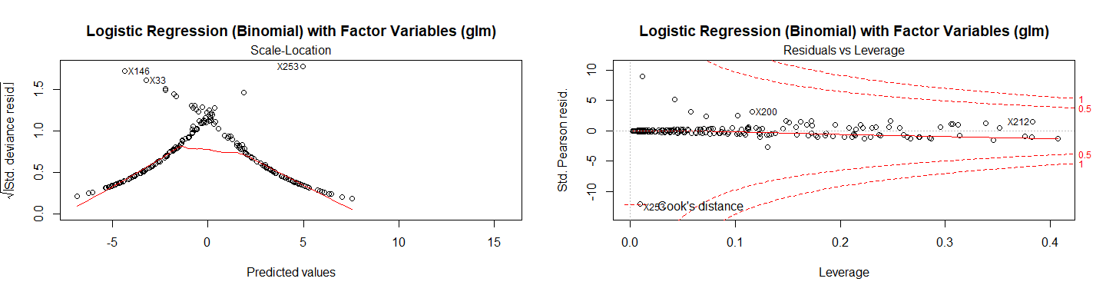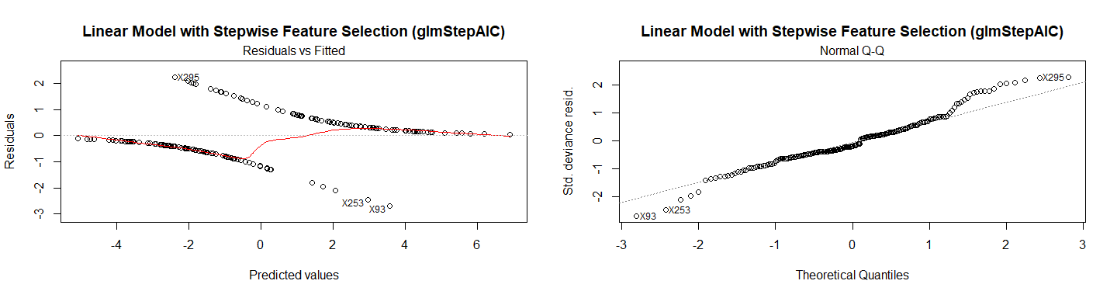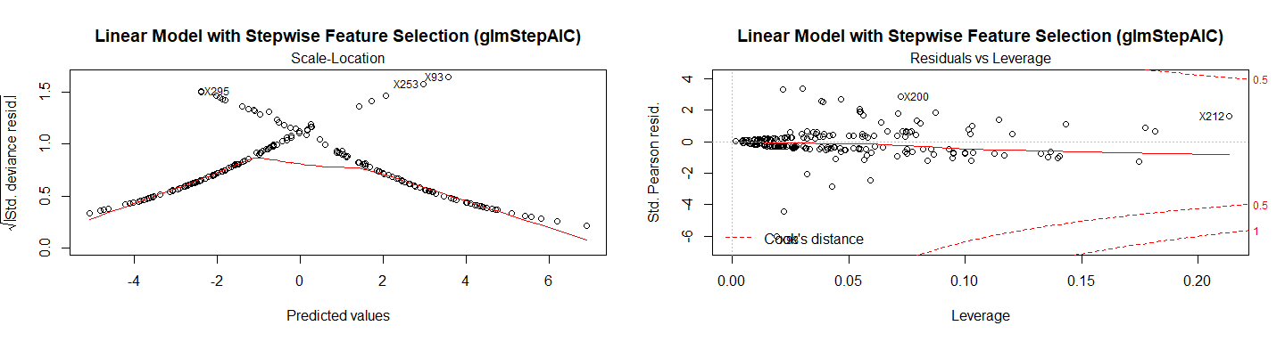

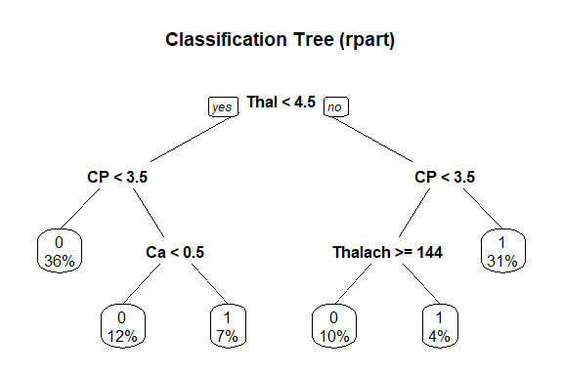

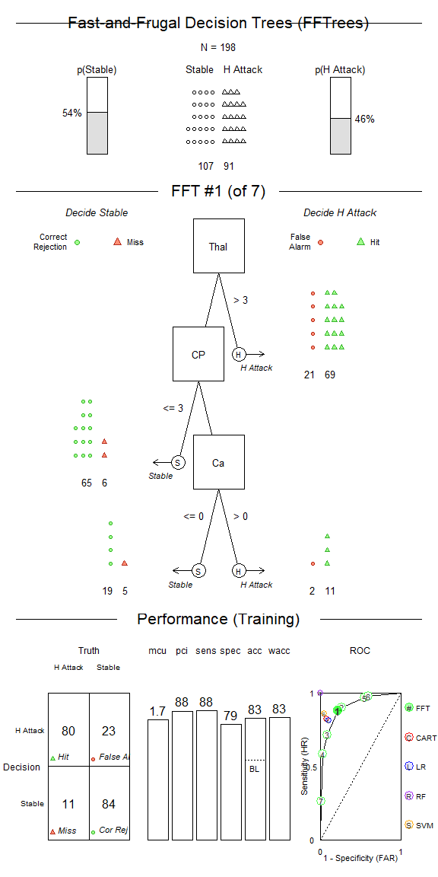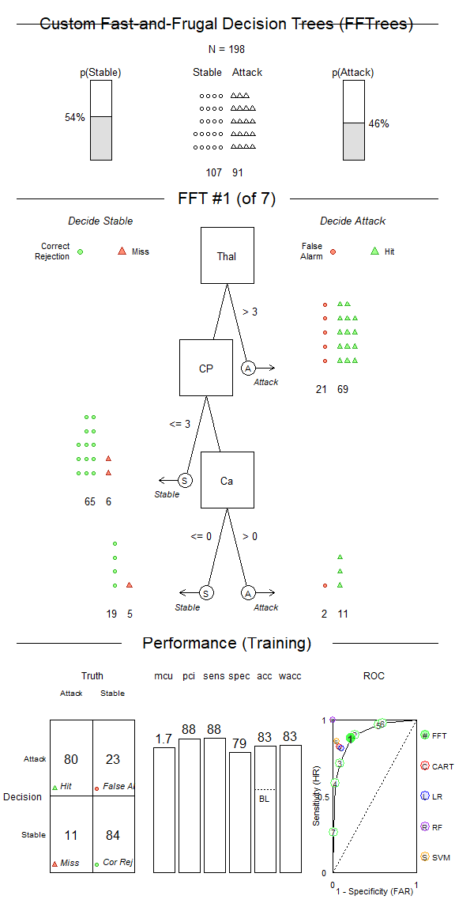

### Models Residuals

